Grade 2
Unit 8Lesson 14CC BY NC 2024 Illustrative Mathematics®
Unit 8, Lesson 14

A Band Concert
- Let’s arrange seats for a concert.
Grade 2
Unit 8Lesson 14CC BY NC 2024 Illustrative Mathematics®

Warm-upWhich Three Go Together: Represent Arrays
Which 3 go together?
A.
B.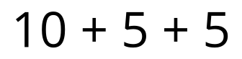
C.
​​​​​​
D.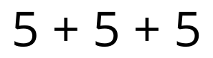
Grade 2
Unit 8Lesson 14CC BY NC 2024 Illustrative Mathematics®

Activity 1How Can They Sit?
Show all the ways a teacher can arrange 24 chairs in an array.
Grade 2
Unit 8Lesson 14CC BY NC 2024 Illustrative Mathematics®

Activity 2My Seating Recommendation
I recommend setting up the chairs this way.
I think this is the best way because

