Grade 2
Unit 6Lesson 8CC BY NC 2024 Illustrative Mathematics®
Unit 6, Lesson 8

Are All Pieces Created Equal?
- Let’s make halves, thirds, and fourths in different ways.
Grade 2
Unit 6Lesson 8CC BY NC 2024 Illustrative Mathematics®

Warm-up Number Talk: 5 Ones
Find the value of each expression mentally.
- $25−15$
- $40−15$
- $65−25$
- $60−35$
Grade 2
Unit 6Lesson 8CC BY NC 2024 Illustrative Mathematics®

Activity 1 Make Quarters and Halves
Lin partitions this square into quarters. She starts by splitting the square into halves.
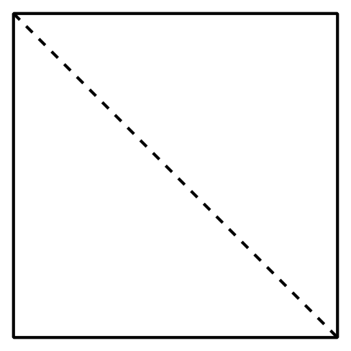
After she draws the first line, she tries 3 different ways to make fourths.
- Which shape shows fourths or quarters? Explain your reasoning.
- A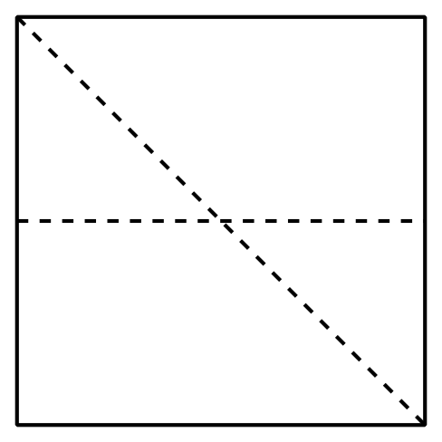
- B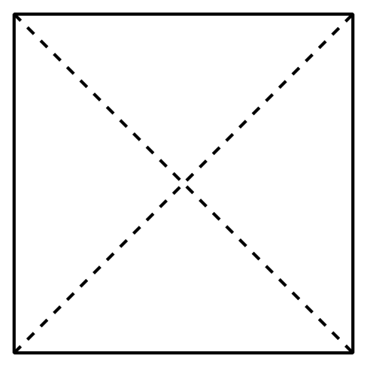
- C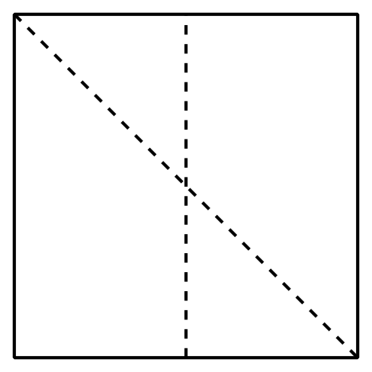
- Name the shaded piece.
- A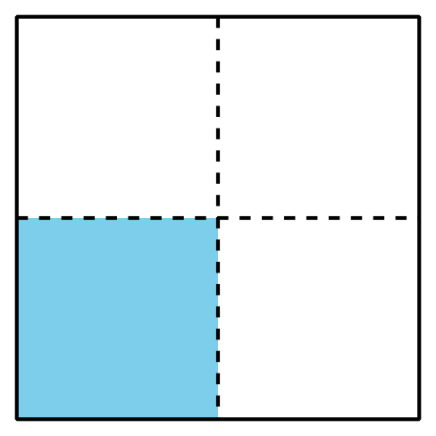
- Shape A has a ______________________ shaded.
- B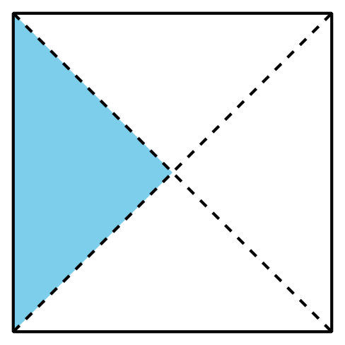
- Shape B has a ______________________ shaded.
- Show 2 different ways to partition the rectangle into quarters or fourths. Shade a fourth of each rectangle.
- 
- Show 2 different ways to partition the square into halves.
Shade half of each square.
- 
Grade 2
Unit 6Lesson 8CC BY NC 2024 Illustrative Mathematics®

Activity 2 Make Equal-Size Pieces
- Lin, Mai, and Andre are asked to shade a third of a shape.
- Lin
- 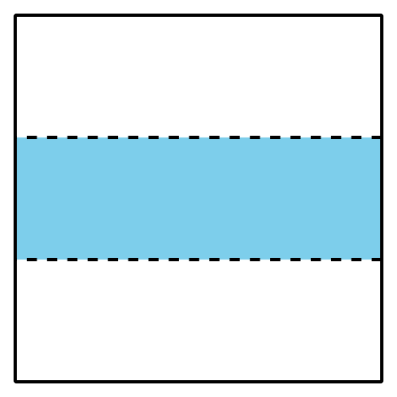
- Mai
- 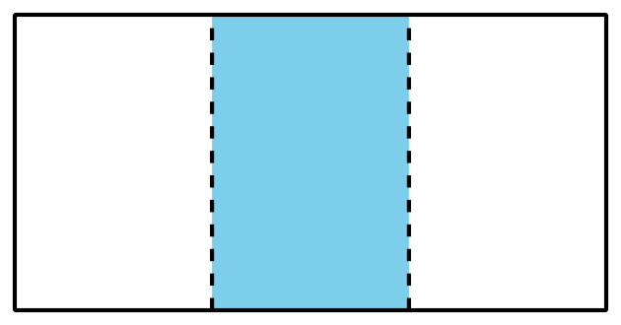
- Andre
- 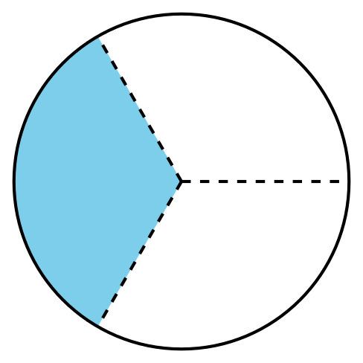
- Do all their shapes show a third shaded? Explain your reasoning.
- Partition the rectangle into thirds. Shade a third of the shape.
- Diego’s dad makes 2 square pans of cornbread. He cuts the pans into pieces for his family.
- Diego’s brother
- Diego
- 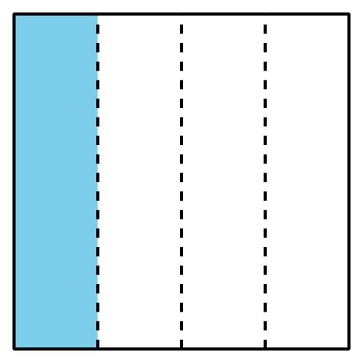
- Diego’s little brother is upset because he thinks his piece of cornbread is smaller than Diego’s. Do you agree? Explain your reasoning.

