Lesson 14 Practice Problems

  - Select all the prisms.
  - For each prism, shade one of its bases.
  - 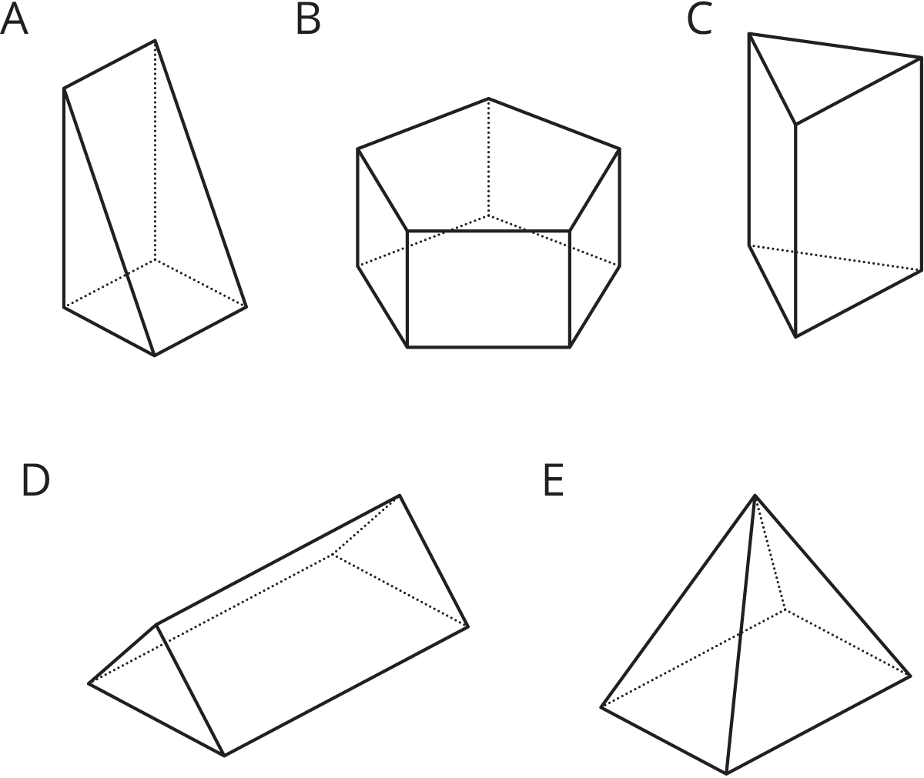
- The volume of both of these trapezoidal prisms is 24 cubic units. Their heights are 6 and 8 units, as labeled. What is the area of a trapezoidal base of each prism?
- 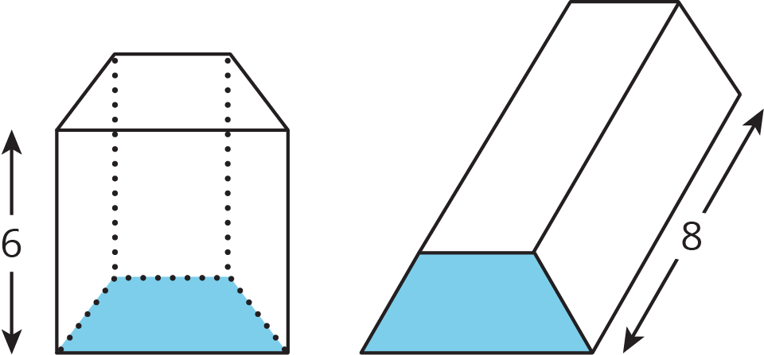

- Two angles are complementary. One has a measure of 19 degrees. What is the measure of the other?
- (From Unit 1, Lesson 12.)
- Two angles are supplementary. One has a measure that is twice as large as the other. Find the two angle measures.
- (From Unit 1, Lesson 12.)
- Match each expression in the first list with an equivalent expression from the second list.
  - $7\left(x+2\right)−x+3$
  - $6x+3+4x+5$
  - $\frac{\text{-}2}{5}x−7+\frac{3}{5}x−3$
  - $8x−5+4−9$
  - $24x+36$
  - $\frac{1}{5}x−10$
  - $6x+17$
  - $2\left(5x+4\right)$
  - $12\left(2x+3\right)$
  - $8x+\left(\text{-}5\right)+4+\left(\text{-}9\right)$
- (From Unit 4, Lesson 11.)
© CC BY Open Up Resources. Adaptations CC BY IM.

