Lesson 6 Practice Problems
- Solve each of these equations. Explain or show your reasoning.
- $2b+8−5b+3=\text{-}13+8b−5$
- $2x+7−5x+8=3\left(5+6x\right)−12x$
- $2c−3=2\left(6−c\right)+7c$
- Solve each equation and check your solution.
- $\text{-}3w−4=w+3$
- $3\left(3−3x\right)=2\left(x+3\right)−30$
- $\frac{1}{3}\left(z+4\right)−6=\frac{2}{3}\left(5−z\right)$
- Elena said the equation $9x+15=3x+15$ has no solutions because $9x$ is greater than $3x$. Do you agree with Elena? Explain your reasoning.
- The table gives some sample data for two quantities, $x$ and $y$, that are in a proportional relationship.
  - Complete the table.
  - Write an equation that represents the relationship between $x$ and $y$ shown in the table.
  - Graph the relationship. Use a scale for the axes that shows all the points in the table.
- $x$ | - $y$
- 14 | - 21
- 64
 | - 39
- 1
- 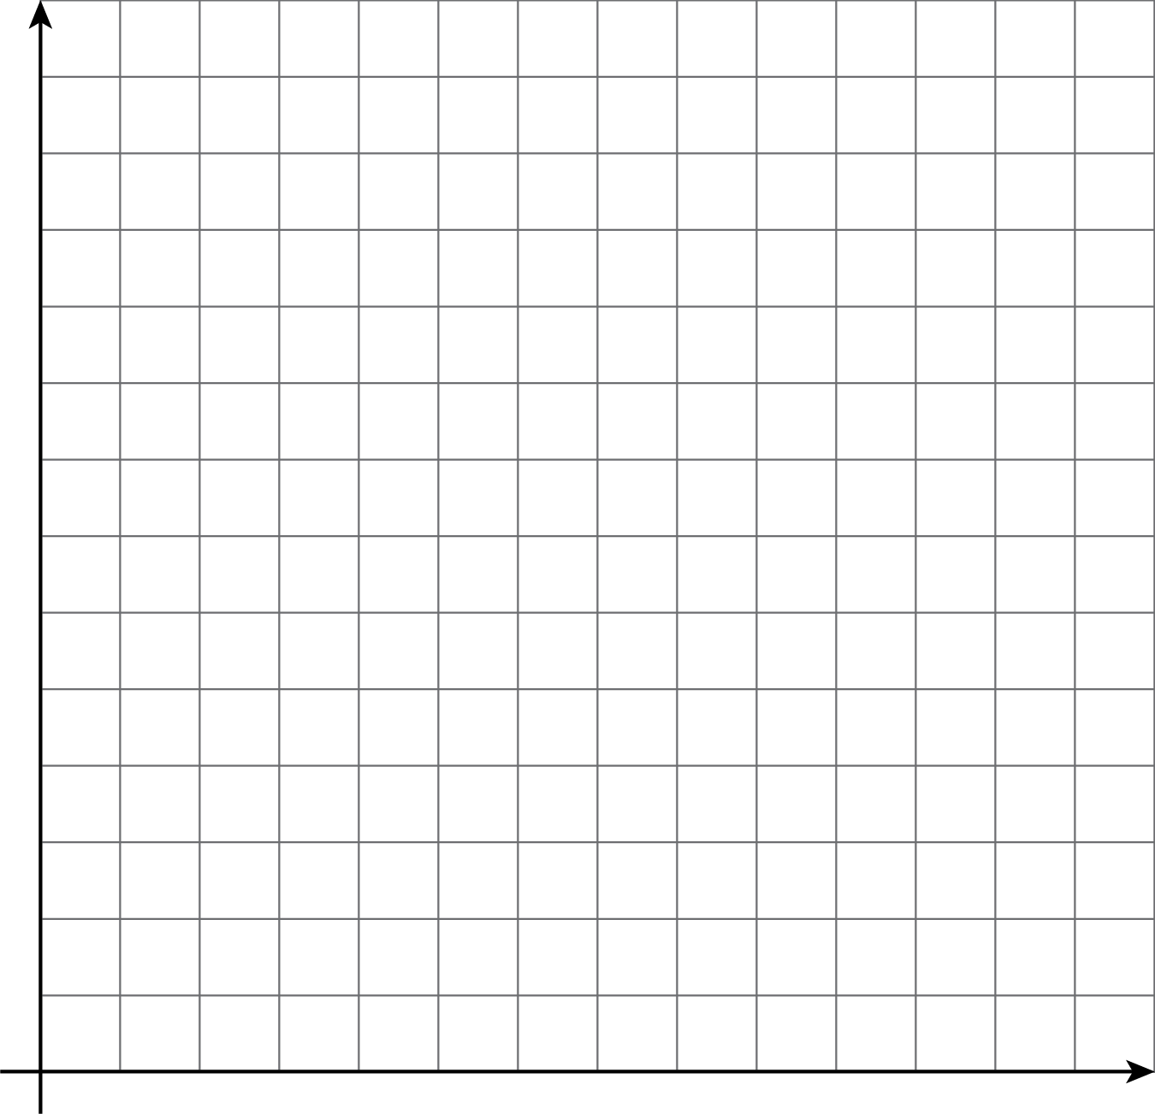
- (From Unit 3, Lesson 3.)
© CC BY Open Up Resources. Adaptations CC BY IM.

