Lesson 6: Create Number Books (Part 1)
- Let’s find things to count at our school.

Warm-up: Notice and Wonder: All Hands On
What do you notice?
What do you wonder?


6.3: Centers: Choice Time
Choose a center.
Find the Pair
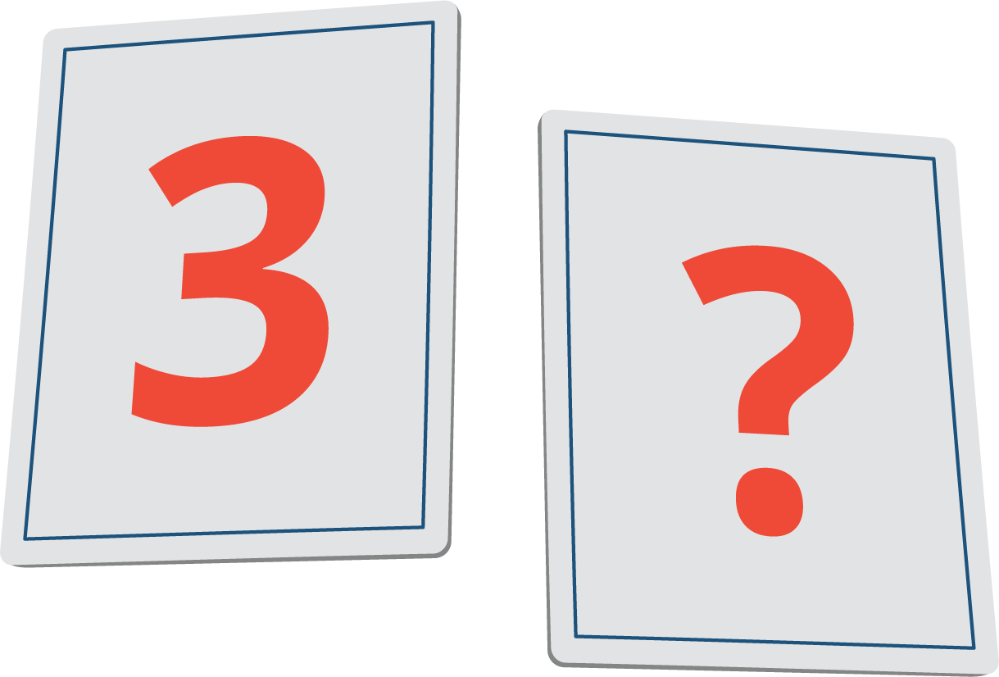
Math Stories
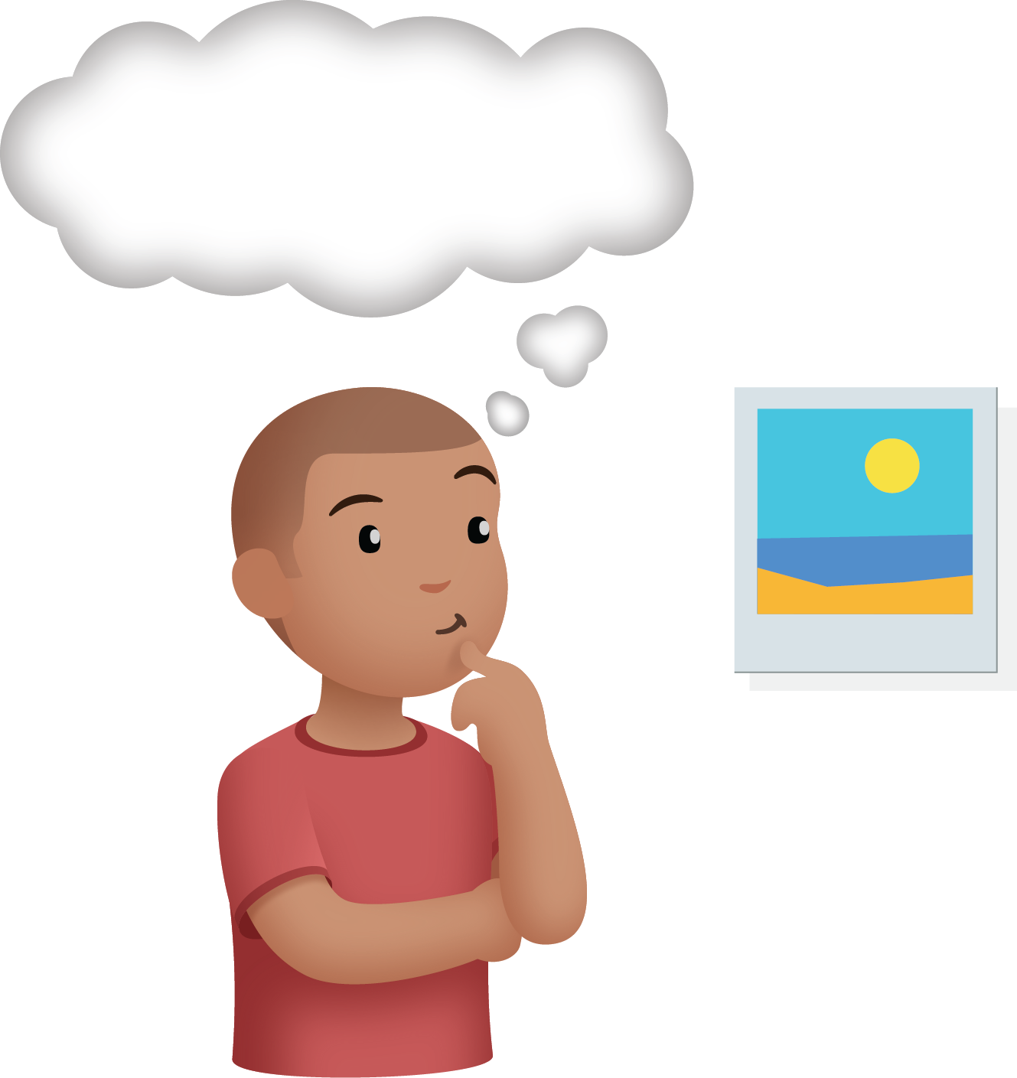
Build Shapes
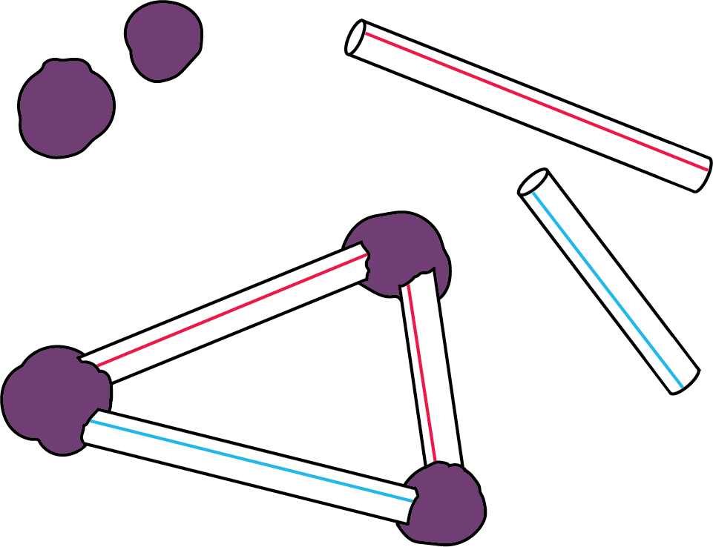
Make or Break Apart Numbers
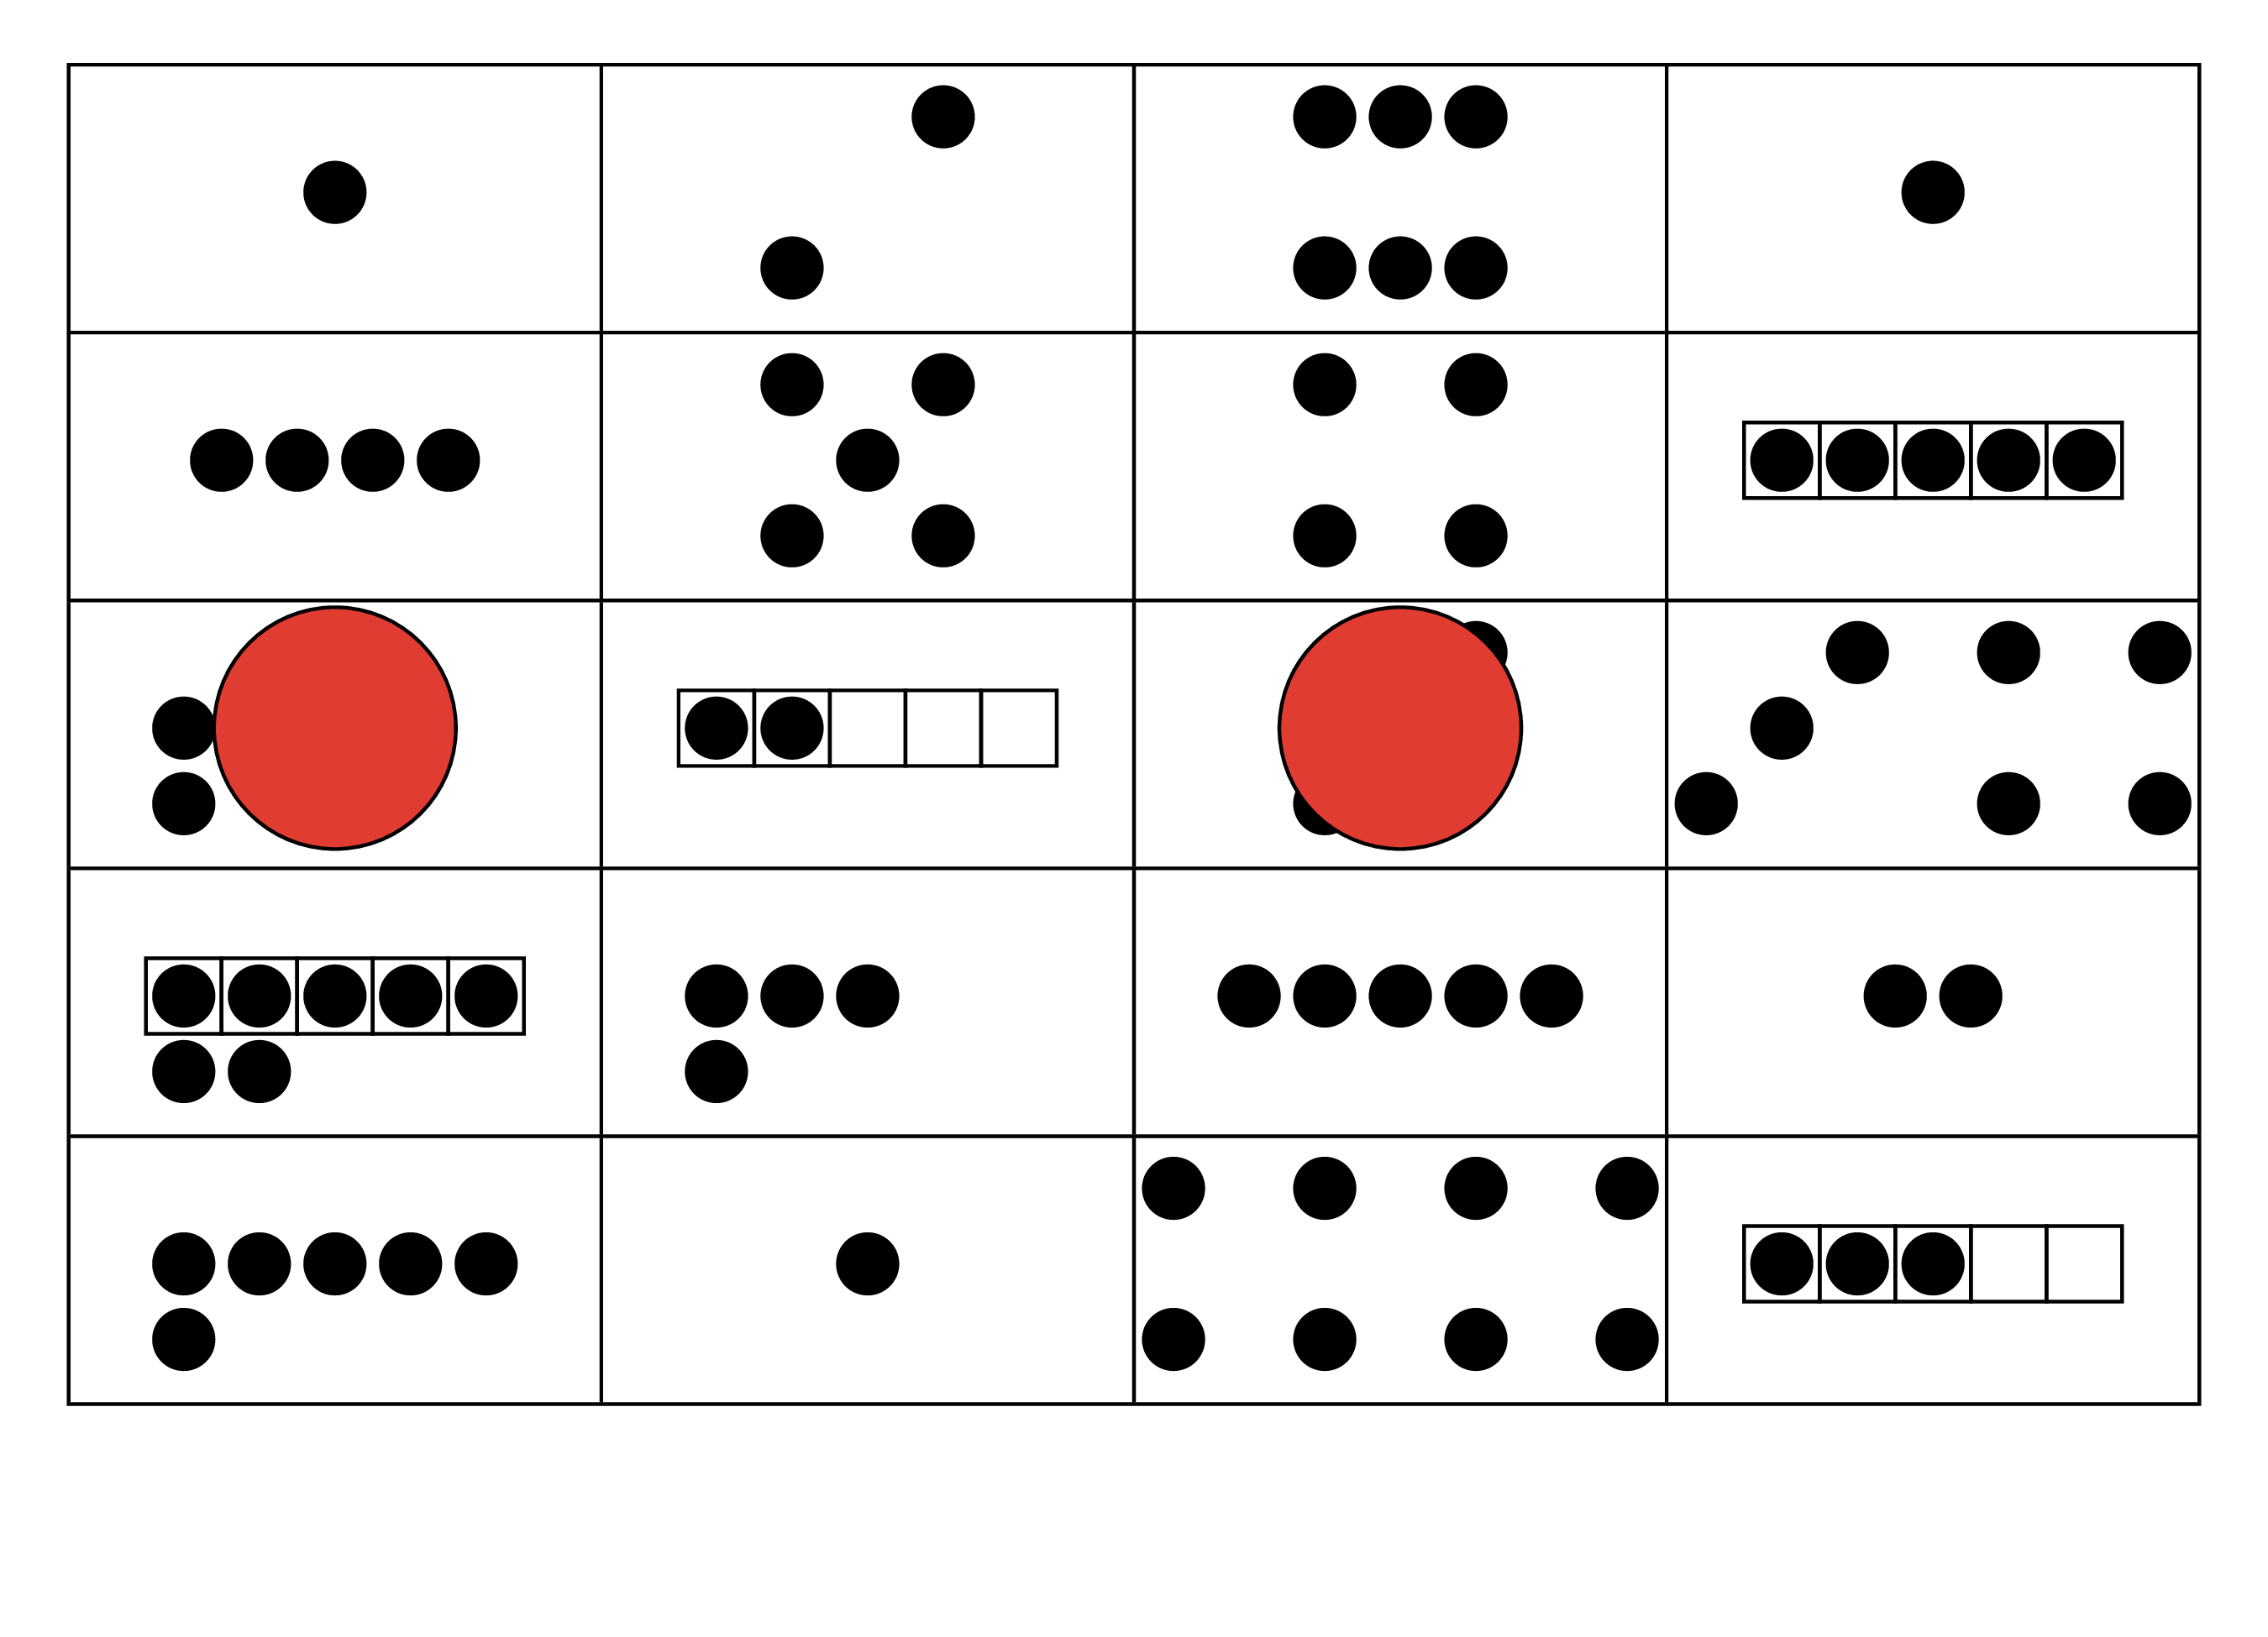
Picture Books
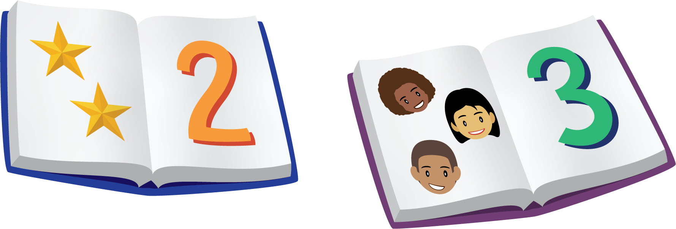
© CC BY 2021 Illustrative Mathematics®

