Lesson 10: Una de las partes, todas las partes

Standards Alignments
Addressing | 1.G.A.3

Teacher-facing Learning Goals
- Describe the whole as two of the halves or four of the fourths.
- Partition circles and rectangles into halves and fourths and describe one piece as “a half of”, “a fourth of” or “a quarter of” the whole shape.

Student-facing Learning Goals
- Describamos partes iguales de figuras.

Lesson Purpose
The purpose of this lesson is for students to partition circles and rectangles into halves and fourths, and use precise language to describe the pieces as a half of or a fourth of the whole shape.
In previous lessons, students partitioned circles and rectangles into two and four equal pieces. They learned the terms halves and fourths to describe how the shapes were partitioned. In this lesson, students describe one piece as a half of, a fourth of, or a quarter of a whole shape. Students also learn that they can describe the whole shape as "two of the halves” or "four of the fourths.”

Access for:

Students with Disabilities
- Representation (Activity 3)

English Learners
- MLR2 (Activity 2)

Instructional Routines
Which One Doesn’t Belong? (Warm-up)

Materials to Gather
- Colored pencils or crayons: Activity 1

Materials to Copy
- Shaded Parts Cards (groups of 1): Activity 2

Lesson Timeline
Warm-up | 10 min
Activity 1 | 10 min
Activity 2 | 15 min
Activity 3 | 10 min
Lesson Synthesis | 10 min
Cool-down | 5 min

Teacher Reflection Question
What part of the lesson went really well today in terms of students’ learning? What did you do that made that part go well?

Cool-down
(to be completed at the end of the lesson) 5min
Parte el rectángulo

Standards Alignments
Addressing | 1.G.A.3

Student-facing Task Statement
- Parte el rectángulo en cuartos.
- 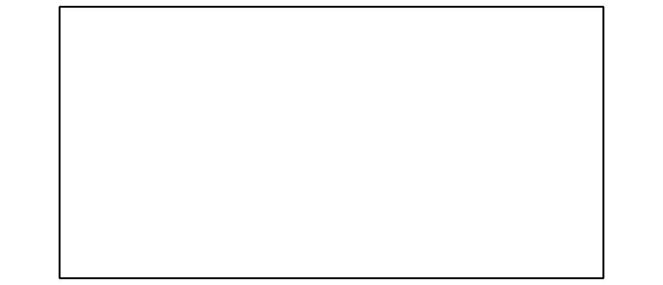
- Colorea una parte.
- Marca todas las maneras de describir la parte que coloreaste.
- una cuarta parte del rectángulo
- una mitad del rectángulo
- un cuarto del
rectángulo
- todo el rectángulo

Student Responses
- Answers vary.
- Answers vary.
- a fourth, a quarter

