Grade 2
Unit 3Lesson 10CC BY NC 2024 Illustrative Mathematics®
Unit 3, Lesson 10

Measure with a Torn Tape
- Let’s measure without starting at 0.
Grade 2
Unit 3Lesson 10CC BY NC 2024 Illustrative Mathematics®

Warm-upTrue or False: Constant Difference
Decide if each statement is true or false. Be prepared to explain your reasoning.
- $10−0=12−2$
- $8−4=10−6$
- $12−4=10−3$
- $15−2=13−0$
Grade 2
Unit 3Lesson 10CC BY NC 2024 Illustrative Mathematics®

Activity 1The Notebook Problem
Jada and Han use an inch ruler. They measure the short side of the notebook.
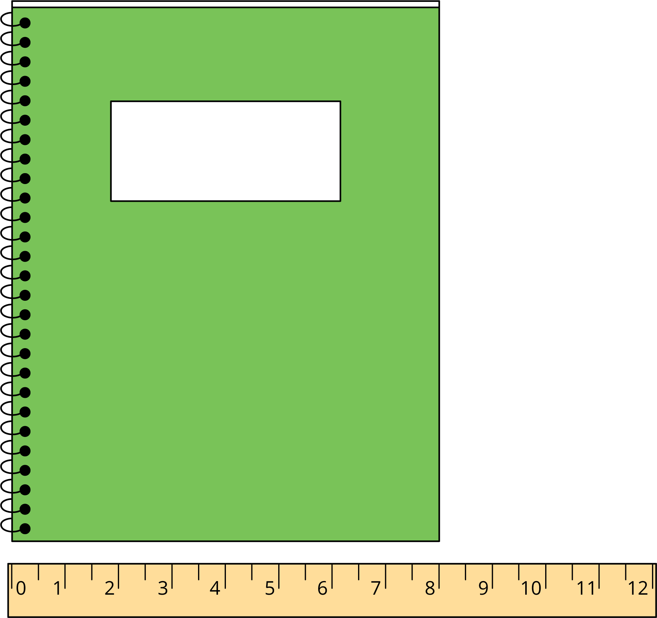
Han says 8 inches.
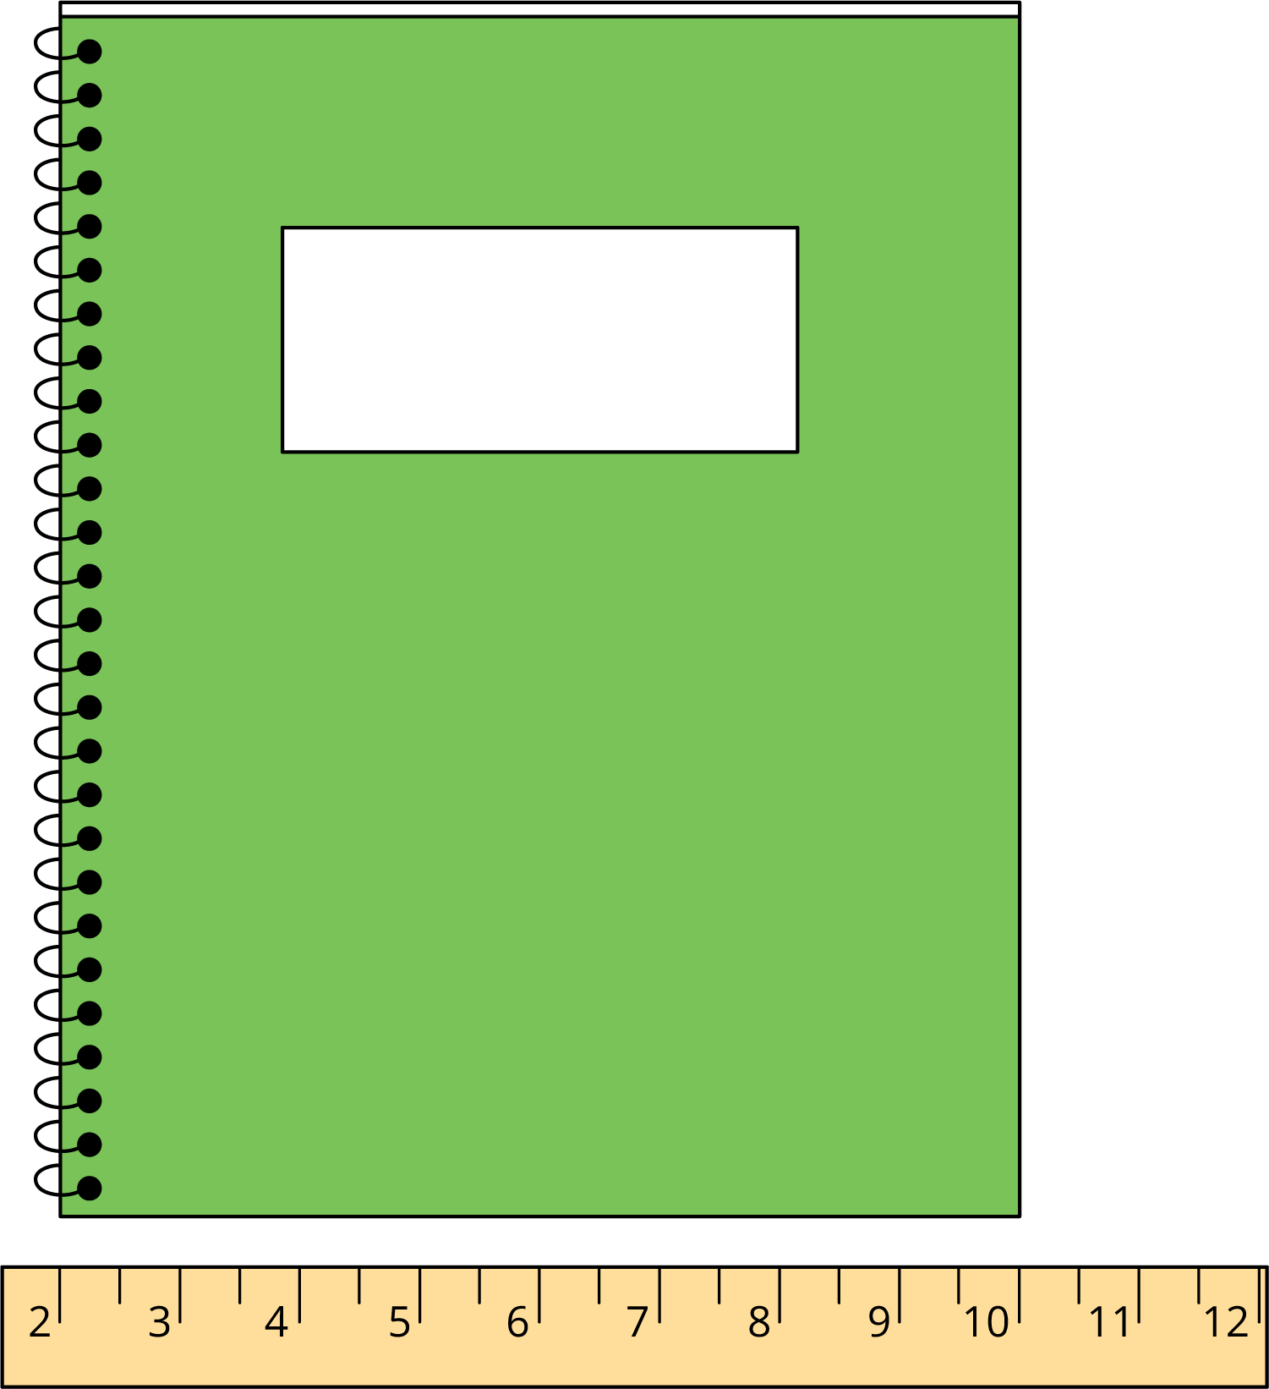
Jada says 8 inches.
- How did Han and Jada get the same measurement?
- Write an equation that shows Jada’s thinking.
- Measure an object using Jada’s method.
  - I measured a ________________________________.
  - I started with the number ____________.
  - I ended with the number ____________.
  - Equation: ________________________________.
  - The length of my object is ____________.
- Compare measurements with a partner.
Grade 2
Unit 3Lesson 10CC BY NC 2024 Illustrative Mathematics®

Activity 2A Desktop to Measure
Lin measures her desktop in inches.
- What is the length of the long side of the desktop? Show your thinking using drawings, numbers, or words.
- 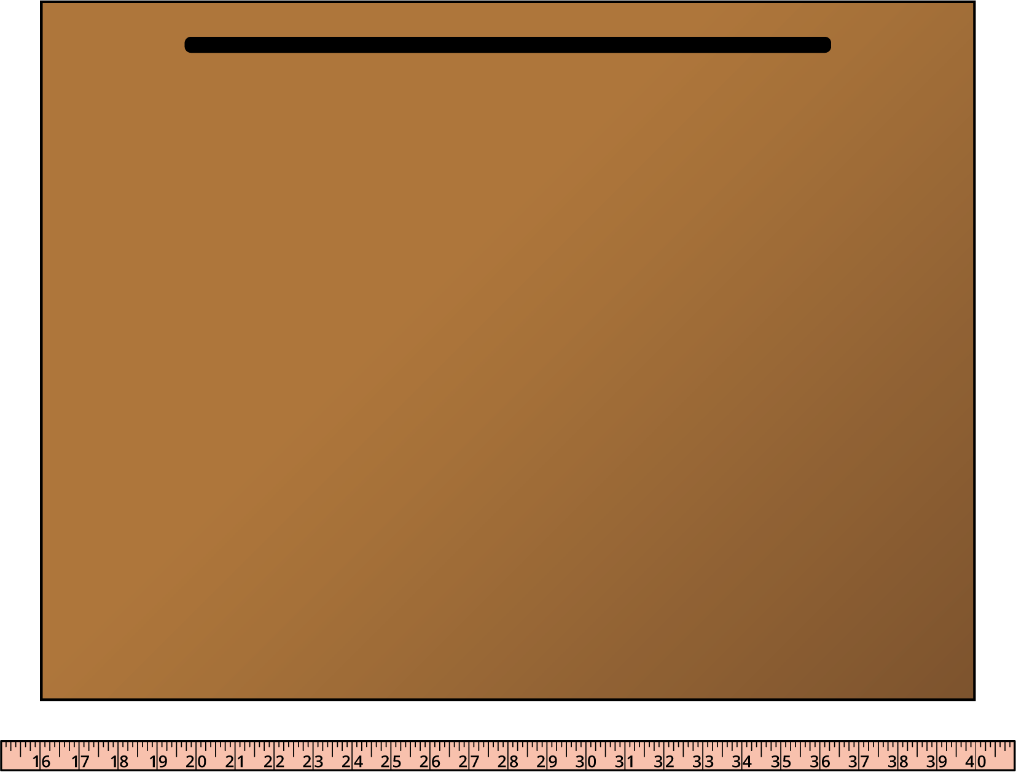
- Equation: ________________________________
- The long side of the desktop is ______________.
- What is the length of the short side of the desktop? Show your thinking using drawings, numbers, or words.
- 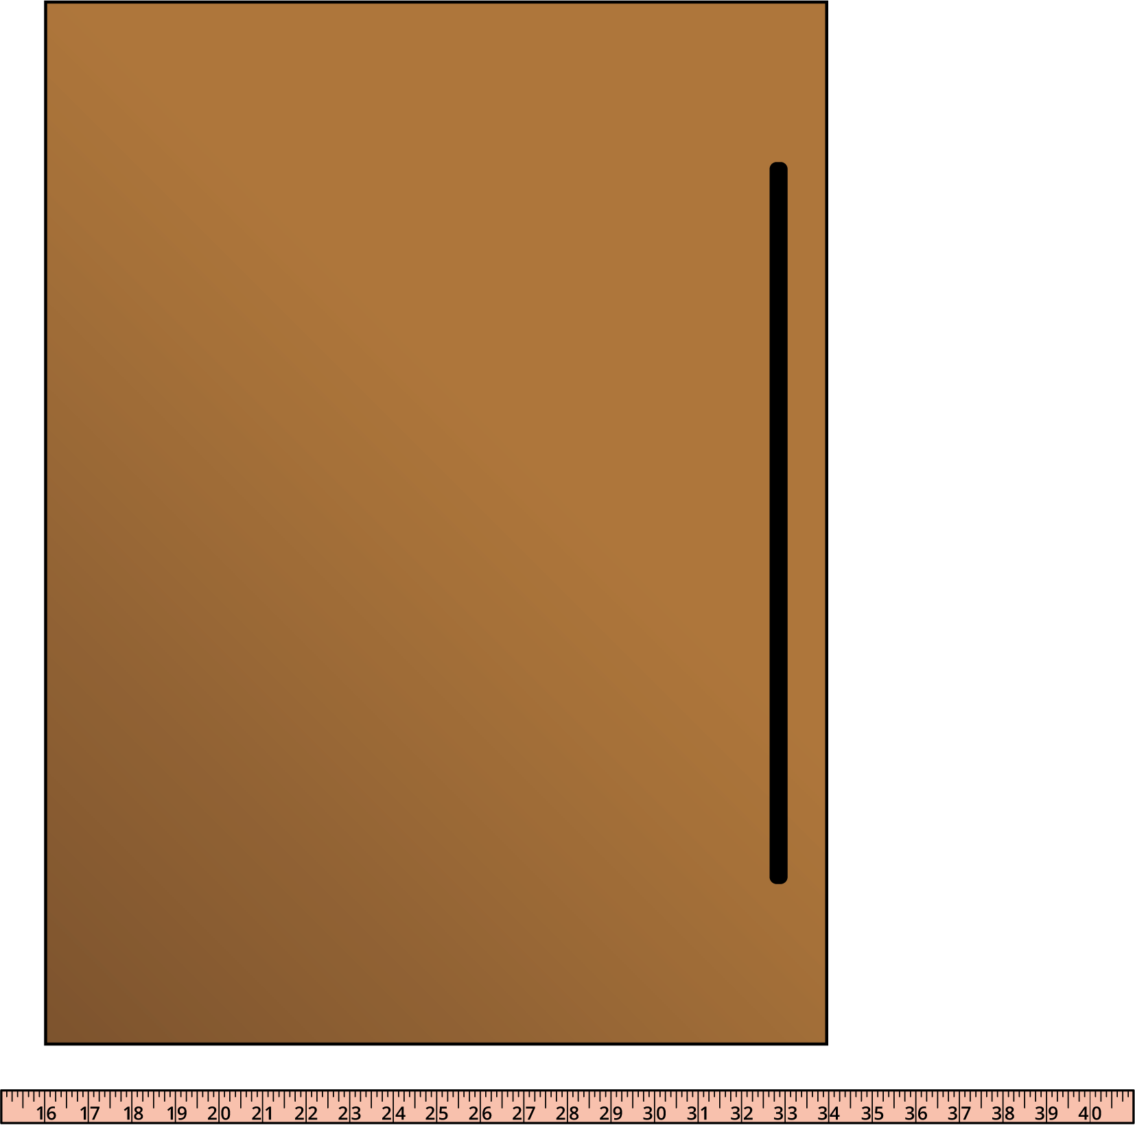
- Equation: ________________________________
- The short side of the desktop is ____________.

