Lesson 3: Características que definen figuras

Standards Alignments
Addressing | 3.G.A.1, 3.NBT.A.3

Teacher-facing Learning Goals
- Describe and identify shapes using their distinguishing attributes.

Student-facing Learning Goals
- Juguemos “El cuadrilátero secreto”.

Lesson Purpose
The purpose of this lesson is for students to describe geometric attributes of shapes.
Students ask yes or no questions about geometric attributes to identify a “mystery quadrilateral.” Students will need their quadrilateral cards from the previous lesson to hide in the mystery quadrilateral folder and will have access to the quadrilaterals in their workbook to support them in questioning, guessing, and ruling out quadrilaterals in the table. Also, it may be helpful to provide counters that students can use to cover quadrilaterals that they rule out with their questioning.

Access for:

Students with Disabilities
- Engagement (Activity 2)

English Learners
- MLR8 (Activity 2)

Instructional Routines
Number Talk (Warm-up)

Materials to Gather
- Counters: Activity 2
- Folders: Activity 2
- Materials from a previous lesson: Activity 1, Activity 2

Lesson Timeline
Warm-up | 10 min
Activity 1 | 10 min
Activity 2 | 25 min
Lesson Synthesis | 10 min
Cool-down | 5 min

Teacher Reflection Question
Identify who participated in math class today. What assumptions are you making about those who did not participate?

Cool-down
(to be completed at the end of the lesson) 5min
Figura secreta

Standards Alignments
Addressing | 3.G.A.1

Student-facing Task Statement
- ¿Cuál cuadrilátero se está describiendo?
  - Pista 1: tiene 4 lados.
  - Pista 2: todos sus lados tienen la misma longitud.
  - Pista 3: no tiene ángulos rectos.
- A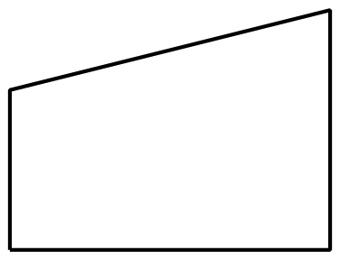
- B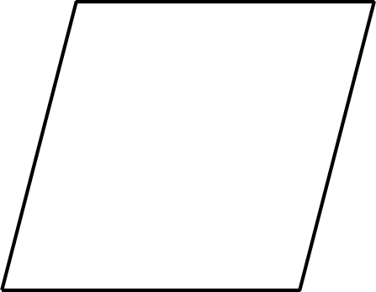
- C
- D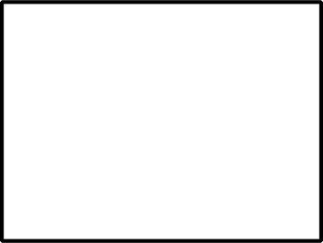
- ¿Cuáles pistas necesitas para adivinar el cuadrilátero? Explica tu razonamiento.

Student Responses
- B
- Sample responses:
  - Hints 2 and 3, because Hint 2 tells you that they have sides that are the same length which gets rid of A and D. Then, Hint 3 tells you that there are no right angles which gets rid of C.
  - You only need Hint 3 because B is the only shape with no right angles.

