Unit 3 Lesson 20: More Practice to Represent and Solve

WU Number Talk: Two Steps (Warm up)

Student Task Statement
Find the value of each expression mentally.
- $20+\left(2×3\right)$
- $30+\left(4×3\right)$
- $50+\left(8×3\right)$
- $99+\left(8×3\right)$

1 Info Gap: Introduction

Student Task Statement
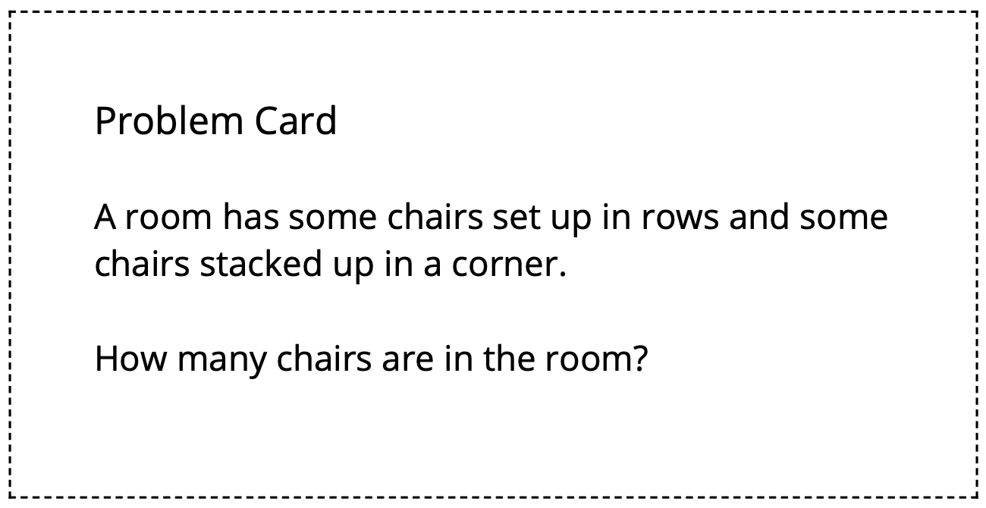

2 Info Gap: Bake Sale

Student Task Statement
Your teacher will give you either a problem card or a data card. Do not show or read your card to your partner.
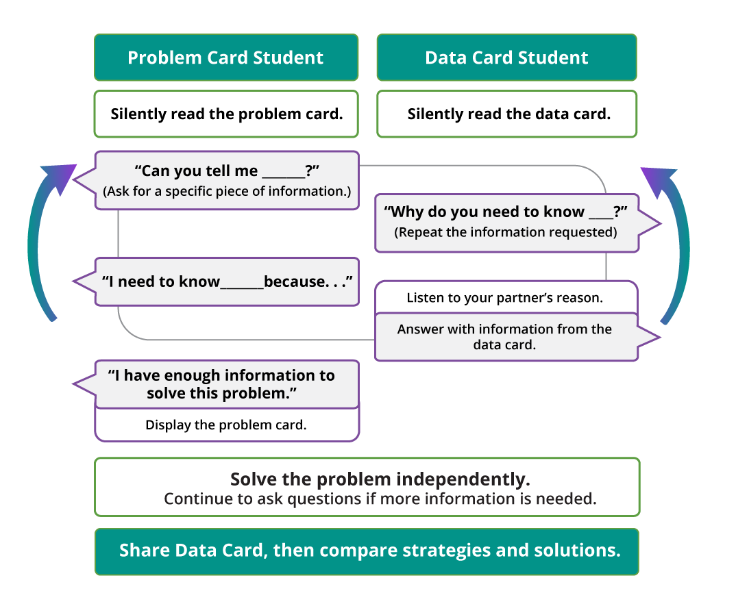
Pause here so your teacher can review your work.
Ask your teacher for a new set of cards and repeat the activity, trading roles with your partner.
© CC BY 2021 Illustrative Mathematics®

