Grade 2
Unit 4Lesson 8CC BY NC 2024 Illustrative Mathematics®
Unit 4, Lesson 8

Equations on a Number Line
- Let’s write equations and represent them on a number line.
Grade 2
Unit 4Lesson 8CC BY NC 2024 Illustrative Mathematics®

Activity 1 Represent Equations
Represent each equation on the number line.
- $15+7=22$
- Unable to process <img src="/tikz_files/238516.svg">Failed: rsvg-convert --format png --dpi-x 300 --dpi-y 300 /app/tmp/svgtopng-1786380948.4048815.svg --output /app/tmp/svgtopng-1786380948.4048815.png Backtrace: /app/app/services/script/runner.rb:34:in `block in run_cmd' <internal:kernel>:90:in `tap' /app/app/services/script/runner.rb:32:in `run_cmd' /app/app/services/script/svg_to_png.rb:27:in `convert_svg_to_png' /app/app/services/script/svg_to_png.rb:17:in `to_png' /app/vendor/bundle/ruby/3.3.0/gems/embeddable_content-1.1.0/app/services/embeddable_content/images/image_downloader.rb:37:in `png_rendered_from_svg' /app/vendor/bundle/ruby/3.3.0/gems/embeddable_content-1.1.0/app/services/embeddable_content/images/image_downloader.rb:33:in `raw_image_data' /app/vendor/bundle/ruby/3.3.0/gems/embeddable_content-1.1.0/app/services/embeddable_content/images/image_downloader.rb:13:in `block in save' <internal:kernel>:90:in `tap' /app/vendor/bundle/ruby/3.3.0/gems/embeddable_content-1.1.0/app/services/embeddable_content/images/image_downloader.rb:13:in `save'
- $18−6=12$
- Unable to process <img src="/tikz_files/238517.svg">Failed: rsvg-convert --format png --dpi-x 300 --dpi-y 300 /app/tmp/svgtopng-1786380948.4885116.svg --output /app/tmp/svgtopng-1786380948.4885116.png Backtrace: /app/app/services/script/runner.rb:34:in `block in run_cmd' <internal:kernel>:90:in `tap' /app/app/services/script/runner.rb:32:in `run_cmd' /app/app/services/script/svg_to_png.rb:27:in `convert_svg_to_png' /app/app/services/script/svg_to_png.rb:17:in `to_png' /app/vendor/bundle/ruby/3.3.0/gems/embeddable_content-1.1.0/app/services/embeddable_content/images/image_downloader.rb:37:in `png_rendered_from_svg' /app/vendor/bundle/ruby/3.3.0/gems/embeddable_content-1.1.0/app/services/embeddable_content/images/image_downloader.rb:33:in `raw_image_data' /app/vendor/bundle/ruby/3.3.0/gems/embeddable_content-1.1.0/app/services/embeddable_content/images/image_downloader.rb:13:in `block in save' <internal:kernel>:90:in `tap' /app/vendor/bundle/ruby/3.3.0/gems/embeddable_content-1.1.0/app/services/embeddable_content/images/image_downloader.rb:13:in `save'
- $46+7=53$
- Unable to process <img src="/tikz_files/238518.svg">Failed: rsvg-convert --format png --dpi-x 300 --dpi-y 300 /app/tmp/svgtopng-1786380948.5695431.svg --output /app/tmp/svgtopng-1786380948.5695431.png Backtrace: /app/app/services/script/runner.rb:34:in `block in run_cmd' <internal:kernel>:90:in `tap' /app/app/services/script/runner.rb:32:in `run_cmd' /app/app/services/script/svg_to_png.rb:27:in `convert_svg_to_png' /app/app/services/script/svg_to_png.rb:17:in `to_png' /app/vendor/bundle/ruby/3.3.0/gems/embeddable_content-1.1.0/app/services/embeddable_content/images/image_downloader.rb:37:in `png_rendered_from_svg' /app/vendor/bundle/ruby/3.3.0/gems/embeddable_content-1.1.0/app/services/embeddable_content/images/image_downloader.rb:33:in `raw_image_data' /app/vendor/bundle/ruby/3.3.0/gems/embeddable_content-1.1.0/app/services/embeddable_content/images/image_downloader.rb:13:in `block in save' <internal:kernel>:90:in `tap' /app/vendor/bundle/ruby/3.3.0/gems/embeddable_content-1.1.0/app/services/embeddable_content/images/image_downloader.rb:13:in `save'
- $33−9=24$
- Unable to process <img src="/tikz_files/238519.svg">Failed: rsvg-convert --format png --dpi-x 300 --dpi-y 300 /app/tmp/svgtopng-1786380948.6595964.svg --output /app/tmp/svgtopng-1786380948.6595964.png Backtrace: /app/app/services/script/runner.rb:34:in `block in run_cmd' <internal:kernel>:90:in `tap' /app/app/services/script/runner.rb:32:in `run_cmd' /app/app/services/script/svg_to_png.rb:27:in `convert_svg_to_png' /app/app/services/script/svg_to_png.rb:17:in `to_png' /app/vendor/bundle/ruby/3.3.0/gems/embeddable_content-1.1.0/app/services/embeddable_content/images/image_downloader.rb:37:in `png_rendered_from_svg' /app/vendor/bundle/ruby/3.3.0/gems/embeddable_content-1.1.0/app/services/embeddable_content/images/image_downloader.rb:33:in `raw_image_data' /app/vendor/bundle/ruby/3.3.0/gems/embeddable_content-1.1.0/app/services/embeddable_content/images/image_downloader.rb:13:in `block in save' <internal:kernel>:90:in `tap' /app/vendor/bundle/ruby/3.3.0/gems/embeddable_content-1.1.0/app/services/embeddable_content/images/image_downloader.rb:13:in `save'
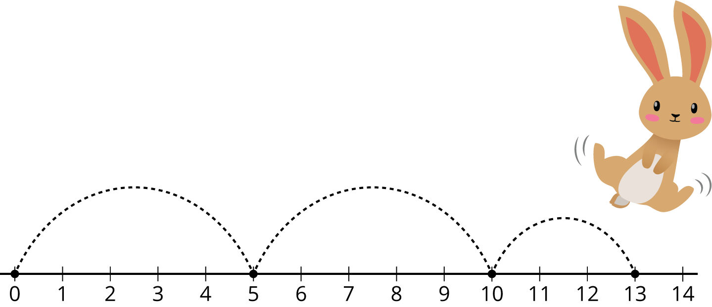
Grade 2
Unit 4Lesson 8CC BY NC 2024 Illustrative Mathematics®

Activity 2Write Equations
Write an equation that matches the diagram.
- Equation: __________________________
- Unable to process <img src="/tikz_files/238524.svg">Failed: rsvg-convert --format png --dpi-x 300 --dpi-y 300 /app/tmp/svgtopng-1786380948.7960756.svg --output /app/tmp/svgtopng-1786380948.7960756.png Backtrace: /app/app/services/script/runner.rb:34:in `block in run_cmd' <internal:kernel>:90:in `tap' /app/app/services/script/runner.rb:32:in `run_cmd' /app/app/services/script/svg_to_png.rb:27:in `convert_svg_to_png' /app/app/services/script/svg_to_png.rb:17:in `to_png' /app/vendor/bundle/ruby/3.3.0/gems/embeddable_content-1.1.0/app/services/embeddable_content/images/image_downloader.rb:37:in `png_rendered_from_svg' /app/vendor/bundle/ruby/3.3.0/gems/embeddable_content-1.1.0/app/services/embeddable_content/images/image_downloader.rb:33:in `raw_image_data' /app/vendor/bundle/ruby/3.3.0/gems/embeddable_content-1.1.0/app/services/embeddable_content/images/image_downloader.rb:13:in `block in save' <internal:kernel>:90:in `tap' /app/vendor/bundle/ruby/3.3.0/gems/embeddable_content-1.1.0/app/services/embeddable_content/images/image_downloader.rb:13:in `save'
- Equation: __________________________
- Unable to process <img src="/tikz_files/238525.svg">Failed: rsvg-convert --format png --dpi-x 300 --dpi-y 300 /app/tmp/svgtopng-1786380948.8519952.svg --output /app/tmp/svgtopng-1786380948.8519952.png Backtrace: /app/app/services/script/runner.rb:34:in `block in run_cmd' <internal:kernel>:90:in `tap' /app/app/services/script/runner.rb:32:in `run_cmd' /app/app/services/script/svg_to_png.rb:27:in `convert_svg_to_png' /app/app/services/script/svg_to_png.rb:17:in `to_png' /app/vendor/bundle/ruby/3.3.0/gems/embeddable_content-1.1.0/app/services/embeddable_content/images/image_downloader.rb:37:in `png_rendered_from_svg' /app/vendor/bundle/ruby/3.3.0/gems/embeddable_content-1.1.0/app/services/embeddable_content/images/image_downloader.rb:33:in `raw_image_data' /app/vendor/bundle/ruby/3.3.0/gems/embeddable_content-1.1.0/app/services/embeddable_content/images/image_downloader.rb:13:in `block in save' <internal:kernel>:90:in `tap' /app/vendor/bundle/ruby/3.3.0/gems/embeddable_content-1.1.0/app/services/embeddable_content/images/image_downloader.rb:13:in `save'
- Equation: __________________________
- Unable to process <img src="/tikz_files/238526.svg">Failed: rsvg-convert --format png --dpi-x 300 --dpi-y 300 /app/tmp/svgtopng-1786380948.9682899.svg --output /app/tmp/svgtopng-1786380948.9682899.png Backtrace: /app/app/services/script/runner.rb:34:in `block in run_cmd' <internal:kernel>:90:in `tap' /app/app/services/script/runner.rb:32:in `run_cmd' /app/app/services/script/svg_to_png.rb:27:in `convert_svg_to_png' /app/app/services/script/svg_to_png.rb:17:in `to_png' /app/vendor/bundle/ruby/3.3.0/gems/embeddable_content-1.1.0/app/services/embeddable_content/images/image_downloader.rb:37:in `png_rendered_from_svg' /app/vendor/bundle/ruby/3.3.0/gems/embeddable_content-1.1.0/app/services/embeddable_content/images/image_downloader.rb:33:in `raw_image_data' /app/vendor/bundle/ruby/3.3.0/gems/embeddable_content-1.1.0/app/services/embeddable_content/images/image_downloader.rb:13:in `block in save' <internal:kernel>:90:in `tap' /app/vendor/bundle/ruby/3.3.0/gems/embeddable_content-1.1.0/app/services/embeddable_content/images/image_downloader.rb:13:in `save'
- Equation: __________________________
- Unable to process <img src="/tikz_files/238527.svg">Failed: rsvg-convert --format png --dpi-x 300 --dpi-y 300 /app/tmp/svgtopng-1786380949.0569983.svg --output /app/tmp/svgtopng-1786380949.0569983.png Backtrace: /app/app/services/script/runner.rb:34:in `block in run_cmd' <internal:kernel>:90:in `tap' /app/app/services/script/runner.rb:32:in `run_cmd' /app/app/services/script/svg_to_png.rb:27:in `convert_svg_to_png' /app/app/services/script/svg_to_png.rb:17:in `to_png' /app/vendor/bundle/ruby/3.3.0/gems/embeddable_content-1.1.0/app/services/embeddable_content/images/image_downloader.rb:37:in `png_rendered_from_svg' /app/vendor/bundle/ruby/3.3.0/gems/embeddable_content-1.1.0/app/services/embeddable_content/images/image_downloader.rb:33:in `raw_image_data' /app/vendor/bundle/ruby/3.3.0/gems/embeddable_content-1.1.0/app/services/embeddable_content/images/image_downloader.rb:13:in `block in save' <internal:kernel>:90:in `tap' /app/vendor/bundle/ruby/3.3.0/gems/embeddable_content-1.1.0/app/services/embeddable_content/images/image_downloader.rb:13:in `save'
- Compare your equations with your partner.
- Pick the 2 number lines you think are most alike. Explain your choice to your partner.

