Unit 2 Lesson 26: Modeling with Systems of Inequalities in Two Variables

1 A Solution to Which Inequalities? (Warm up)

Student Task Statement
Is the ordered pair $\left(5.43,0\right)$ a solution to all, some, or none of these inequalities? Be prepared to explain your reasoning.
$x>0$
$y>0$
$x≥0$
$y≥0$

Activity Synthesis
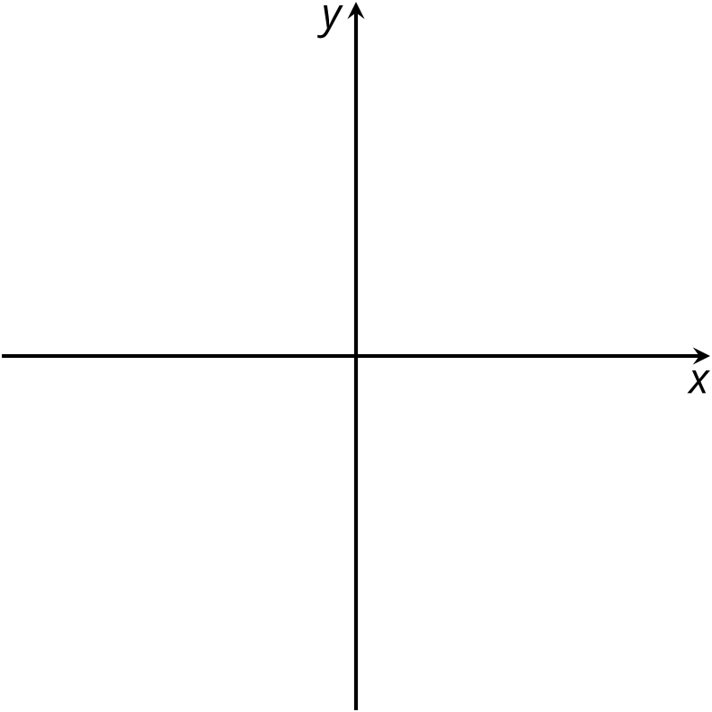

2 Custom Trail Mix

Student Task Statement
Here is the nutrition information for some trail mix ingredients:
 | calories per gram (kcal) | protein per gram (g) | sugar per gram (g) | fat per gram (g) | fiber per gram (g)
peanuts | 5.36 | 0.21 | 0.04 | 0.46 | 0.07
almonds | 5.71 | 0.18 | 0.21 | 0.46 | 0.07
raisins | 3.00 | 0.03 | 0.60 | 0.00 | 0.05
chocolate pieces | 4.76 | 0.05 | 0.67 | 0.19 | 0.02
shredded coconut | 6.67 | 0.07 | 0.07 | 0.67 | 0.13
sunflower seeds | 5.50 | 0.20 | 0.03 | 0.47 | 0.10
dried cherries | 3.25 | 0.03 | 0.68 | 0.00 | 0.03
walnuts | 6.43 | 0.14 | 0.04 | 0.61 | 0.07
Tyler and Jada each designed their own custom trail mix using two of these ingredients. They wrote inequalities and created graphs to represent their constraints.
Tyler
- $x+y>50$
- $4.76x+6.67y≤400$
- $0.67x+0.07y<30$
- $x>0$
- $y>0$
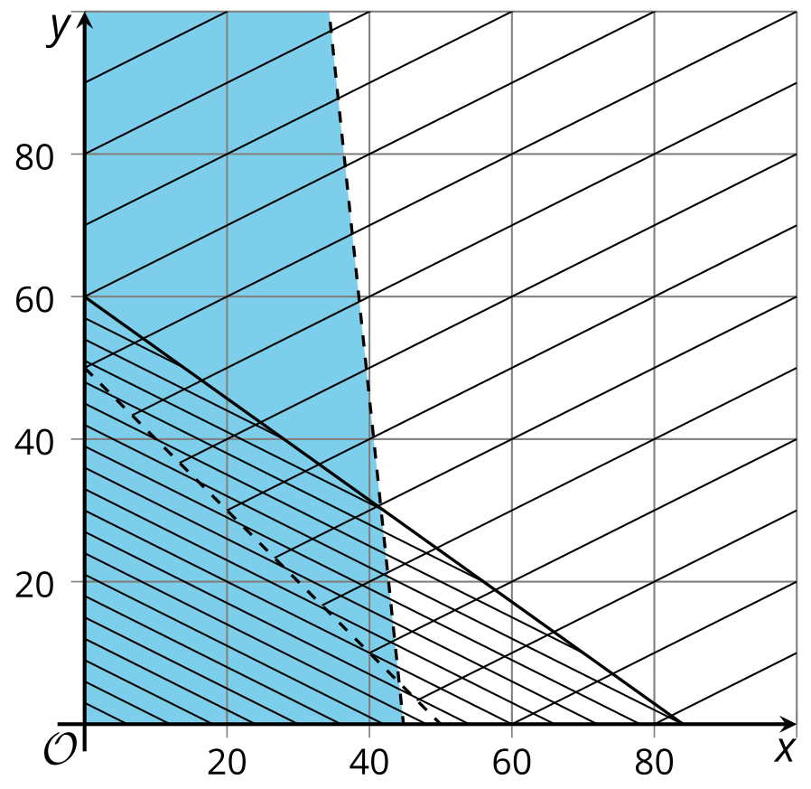
Jada
- $w+z>50$
- $0.14w+0.03z>4$
- $0.61w+0z≤15$
- $w>0$
- $z>0$
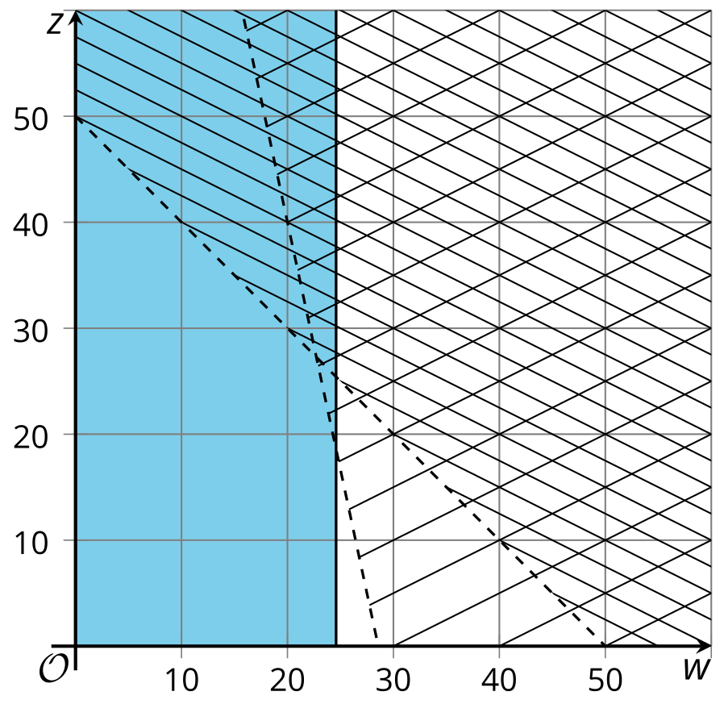
Use the inequalities and graphs to answer these questions about each student's trail mix. Be prepared to explain your reasoning.
- Which two ingredients did they choose?
- What do their variables represent?
- What does each constraint mean?
- Which graph represents which constraint?
- Name one possible combination of ingredients for their trail mix.

3 Design Your Own Trail Mix

Student Task Statement
It's time to design your own trail mix!
- Choose two ingredients that you like to eat. (You can choose from the ingredients in the previous activity, or you can look up nutrition information for other ingredients.)
- Think about the constraints for your trail mix. What do you want to be true about its calories, protein, sugar, fat, or fiber?
- Write inequalities to represent your constraints. Then, graph the inequalities.

- 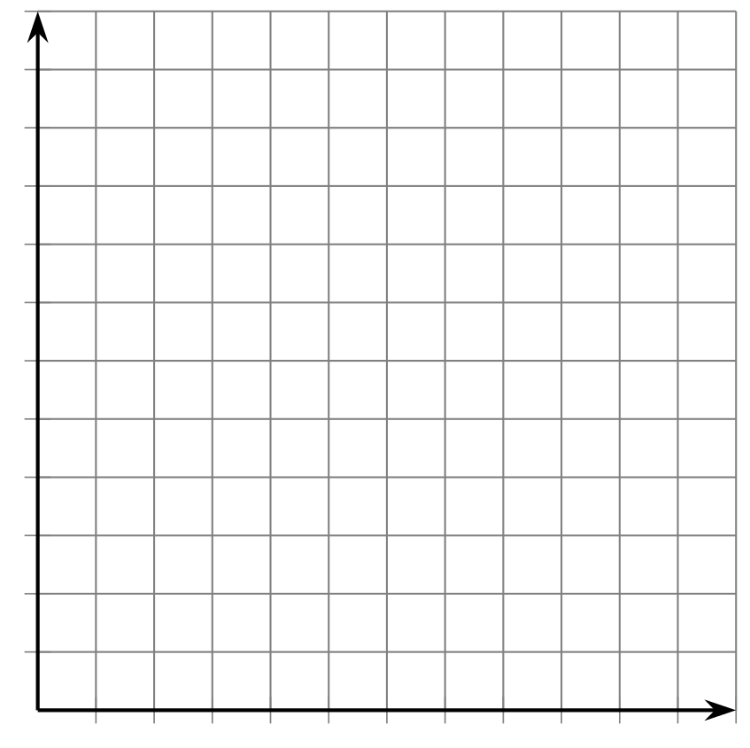
- Is it possible to make trail mix that meets all your constraints using your ingredients? If not, make changes to your constraints or your ingredients and record them here.
- Write a possible combination of ingredients for your trail mix.
Pause here so your teacher can review your work and give further instructions for displaying your work.
© CC BY 2019 by Illustrative Mathematics®

