## Lesson 15: Greater Than, Less Than

* Let’s make sense of comparisons and decide if they're true.

### Warm-up: Number Talk: Add or Subtract 10

Find the value of each expression mentally.

$35+10$

$52+10$

$52−10$

$83−10$

### 15.1: Which is Greater, Which is Less?

Circle the statement that is true in each pair.  
Be ready to explain how you know so that others will understand.

$27<17$

$17<27$

$34<36$

$36<34$

$25<52$

$52<25$

$24>54$

$54>24$

$21>29$

$29>21$

$85>58$

$58>85$

$45<54$

$45>54$

$74<78$

$74>78$

$21<12$

$21>12$

### 15.2: True or False Comparisons

Read each statement.  
Determine whether each statement is true or false.  
Be ready to explain how you know so that others will understand.

$17<47$

$58=53$

$45>63$

$39<93$

$4=46$

If you have time, rewrite each false statement to make it true.

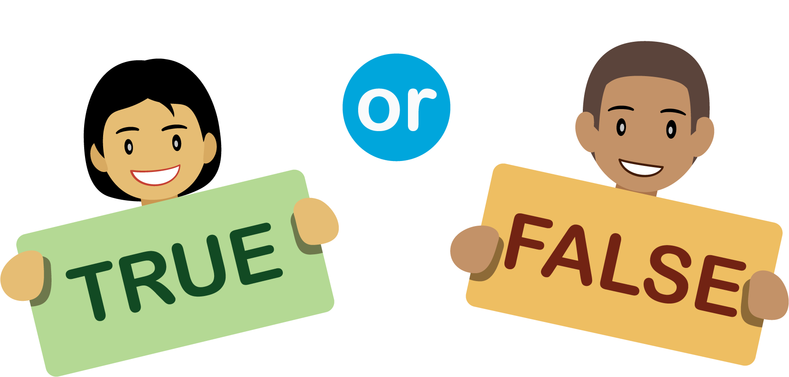



© CC BY 2021 Illustrative Mathematics®