Lesson 5 Practice Problems
- Here are two stories:
  - A family buys 6 tickets to a show. They also each spend $3 on a snack. They spend $24 on the show.
  - Diego has 24 ounces of juice. He pours equal amounts for each of his 3 friends, and then adds 6 more ounces for each.
- Here are two equations:
  - $3\left(x+6\right)=24$
  - $6\left(x+3\right)=24$
  - Which equation represents which story?
  - What does $x$ represent in each equation?
  - Find the solution to each equation. Explain or show your reasoning.
  - What does each solution tell you about its situation?
- Here is a diagram and its corresponding equation. Find the solution to the equation and explain your reasoning.
- 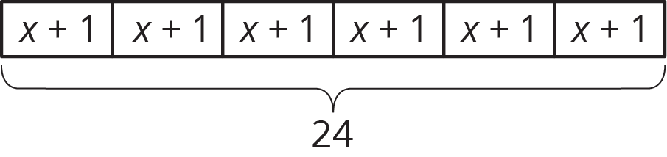
- $6\left(x+1\right)=24$
- Find a sequence of rotations, reflections, translations, and dilations showing that one figure is similar to the other. Be specific: give the amount and direction of a translation, a line of reflection, the center and angle of a rotation, and the center and scale factor of a dilation.
- 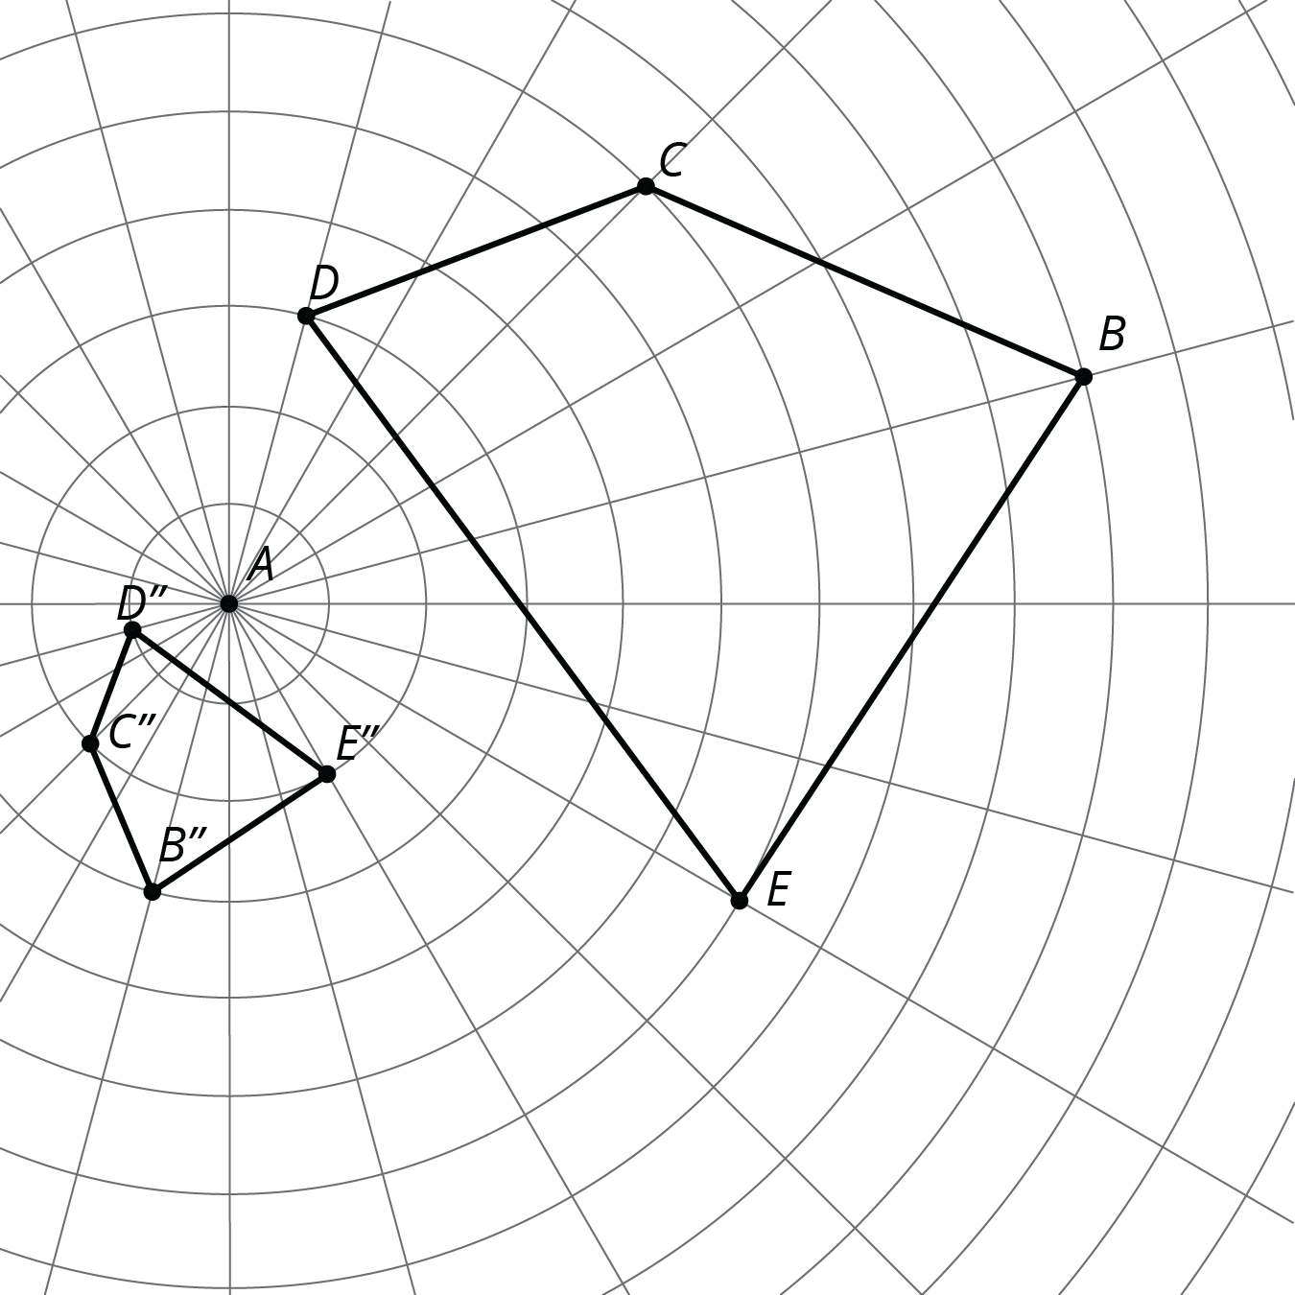

- (From Unit 2, Lesson 11.)
- Suppose Quadrilaterals A and B are both squares. Are A and B necessarily scaled copies of one another? Explain.
- (From Unit 2, Lesson 2.)
© CC BY Open Up Resources. Adaptations CC BY IM.

