Lesson 12: Partamos rectángulos en cuadrados

Standards Alignments
Addressing | 2.G.A.2, 2.OA.C.4
Building Towards | 3.MD.C

Teacher-facing Learning Goals
- Partition rectangles into rows and columns of equal-size squares, and count to find the total number of squares.

Student-facing Learning Goals
- Partamos rectángulos en cuadrados.

Lesson Purpose
The purpose of this lesson is for students to partition rectangles into equal-size squares.
Students have arranged tiles to make arrays and rectangles, represented their rectangles by shading squares on a grid, and completed the partitioning of rectangles into equal-size squares. In this lesson, students partition rectangles into equal-size squares with and without guiding marks and represent the total number of squares within the rectangles with equations that show the sum of the number of squares in each row or the number of squares in each column. Monitor for the ways students use what they know about the structure of arrays to plan and partition their rectangles. It is not important that students partition the rectangles into exactly equal-size squares.
This lesson has a Student Section Summary.

Access for:

Students with Disabilities
- Action and Expression (Activity 2)

English Learners
- MLR2 (Activity 1)

Instructional Routines
Estimation Exploration (Warm-up)

Materials to Gather
- Inch tiles: Activity 1, Activity 2
- Rulers: Activity 1, Activity 2

Lesson Timeline
Warm-up | 10 min
Activity 1 | 15 min
Activity 2 | 20 min
Lesson Synthesis | 10 min
Cool-down | 5 min

Teacher Reflection Question
How did the work of arranging objects to make arrays support the understanding of partitioning rectangles into equal-size squares? What additional support is needed as students build this understanding?

Cool-down
(to be completed at the end of the lesson) 5min
¿Cuántos cuadrados?

Standards Alignments
Addressing | 2.G.A.2, 2.OA.C.4

Student-facing Task Statement
- Parte el rectángulo en cuadrados de igual tamaño.
- 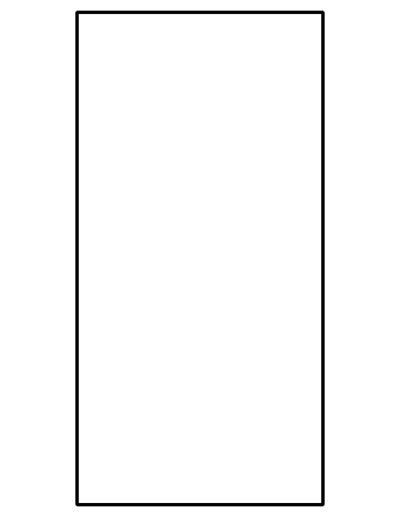
- ¿Cuántas filas de cuadrados de igual tamaño hiciste?
- ¿Cuántas columnas de cuadrados de igual tamaño hiciste?
- Escribe una ecuación que represente el número de cuadrados que hay en el rectángulo.

Student Responses
Sample response:
- The rectangle is split into 4 rows of 2 equal-size squares.
- 4 rows
- 2 columns
- $4+4=8$ or $2+2+2+2=8$

