Unit 2 Lesson 4: Groups that Look Alike

WU How Many Do You See: Fingers on One Hand (Warm up)

Images for Launch


Student Task Statement

1 Which Has More?

Student Task Statement
Priya and her family are sitting down at the table for dinner.
There are 4 people sitting at the table.
There are 6 spoons.
Are there enough spoons for each person to get one?
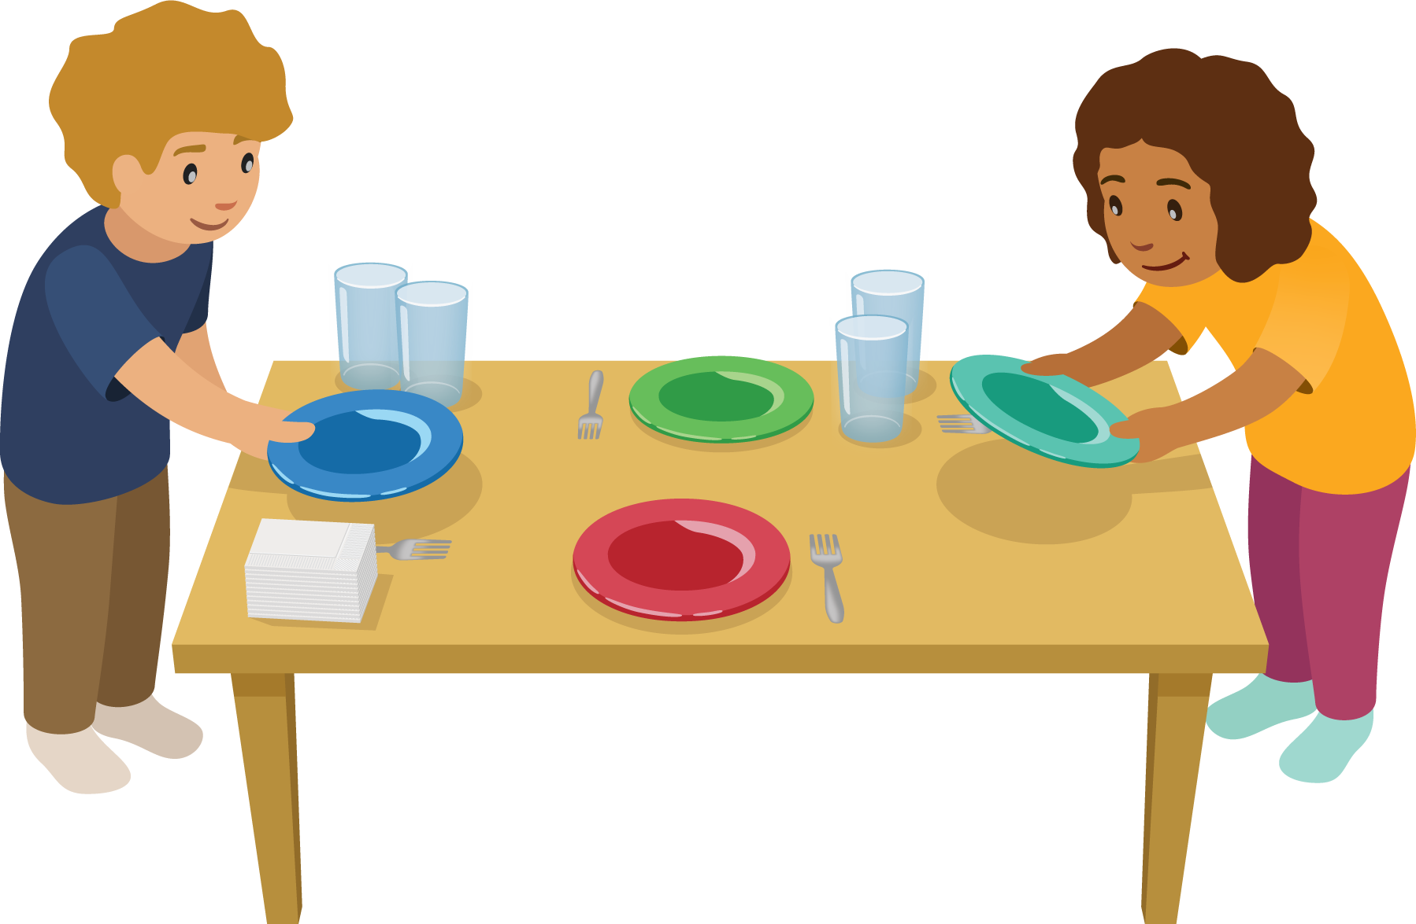

2 Introduce Shake and Spill: Which Is More?

Student Task Statement

3 Centers: Choice Time

Student Task Statement
Choose a center.
Number Race
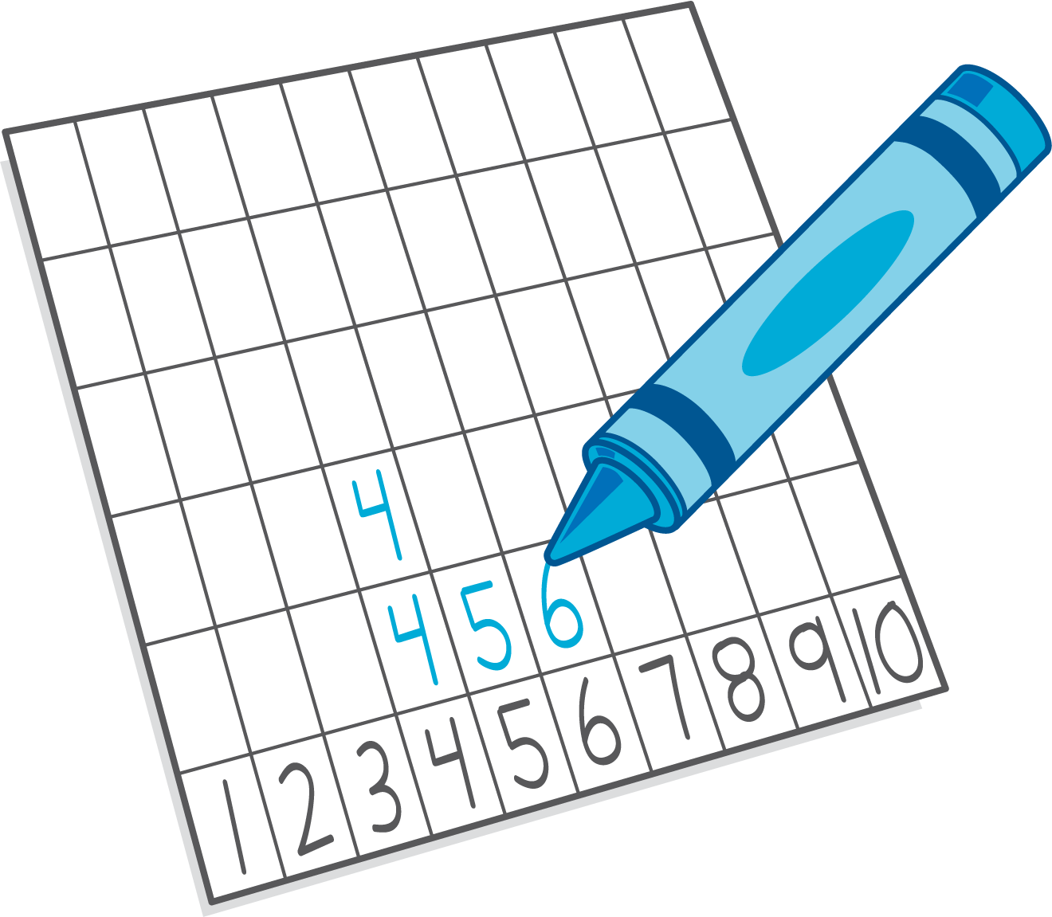
Shake and Spill

Math Fingers
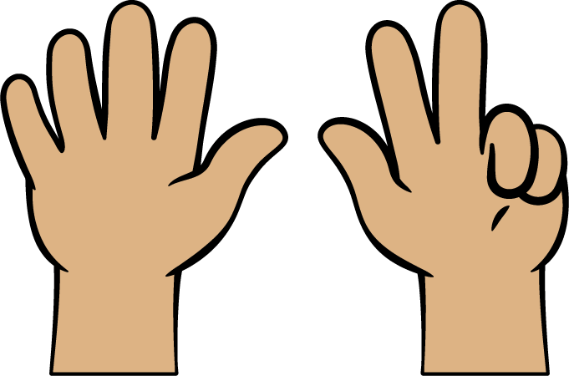
Pattern Blocks
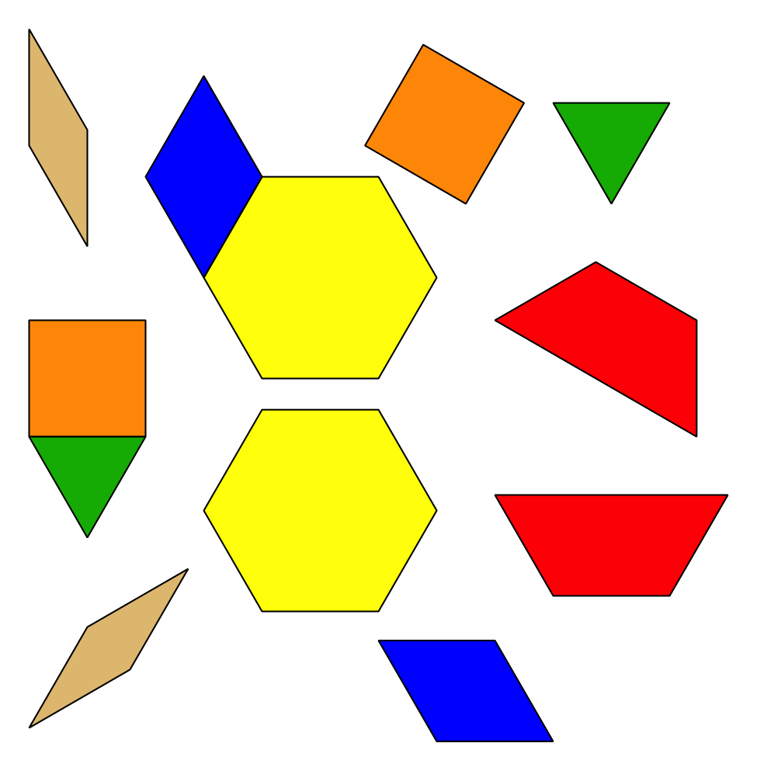
Picture Books
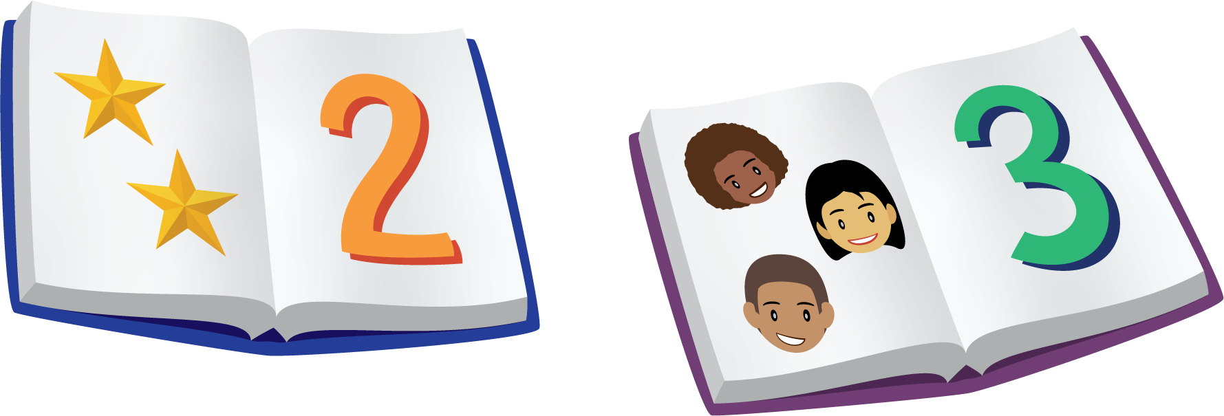
© CC BY 2021 Illustrative Mathematics®

