Algebra 1
Unit 2Lesson 10CC BY NC 2024 Illustrative Mathematics®
Unit 2, Lesson 10

Connecting Equations to Graphs (Part 1)
- Let’s investigate what graphs can tell us about the equations and relationships they represent.
Algebra 1
Unit 2Lesson 10CC BY NC 2024 Illustrative Mathematics®

10.1Games and Rides
Jada has $20 to spend on games and rides at a carnival. Games cost $1 each and rides are $2 each.
- Which equation represents the relationship between the number of games, $x$, and the number of rides, $y$, that Jada could spend money on if she spends all her money?
- A: $x+y=20$
- B: $2x+y=20$
- C: $x+2y=20$
- Explain what each of the other two equations could mean in this situation.
Algebra 1
Unit 2Lesson 10CC BY NC 2024 Illustrative Mathematics®

10.2Graphing Games and Rides
Here are the three equations. Each represents the relationship between the number of games, $x$, the number of rides, $y$, and the dollar amount a student is spending on games and rides at a different amusement park.
Equation 1: $x+y=20$
Equation 2: $2.50x+y=15$
Equation 3: $x+4y=28$

Your teacher will assign to you (or ask you to choose) 1–2 equations. For each assigned (or chosen) equation, answer the questions.
First assigned (or chosen) equation: $\underset{_}{}$
- What’s the number of rides the student could get on if the student doesn’t play any games? On the coordinate plane, mark the point that represents this situation and label the point with its coordinates.
- What’s the number of games the student could play if the student doesn’t get on any rides? On the coordinate plane, mark the point that represents this situation and label the point with its coordinates.
- 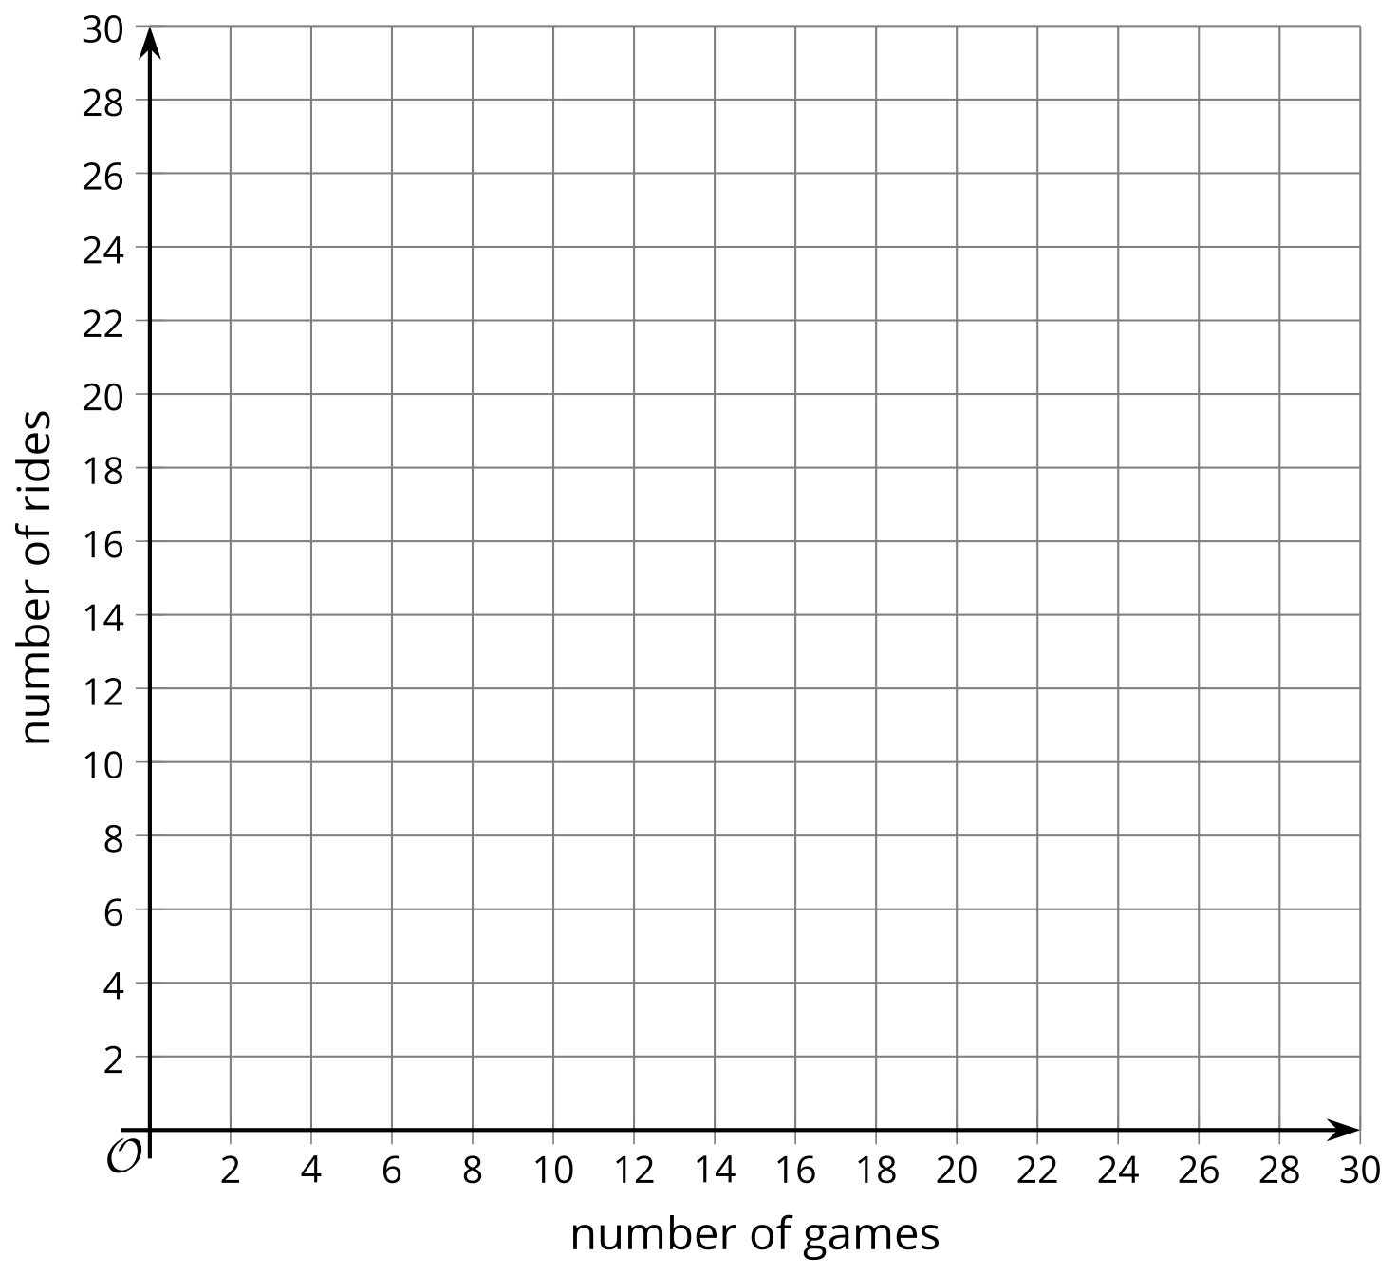
- Draw a line to connect the two points you’ve drawn.
- Complete the sentences: “If the student played no games, the student can get on $\underset{_}{​}$ rides. For every additional game that the student plays, $x$, the possible number of rides, $y$, $\underset{_}{}$ (increases or decreases) by $\underset{_}{​}$.”
- What is the slope of your graph? Where does the graph intersect the vertical axis?
- Rearrange the equation to solve for $y$.
- What connections, if any, do you notice between your new equation and the graph?
Second assigned (or chosen) equation: $\underset{_}{}$
- What’s the number of rides the student could get on if the student doesn’t play any games? On the coordinate plane, mark the point that represents this situation and label the point with its coordinates.
- What’s the number of games the student could play if the student doesn’t get on any rides? On the coordinate plane, mark the point that represents this situation and label the point with its coordinates.
- Draw a line to connect the two points you’ve drawn.
- Complete the sentences: “If the student played no games, the student can get on $\underset{_}{​}$ rides. For every additional game that the student plays, $x$, the possible number of rides, $y$, $\underset{_}{}$ (increases or decreases) by $\underset{_}{​}$.”
- What is the slope of your graph? Where does the graph intersect the vertical axis?
- Rearrange the equation to solve for $y$.
- What connections, if any, do you notice between your new equation and the graph?
Algebra 1
Unit 2Lesson 10CC BY NC 2024 Illustrative Mathematics®

10.3Nickels and Dimes
Andre’s coin jar contains 85 cents. There are no quarters or pennies in the jar, so the jar has all nickels, all dimes, or some of each.
- Write an equation that relates the number of nickels, $n$, the number of dimes, $d$, and the amount of money, in cents, in the coin jar.
- Graph your equation on the coordinate plane. Be sure to label the axes.
- How many nickels are in the jar if there are no dimes?
- How many dimes are in the jar if there are no nickels?
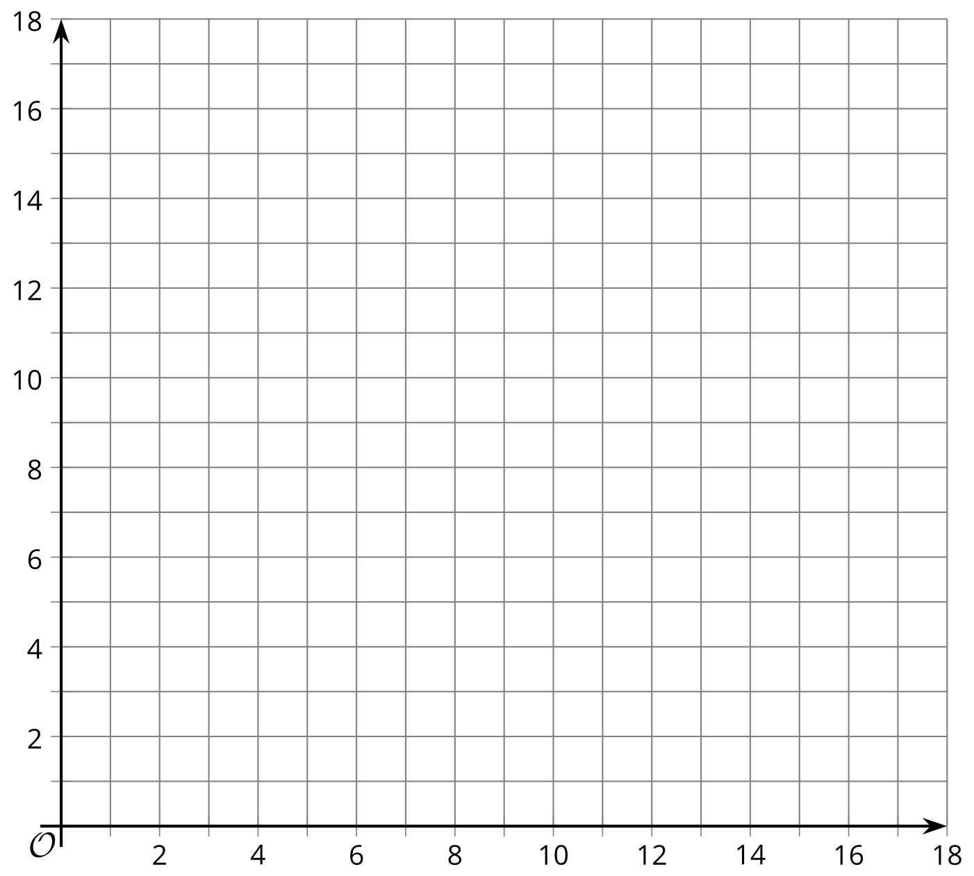

Are you ready for more?
What are all the different ways the coin jar could have 85 cents if it could also contain quarters?

Lesson 10 Summary
Linear equations can be written in different forms. Some forms allow us to better see the relationship between quantities or to predict the graph of the equation.
Suppose a person wishes to travel 7,000 meters a day by running and swimming. The person runs at a speed of 130 meters per minute and swims at a speed of 54 meters per minute.
Let $x$ represents the number of minutes of running and $y$ the number of minutes of swimming. To represent the combination of running and swimming that would allow the person to travel 7,000 meters, we can write:
$130x+54y=7,​000$
We can reason that the more minutes the person runs, the fewer minutes the person has to swim to meet the goal. In other words, as $x$ increases, $y$ decreases. If we graph the equation, the line will slant down from left to right.
If the person only runs and doesn't swim, how many minutes would the person need to run?
Let's substitute 0 for $y$ to find $x$:
$\begin{matrix}130x+54\left(0\right)=7,​000 \\ 130x=7,​000 \\ x=\frac{7,​000}{130} \\ x=53.85\end{matrix}$
On a graph, this combination of times is the point $\left(53.85,0\right)$, which is the $x$-intercept.
If the person only swims and doesn't run, how many minutes would the person need to swim?
Let's substitute 0 for $x$ to find $y$:
$\begin{matrix}130\left(0\right)+54y=7,​000 \\ 54y=7,​000 \\ y=\frac{7,​000}{54} \\ y=129.63\end{matrix}$
On a graph, this combination of times is the point $\left(0,129.63\right)$, which is the $y$-intercept.
To determine how many minutes the person would need to swim after running for 15 minutes, 20 minutes, or 30 minutes, substitute each of these values for $x$ in the equation and find $y$. Or, first solve the equation for $y$:
$\begin{matrix}130x+54y=7,​000 \\ 54y=7,​000−130x \\ y=\frac{7,​000−130x}{54} \\ y=129.63−2.41x\end{matrix}$
Notice that $y=129.63−2.41x$, or $y=\text{-}2.41x+129.63$, is written in slope-intercept form.
- The coefficient of $x$, -2.41, is the slope of the graph. It means that as $x$ increases by 1, $y$ falls by 2.41. For every additional minute of running, the person can swim 2.41 fewer minutes.
- The constant term, 129.63, tells us where the graph intersects the $y$-axis. It tells us the number minutes the person would need to swim if they do no running.
The first equation we wrote, $130x+54y=7,​000$, is a linear equation in standard form. ​In general, it is expressed as $Ax+By=C$, where $x$ and $y$ are variables, and $A,B$, and $C$ are numbers.
The two equations, $130x+54y=7,​000$ and $y=\text{-}2.41x+129.63$, are equivalent, so they have the same solutions and the same graph.
