Grade 6
Unit 2CC BY NC Illustrative Mathematics, based on IM 6–8 Math, CC BY Open Up Resources.

Unit 2 Family Support Materials

Introducing Ratios

Section A: What Are Ratios?
A ratio is an association between two or more quantities. For example, the cups of juice and the cups of soda water in a drink recipe form a ratio. Ratios can be represented with diagrams. Here is one diagram for a drink recipe:
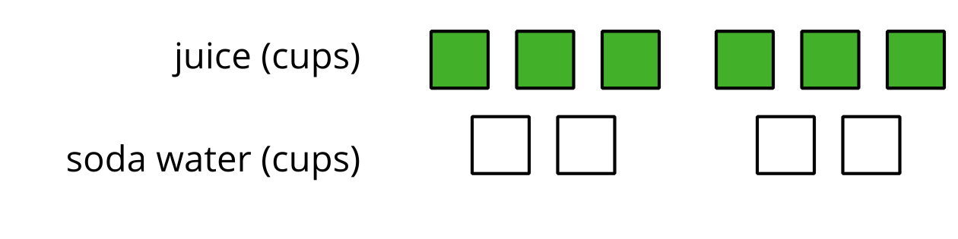
Here are some correct ways to describe this diagram:
- The ratio of cups of juice to cups of soda water is $6:4$.
- The ratio of cups of soda water to cups of juice is 4 to 6.
- There are 6 cups of juice for every 4 cups of soda water.
We can also use other numbers to describe the quantities in this situation. For instance, we can say that there are 3 cups of juice for every 2 cups of soda water. The ratios $6:4$ and $3:2$ are equivalent because mixing juice and soda water in these amounts would make drinks that taste the same.
Two situations that can be described with equivalent ratios are the same in some important way. For example, mixing 1 ml of black paint and 10 ml of white paint would create the same shade of gray as mixing 3 ml of black paint and 30 ml of white paint, so these ratios of black paint to white paint are equivalent.
Here is a task to try with your student:
There are 4 horses in a stall. Each horse has 4 legs, 1 tail, and 2 ears.
- Draw a diagram that shows the ratio of legs, tails, and ears in the stall.
- Complete each statement.
  - The ratio of ________ to ________ to ________ is ________ : ________ : ________.
  - There are ________ ears for every tail. There are ________ legs for every ear.
Solution:
- Sample response:
- 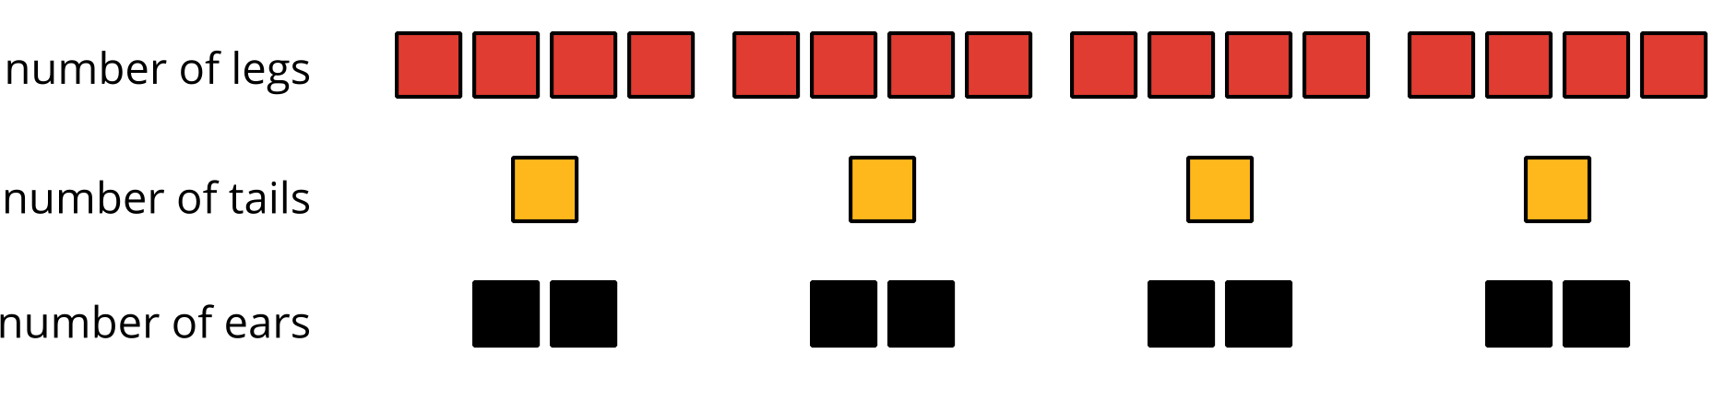
- Sample response: The ratio of legs to tails to ears is $16:4:8$. There are 2 ears for every tail. There are 2 legs for every ear.

Section C: Representing Equivalent Ratios
There are different ways to represent equivalent ratios.
Let’s say that the sixth grade class is selling raffle tickets at a price of $6 for 5 tickets. At that rate, 10 tickets cost $12. Some students may use diagrams with shapes to represent the situation. For example, here is a diagram representing 10 tickets for $12.
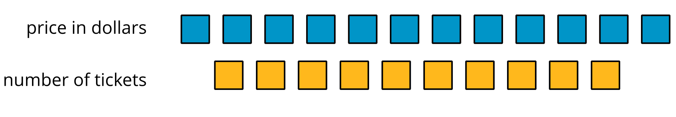
Drawing so many shapes becomes impractical. Double number line diagrams can be a quicker way to show equivalent ratios. Here is a diagram that represents the price in dollars for different numbers of raffle tickets all sold at the same rate of $6 for 5 tickets.
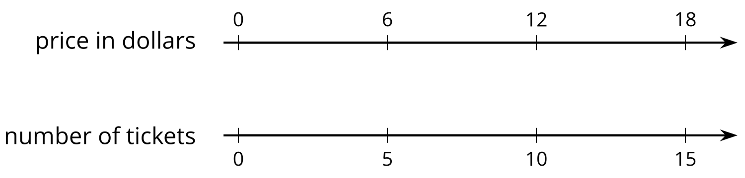
The diagram can be partitioned, extended, and marked up to find the prices for other numbers of tickets—including the price for 1 ticket, which is the unit price.
Here is a task to try with your student:
Raffle tickets cost $6 for 5 tickets.
- How many tickets can you get for $90?
- What is the price of 1 ticket?
Solution:
- 75 tickets. Sample reasoning:
  - Extend the double number line shown and observe that $90 is lined up with 75 tickets.
  - If $6 buys 5 tickets, then $60 buys 50 tickets and $30 buys 25 tickets. So, $90, which is $60+30$, buys $50+25$, or 75 tickets.
- $1.20. Sample reasoning: Divide the number line into 5 equal intervals, as shown. Reason that the price in dollars of 1 ticket must be $6÷5$.
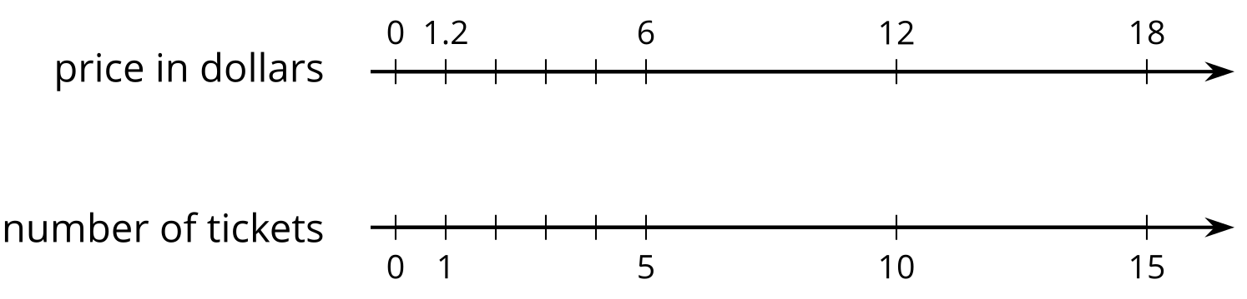

Section D: Solving Ratio and Rate Problems
Let’s think about an example that we saw before: The sixth grade class is selling raffle tickets at a price of $6 for 5 tickets. If we tried to find the price of 300 tickets by extending the double number line diagram here, it would take 5 times more paper!
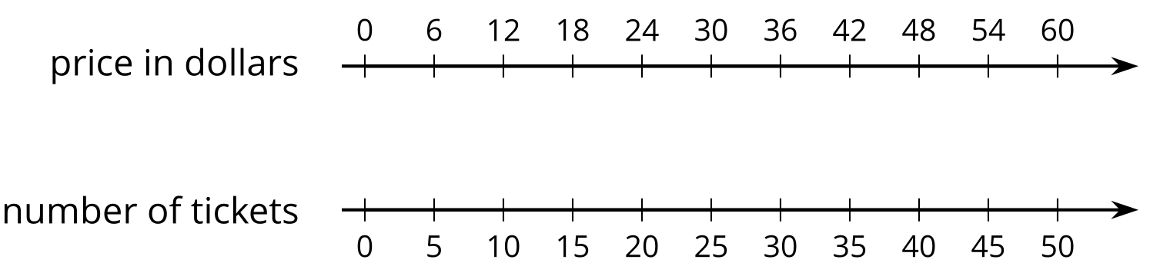
Double number line diagrams are hard to use in problems with large amounts. A table is a better choice to represent this situation. Tables of equivalent ratios are useful because you can arrange the rows in any order. For example, a student may find the price for 300 raffle tickets by making the table shown.
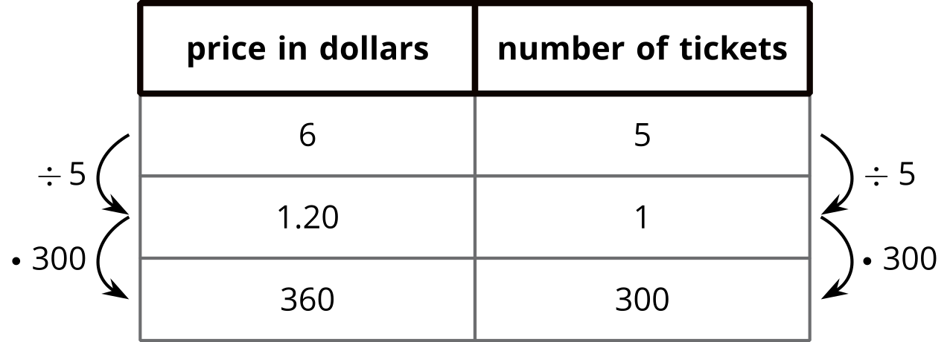
Although students can choose any representation that helps them solve a problem, it is important that they get comfortable with tables because they are used for a variety of purposes throughout future mathematics courses.
Here is a task to try with your student:
At a constant speed, a train travels 45 miles in 60 minutes. At this rate, how far does the train travel in 12 minutes? If you get stuck, consider creating a table.
Solution:
9 miles. Sample reasoning:
time in minutes | distance in miles
60 | 45
1 | 0.75
12 | 9

