Grade 2
Unit 8Lesson 8CC BY NC 2024 Illustrative Mathematics®
Unit 8, Lesson 8

Count Columns and Objects in Columns
- Let’s learn about columns in arrays.
Grade 2
Unit 8Lesson 8CC BY NC 2024 Illustrative Mathematics®

Warm-up Estimation Exploration: Rearrange the Dots
How many counters do you see?
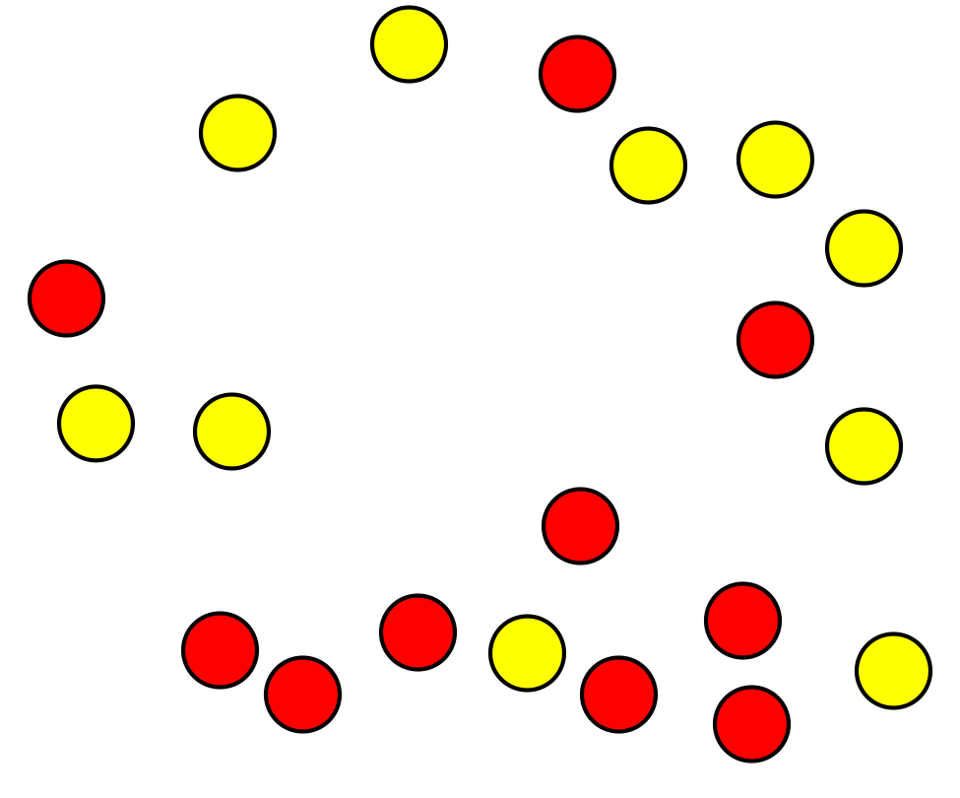
Record an estimate that is:
too low | about right | too high
Grade 2
Unit 8Lesson 8CC BY NC 2024 Illustrative Mathematics®

Activity 1 Count by Columns

- 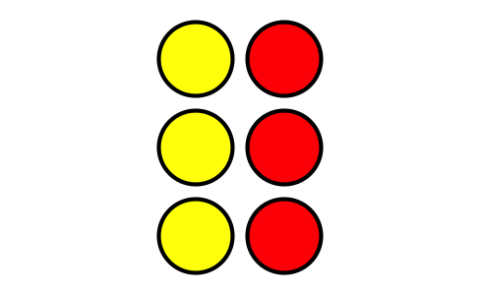
  - How many columns are in this array?
  - How many counters are in each column?
  - How many counters are there in all?

- 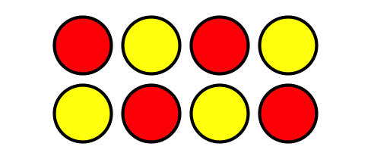
  - How many columns are in this array?
  - How many counters are in each column?
  - How many counters are there in all?
- Use 10 counters. Make 2 columns with the same number in each column.
  - How many counters are in each column?
  - How many rows are in the array?
  - How can you count these counters without counting by ones?
- Use 15 counters. Make 3 columns with the same number in each column.
  - How many counters are in each column?
  - How many rows are in the array?
  - How many counters are in each row?
  - How can you count these counters without counting by ones?
Grade 2
Unit 8Lesson 8CC BY NC 2024 Illustrative Mathematics®

Activity 2 Guess My Array
Four students make arrays.
- Han says, “My array has an even number of counters. It has 2 rows with 6 counters in each row.”
- Priya says, “My array has more than 10 counters. It has 4 rows with 3 counters in each row.”
- Elena says, “My array is very long. It has 6 counters in each column.”
- Kiran says, “My array has more columns than rows. It has 3 rows.”
- Write the name of each student below their array.
- A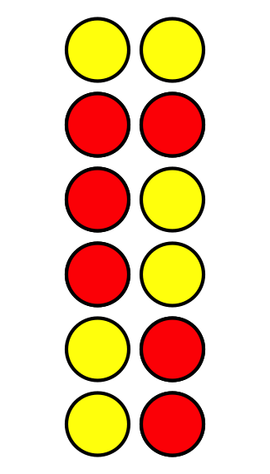
- B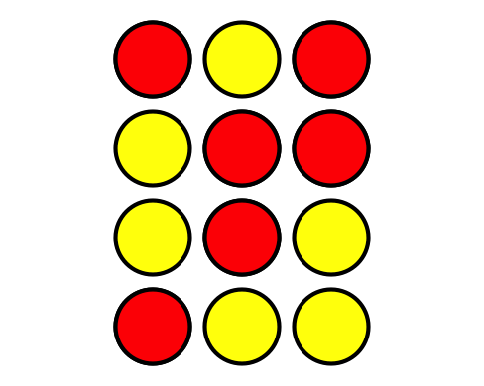
- C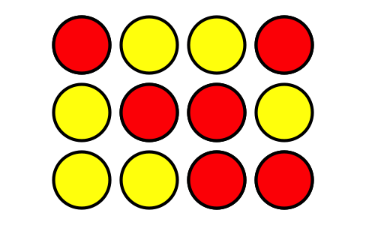
- D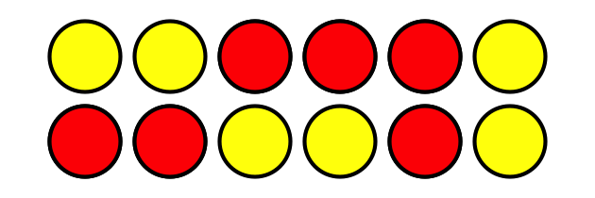
- Each student used _____ counters to make an array.
- Make an array using up to 25 counters. Don’t let your partner see.
- Give your partner clues so they can try to make your array. Compare your arrays.
- How do you know the total number of counters in each array? Be prepared to explain your reasoning.

