Grade 2
Unit 3CC BY NC 2024 Illustrative Mathematics®

Unit 3 Family Support Materials

Measuring Length
In this unit, students measure and estimate lengths in standard units, and solve measurement story problems within 100.

Section A: Metric Measurement
In this section, before learning to use a ruler, students use base-ten blocks, with lengths of 1 cm and 10 cm, to measure objects in the classroom. Using these tools to measure the lengths of objects reinforces place-value concepts. Students use metric units to create their own centimeter ruler. They see that each tick mark represents the distance, in centimeters, from the 0 mark, and that the length units accumulate as they move along the ruler, away from zero. Students learn the importance of placing the end of an object at the starting point of zero, and discuss how the numbers on the ruler represent the distance from zero. Students learn that the meter is equivalent to 100 centimeters, further reinforcing place- value concepts. They make estimations about metric units and measure shorter objects, with centimeters, and longer objects, with decimeters and meters.

Section B: Customary Measurement
In this section, students learn about customary units of linear measurement (inches and feet). They apply length-measurement concepts and skills from the previous section in order to measure and estimate with customary units. Students develop the generalization that when a unit of measure is longer, fewer of those units are required to measure the length of the object. Students make choices about which tool would be appropriate, based on the size of the object.

Section C: Line Plots
In this section, students represent their measurement data on a line plot. They learn that the horizontal scale is marked off in whole-number units that represent the counting sequence. Students use a template to create line plots and understand that each data point is represented by an X made on the number line, above the number that represents the length of the object. They label line plots with titles and the measurement unit used.
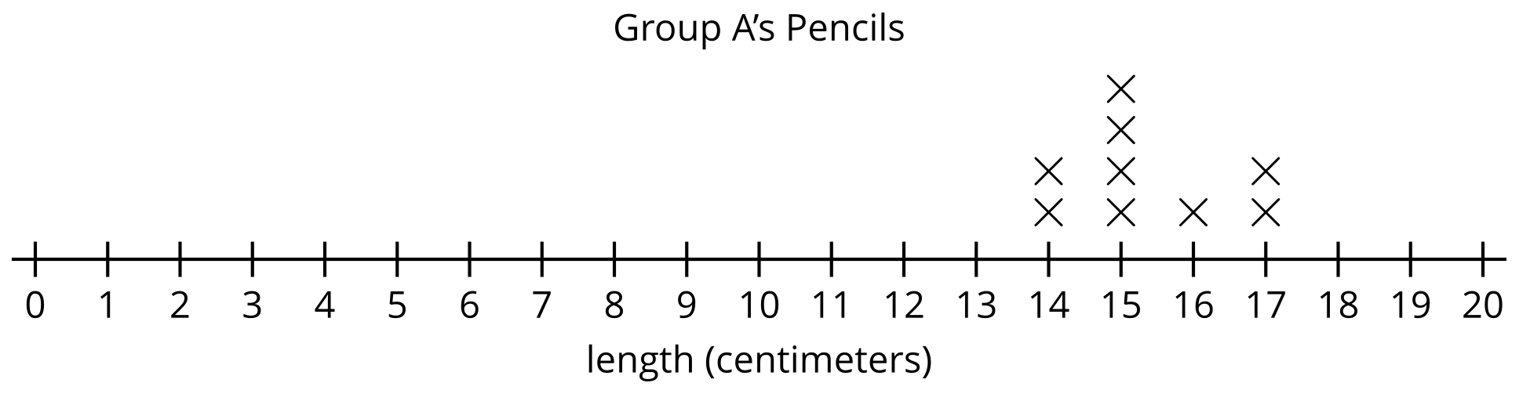

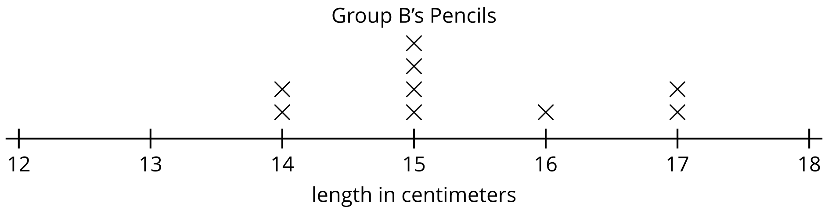

Try it at home!
Near the end of the unit, ask your second grader to measure objects around the house, with a ruler or other measuring tool.
Questions that may be helpful as they work:
- Why did you choose to measure that object, using ___________ (feet, inches, meters, centimeters)?
- If you measured it, using __________ (feet, inches, meters, centimeters) instead, would there be more or fewer of those units needed?
Solution:
Answers may vary.
Sample response:
- I used inches to measure the length of the book because feet would be too big.
- If I measured the book, using centimeters instead, the number of centimeters would be more than the number of inches.

