Unit 7 Lesson 23: Using Quadratic Expressions in Vertex Form to Solve Problems

1 Values of a Function (Warm up)

Student Task Statement
Here are graphs that represent two functions, $f$ and $g$, defined by:
$f\left(x\right)={\left(x−4\right)}^{2}+1$
$g\left(x\right)=\text{-}{\left(x−12\right)}^{2}+7$
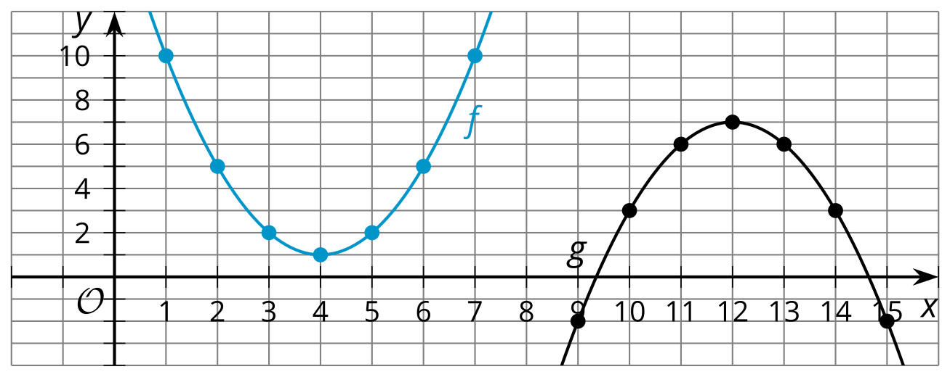
- $f\left(1\right)$ can be expressed in words as “the value of $f$ when $x$ is 1.” Find or compute:
  - the value of $f$ when $x$ is 1
  - $f\left(3\right)$
  - $f\left(10\right)$
- Can you find an $x$ value that would make $f\left(x\right)$:
  - Less than 1?
  - Greater than 10,000?
- $g\left(9\right)$ can be expressed in words as “the value of $g$ when $x$ is 9.” Find or compute:
  - the value of $g$ when $x$ is 9
  - $g\left(13\right)$
  - $g\left(2\right)$
- Can you find an $x$ value that would make $g\left(x\right)$:
  - Greater than 7?
  - Less than -10,000?

2 Maximums and Minimums

Student Task Statement
- The graph that represents $p\left(x\right)={\left(x−8\right)}^{2}+1$ has its vertex at $\left(8,1\right)$. Here is one way to show, without graphing, that $\left(8,1\right)$ corresponds to the minimum value of $p$.
  - When $x=8$, the value of ${\left(x−8\right)}^{2}$ is 0, because ${\left(8−8\right)}^{2}=0^{2}=0$.
  - Squaring any number always results in a positive number, so when $x$ is any value other than 8, $\left(x−8\right)$ will be a number other than 0, and when squared, ${\left(x−8\right)}^{2}$ will be positive.
  - Any positive number is greater than 0, so when $x≠8$, the value of ${\left(x−8\right)}^{2}$ will be greater than when $x=8$. In other words, $p$ has the least value when $x=8$.
- Use similar reasoning to explain why the point $\left(4,1\right)$ corresponds to the maximum value of $q$, defined by $q\left(x\right)=\text{-}2{\left(x−4\right)}^{2}+1$.
- Here are some quadratic functions, and the coordinates of the vertex of the graph of each. Determine if the vertex corresponds to the maximum or the minimum value of the function. Be prepared to explain how you know.
equation | coordinates of  the vertex | maximum or minimum?
$f\left(x\right)=\text{-}{\left(x−4\right)}^{2}+6$ | $\left(4,6\right)$
$g\left(x\right)={\left(x+7\right)}^{2}−3$ | $\left(\text{-}7,\text{-}3\right)$
$h\left(x\right)=4{\left(x+5\right)}^{2}+7$ | $\left(\text{-}5,7\right)$
$k\left(x\right)=x^{2}−6x−3$ | $\left(3,\text{-}12\right)$
$m\left(x\right)=\text{-}x^{2}+8x$ | $\left(4,16\right)$

3 All the World’s a Stage

Student Task Statement
A function $A$, defined by $p\left(600−75p\right)$, describes the revenue collected from the sales of tickets for Performance A, a musical.
The graph represents a function $B$ that models the revenue collected from the sales of tickets for Performance B, a Shakespearean comedy.
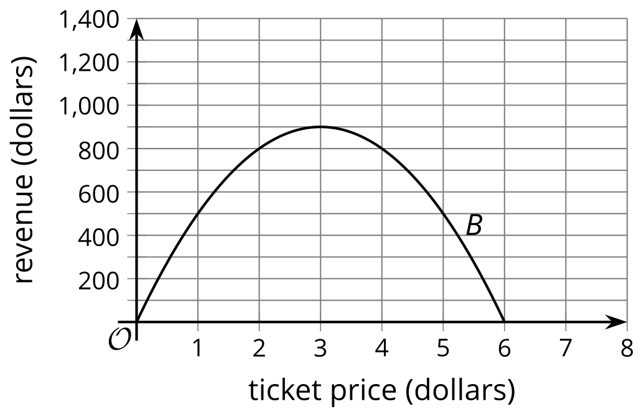

In both functions, $p$ represents the price of one ticket, and both revenues and prices are measured in dollars.
Without creating a graph of $A$, determine which performance gives the greater maximum revenue when tickets are $p$ dollars each. Explain or show your reasoning.
© CC BY 2019 by Illustrative Mathematics®

