Unit 6 Lesson 25: Paper Flower Decorations

WU How Many Do You See: Paper Flowers (Warm up)

Student Task Statement
How many do you see? How do you see them?
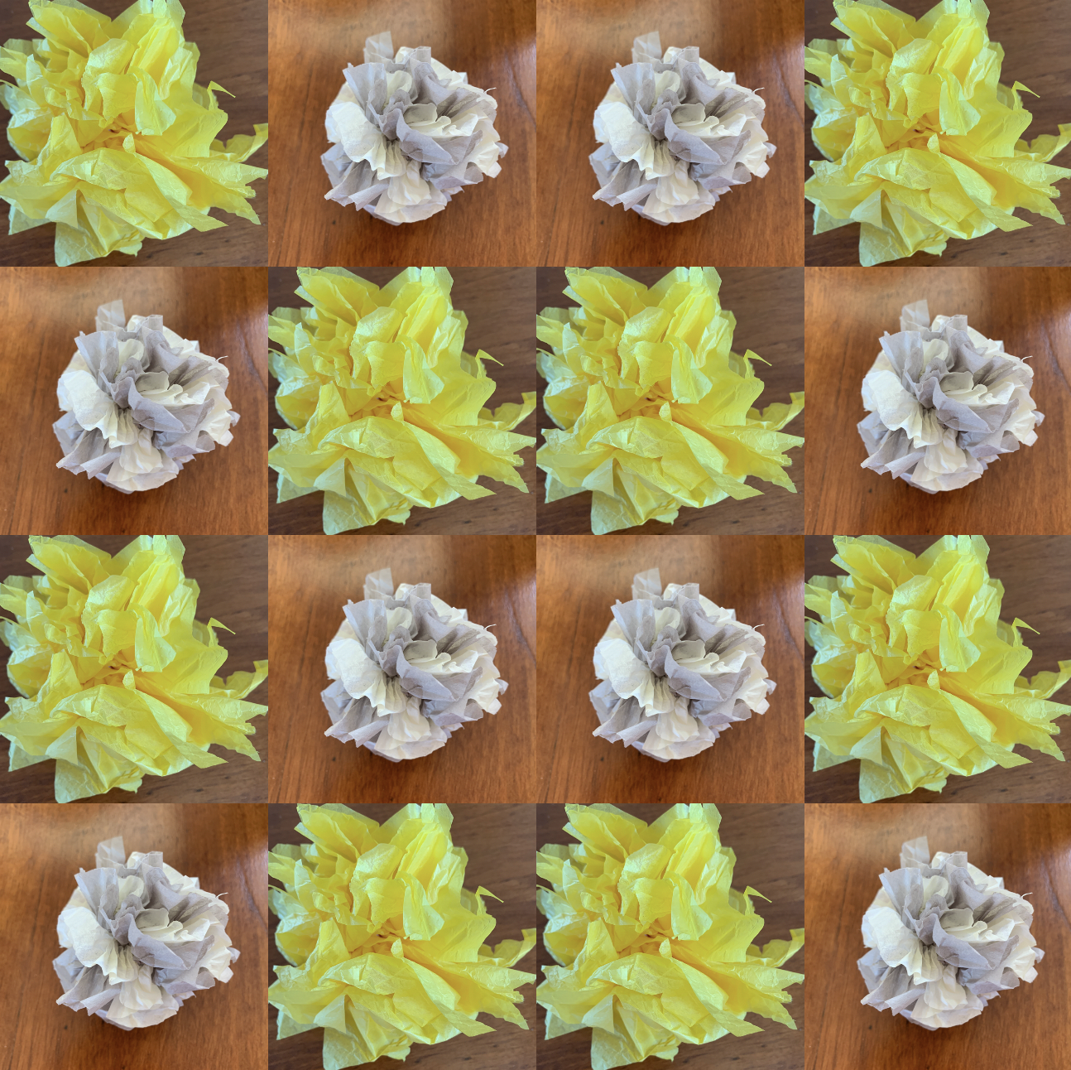

1 Paper Flower Construction

Student Task Statement
Follow these steps to make paper flowers:
- Place 6 pieces of tissue paper on top of each other.
- Starting at one side, fold over about 1 inch, then fold in the opposite direction. Repeat with this accordion fold (like a paper fan) until you have a strip that is 1 inch wide and the length of the original paper.
- Tie a rubber band around the middle of the folded paper strip. Then, open up the folds.
- 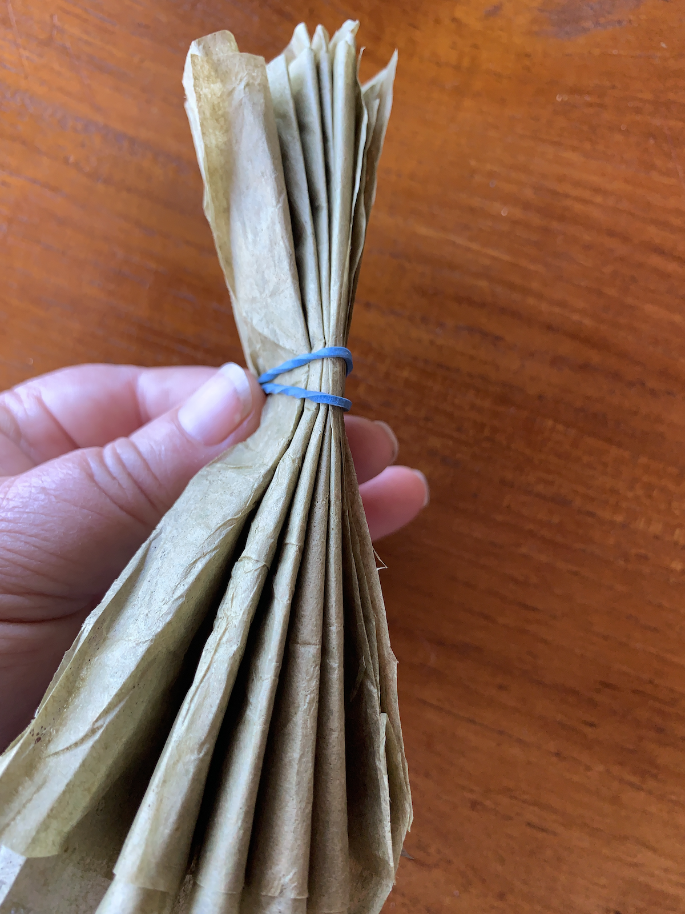
- 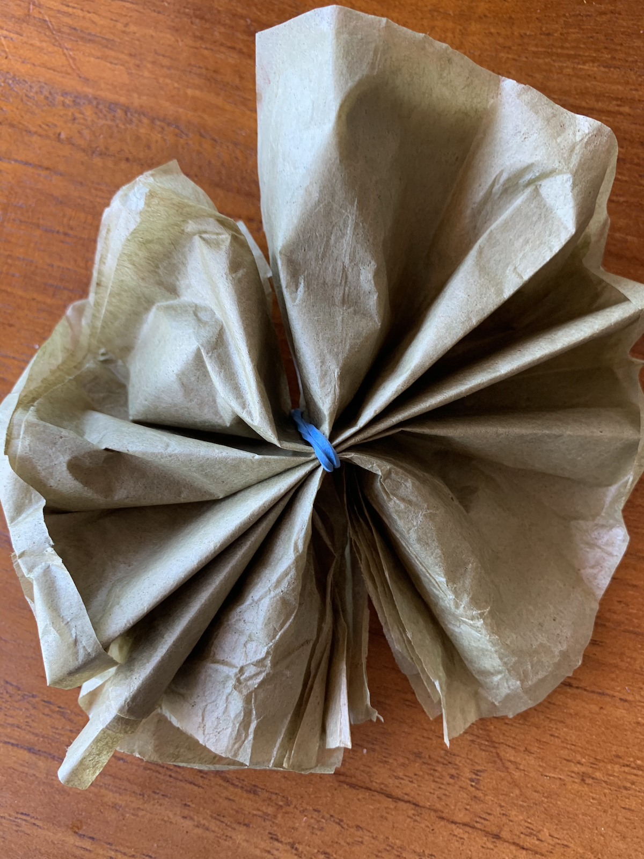
- Carefully, one layer at a time, fold the layers up into the middle to make the petals.
- 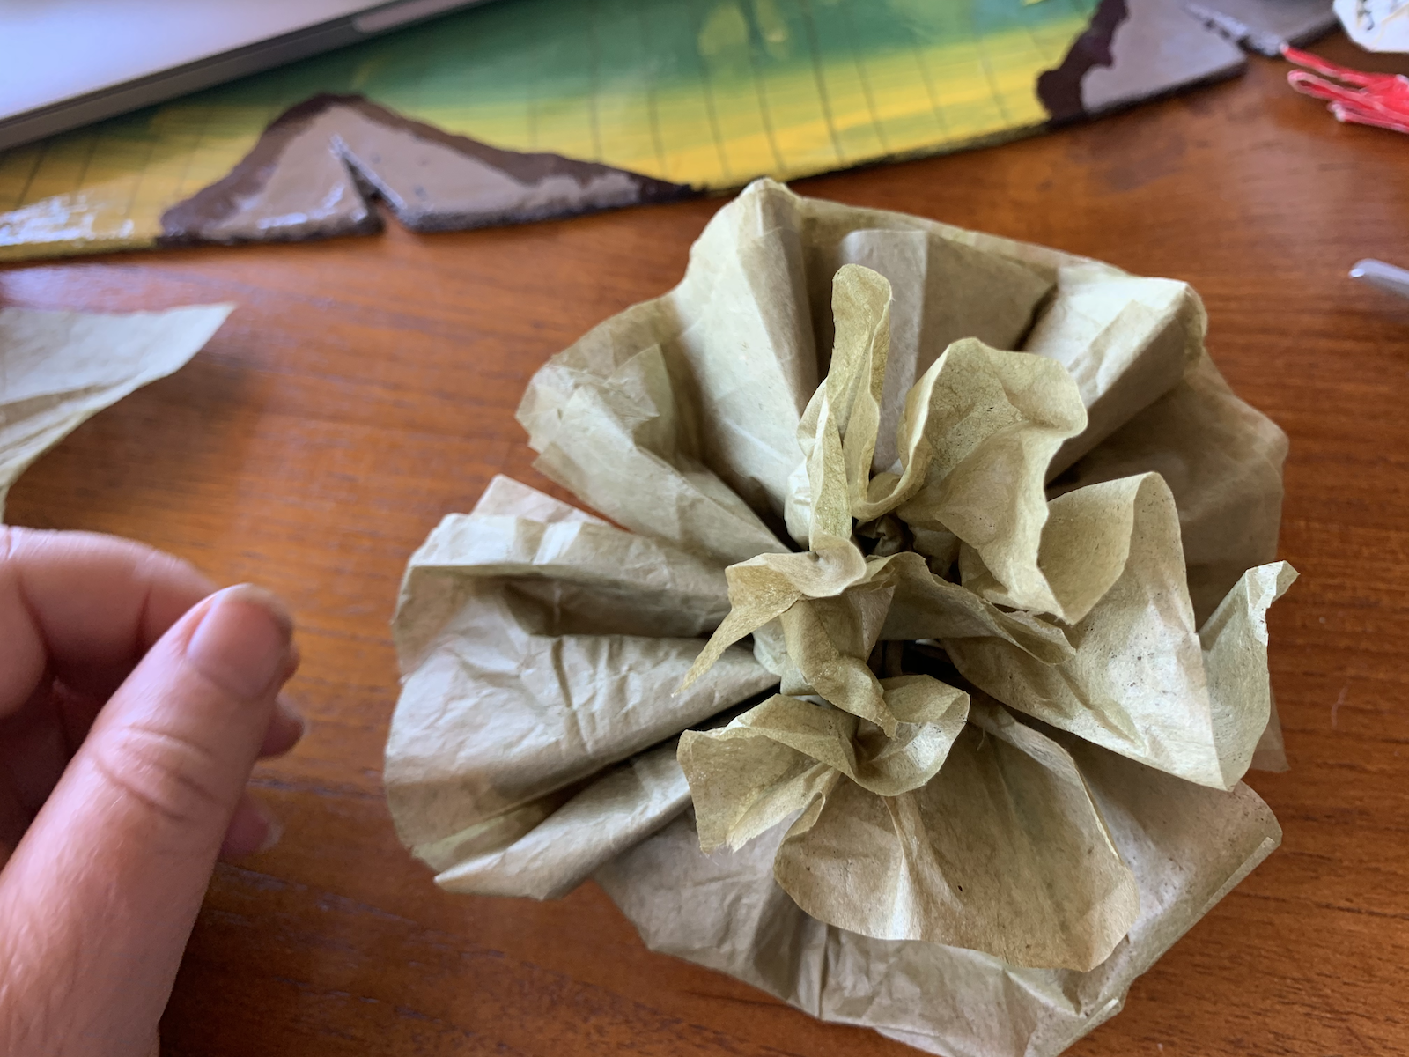

2 Quinceañera Decorations

Student Task Statement

Priya and Jada are making paper flower garlands for their friend’s quinceañera. Each garland uses 12 flowers.
- Priya wants 2 big flowers, followed by 2 small flowers. Jada wants 1 big flower, followed by 2 small flowers. Use their patterns to draw the garlands.
- Priya and Jada make 25 garlands of each type. How many large and small flowers will they need altogether?
- Diego and Kiran also made flowers. They made a total of 155 flowers for garlands that require 16 flowers each. How many garlands can they make?
- It takes 1 minute to cut the strips for a flower and 2 minutes to finish it. How long did it take Diego and Kiran to make the 155 flowers, if they each make about the same number of flowers?

3 Make Your Own Problems

Student Task Statement
- Write a multi-step problem about making paper flowers.
- Exchange the problem with your partner and solve each other’s problems.
© CC BY 2021 Illustrative Mathematics®

