Grade 2
Unit 2CC BY NC 2024 Illustrative Mathematics®

Unit 2 Family Support Materials

Adding and Subtracting within 100
In this unit, students add and subtract within 100, using strategies based on place value, the properties of operations, and the relationship between addition and subtraction. They then use what they know to solve story problems.

Section A: Add and Subtract
This section allows students to use methods that make sense to them to solve addition and subtraction problems. They can draw diagrams and use connecting cubes to show their thinking. For example, students represent different numbers, using connecting cubes, and are tasked with the following:
- Find the total number of cubes you and your partner used. Show your thinking.
- Find the difference between the number of cubes you and your partner used. Show your thinking.
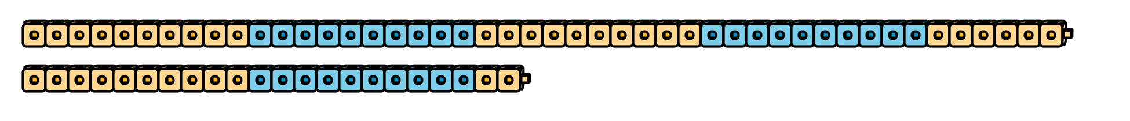
As the lessons progress, students analyze the structure of base-ten blocks and use them to support place-value reasoning. Unlike connecting cubes, base-ten blocks cannot be pulled apart. Students begin to think about two-digit numbers in terms of tens and ones. Using base-ten blocks to add, they group the tens and the ones, and then count to find the sum.

Section B: Decompose to Subtract
In this section, students subtract one- and two-digit numbers from two-digit numbers within 100. They use strategies based on place value and the properties of operations to evaluate expressions that involve decomposing a ten. For example, to evaluate expressions such as $63−18$, students use connecting cubes or base-ten blocks as they learn to decompose a ten into 10 ones before grouping by place value. In this case, they can decompose 1 ten in the 63 into 10 ones, making it 5 tens and 13 ones. They then can subtract 1 ten from 5 tens and 8 ones from 13 ones, resulting in 4 tens and 5 ones, or 45.
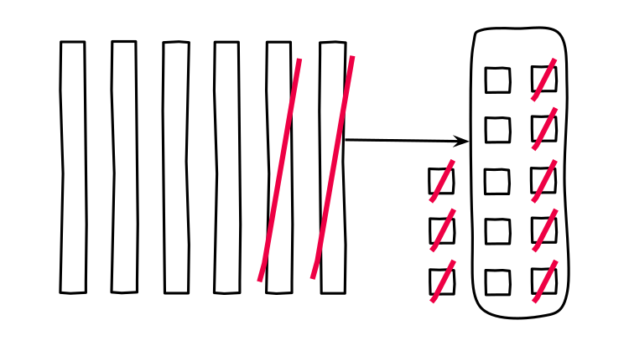

Section C: Represent and Solve Story Problems
This section focuses on solving one-step story problems that involve addition and subtraction within 100. The story problems are all types—Add To, Take From, Put Together, Take Apart, and Compare—and have unknowns in all positions, for example:
Diego gathered 42 orange seeds.
Jada gathered 16 apple seeds.
How many more seeds did Diego gather than Jada?
Show your thinking.

Try it at home!
Near the end of the unit, ask your second grader to solve the problem:
Diego gathered 37 orange seeds.
Jada gathered 25 more seeds than Diego.
How many seeds did Jada gather?
Show your thinking.
Questions that may be helpful as they work:
- Can you explain to me how you solved the problem?
- What pieces of information were helpful?
- How does your representation show the answer to the problem?
Solution:
Jada gathered 62 seeds.
Sample responses:
- I drew a diagram and wrote the equation $37+25=?$ to represent the problem. Then I added 37 and 25 to solve.
- It was helpful to know how many seeds Diego gathered and how many more seeds Jada gathered.
- My representation shows that Jada gathered the amount of seeds Diego gathered plus 25 more seeds.

