Grade 6
Unit 6Lesson 3CC BY NC Illustrative Mathematics, based on IM 6–8 Math, CC BY Open Up Resources.
Unit 6, Lesson 3

Staying in Balance
Let's use balanced hangers to help us solve equations.
Grade 6
Unit 6Lesson 3CC BY NC Illustrative Mathematics, based on IM 6–8 Math, CC BY Open Up Resources.

3.1Hanging Around
A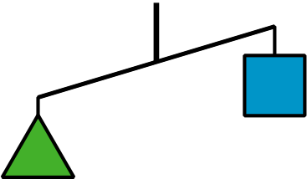
B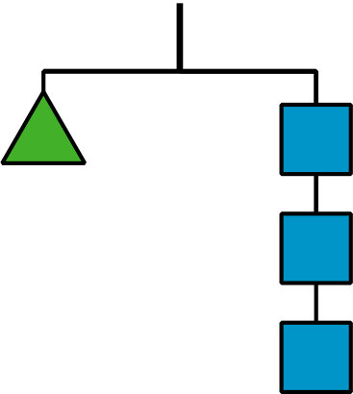
For Diagram A, make:
- One statement that must be true
- One statement that could be true or false
- One statement that cannot possibly be true
For Diagram B, find:
- One statement that must be true
- One statement that could be true or false
- One statement that cannot possibly be true
Grade 6
Unit 6Lesson 3CC BY NC Illustrative Mathematics, based on IM 6–8 Math, CC BY Open Up Resources.

3.2Match Equations and Hangers
A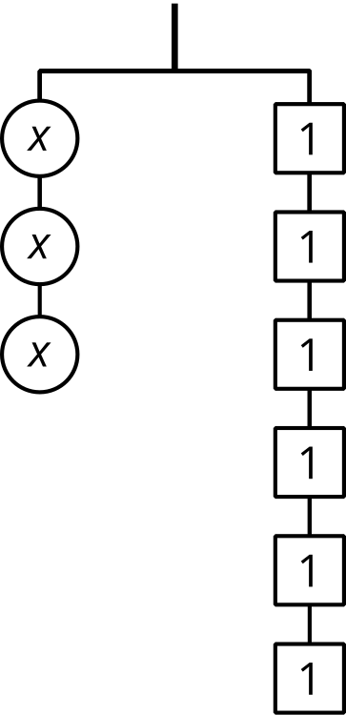
B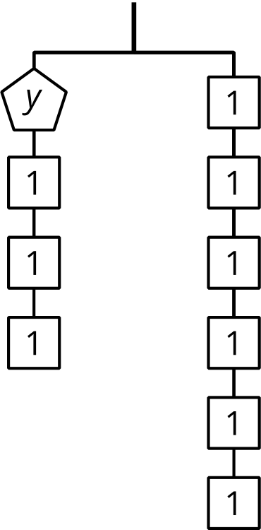
C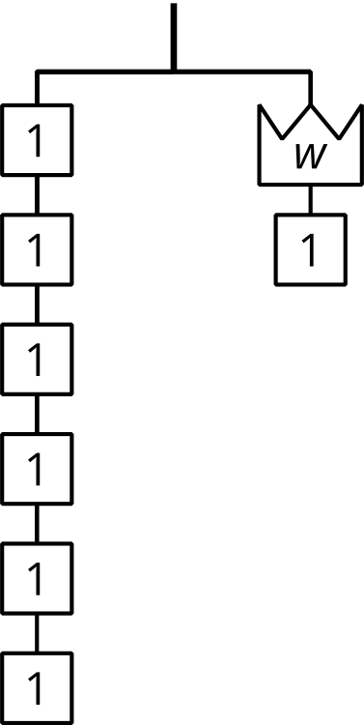
- Match each hanger diagram to an equation. Complete the equation by writing $x$, $y$, or $w$ in the empty box.
- 13+3=6
- 3⋅13=6
- 6=13+1
- ​​Find a solution to each equation. Use the diagrams to explain what each solution means.
Grade 6
Unit 6Lesson 3CC BY NC Illustrative Mathematics, based on IM 6–8 Math, CC BY Open Up Resources.

3.3Connecting Diagrams to Equations and Solutions
Here are some balanced hanger diagrams. Each piece is labeled with its weight in the same units.
A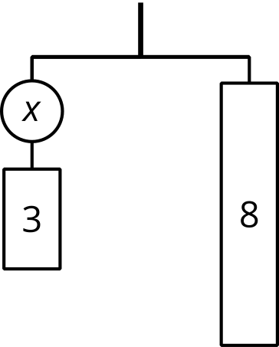
B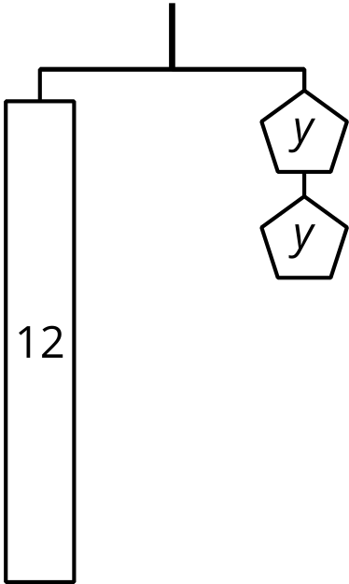
C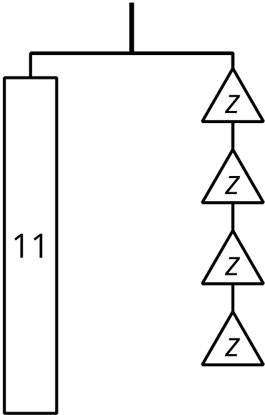
D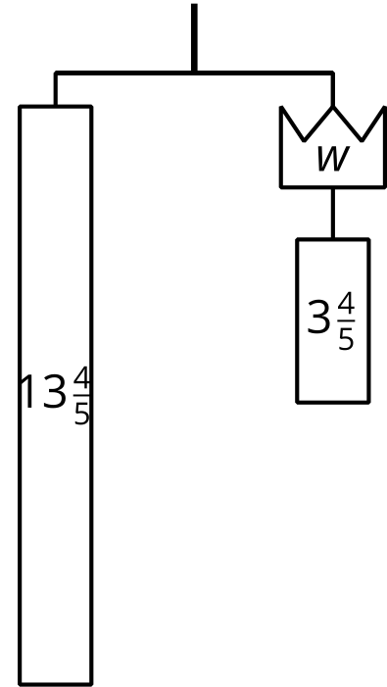
For each diagram:
- Write an equation to represent the relationship between the weights.
- Explain how to reason with the diagram or the equation to find the value of the variable.

Lesson 3 Summary
A hanger stays balanced when the weights on both sides are equal. We can change the weights and the hanger will stay balanced as long as both sides are changed in the same way. For example, adding 2 pounds to each side of a balanced hanger will keep it balanced. Removing half of the weight from each side will also keep it balanced.
An equation can be compared to a balanced hanger. We can change the equation, but for a true equation to remain true, the same thing must be done to both sides of the equal sign. If we add or subtract the same number on each side, or multiply or divide each side by the same number, the new equation will still be true.
This way of thinking can help us find solutions to equations. Instead of checking different values for the variable, we can think about subtracting the same amount from each side or dividing each side by the same number.
A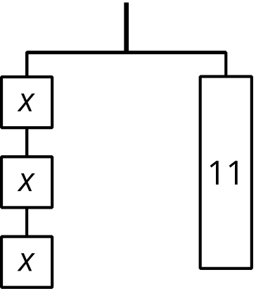
B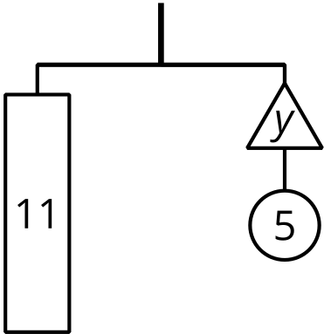
Diagram A can be represented by the equation $3x=11$.
If we break the 11 into 3 equal parts, each part will have the same weight as 1 block with an $x$.
Splitting each side of the diagram into 3 equal parts is the same as dividing each side of the equation by 3.
- $3x$ divided by 3 is $x$.
- 11 divided by 3 is $\frac{11}{3}$.
- If $3x=11$ is true, then $x=\frac{11}{3}$ is true.
- The solution to $3x=11$ is $\frac{11}{3}$.
Diagram B can be represented with the equation $11=y+5$.
If we remove a weight of 5 from each side of the diagram, it will stay in balance.
Removing 5 from each side of the diagram is the same as subtracting 5 from each side of the equation.
- $11−5$ is 6.
- $y+5−5$ is $y$.
- If $11=y+5$ is true, then $6=y$ is true.
- The solution to $11=y+5$ is 6.

