Grade 6
Unit 9Lesson 7CC BY NC Illustrative Mathematics, based on IM 6–8 Math, CC BY Open Up Resources.
Unit 9, Lesson 7

Comparing Voting Systems
Let's compare voting systems.
Grade 6
Unit 9Lesson 7CC BY NC Illustrative Mathematics, based on IM 6–8 Math, CC BY Open Up Resources.

7.1Rank Your Vote
Use these symbols to rank your choices for the field trip.
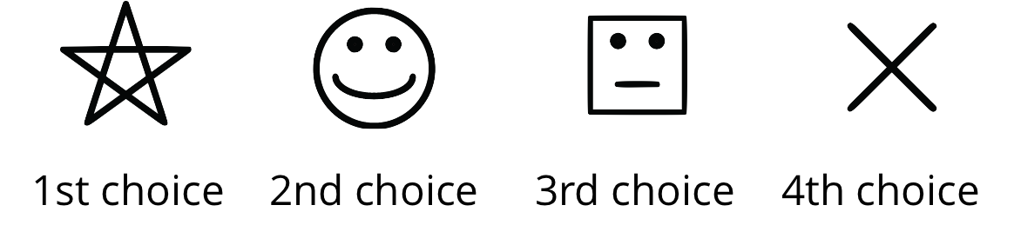
option | vote
baseball game
amusement park
museum
dance

Grade 6
Unit 9Lesson 7CC BY NC Illustrative Mathematics, based on IM 6–8 Math, CC BY Open Up Resources.

7.2Just Vote Once
Your class just voted using the instant runoff system. Use the class data for the following questions.
- For our class, which choice received the most points?
- Does this result agree with that from the runoff election in an earlier activity?
- In the runoff voting system, if there is not a winner from everyone’s first choices another vote is held and voters can change their choice because the least-voted option is eliminated. How does the instant runoff voting system also show voters’ other choices?
- Complete the table to see voters' satisfaction with the instant runoff results. After comparing the satisfaction for the 3 voting rules our class used (plurality, runoff, instant runoff), which method do you think is fairest? Explain your reasoning.
what points did you give the winner? | number of people | % of people
top choice (3)
second choice (2)
third choice (1)
last choice (0)

Are you ready for more?
Numbering your choices 0 through 3 might not really describe your opinions. For example, what if you really liked A and C a lot, and you really hated B and D? You might want to give A and C both a 3, and B and D both a 0.
- Design a numbering system where the size of the number shows how much you like a choice. Some ideas:
  - The same 0 to 3 scale, but you can choose more than one of each number, or even decimals between 0 and 3.
  - A scale of 1 to 10, with 10 for the best and 1 for the worst.
- Try out your system with the people in your group, using the same field trip options for the election.
- Do you think your system provides a more fair way to make choices? Explain your reasoning.
Grade 6
Unit 9Lesson 7CC BY NC Illustrative Mathematics, based on IM 6–8 Math, CC BY Open Up Resources.

7.3Weekend Choices
Clare, Han, Mai, Tyler, and Noah are deciding what to do on the weekend. Their options are cooking, hiking, and bowling. Here are the points for their instant runoff vote. Each first choice gets 2 points, the second choice gets 1 point, and the last choice gets 0 points.
 | cooking | hiking | bowling
Clare | 2 | 1 | 0
Han | 2 | 1 | 0
Mai | 2 | 1 | 0
Tyler | 0 | 2 | 1
Noah | 0 | 2 | 1
- Which activity won using the instant runoff method? Show your calculations, and use expressions or equations.
- Which activity would have won if there were just a vote for their top choice, with a majority or plurality winning?
- Which activity would have won if there were a runoff election?

