Grade 6
Unit 6Lesson 8CC BY NC Illustrative Mathematics, based on IM 6–8 Math, CC BY Open Up Resources.
Unit 6, Lesson 8

Equal and Equivalent
Let's use diagrams to figure out which expressions are equivalent and which are just sometimes equal.
Grade 6
Unit 6Lesson 8CC BY NC Illustrative Mathematics, based on IM 6–8 Math, CC BY Open Up Resources.

8.1Show It with a Diagram
On the grid, draw diagrams that can represent each statement.
- $2+3$ equals $3+2$.
- $2⋅3$ equals $3⋅2$.
- $2+3$ does not equal $2⋅3$.
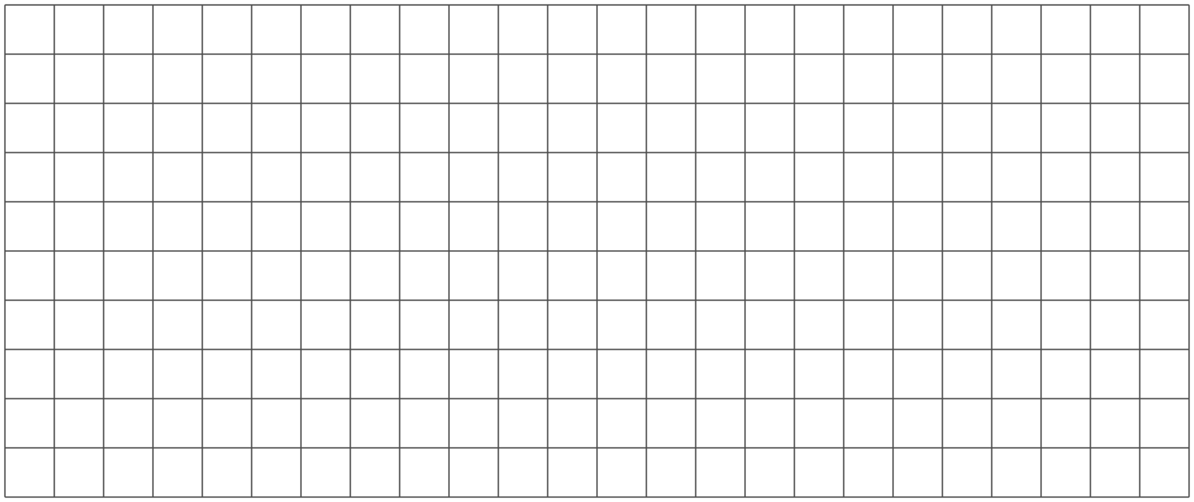
Grade 6
Unit 6Lesson 8CC BY NC Illustrative Mathematics, based on IM 6–8 Math, CC BY Open Up Resources.

8.2Using Tape Diagrams to Show That Expressions Are Equivalent
Here are tape diagrams that represent $x+2$ and $3x$ when $x$ is 4. Notice that the two diagrams are lined up on their left sides, so you can compare their lengths.
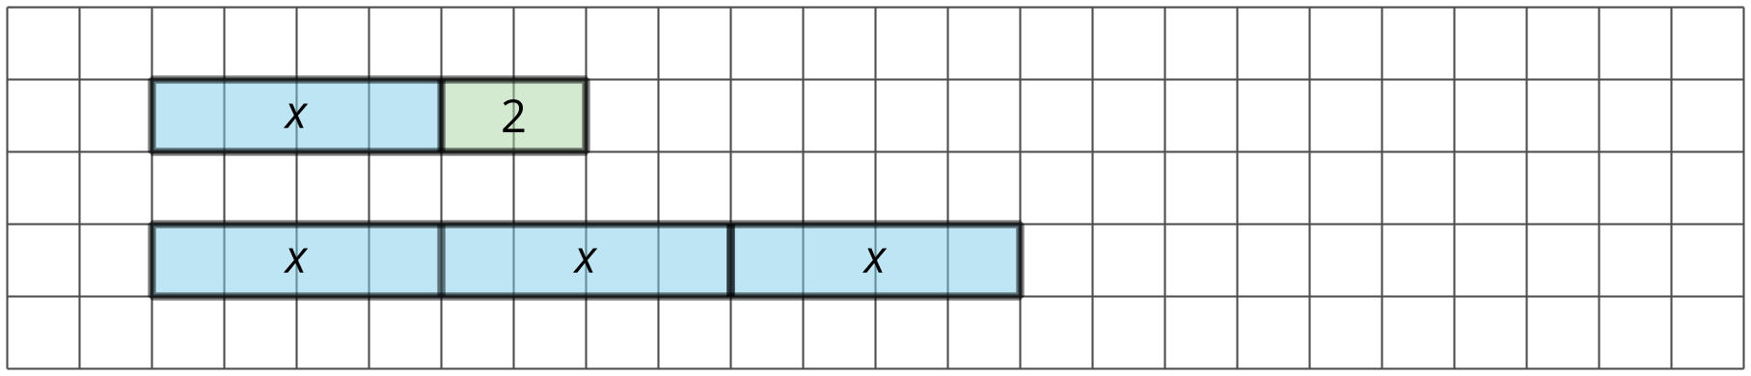
On each grid, line up your two diagrams on one side.
- Draw tape diagrams that represent $x+2$ and $3x$ when $x$ is 3.
- 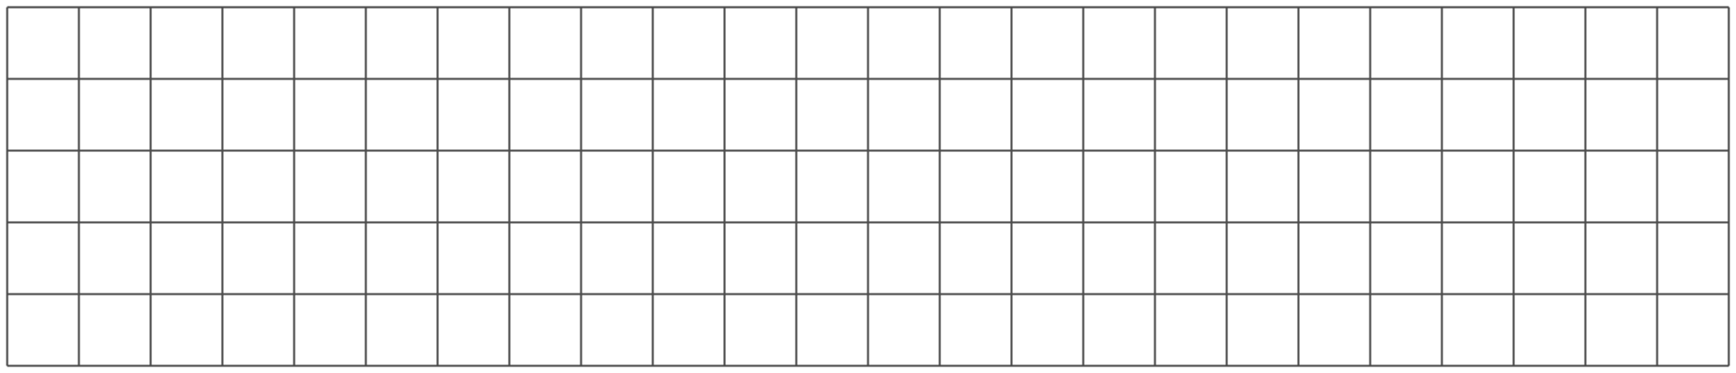
- Draw tape diagrams that represent of $x+2$ and $3x$ when $x$ is 2.
- Draw tape diagrams the represent $x+2$ and $3x$ when $x$ is 1.
- Draw tape diagrams that represent $x+2$ and $3x$ when $x$ is 0.
- When are $x+2$ and $3x$ equal? When are they not equal? Use your diagrams to explain.

  - Draw tape diagrams of $x+3$ and $3+x$. Choose your own value for $x$.
  - When are $x+3$ and $3+x$ equal? When are they not equal? Use your diagrams to explain.
Grade 6
Unit 6Lesson 8CC BY NC Illustrative Mathematics, based on IM 6–8 Math, CC BY Open Up Resources.

8.3Identifying Equivalent Expressions
Here is a list of expressions. Find any pairs of expressions that are equivalent. If you get stuck, consider drawing diagrams.
$a+3$
$a+a+a$
$a÷\frac{1}{3}$
$a⋅3$
$\frac{1}{3}a$
$3a$
$\frac{a}{3}$
$1a$
$a$
$3+a$

Are you ready for more?
Here are four questions about equivalent expressions. For each one:
- Decide if the expressions are equivalent.
- Test your guess by choosing numbers for $x$ (and $y$, if needed).
- Are $2\left(x+y\right)$ and $2x+2y$ equivalent expressions?
- Are $2xy$ and $2x⋅2y$ equivalent expressions?
- Are $\frac{x⋅x⋅x⋅x}{x}$ and $x⋅x⋅x$ equivalent expressions?
- Are $\frac{x+x+x+x}{x}$ and $x+x+x$ equivalent expressions?

Lesson 8 Summary
We can use tape diagrams to see when expressions are equal. For example, the expressions $x+9$ and $4x$ are equal when $x$ is 3, but they are not equal for other values of $x$.
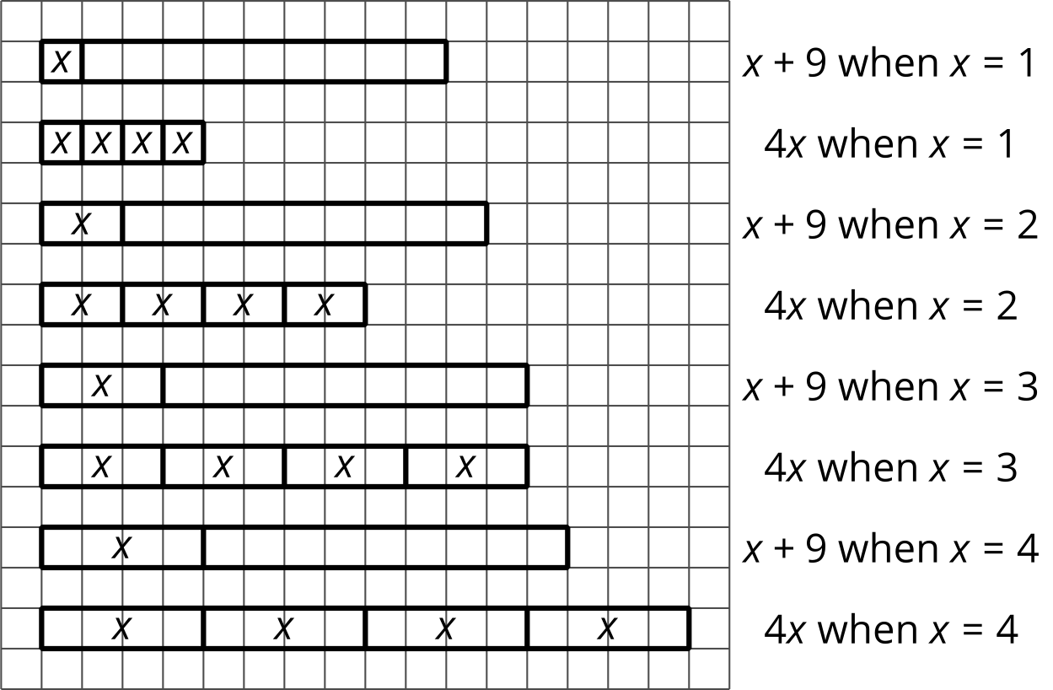
Sometimes two expressions are equal for only one particular value of their variable. Other times, they seem to be equal no matter what the value of the variable.
Expressions that are always equal for the same value of their variable are called equivalent expressions. However, it would be impossible to test every possible value of the variable. How can we know for sure that expressions are equivalent?
We can use the meaning of operations and properties of operations to know that expressions are equivalent. Here are some examples:
- $x+3$ is equivalent to $3+x$ because of the commutative property of addition. The order of the values being added doesn’t affect the sum.
- $4⋅y$ is equivalent to $y⋅4$ because of the commutative property of multiplication. The order of the factors doesn’t affect the product.
- $a+a+a+a+a$ is equivalent to $5⋅a$ because adding 5 copies of something is the same as multiplying it by 5.
- $b÷3$ is equivalent to $b⋅\frac{1}{3}$ because dividing by a number is the same as multiplying by its reciprocal.
In the coming lessons, we will see how another property, the distributive property, can show that expressions are equivalent.

