Grade 6
Unit 6Lesson 12CC BY NC Illustrative Mathematics, based on IM 6–8 Math, CC BY Open Up Resources.
Unit 6, Lesson 12

Meaning of Exponents
Let’s see how exponents show repeated multiplication.
Grade 6
Unit 6Lesson 12CC BY NC Illustrative Mathematics, based on IM 6–8 Math, CC BY Open Up Resources.

12.1Notice and Wonder: Dots and Lines
What do you notice? What do you wonder?
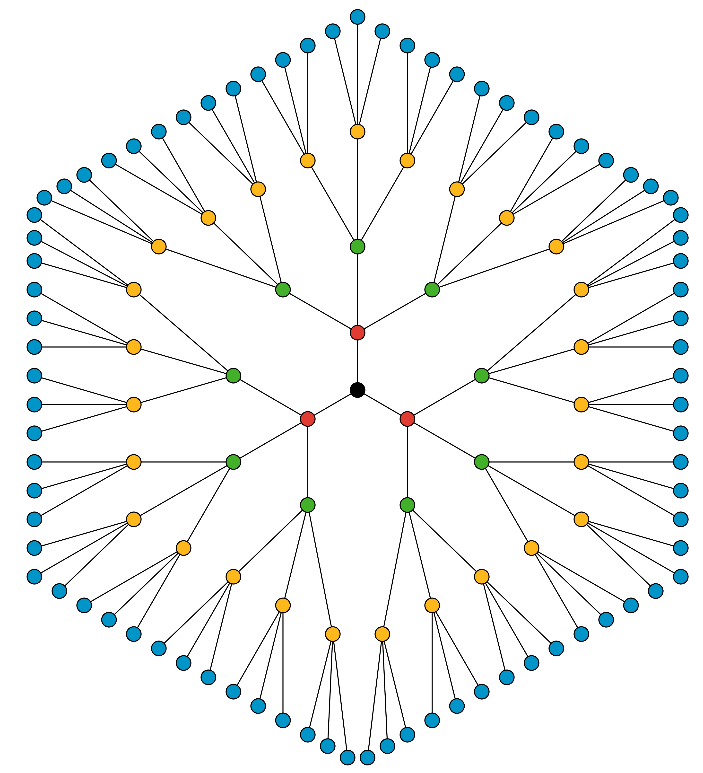

Grade 6
Unit 6Lesson 12CC BY NC Illustrative Mathematics, based on IM 6–8 Math, CC BY Open Up Resources.

12.2Rice on a Chessboard
A wealthy king wanted to reward the inventor of chess for creating a beautiful game. The king offered the inventor a chest of jewels, a palace, or land to rule.
The inventor declined these rewards and said that all he wished for were some grains of rice.
Shocked, the king demanded an explanation.
​​​​
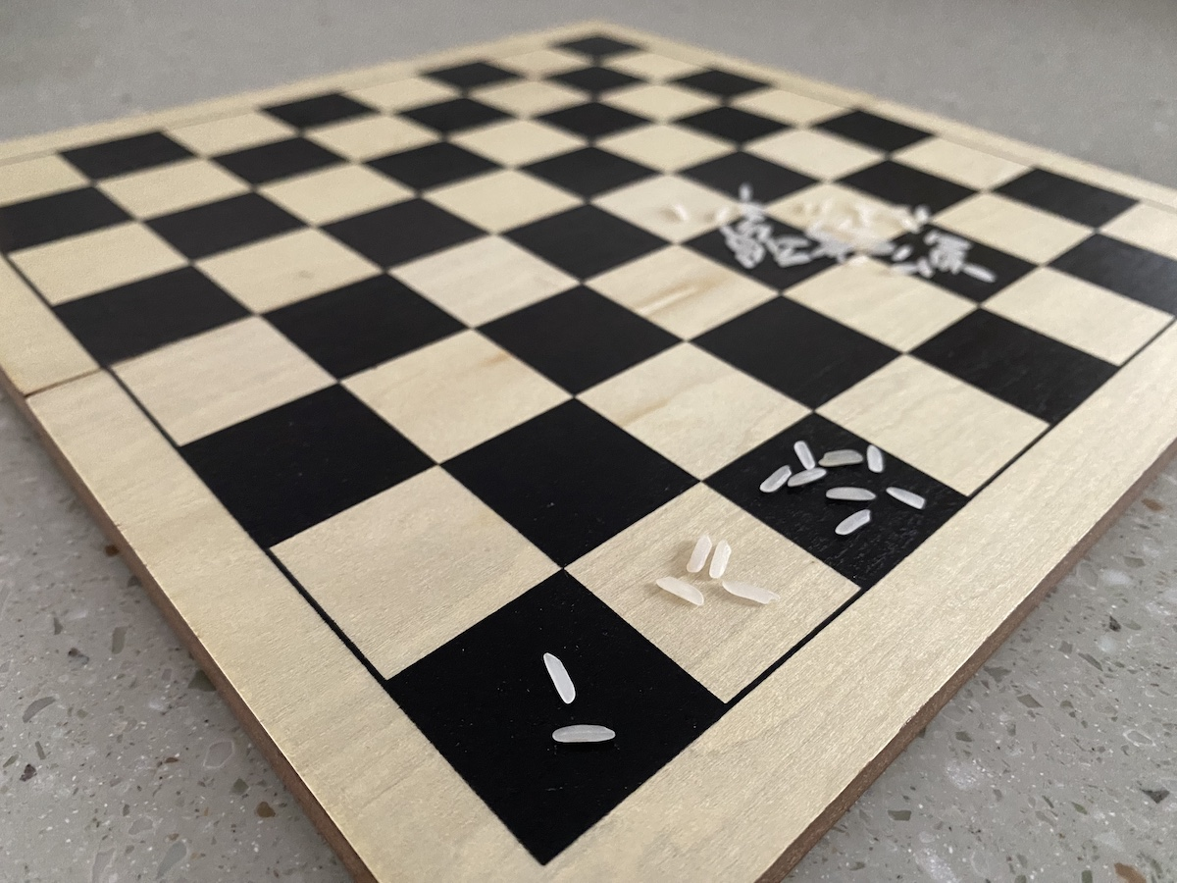
The inventor explained, “On the first day, give me 2 grains of rice for the first square on the chessboard. On the second day, give me 4 grains of rice for the second square on the board, and 8 on the third day. Keep doubling the grains of rice each day for each of the 64 squares on the board.”
The king and all the members of his court burst out into laughter. “How foolish! You decline the treasures I offer for a few handfuls of rice?”
Do you think the inventor was foolish?
- Complete this table to show the number of grains on the first 5 days.
- day | - expression with repeated multiplication | - expression with exponents | - number of grains of rice
- 1 | - $2$ | - $2^{1}$ | - 2
- 2 | - $2⋅2$ |  | - 4
- 3 | - $2⋅2⋅2$ |  | - 8
- 4 |  | - $2^{4}$
- 5
- What does $2^{6}$ represent in this situation? Find the value of $2^{6}$ without a calculator.
- Pause for discussion.
- How many days would it take for the number of grains of rice to exceed 50,000?
- Will the number of grains of rice exceed 1 million before half of the chessboard is reached? Explain or show your reasoning.

Are you ready for more?
Today, India is the second largest producer of rice in the world. It produces about 120 million metric tons of rice each year. Each ton is about 2,200 pounds. Each pound of rice contains about 25,000 grains.
You can use your calculator to answer these questions.
- Would the inventor's prize be more than all the rice produced in a year in India in modern times?
- In the United States today, the average price of 1 pound of rice is $1.30. At that price, approximately how much money would the inventor’s final prize be worth?
Grade 6
Unit 6Lesson 12CC BY NC Illustrative Mathematics, based on IM 6–8 Math, CC BY Open Up Resources.

12.3Make 81
- Here are some expressions. All but one of them equals 16. Find the one that is not equal to 16 and explain how you know.
- $2^{3}⋅2$
- $4^{2}$
- $\frac{2^{5}}{2}$
- $8^{2}$
- Write three expressions with exponents so that each expression equals 81.

Lesson 12 Summary
When we write an expression like $2^{n}$, we call $n$ the exponent.
If $n$ is a whole number, it tells how many factors of 2 we should multiply to find the value of the expression. For example, $2^{1}=2$, and $2^{5}=2⋅2⋅2⋅2⋅2$.
There are different ways to say $2^{5}$. We can say “two raised to the power of five” or “two to the fifth power” or just “two to the fifth.”

