Grade 2
Unit 7Lesson 1CC BY NC 2024 Illustrative Mathematics®
Unit 7, Lesson 1

Compare, Count On, and Count Back
- Let’s compare numbers and add or subtract.
Grade 2
Unit 7Lesson 1CC BY NC 2024 Illustrative Mathematics®

Warm-up Number Talk: Count Back
Find the value of each expression mentally.
- $586−6$
- $586−8$
- $434−5$
- $352−4$
Grade 2
Unit 7Lesson 1CC BY NC 2024 Illustrative Mathematics®

Activity 1 Notice the Difference
Tyler and Elena find the value of $81−79$.
Tyler
$\begin{matrix}81−70 & =11 \\ 11−9 & =2\end{matrix}$
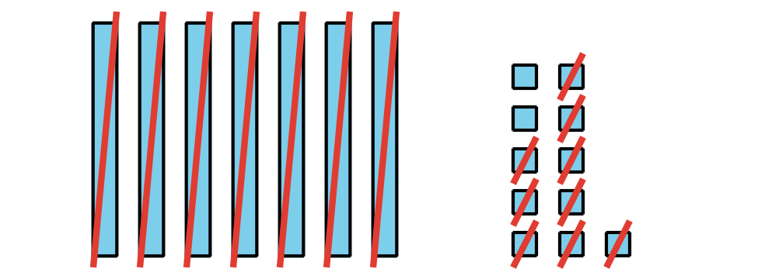
Elena
$81−79=2$
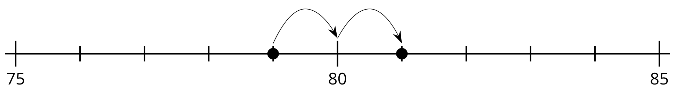
What do you notice? What do you wonder?

- Locate and label 203 and 198.
- Compare, using $<$, $>$, or $=$.
- _ 00 _
- Find the value of $203−198$. Show your thinking, using drawings, numbers, or words.
- Locate and label 673 and 680.
- Compare, using $<$, $>$, or $=$.
- _ 00 _
- Find the value of $680−673$. Show your thinking, using drawings, numbers, or words.
- Locate and label 501 and 499.
- Find the value of $501−499$. Show your thinking, using drawings, numbers, or words.
- Find the value of $400−396$. Show your thinking, using drawings, numbers, or words.
Grade 2
Unit 7Lesson 1CC BY NC 2024 Illustrative Mathematics®

Activity 2 What’s the Big Difference?
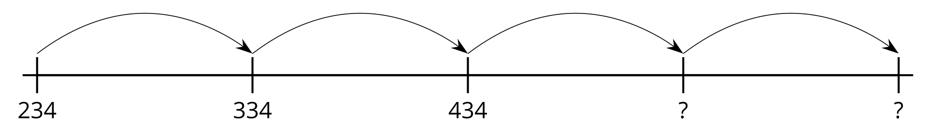
- Fill in the missing numbers.
- 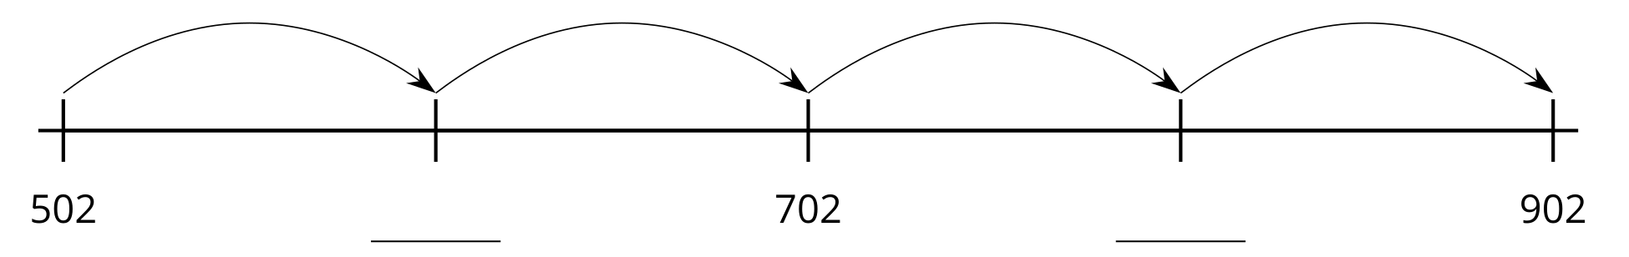
- Does this number line show counting on by tens or counting on by hundreds?
- Fill in the missing numbers.
- 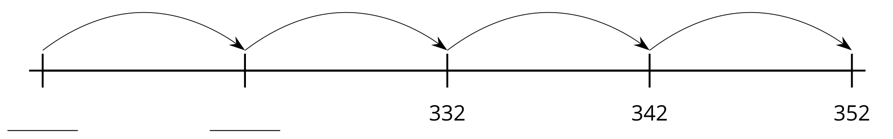
- Does this number line show counting on by tens or counting on by hundreds?
- Fill in the missing numbers.
- 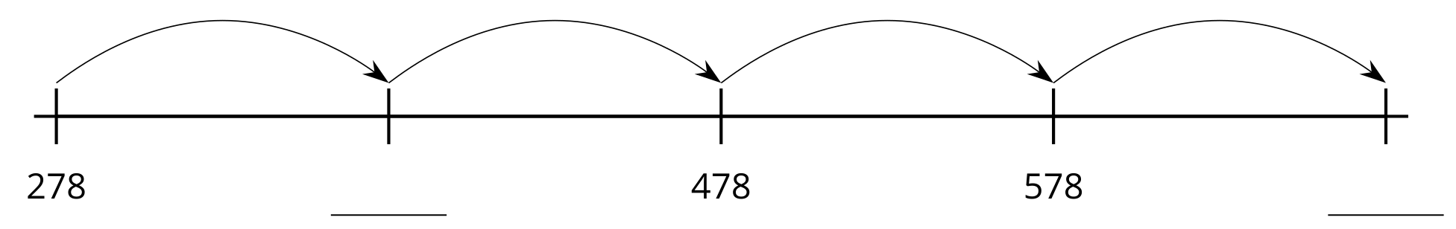
- Does this number line show counting on by tens or counting on by hundreds?
- Fill in the missing numbers, counting on by tens.
- 739, 749, __________, 769, __________
- Explain how you know your numbers show counting on by tens and not counting on by hundreds.

