Unit 8 Lesson 12: Partition Rectangles into Squares

WU Estimation Exploration: Fill it Up (Warm up)

Student Task Statement
How many little squares would fill the rectangle?
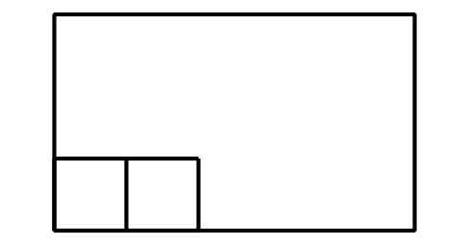
Record an estimate that is:
too low | about right | too high

1 How Many Squares?

Student Task Statement
- Build a rectangle with 8 tiles arranged in 2 rows. Use a ruler to partition the rectangle to match the rectangle you made.
- 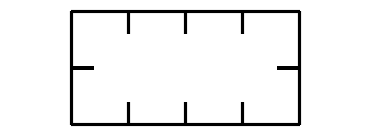
- Use a ruler to partition the rectangle using the tick marks as a guide.
- 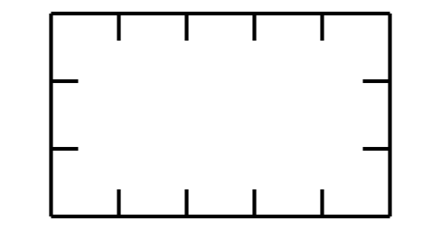
  - How many rows of equal-size squares did you make?
  - How many columns did you make?
  - Write 2 equations to represent the total number of equal-size squares.
- Use a ruler to partition the rectangle using the tick marks as a guide.
- 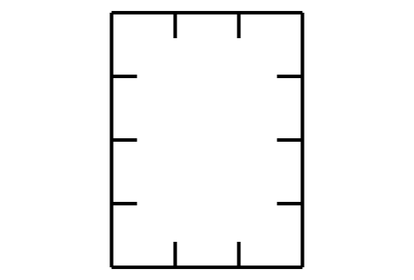
  - How many rows of equal-size squares did you make?
  - How many columns did you make?
  - Write 2 equations to represent the total number of equal-size squares.

Activity Synthesis
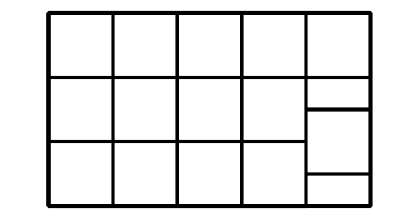

2 Partition Rectangles

Student Task Statement
- Use 12 tiles to make a rectangle. Split one of the rectangles into equal-size squares to match your rectangle made of tiles.
- 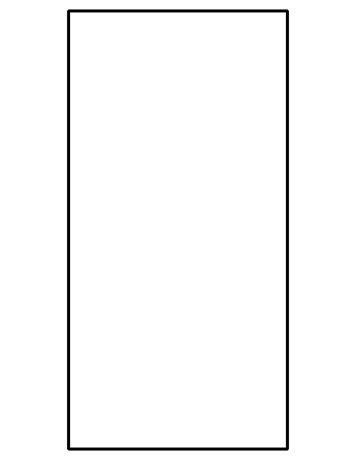
- 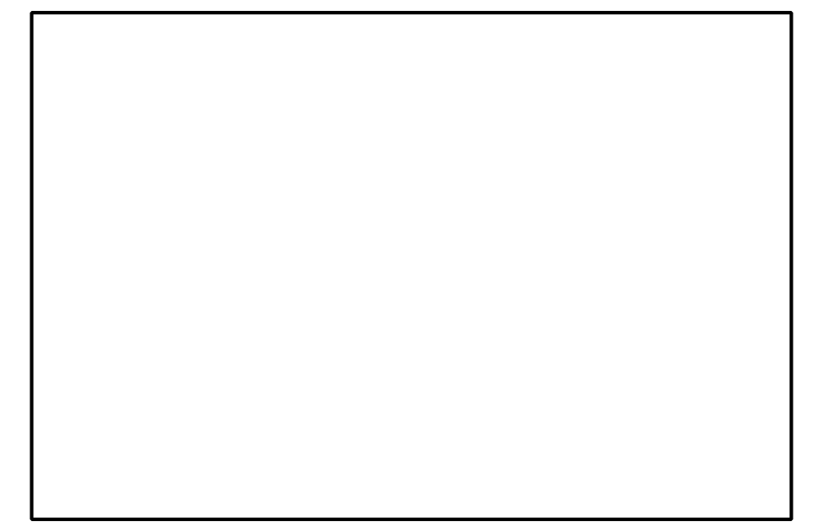
  - Write 2 equations to represent the total number of squares.
- Split this rectangle into equal-size squares.
- 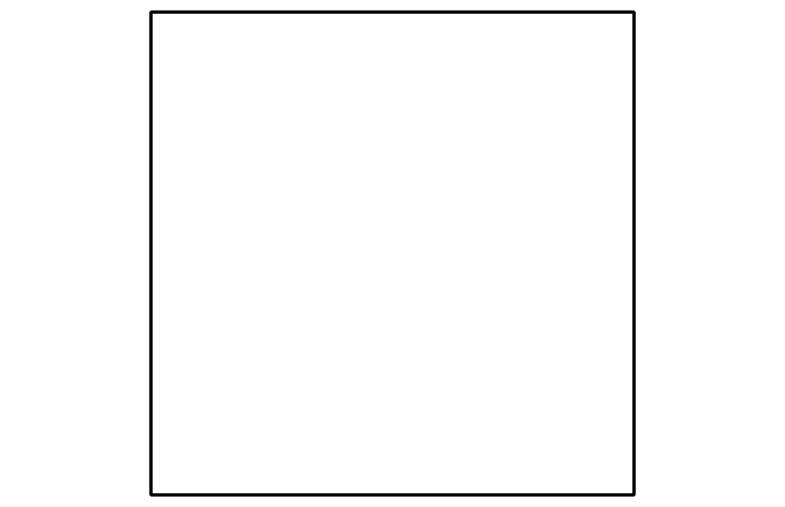
  - Write 2 equations to represent the total number of squares.
- Split this rectangle into equal-size squares.
  - Write 2 equations to represent the total number of squares.

Images for Activity Synthesis
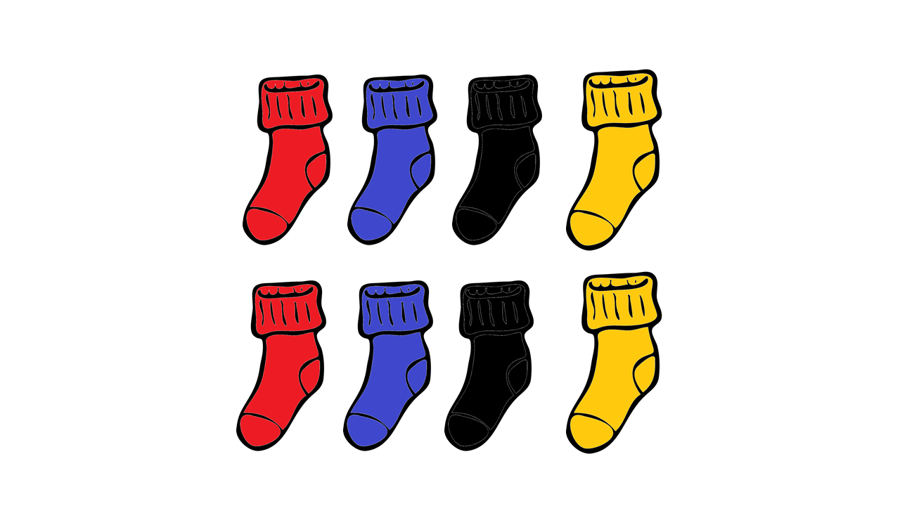
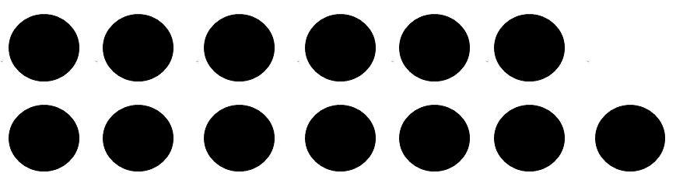
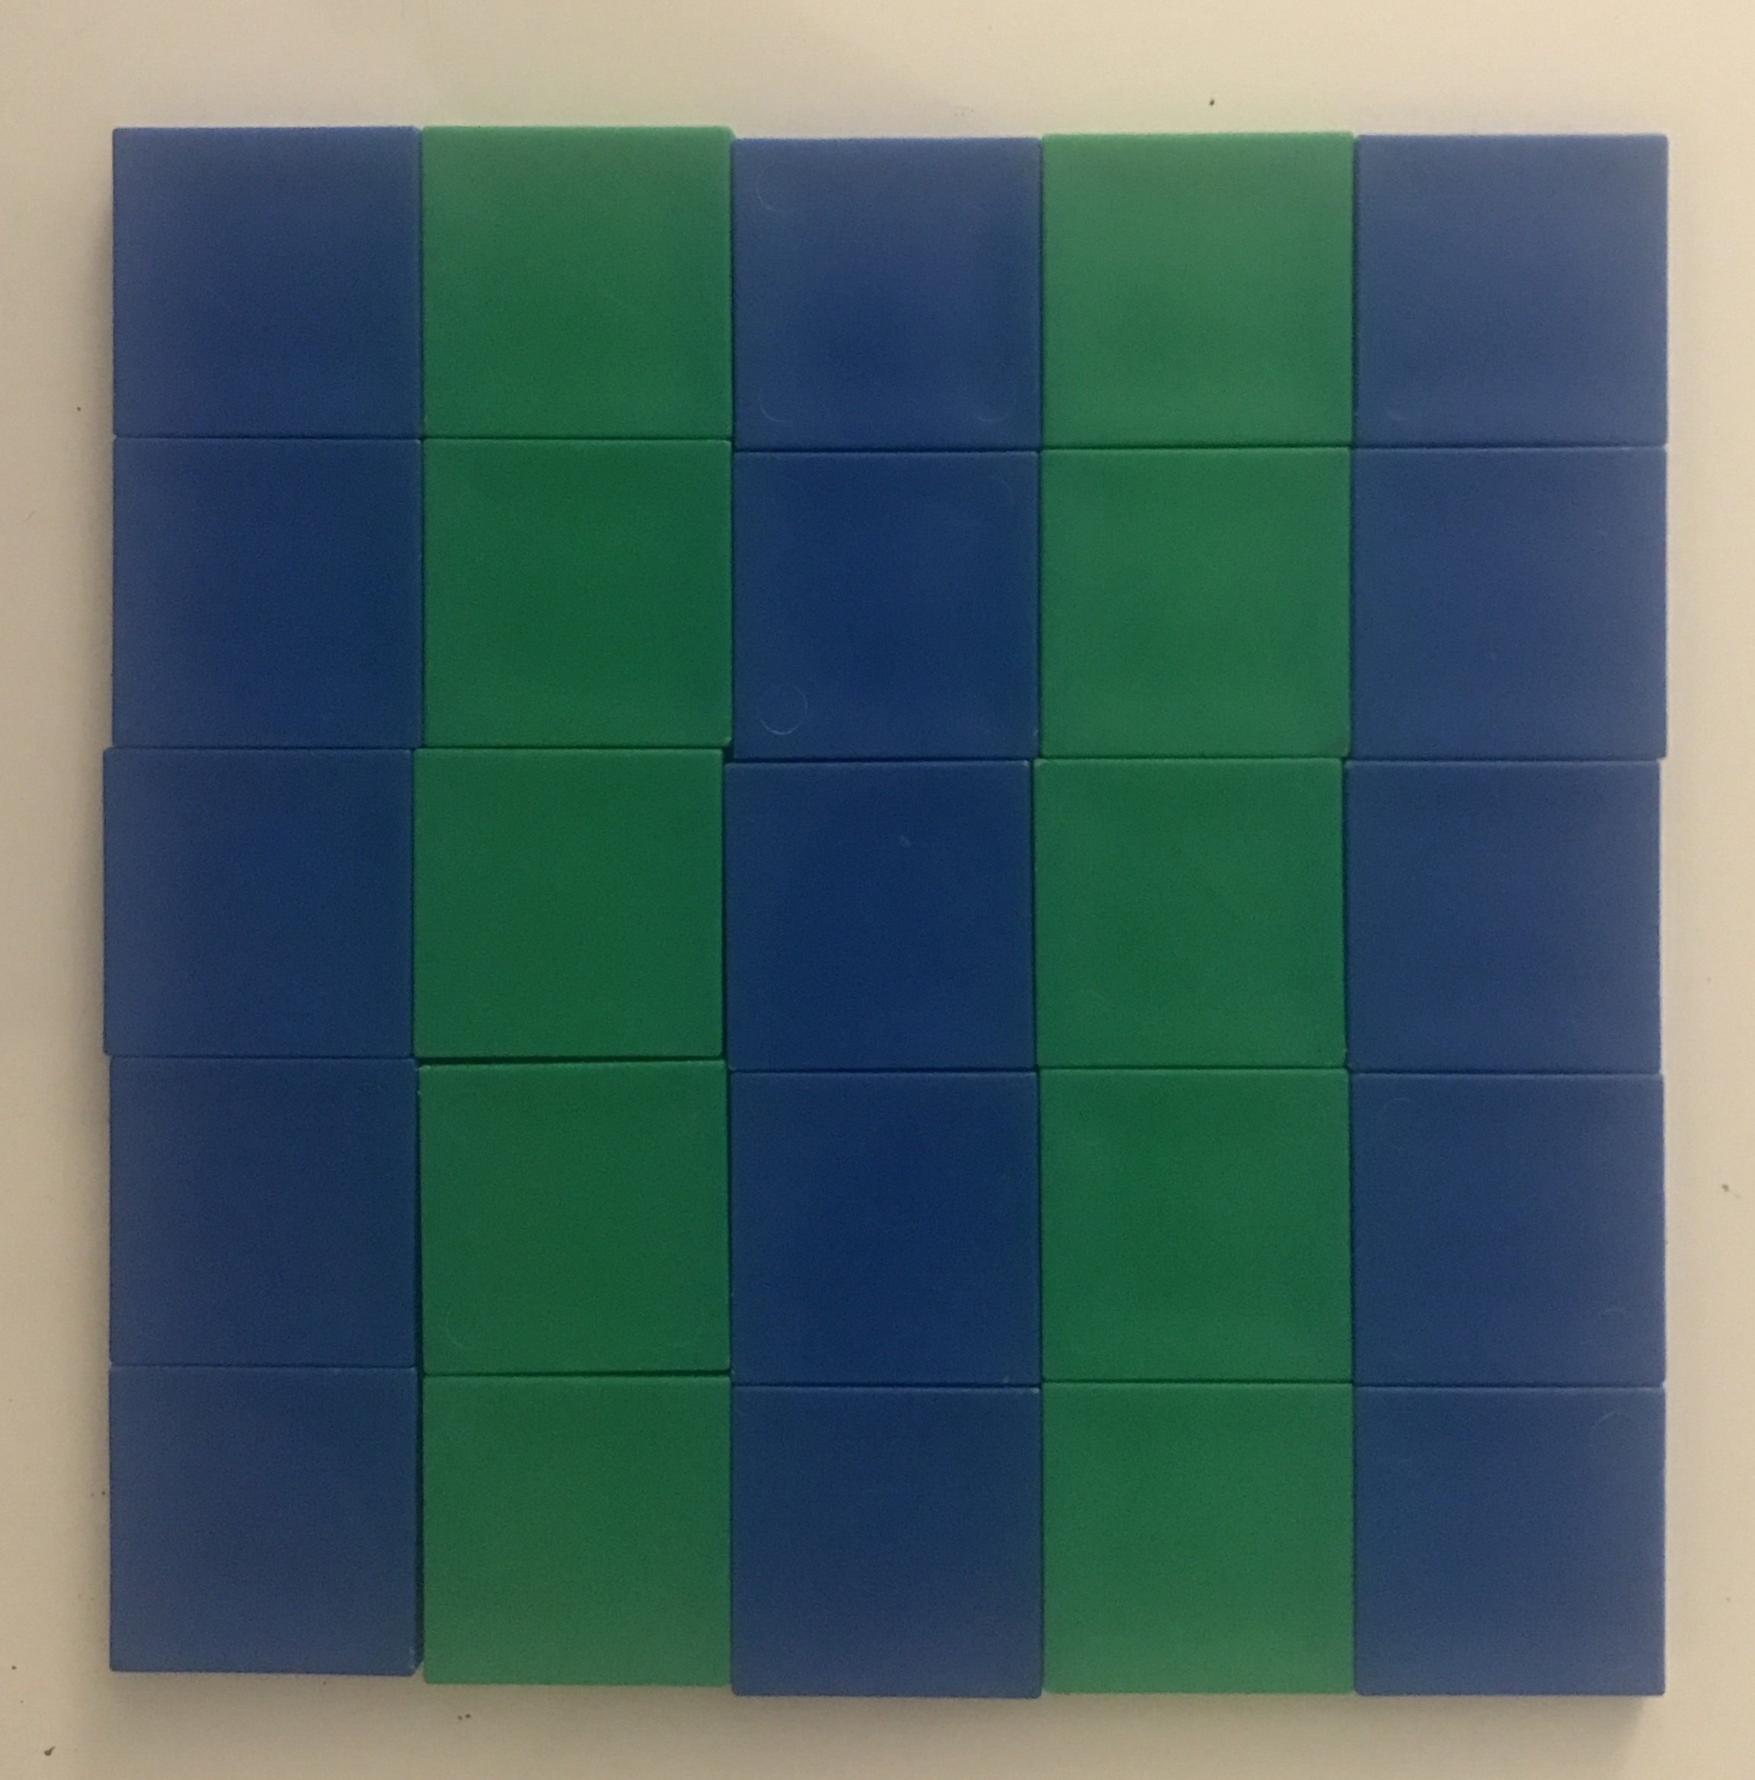
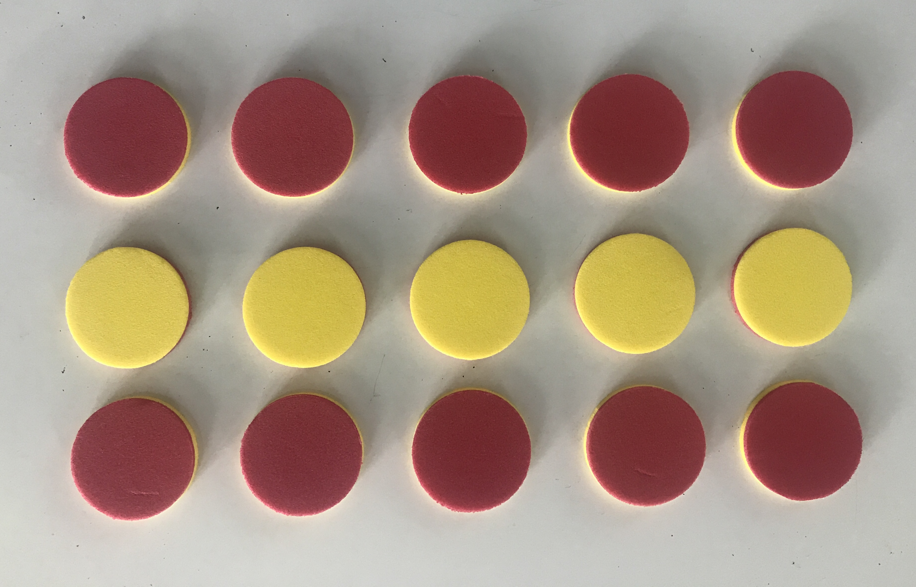
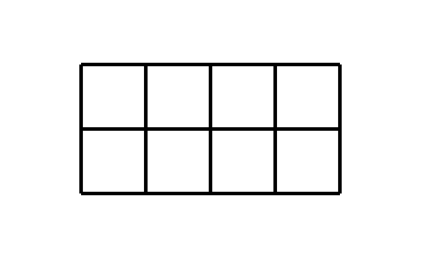
B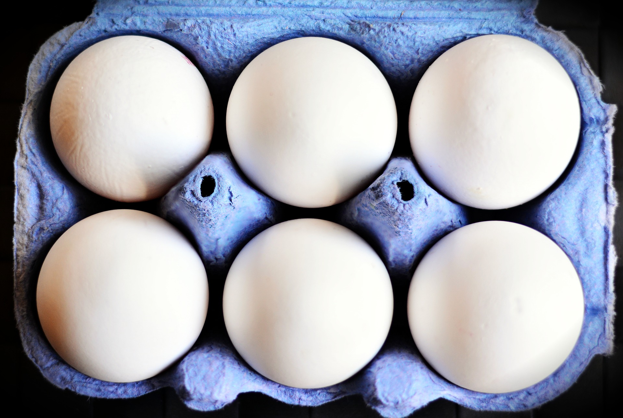
© CC BY 2021 Illustrative Mathematics®

