Grade 2
Unit 6Lesson 15CC BY NC 2024 Illustrative Mathematics®
Unit 6, Lesson 15

Identify Pennies, Nickels, and Dimes
- Let’s learn about coins and their values.
Grade 2
Unit 6Lesson 15CC BY NC 2024 Illustrative Mathematics®

Warm-up What Do You Know about Money?
What do you know about money?
Grade 2
Unit 6Lesson 15CC BY NC 2024 Illustrative Mathematics®

Activity 1 Show Me the Money
Name the coins in each collection. Find the value in cents. The cent sign (¢) is a symbol used to represent cents. Show your thinking, using drawings, numbers, or words.
- Andre’s coins
- 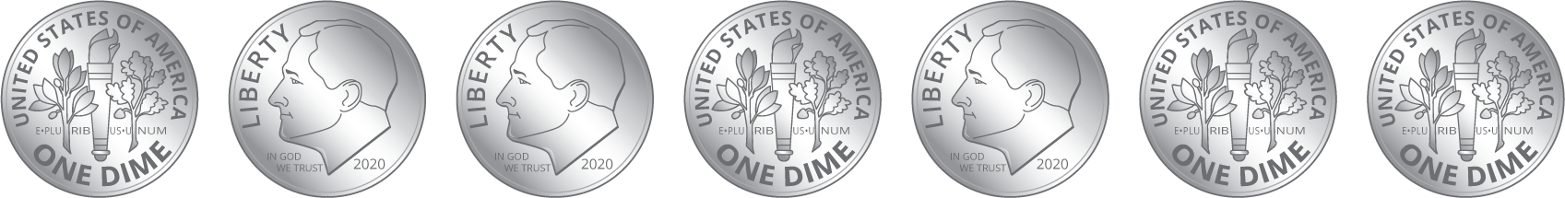
  - Circle the name of the coins in this collection.
  - dimes
  - nickels
  - pennies
  - What is the value of the coins?
- Clare’s coins
- 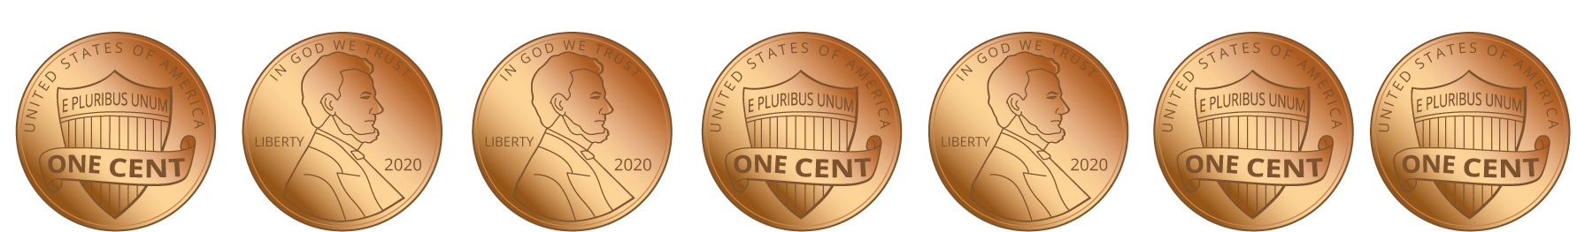
  - Circle the name of the coins in this collection.
  - dimes
  - nickels
  - pennies
  - What is the value of the coins?
- Han’s coins
- 
  - Circle the name of the coins in this collection.
  - dimes
  - nickels
  - pennies
  - What is the value of the coins?
- Show 2 different ways to make 10¢. Show your thinking, using drawings, numbers, or words.
Grade 2
Unit 6Lesson 15CC BY NC 2024 Illustrative Mathematics®

Activity 2Compare Coins
Name the coins in each collection. Then find the value in cents. Show your thinking, using drawings, numbers, or words.
- Mai’s coins
- 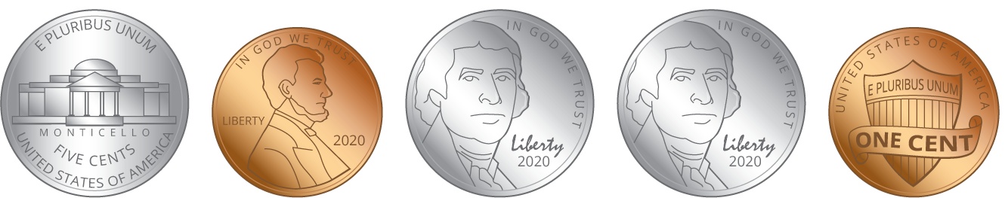
  - Circle the names of the coins in this collection.
  - dimes
  - nickels
  - pennies
  - What is the value of the coins?
- Andre’s coins
- 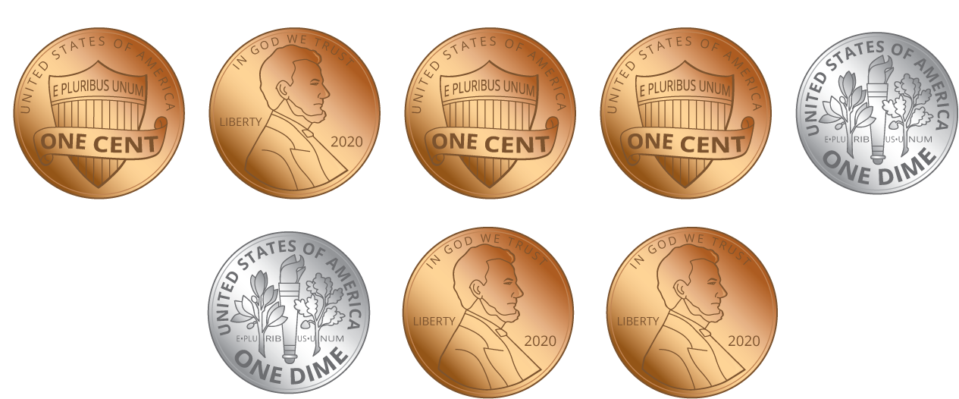
  - Circle the names of the coins in this collection.
  - dimes
  - nickels
  - pennies
  - What is the value of the coins?
- Clare’s coins
- 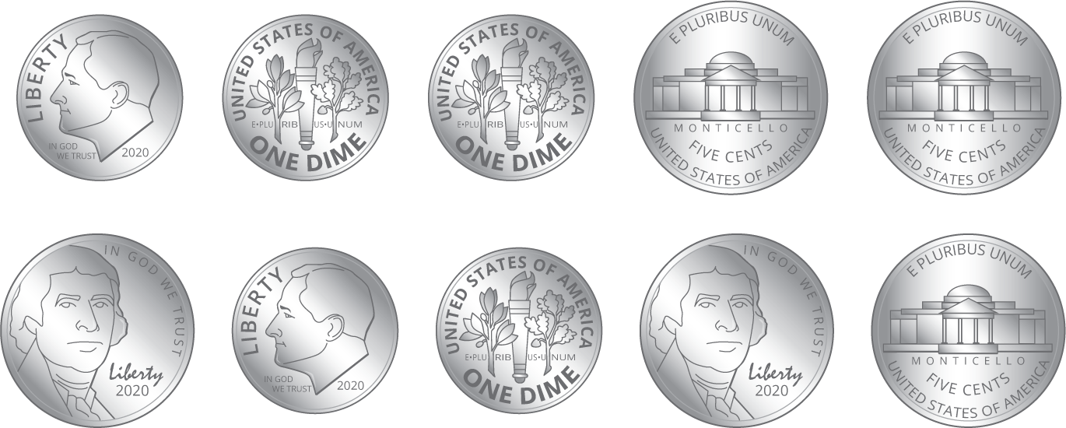
  - Circle the names of the coins in this collection.
  - dimes
  - nickels
  - pennies
  - What is the value of the coins?
- Priya’s coins
- 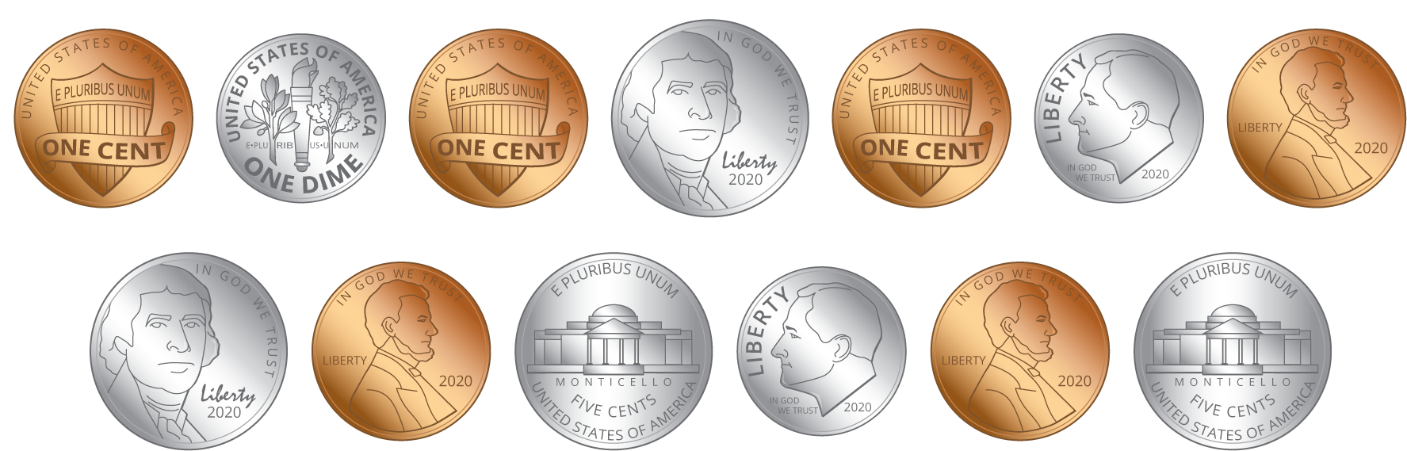
  - Circle the names of the coins in this collection.
  - dimes
  - nickels
  - pennies
  - What is the value of the coins?
- Compare your coin names. Tell your partner how you found the values.
- Whose collection of coins has the least value?
- Who has the most coins? Does this collection of coins have the greatest value? Explain your reasoning.

