Lesson 7 Practice Problems
- Sketch a figure that is similar to this figure. Label side and angle measures.
- 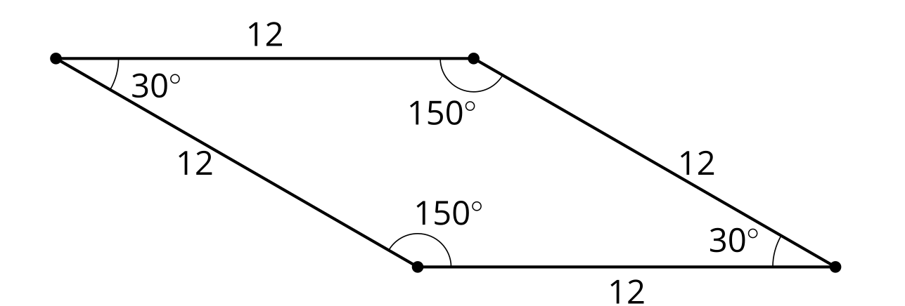
- Write 2 different sequences of transformations that would show that triangles $ABC$ and $AED$ are similar. The length of $AC$ is 6 units.

- $AC=6$
- 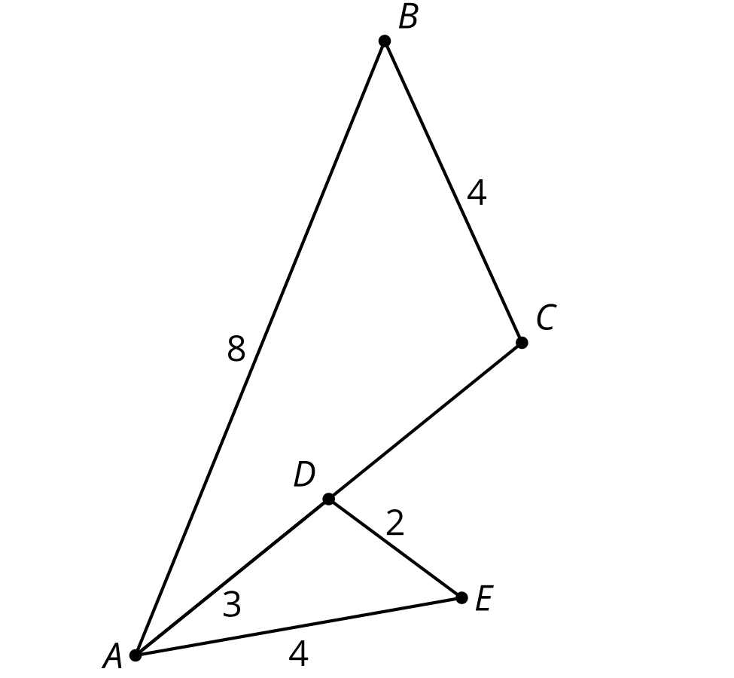
- What is the definition of similarity?
- (From Unit 3, Lesson 6.)
- Select all figures which are similar to Parallelogram $P$.

- Parallelogram $P$
- 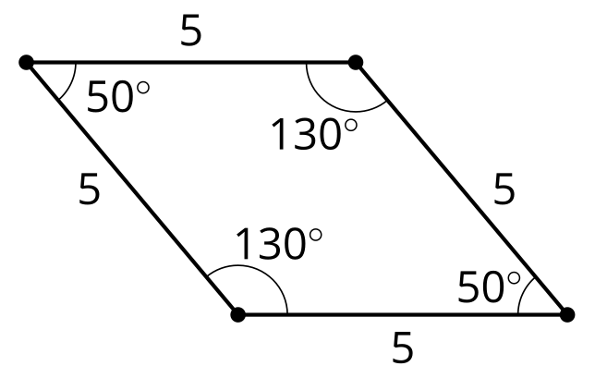

- Figure $A$

- Figure $B$
- 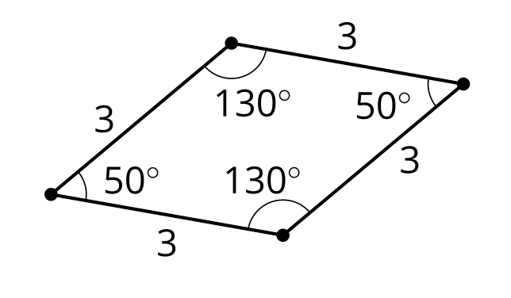

- Figure $C$
- 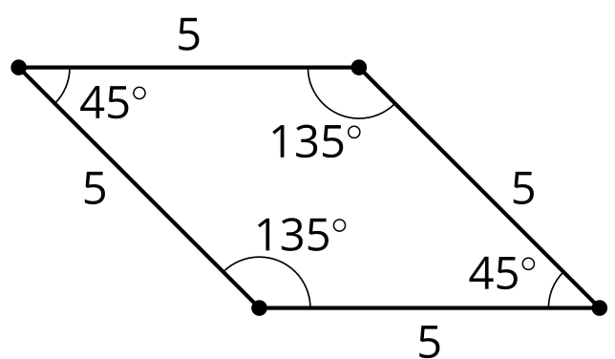

- Figure $D$
- 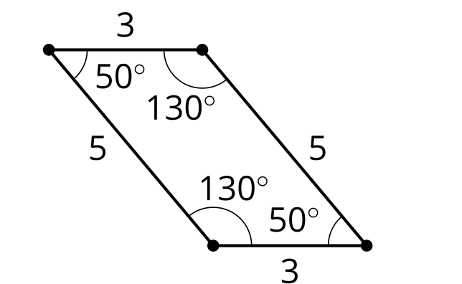

- Figure $E$
- 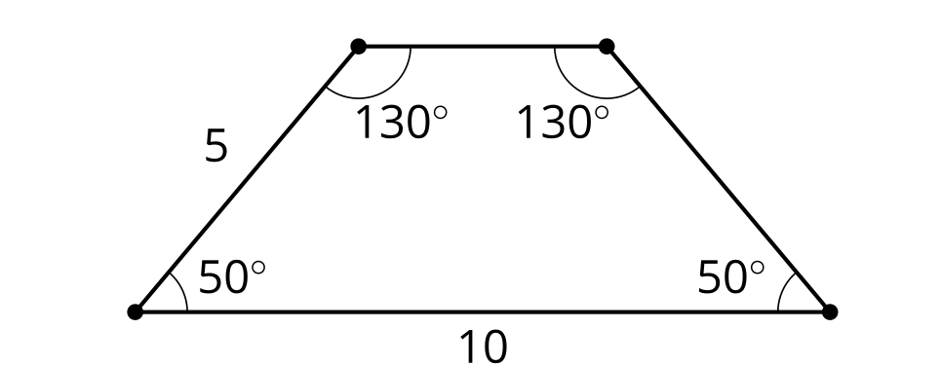
  - Figure $A$
  - Figure $B$
  - Figure $C$
  - Figure $D$
  - Figure $E$
- Find a sequence of rigid transformations and dilations that takes square $ABCD$ to square $EFGH$.
- 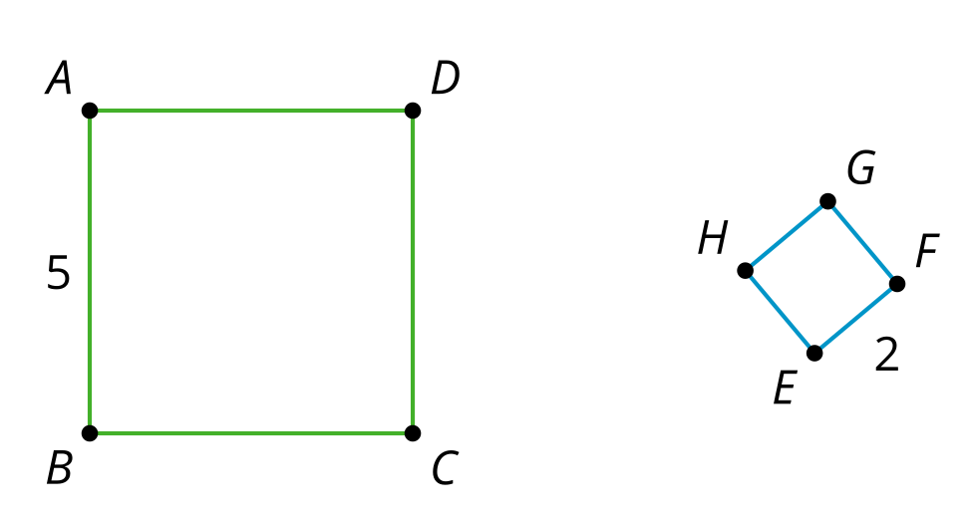
  - Translate by the directed line segment $AE$, which will take $B$ to a point $B^{′}$. Then rotate with center $E$ by angle $B^{′}EF$. Finally, dilate with center $E$ by scale factor $\frac{5}{2}$.
  - Translate by the directed line segment $AE$, which will take $B$ to a point $B^{′}$. Then rotate with center $E$ by angle $B^{′}EF$. Finally, dilate with center $E$ by scale factor $\frac{2}{5}$.
  - Dilate using center $E$ by scale factor $\frac{2}{5}$.
  - Dilate using center $E$ by scale factor $\frac{5}{2}$.
- (From Unit 3, Lesson 6.)
- Triangle $DEF$ is formed by connecting the midpoints of the sides of triangle $ABC$. What is the perimeter of triangle $ABC$?
- 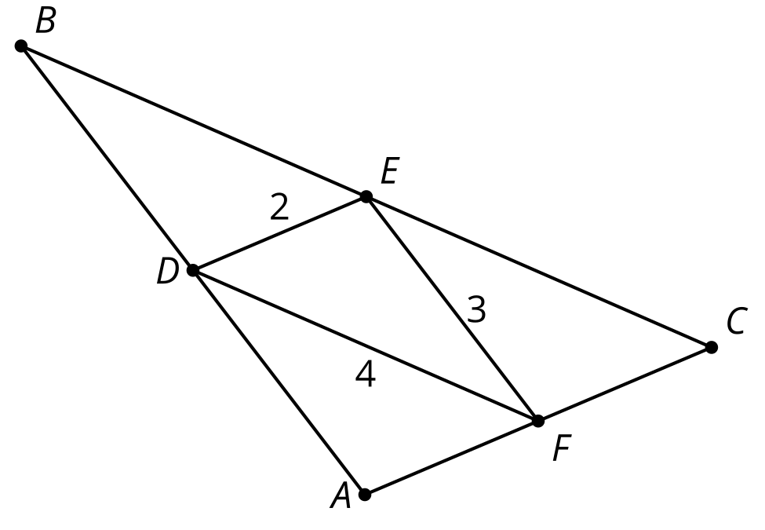
- (From Unit 3, Lesson 5.)
- Select the quadrilateral for which the diagonal is a line of symmetry.
  - parallelogram
  - square
  - trapezoid
  - isosceles trapezoid
- (From Unit 2, Lesson 14.)
- Triangles $FAD$ and $DCE$ are each translations of triangle $ABC$
- 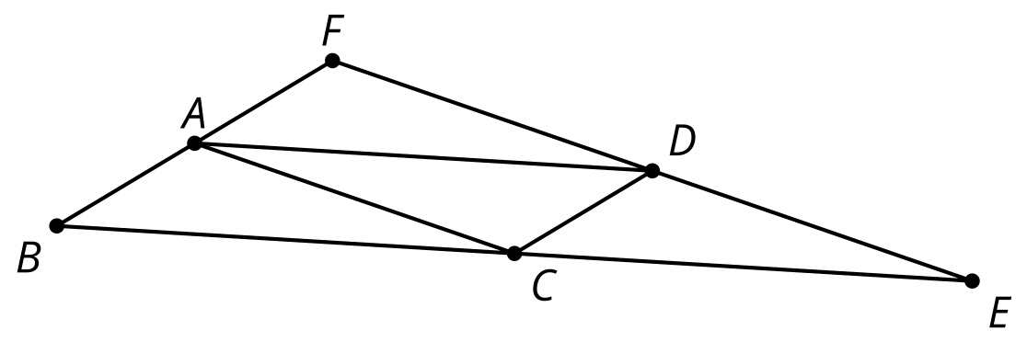
- Explain why angle $CAD$ has the same measure as angle $ACB$.
- (From Unit 1, Lesson 21.)
© CC BY 2019 by Illustrative Mathematics®

