Lesson 14: Putting It All Together
- Let’s use geometry to solve problems.

14.1: Equal Slices
At a pizza restaurant, a personal pizza has a radius of 10 centimeters and costs $5. Another restaurant takes a pizza with radius 30 centimeters, cuts it into 8 slices of equal area, and charges $5 per slice. Which is a better deal? Explain your reasoning.

14.2: Pizza Palooza
Elena was researching offers for the upcoming Pizza Palooza festival. She wants to get a good deal on a single slice of pizza.
Your teacher will give you cards that show the deals offered by 4 vendors. Which vendor should Elena choose? Explain or show your reasoning.

14.3: A Fair Split
Jada and Andre want to share a big slice of pizza so that each of them gets the same amount, but Andre doesn’t like the crust. The pizza slice is a sector of a circle with a radius of 20 cm and a central angle that measures $\frac{π}{3}$ radians.
How can Andre and Jada divide the slice of pizza into 2 equal pieces so that Andre doesn’t have to eat any crust?

14.4: Let Your Light Shine
Noah is taking photos of a sculpture he made in art class. He will submit the photos to a contest. The sculpture is in front of a backdrop, which is represented from an overhead view in the image by segment $AB$. Noah positioned a light at point $C$ so that the edges of the light beam meet up exactly with the backdrop at segment $AB$.
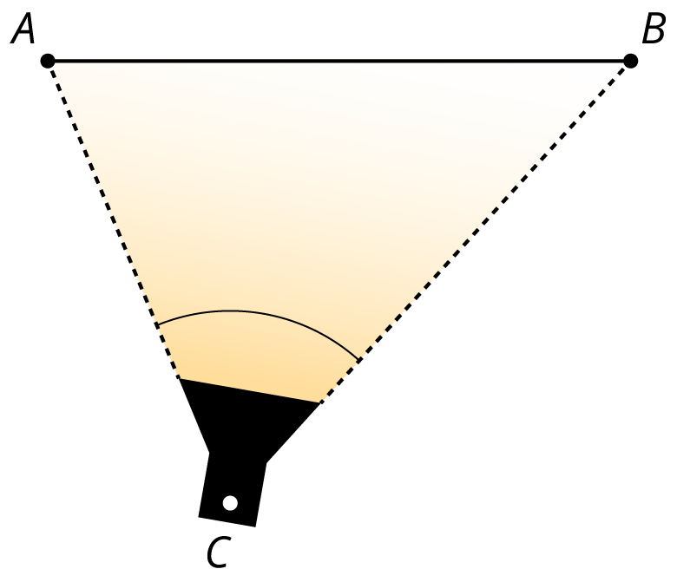
Noah wants to try different positions for the light to highlight different aspects of the sculpture, but he still wants the edges of the beam to exactly meet the endpoints of the backdrop. Find at least 3 other places Noah can place the light. Explain or show your reasoning.

Lesson 14 Summary
We can use sector areas to compare the value of product offers. Suppose the manager of a store wants to buy several dozen mirrors shaped like sectors of a circle to decorate the store. The manager is choosing between these 2 brands of mirrors at a tradeshow. Brand A’s mirror has radius 14 inches and costs $35 for each sector. Brand B’s mirror has radius 15 inches and costs $42. Which is the better deal in terms of cost per square inch of mirror?

brand A


brand B

Brand A’s mirror is made from a circle cut into 6 congruent slices. Using the expression $πr^{2}$ with radius 14 inches, we find that the area of the full circle is $196π$ or about 616 square inches. Divide that by 6 to find that each sector-shaped mirror has an area of about 103 square inches. At $35 per sector, this mirror costs about $0.34 per square inch.
For brand B, we don’t know how many slices the mirror was cut into. However, we can estimate the measure of the central angle using arc length and radius. Suppose the manager uses a flexible measuring tape to find that the length of the arc around the outside of the sector is 19 inches. The ratio of the arc length to the radius gives the measure of the central angle in radians, $\frac{19}{15}$. This is about 1.27 radians, but to avoid rounding errors, let’s use the exact value, $\frac{19}{15}$, in our calculations.
Next, we can find the area of the sector with the formula $\frac{1}{2}r^{2}θ$ where $r$ is the radius and $θ$ is the radian measure of the central angle. Substitute in our values to get $\frac{1}{2}{\left(15\right)}^{2}⋅\frac{19}{15}$, or 142.5 square centimeters. At $42 per sector, this mirror costs about $0.29 per square inch. Brand B’s mirror is a better deal.
© CC BY 2019 by Illustrative Mathematics®

