Grade 2
Unit 1Lesson 15CC BY NC 2024 Illustrative Mathematics®
Unit 1, Lesson 15

Diagrams with All Kinds of Compare Problems
- Let’s connect problems to tape diagrams.
Grade 2
Unit 1Lesson 15CC BY NC 2024 Illustrative Mathematics®

Warm-upNumber Talk: 10 and Some More
Find the value of each sum mentally.
- $4+8+2$
- $4+5+3+2$
- $9+3+1$
- $9+5$
Grade 2
Unit 1Lesson 15CC BY NC 2024 Illustrative Mathematics®

Activity 1Shell Collections
Diego has 55 shells. Lin has 20 fewer shells than Diego.
- Use the story problem to complete the diagram.
- 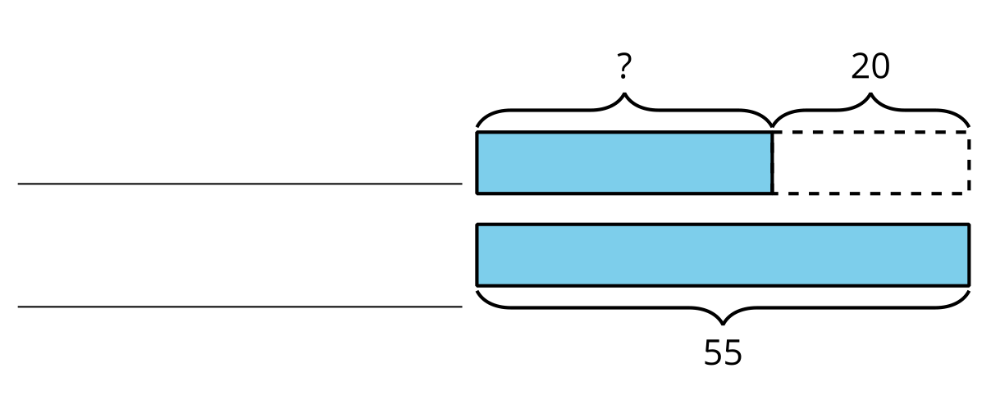
- Write an equation to find the unknown number of shells. Use ? to represent the unknown.

Grade 2
Unit 1Lesson 15CC BY NC 2024 Illustrative Mathematics®

Activity 2Card Sort: At the Beach
- Read a story problem card.
- Match each story problem to a diagram and an equation.
- Be prepared to explain your reasoning.

