Lesson 9: Same Situation, Different Symbols
- Let’s think about the how and why of solving equations, and use those ideas to make problems easier.

9.1: Math Talk: True Values
For each equation, mentally find the value that makes it true.
- $25+3=21+x$
- $5⋅3+15=x⋅5+10$
- $2−x+8=2−7+10$
- $2⋅12−50=3⋅12−x$

9.2: Fizzy Drinks and Fast Driving
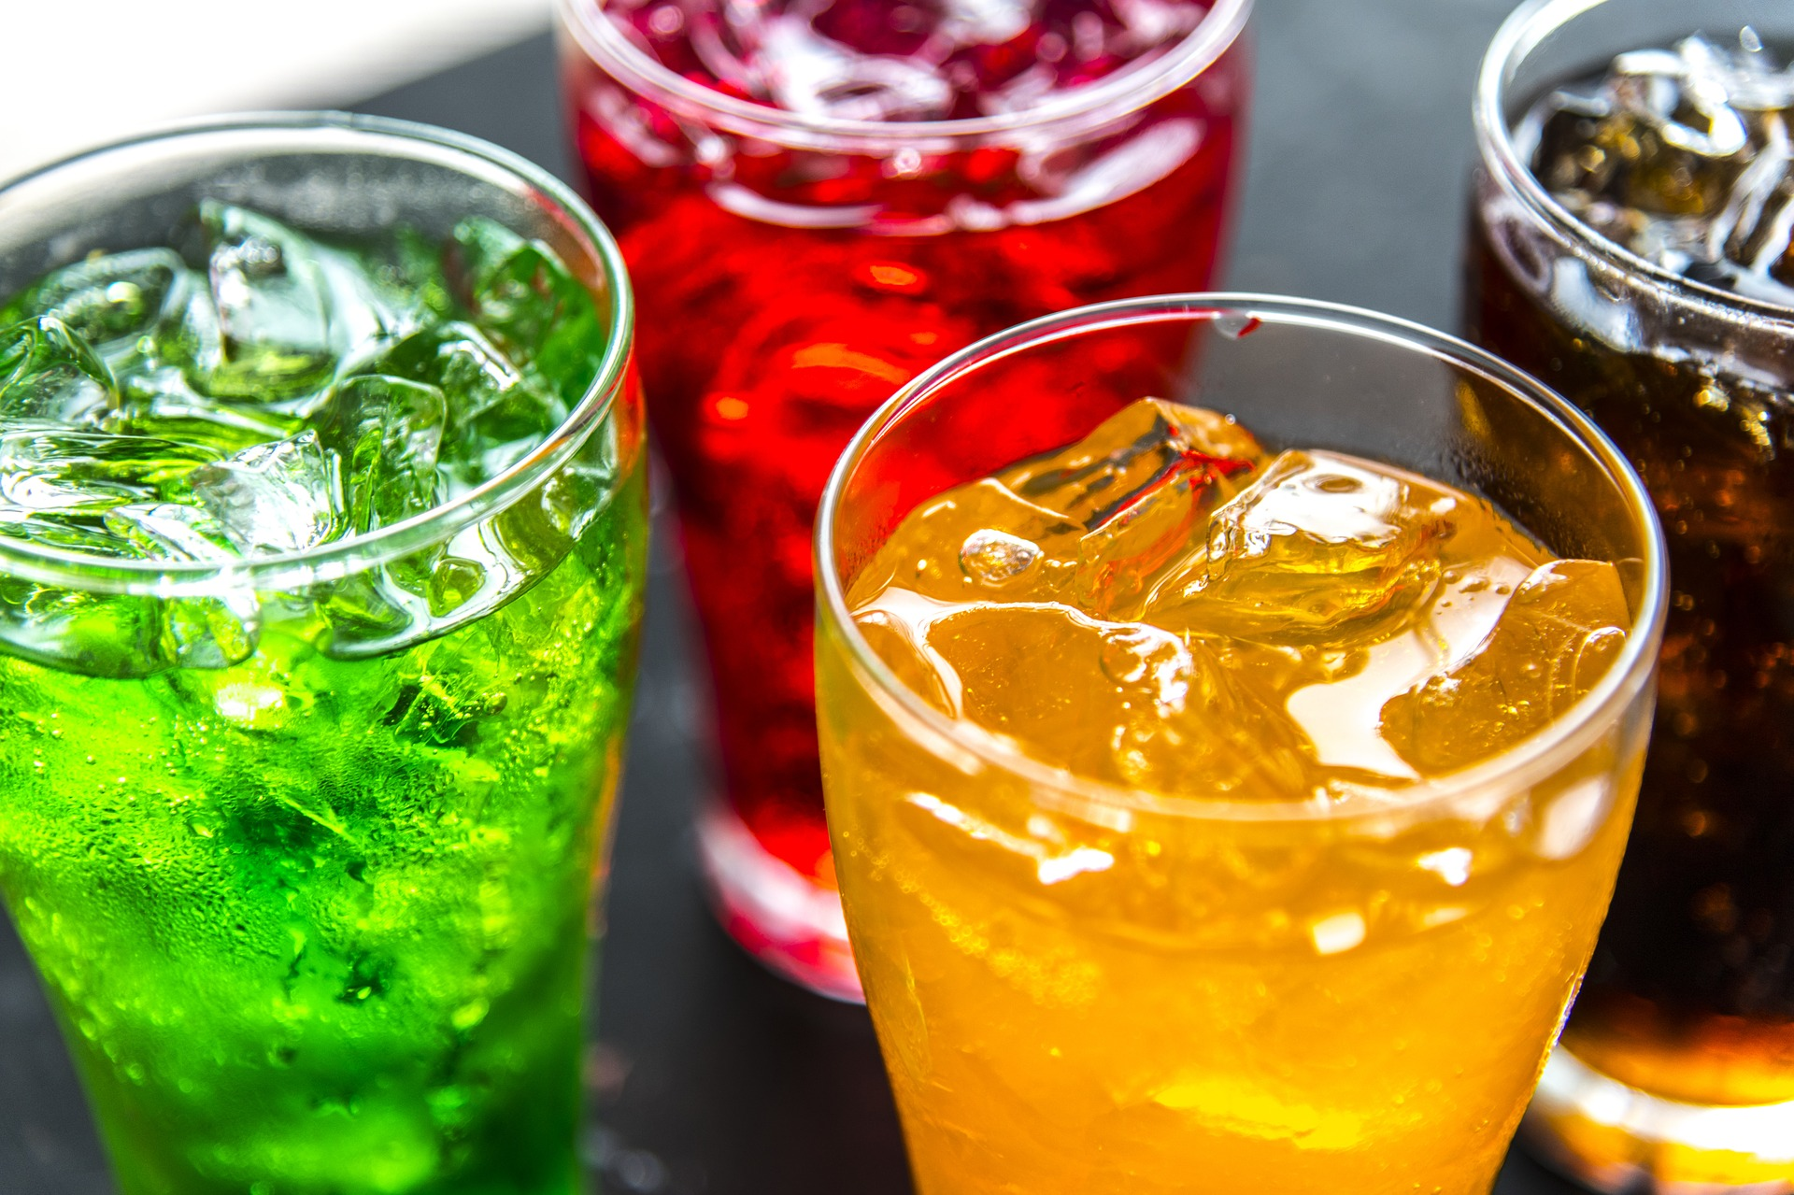
- Sparkling water and grape juice are mixed together to make 36 ounces of fizzy juice.
  - How much sparkling water was used if the mixture contains 19 ounces of grape juice?
  - How much grape juice was used if the mixture contains 15 ounces of sparkling water?
  - Han wrote the equation, $x+y=36$, with $x$ representing the amount of grape juice used, in ounces, and $y$ representing the amount of sparkling water used, in ounces. Explain why Han’s equation matches the story.
  - Clare wrote the equation $y=36−x$, with $x$ representing the amount of grape juice used, in ounces, and $y$ representing the amount of sparkling water used, in ounces. Explain why Clare’s equation matches the story.
  - Kiran wrote the equation $x=y+36$, with $x$ representing the amount of grape juice used, in ounces, and $y$ representing the amount of sparkling water used, in ounces. Explain why Kiran’s equation does not match the story.
- A car is going 65 miles per hour down the highway.
  - How far does it travel in 1.5 hours?
  - How long does it take the car to travel 130 miles?
  - Mai wrote the equation $y=65x$, with $x$ representing the time traveled, in hours, and $y$ representing the distance traveled, in miles. Explain why Mai’s equation matches the story.
  - Tyler wrote the equation $x=\frac{y}{65}$, with $x$ representing the time traveled, in hours, and $y$ representing the distance traveled, in miles. Explain why Tyler’s equation matches the story.
  - Lin wrote the equation $y=\frac{x}{65}$, with $x$ representing the time traveled, in hours, and $y$ representing the distance traveled, in miles. Explain why Lin’s equation does not match the story.

9.3: Finding an Error

Tyler is practicing finding different equivalent equations that match the story. For each of the problems below, he gets one equation right but the other equation wrong. For each one, explain the error, give the correct equivalent equation, and explain your reasoning.
- Situation: The yogurt at Sweet Delights costs $0.65 per pound and $0.10 per topping. The total cost of a purchase was $1.70. Let $p$ be the weight of the yogurt in pounds and $t$ be the number of toppings bought.
Tyler’s first and correct equation: $0.65p+0.10t=1.70$
Tyler’s second and incorrect equation: $t=\left(1.70−.65p\right)⋅0.10$
  - What is the error?
  - What is a correct second equation Tyler could have written?
  - What might Tyler have been thinking that led to his mistake?
- Situation: The perimeter of a rectangle (twice the sum of the length and width) is 13.5 inches. Let $l$ be the length of the rectangle and $w$ be the width of the rectangle.
Tyler’s first and correct equation: $2\left(l+w\right)=13.5​​​​​​​​​​​​​​$
Tyler’s second and incorrect equation: $w=13.5−2l$
  - What is the error?
  - What is a correct second equation Tyler could have written?
  - What might Tyler have been thinking that led to his mistake?
- Situation: For a fundraiser, a school is selling flavored waters for $2.00 each and pretzels for $1.50 each. The school has a fundraising goal of $200. Let $w$ be the number of waters sold and $p$ be the number of pretzels sold.
Tyler’s first and correct equation: $2w+1.5p=200$
Tyler’s second and incorrect equation: $1.5p=198w$
  - What is the error?
  - What is a correct second equation Tyler could have written?
  - What might Tyler have been thinking that led to his mistake?
© CC BY 2019 by Illustrative Mathematics®

