Grade 6
Unit 5Lesson 8CC BY NC Illustrative Mathematics, based on IM 6–8 Math, CC BY Open Up Resources.
Unit 5, Lesson 8

Calculating Products of Decimals
Let’s multiply decimals.
Grade 6
Unit 5Lesson 8CC BY NC Illustrative Mathematics, based on IM 6–8 Math, CC BY Open Up Resources.

8.1Math Talk: Twenty Times a Number
Find the value of each expression mentally.
- $20⋅5$
- $20⋅\left(0.8\right)$
- $20⋅\left(0.04\right)$
- $20⋅\left(5.84\right)$
Grade 6
Unit 5Lesson 8CC BY NC Illustrative Mathematics, based on IM 6–8 Math, CC BY Open Up Resources.

8.2Calculating Products of Decimals
- A common way to multiply decimals is to multiply whole numbers, then place the decimal point in the product.
- 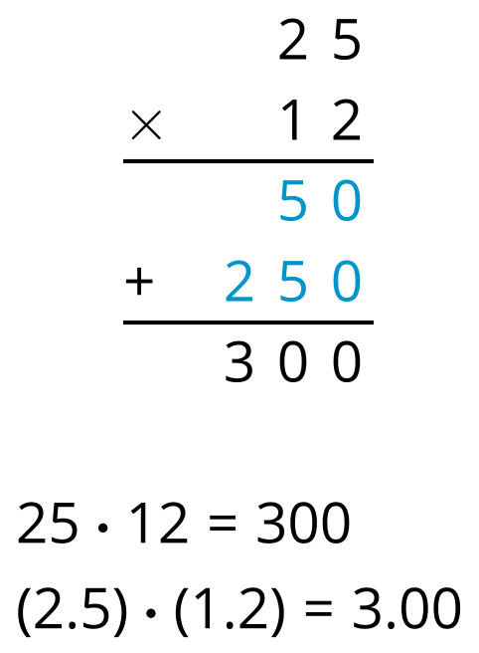
- Here is an example for $\left(2.5\right)⋅\left(1.2\right)$.
- Use what you know about place value to explain why the decimal point of the product is placed where it is.

  - Use the method shown in the first question to calculate $\left(16.5\right)⋅\left(0.7\right)$.
  - Complete this area diagram and use it to check your calculation for $\left(16.5\right)⋅\left(0.7\right)$.
    - Decompose each factor by place value and write the numbers in the boxes on each side of the rectangle.
    - Write the area of each lettered region in the diagram. Then find the area of the entire rectangle. Show your reasoning.
    - 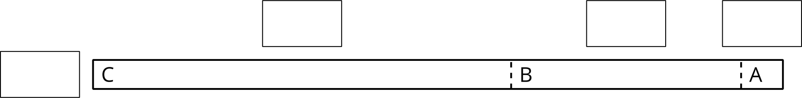
- About how many centimeters are in 6.25 inches if 1 inch is about 2.5 centimeters? Show your reasoning.
Grade 6
Unit 5Lesson 8CC BY NC Illustrative Mathematics, based on IM 6–8 Math, CC BY Open Up Resources.

8.3Practicing Multiplication of Decimals
- Calculate each product. Show your reasoning. If you get stuck, consider drawing a diagram.
  - $\left(5.6\right)⋅\left(1.8\right)$
  - $\left(0.008\right)⋅\left(7.2\right)$
- A rectangular playground is 18.2 meters by 12.75 meters.
  - Find its area in square meters. Show your reasoning.
  - If 1 meter is approximately 3.28 feet, what are the approximate side lengths of the playground in feet? Show your reasoning.

Are you ready for more?
- Find the value of each expression.
  - $1−0.1$
  - $1−0.1+10−0.01$
  - $1−0.1+10−0.01+100−0.001$
- Suppose we keep writing expressions that follow the same pattern of adding a whole number and subtracting a decimal. What would the values of those expressions look like? Make a prediction.
- What would the value of the expressions be if all of the addition and subtraction symbols became multiplication symbols? Explain your reasoning.

Lesson 8 Summary
To multiply two decimals, such as $\left(1.25\right)⋅\left(0.7\right)$, we can multiply the whole numbers that have the same digits, $125⋅7$, and then use what we know about place value to place the decimal point.
- Multiplying 125 and 7 gives 875.
- We know that 125 is 100 times 1.25, and 7 is 10 times 0.7, so the product of 125 and 7 is 1,000 times the product of 1.25 and 0.7.
- This means we need to divide 875 by 1,000, which moves the digits 3 places to the right and gives 0.875.
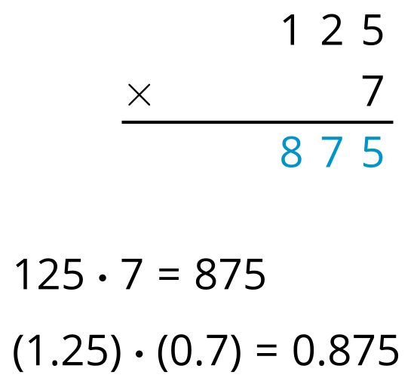
Let’s find the product of 8.4 and 4.3!
- First, we multiply 84 and 43.
- 84 is 10 times 8.4, and 43 is 10 times 4.3, so the product of 84 and 43 is 100 times the product of 8.4 and 4.3.
- Dividing 3,612 by 100 moves the digits 2 places to the right, giving 36.12.
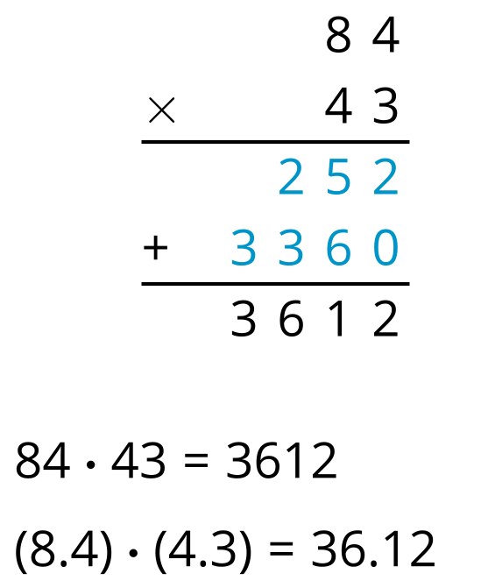
Notice that:
- The factor 1.25 has 2 decimal places, the factor 0.7 has 1 decimal place, and the product 0.875 has 3 decimal places.
- The factors 8.4 and 4.3 each have 1 decimal place, and the product 36.12 has 2 decimal places.
In general, to find the product of decimals, we can first multiply the corresponding whole numbers. Then we can place the decimal point so the product has as many decimal places as the sum of decimal places in the factors.

