Unit 1 Lesson 10: Are There Enough?

WU How Many Do You See: Building On (Warm up)

Student Task Statement
How many do you see?
How do you see them?



1 Act It Out: Four Little Speckled Frogs (Part 1)

Student Task Statement
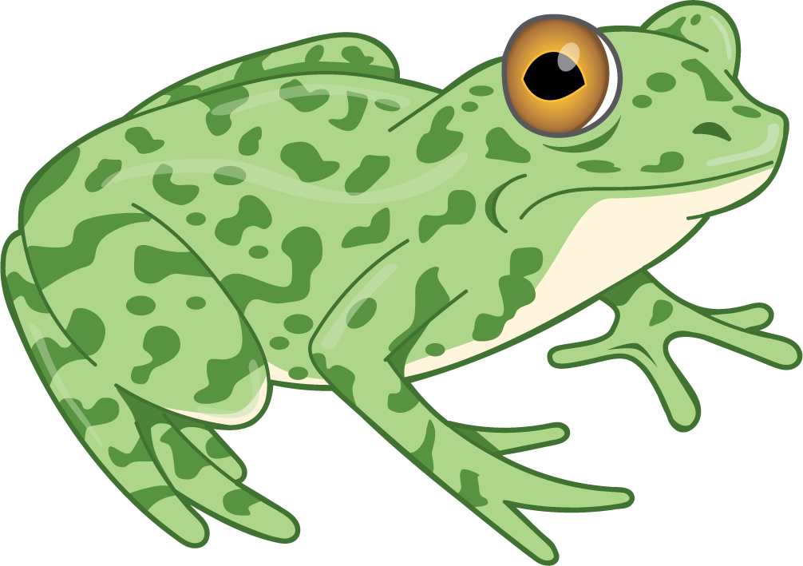
4 little speckled frogs sat on a speckled log,
eating the most delicious bugs. Yum! Yum!
1 jumped into the pool, where it was nice and cool.
Now there are 3 green speckled frogs. Glub! Glub!

2 Are There Enough?

Student Task Statement

3 Centers: Choice Time

Student Task Statement
Choose a center.
Geoblocks

Connecting Cubes
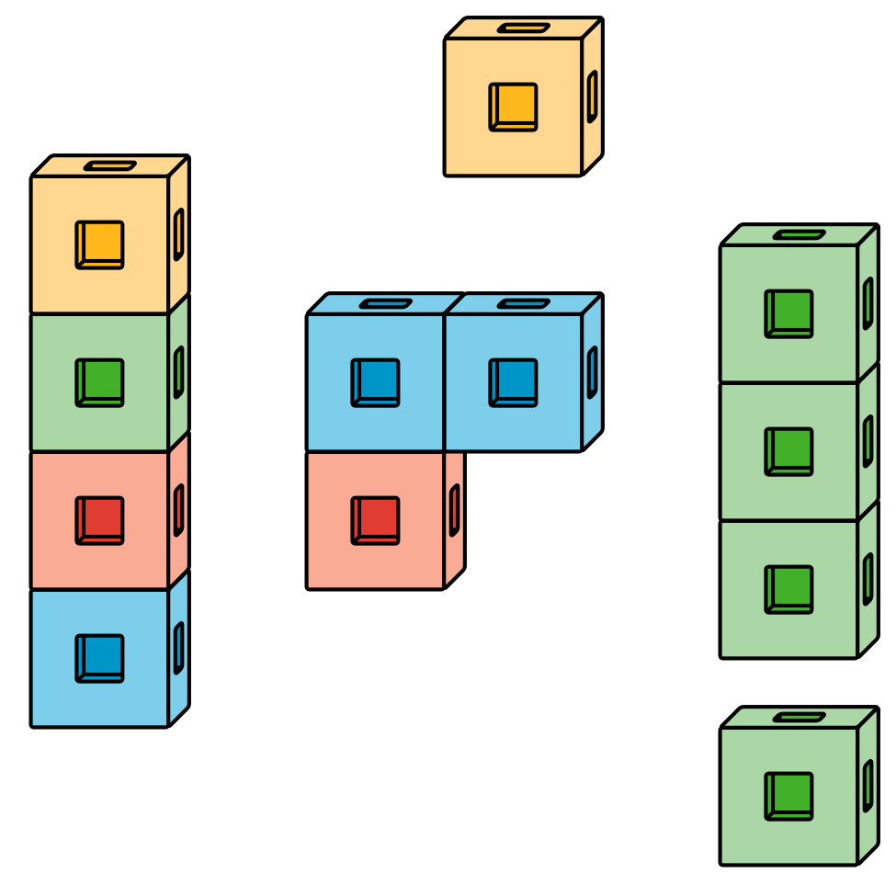
Pattern Blocks
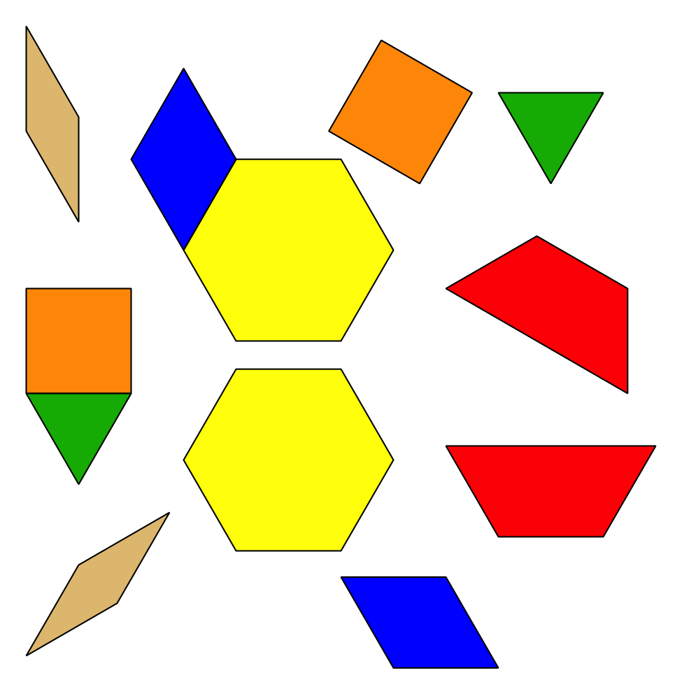
Picture Books

© CC BY 2021 Illustrative Mathematics®

