Unit 4 Lesson 11: Examining Domains and Ranges

1 Notice and Wonder: A Wiggly Graph (Warm up)

Student Task Statement
What do you notice? What do you wonder?
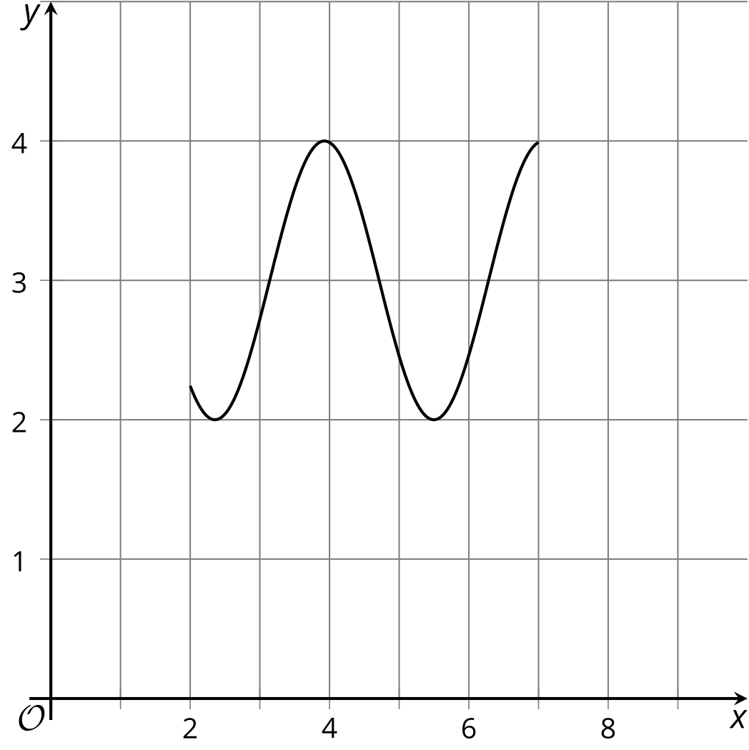

2 Moving Weeds and a Ball

Student Task Statement
- Examine these graphs and describe a situation that could match the situation.
  - 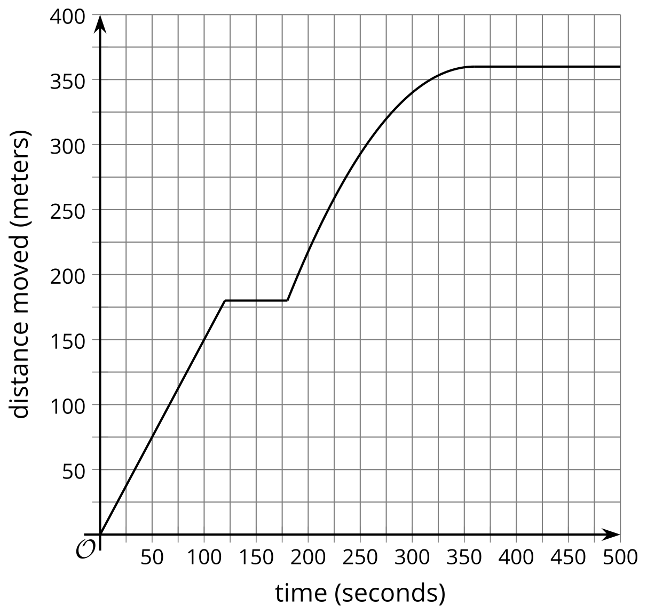
  - 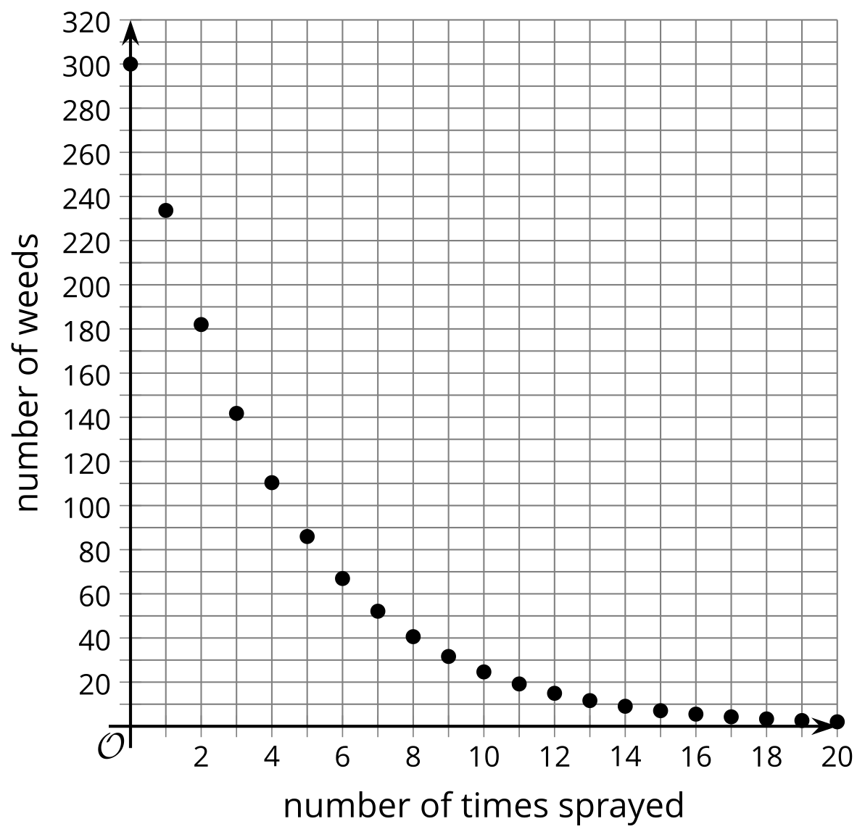
  - 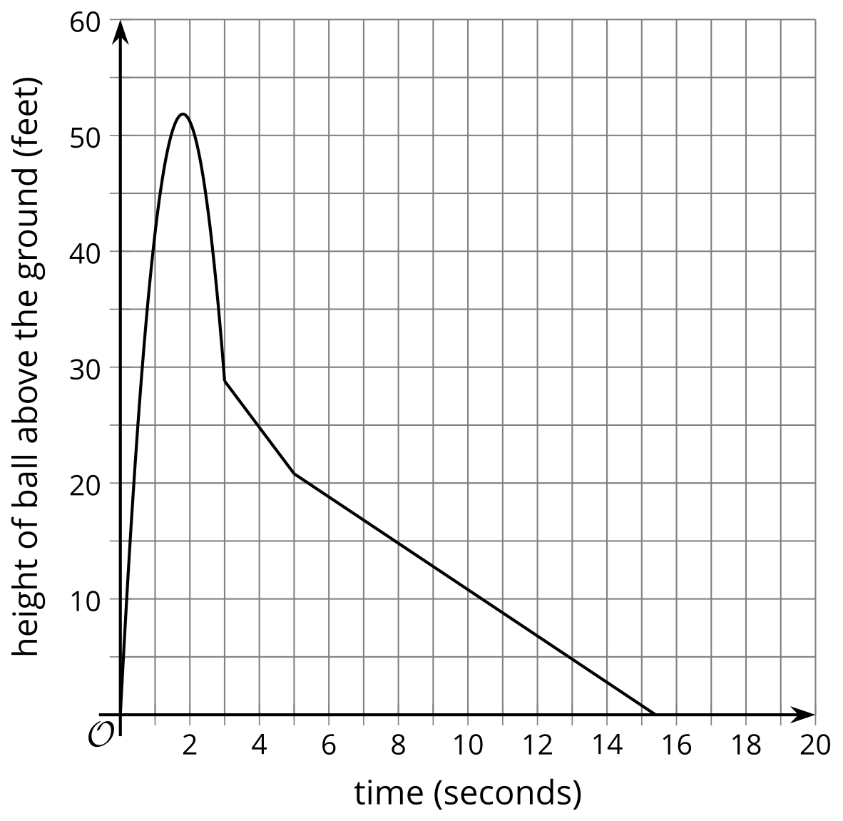
- For each situation, give an example of a value that could be:
  - In the domain
  - Not in the domain
  - In the range
  - Not in the range

3 Make It Realistic

Student Task Statement
- What is wrong with these graphs?
  - The graph relates the length of a side for a square and the area of the square.
  - 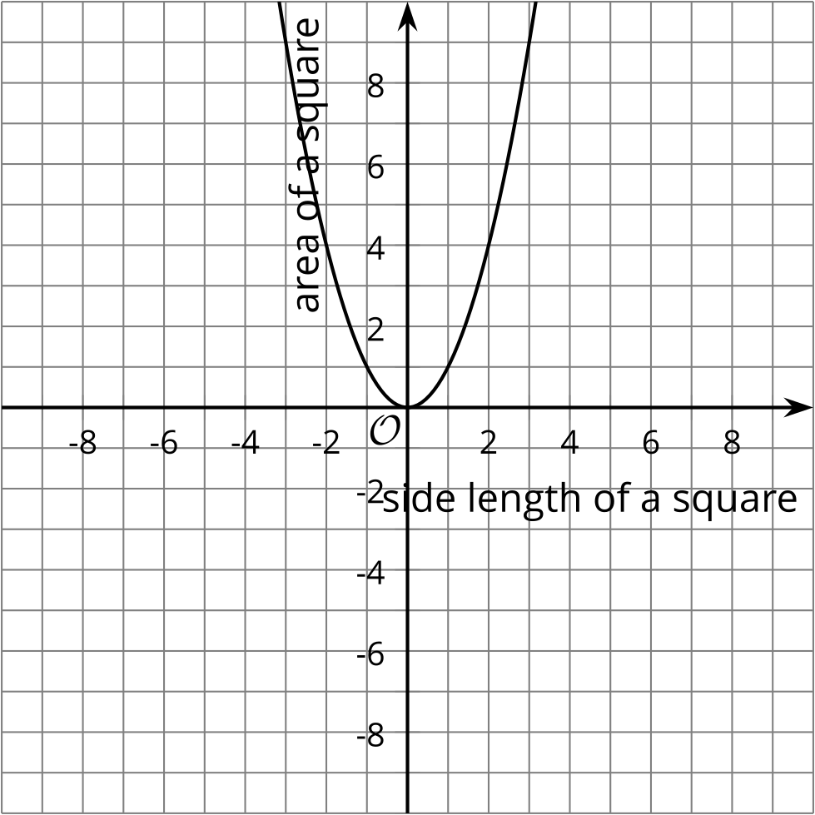
  - The graph relates the number of students going on a field trip and the cost of the trip.
  - 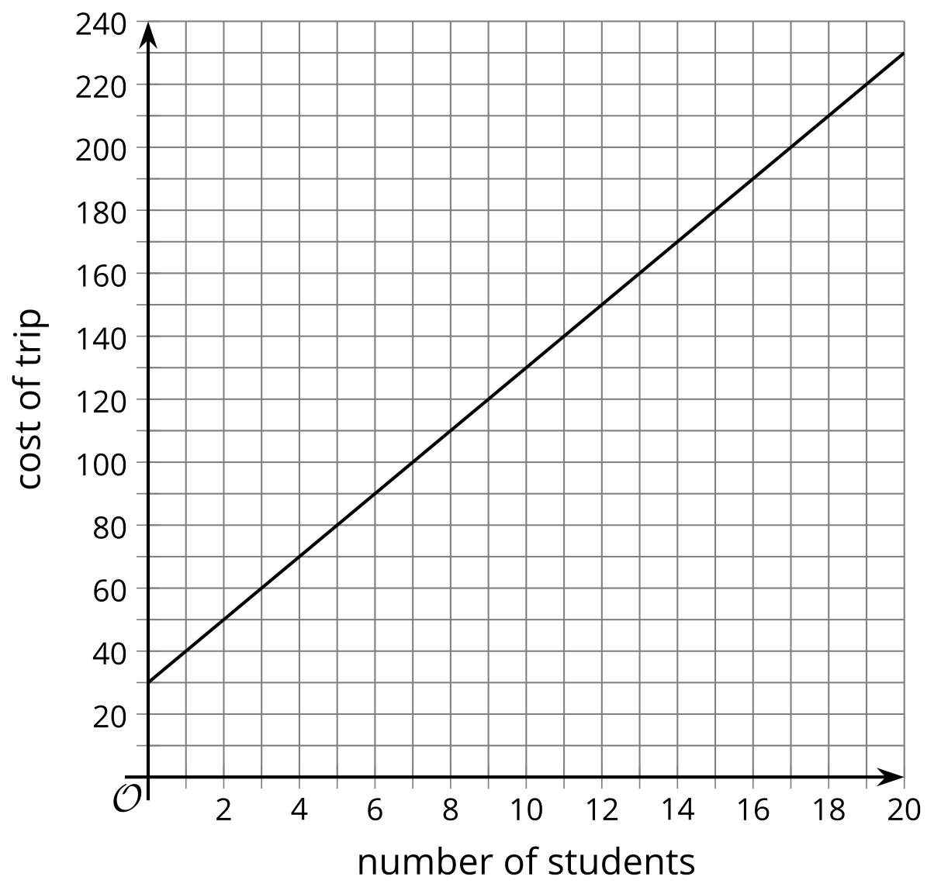
  - The graph represents Han’s height since he was 4 years old until now when he is 14.
  - 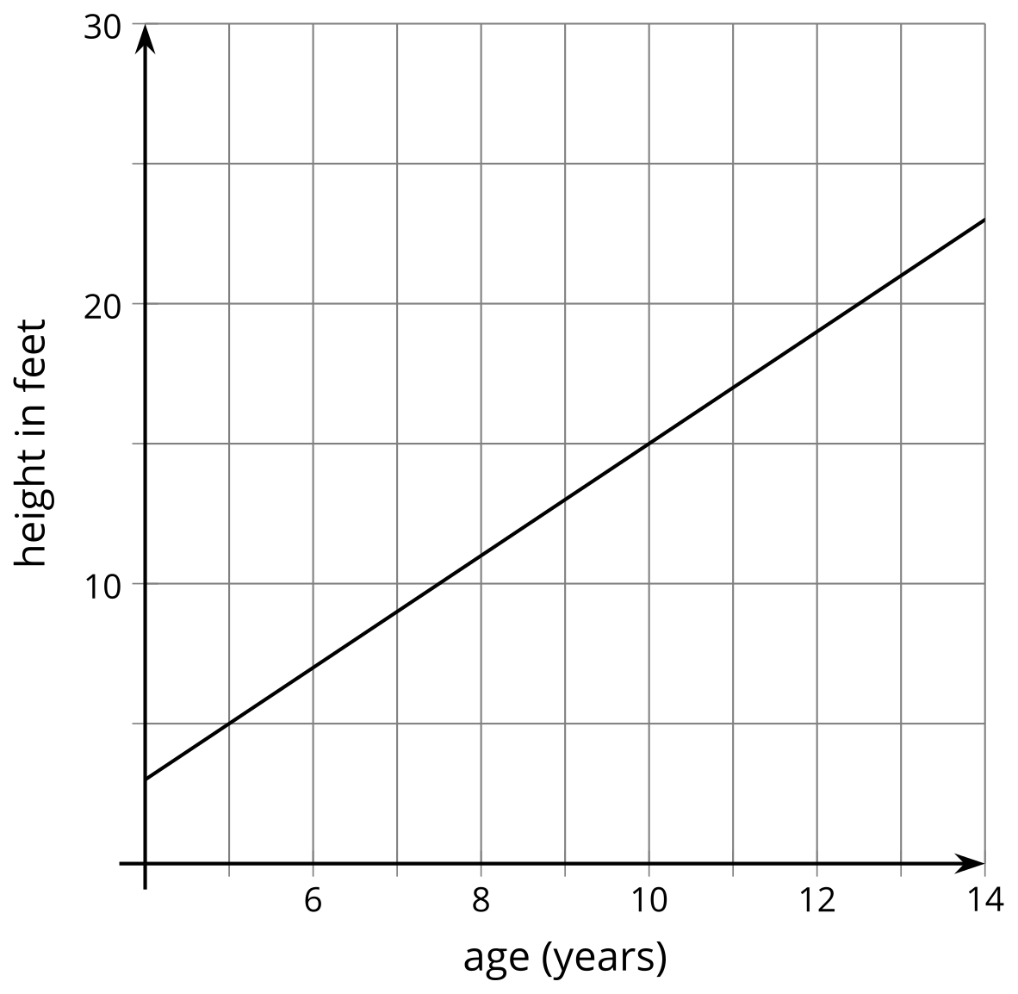
- On each graph, draw a more realistic graph.
© CC BY 2019 by Illustrative Mathematics®

