Grade 6
Unit 5Lesson 10CC BY NC Illustrative Mathematics, based on IM 6–8 Math, CC BY Open Up Resources.
Unit 5, Lesson 10

Using Partial Quotients
Let’s divide whole numbers.
Grade 6
Unit 5Lesson 10CC BY NC Illustrative Mathematics, based on IM 6–8 Math, CC BY Open Up Resources.

10.1Notice and Wonder: Kiran’s Calculations
Here are Kiran’s calculations for finding $657÷3$:
600 ÷ 3=20030 ÷ 3=21027 ÷ 3=219 657 ÷ 3¯ =219 ¯
What do you notice? What do you wonder?
Grade 6
Unit 5Lesson 10CC BY NC Illustrative Mathematics, based on IM 6–8 Math, CC BY Open Up Resources.

10.2Using Partial Quotients to Calculate Quotients
- Andre calculated $657÷3$ using a method that was different from Kiran's.
- 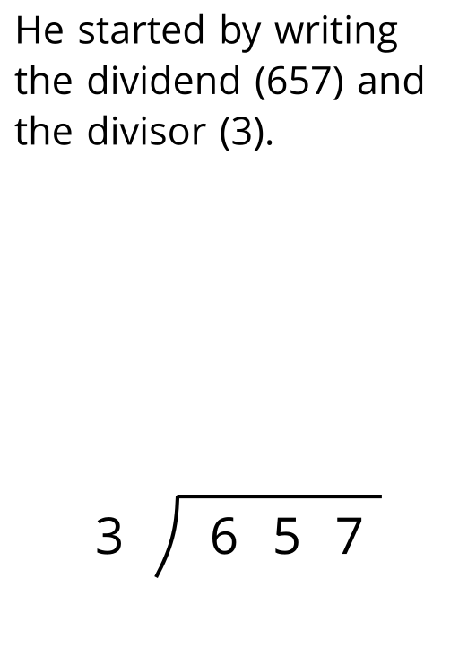
- 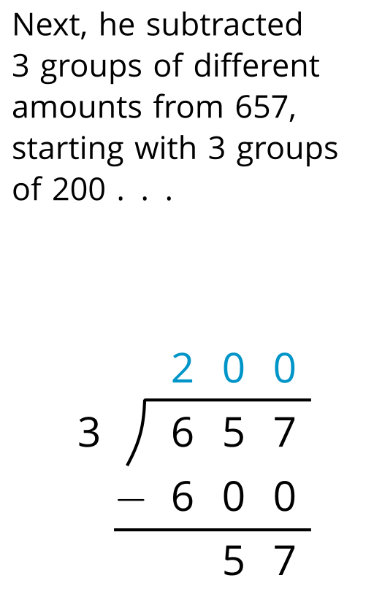
- 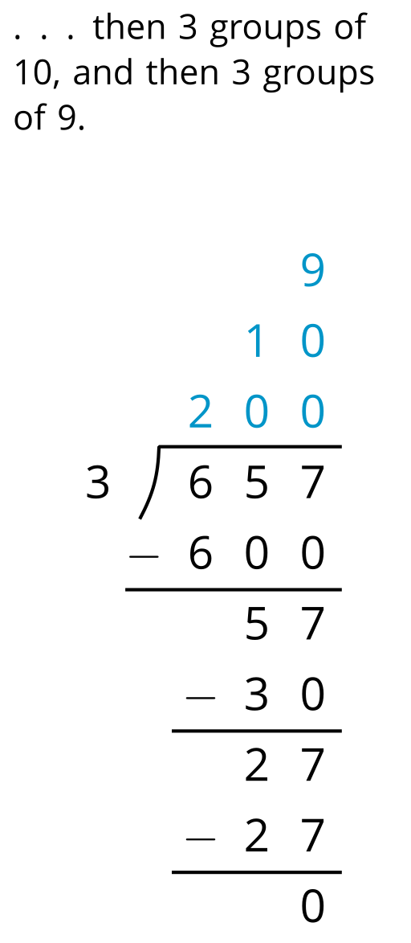
- 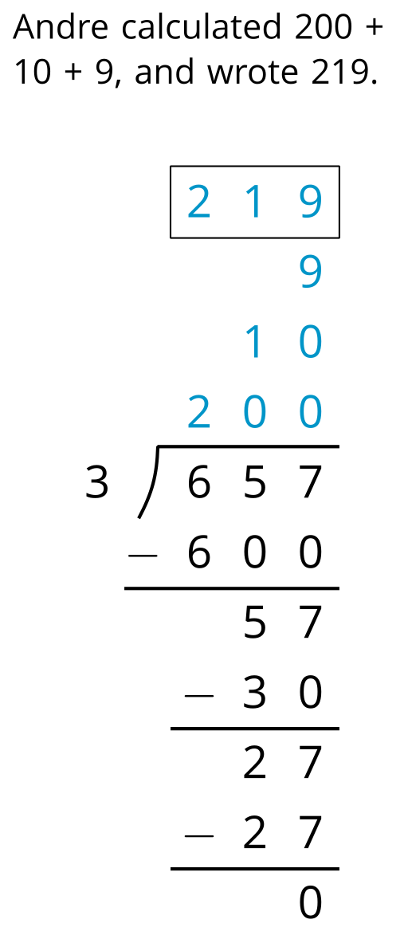
  - Andre subtracted 600 from 657. What does the 600 represent?
  - Andre wrote 10 above the 200, and then subtracted 30 from 57. How is the 30 related to the 10?
  - What do the numbers 200, 10, and 9 represent?
  - What is the meaning of the 0 at the bottom of Andre’s work?
- How might Andre calculate $896÷4$? Explain or show your reasoning.
Grade 6
Unit 5Lesson 10CC BY NC Illustrative Mathematics, based on IM 6–8 Math, CC BY Open Up Resources.

10.3What’s the Quotient?
Find the value of each quotient. Show your reasoning. Use vertical calculations at least once.
- $1,​332÷9$
- $1,​115÷5$
- $432÷16$

Lesson 10 Summary
Another way to find the quotient of $345÷3$ is by using partial quotients, in which we keep subtracting 3 groups of some amount from 345. We can organize the steps and record the partial quotients in a vertical calculation.
Here are two calculations for finding $345÷3$:
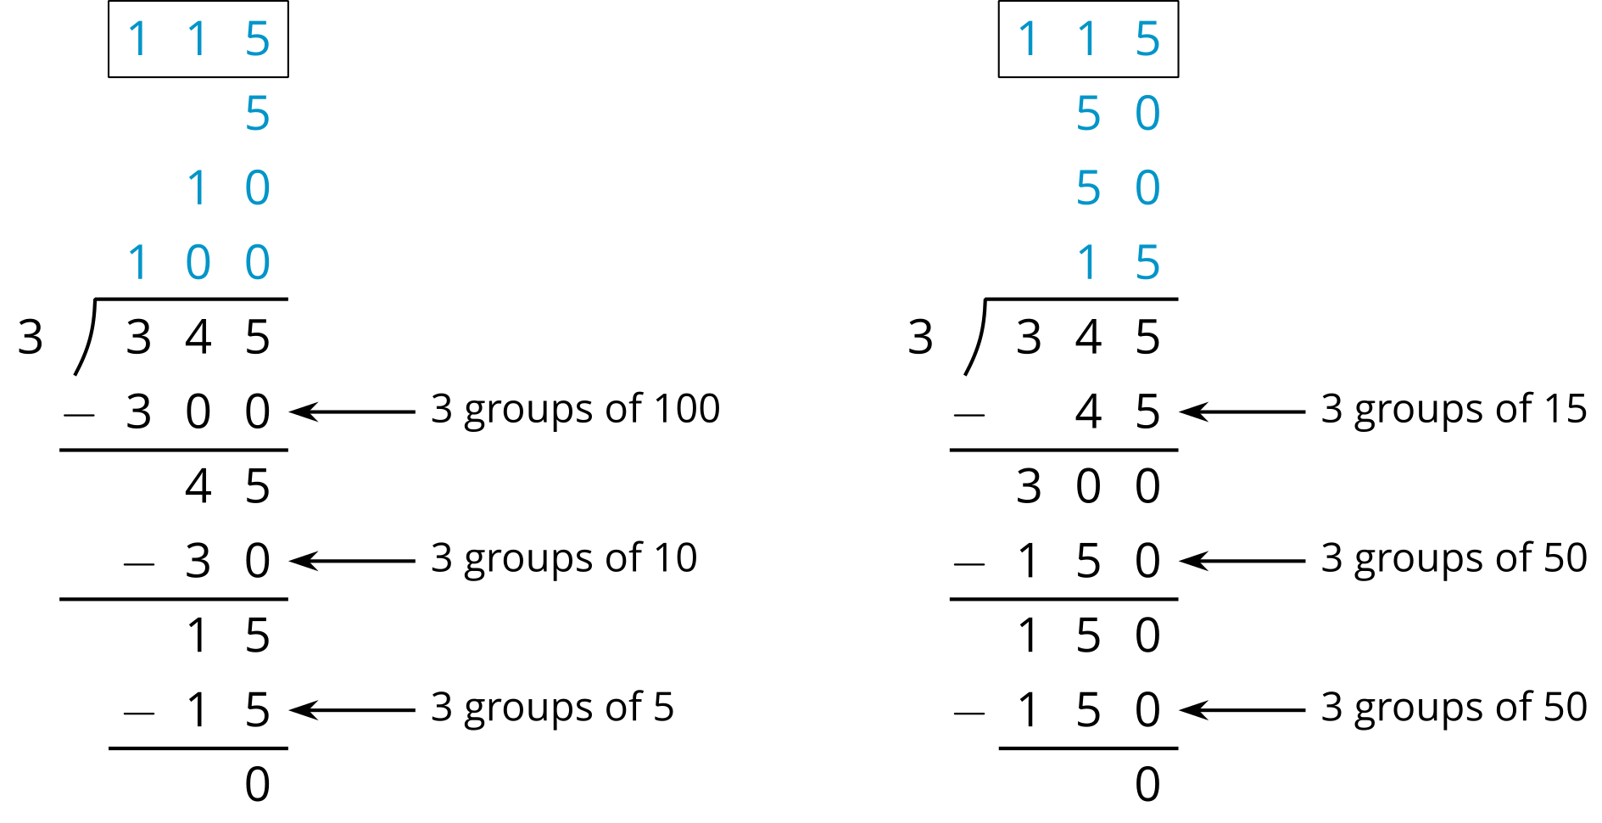
- In the calculation on the left, first we subtract 3 groups of 100, then 3 groups of 10, and then 3 groups of 5. Adding up the partial quotients ($100+10+5$) gives us 115.
- The calculation on the right shows a different amount per group subtracted each time (3 groups of 15, 3 groups of 50, and 3 more groups of 50), but the total amount in each of the 3 groups is still 115.
There are other ways of calculating $345÷3$ using partial quotients. We can calculate with fewer steps by removing groups of larger sizes.

