Grade 2
Unit 4CC BY NC 2024 Illustrative Mathematics®

Unit 4 Family Support Materials

Addition and Subtraction on the Number Line
In this unit, students learn about the structure of a number line and use it to represent numbers within 100. They also relate addition and subtraction to length and represent the operations on the number line.

Section A: The Structure of the Number Line
In this section, students make connections between rulers and the number line. Students notice how they are the same and how they are different, and come to understand the number line as a visual representation of numbers. They learn that number lines display numbers in sequence, from left to right, with equal spacing between the numbers. As students begin to use the number line as a tool for understanding numbers and number relationships, they learn that numbers can be represented with a point on the number line. They identify, locate, and represent numbers on a number line. Students also use the number line to compare numbers, based on their location relative to zero and each other. They understand that greater numbers are to the right along the number line and lesser numbers are to the left.
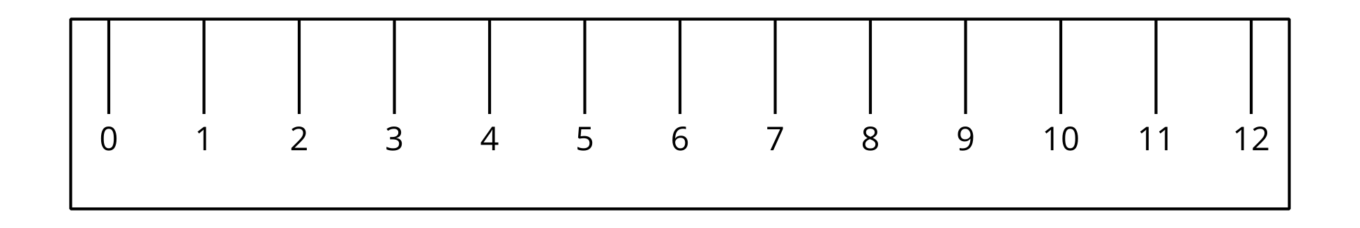

Section B: Add and Subtract on a Number Line
In this section, students learn to represent sums and differences on the number line. They begin by representing addition and subtraction, with directional arrows. An arrow pointing right represents addition, and an arrow pointing left represents subtraction. For example, the number lines show how students can represent $8+4=12$ (top) and $12−4=8$ (bottom) on the number line.
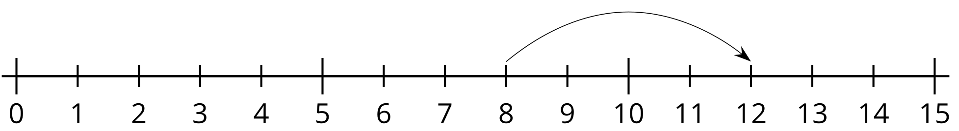
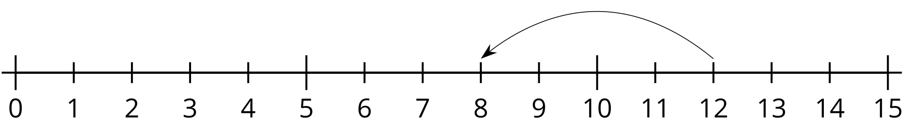
Students use this understanding to write equations, based on number-line representations, as well as to create the number-line representation of a given equation. Students also use the number line to represent computation strategies, based on place value, and the properties of addition (for example, adding tens and then ones versus adding ones and then tens) as they explain their strategies and compare them with those of their classmates.

Try it at home!
Near the end of the unit, ask your second grader to solve these problems on separate number lines:
- $29+48$
- $55−37$
Questions that may be helpful as they work:
- How are the problems similar?
- How are they different?
- How did you show addition? Subtraction?
- Where is your answer on the number line?
- Can you solve it in a different way?
Sample response:
- For both problems, I started at a number and showed a jump on the number line, using an arrow.
- They are different because one problem is addition and the other problem is subtraction, which means that my jumps went in different directions.
- I showed addition by jumping to the right (or forward) on the number line. I showed subtraction by jumping to the left (or backward) on the number line.
- My answer is where the jump ends on the number line.
- I can jump back by 10s and 1s from 55 until I reach 37. The amount I jump back is my answer. I also can start at 37 and jump to the right until I reach 55. The total amount I jump to reach 55 will be my answer.

