Grade 2
Unit 1Lesson 2CC BY NC 2024 Illustrative Mathematics®
Unit 1, Lesson 2

Relate Addition and Subtraction within 10
- Let’s think about how addition and subtraction relate.
Grade 2
Unit 1Lesson 2CC BY NC 2024 Illustrative Mathematics®

Warm-upWhat Do You Know about 10?
What do you know about 10?
Grade 2
Unit 1Lesson 2CC BY NC 2024 Illustrative Mathematics®

Activity 2Sums of 10
- Write as many equations as you can to represent the cube towers.
- A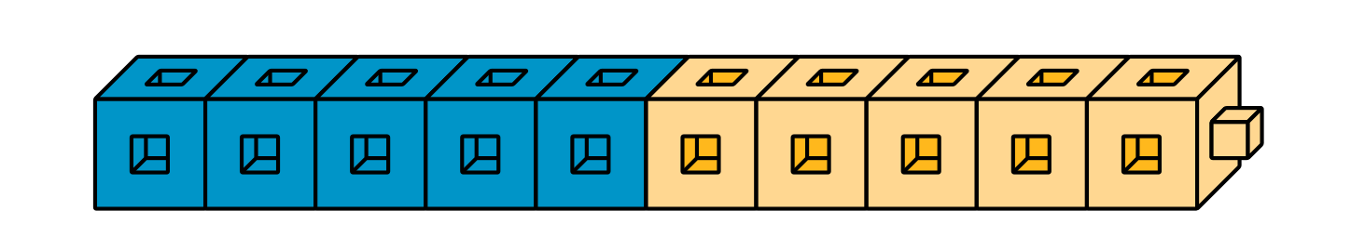
- B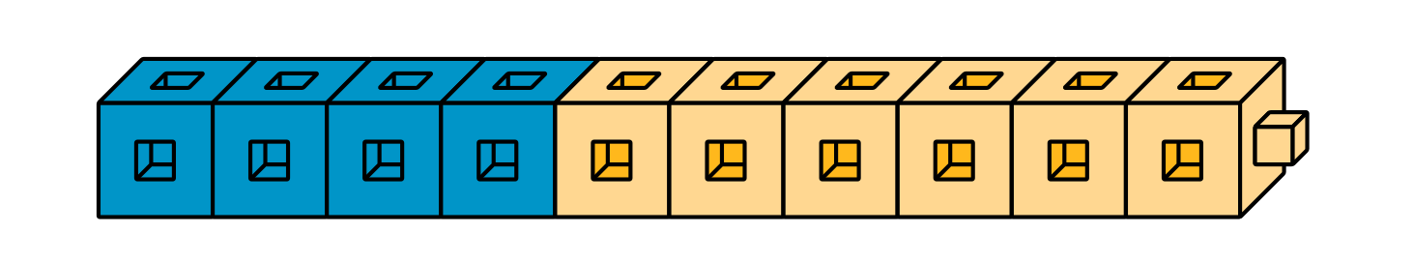
- C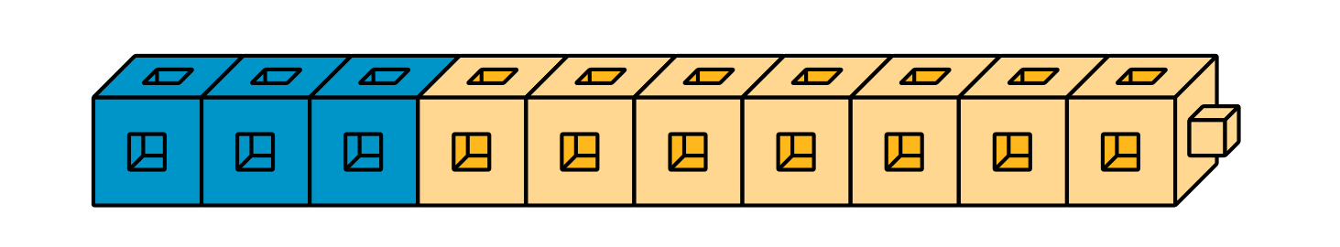
- D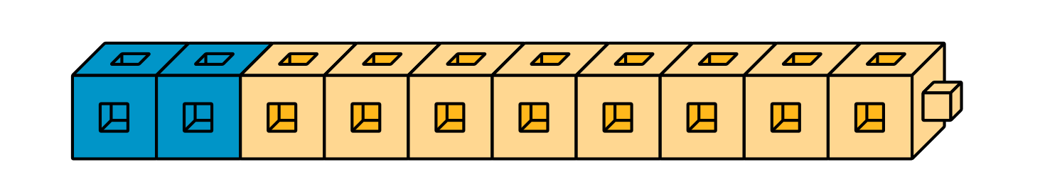
- E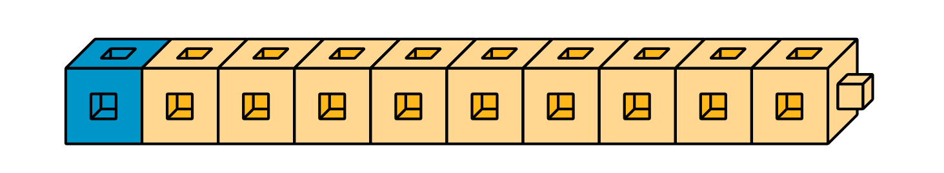
- Find the number that makes each equation true. Then write the letter of the cube tower that represents the equation.
- $3+\underset{_}{}=10$
- Letter: ___
- $10−7=\underset{_}{}$
- Letter: ___
- $10−5=\underset{_}{}$
- Letter: ___
- $2+\underset{_}{}=10$
- Letter: ___
- $10−1=\underset{_}{}$
- Letter: ___
- $10−2=\underset{_}{}$
- Letter: ___
- $\underset{_}{}+6=10$
- Letter: ___
- $\underset{_}{}+9=10$
- Letter: ___
- $5+\underset{_}{}=10$
- Letter: ___
- $10−\underset{_}{}=4$
- Letter: ___

