Lesson 9: Scaling the Inputs
- Let’s use scale factors in different ways.

9.1: Out and Back
Every weekend, Elena takes a walk along the straight road in front of her house for 2 miles, then turns around and comes back home. Let’s assume Elena walks at a constant speed.
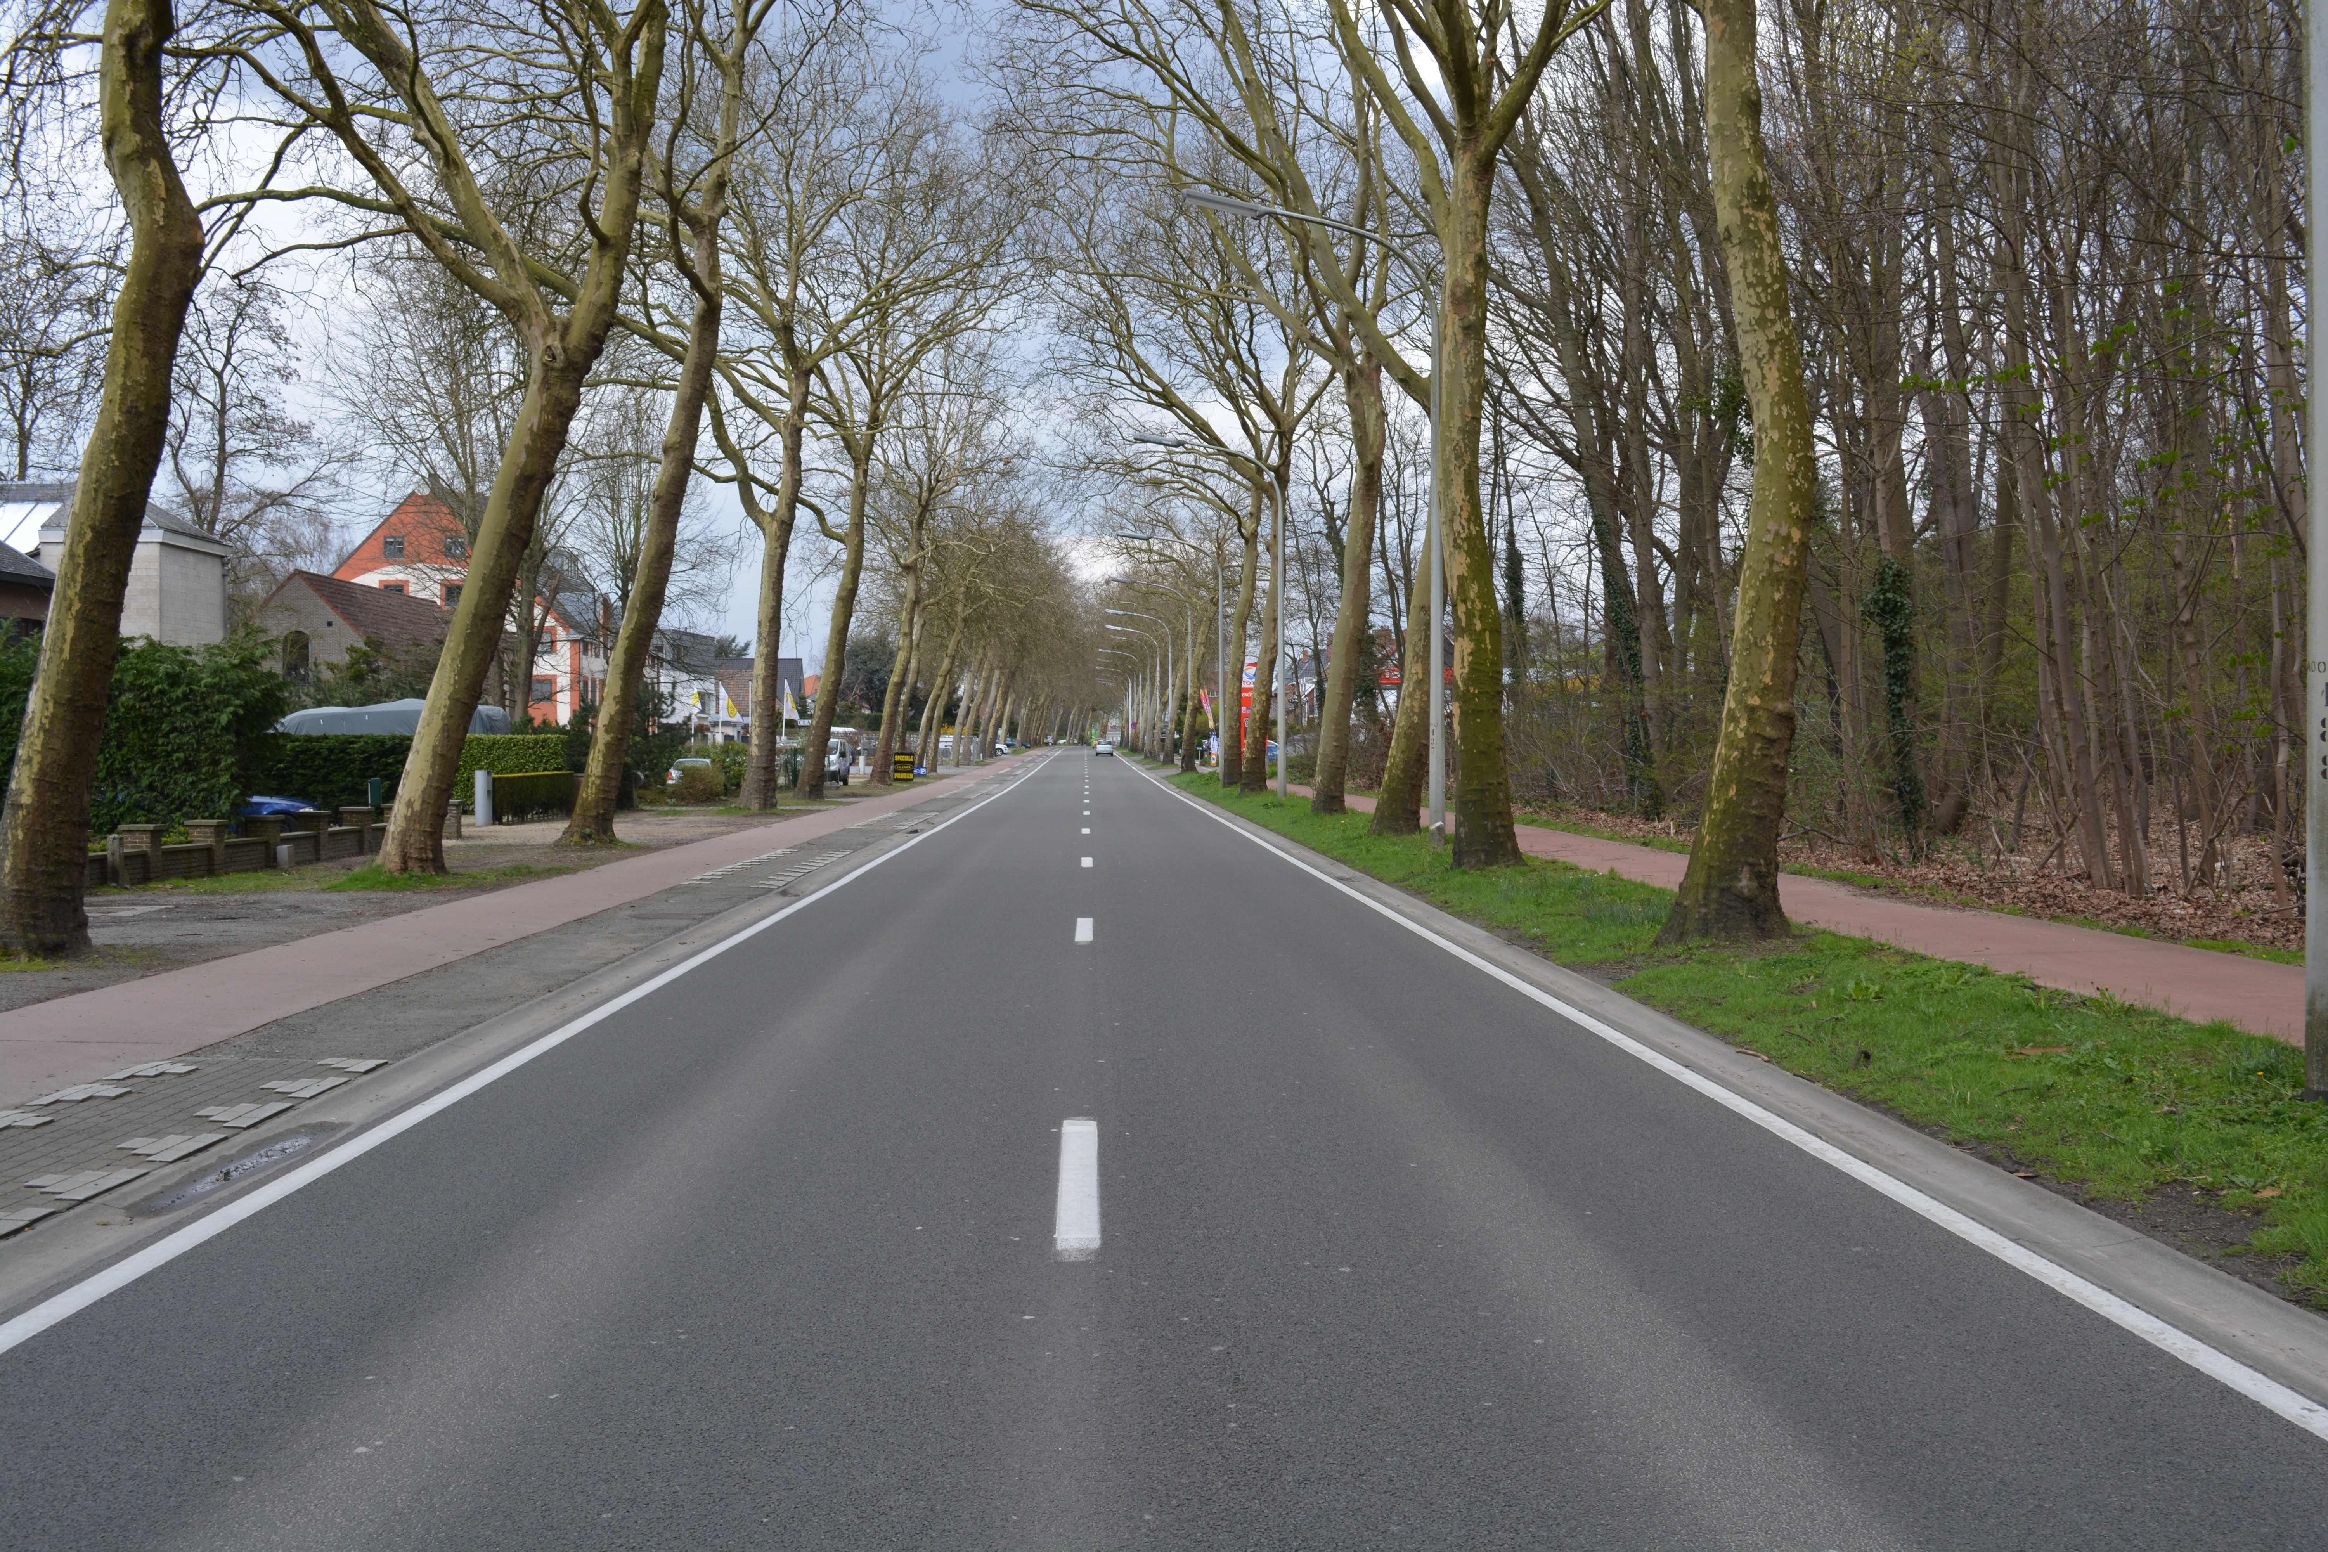
Here is a graph of the function $f$ that gives her distance $f\left(t\right)$, in miles, from home as a function of time $t$ if she walks 2 miles per hour.
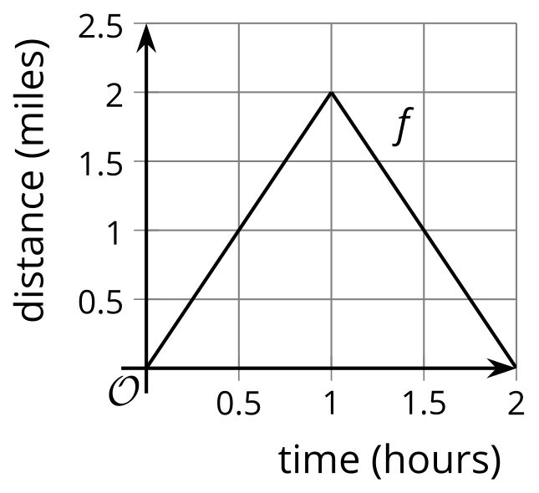
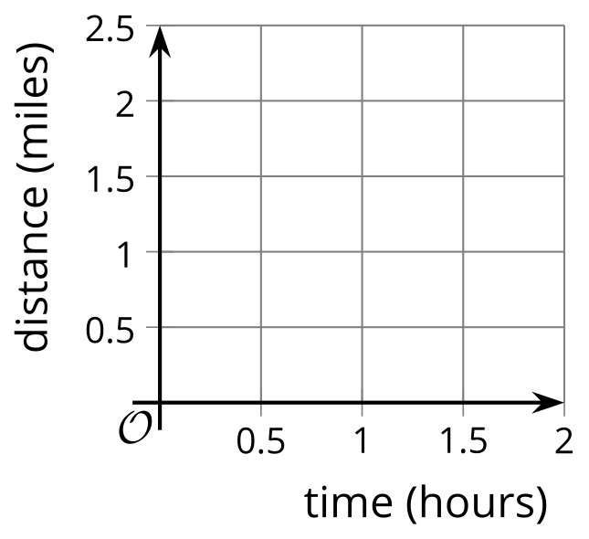
- Sketch a graph of the function $g$ that gives her distance $g\left(t\right)$, in miles, from home as a function of time $t$ if she walks 4 miles per hour.
- Write an equation for $g$ in terms of $f$. Be prepared to explain why your equation makes sense.

9.2: A New Set of Wheels
Remember Clare on the Ferris wheel? In the table, we have the function $F$ which gives her height $F\left(t\right)$ above the ground, in feet, $t$ seconds after starting her descent from the top. Today Clare tried out two new Ferris wheels.
- The first wheel is twice the height of $F$ and rotates at the same speed. The function $g$ gives Clare's height $g\left(t\right)$, in feet, $t$ seconds after starting her descent from the top.
- The second wheel is the same height as $F$ but rotates at half the speed. The function $h$ gives Clare's height $h\left(t\right)$, in feet, $t$ seconds after starting her descent from the top.
$t$ | $F\left(t\right)$ | $g\left(t\right)$ | $h\left(t\right)$
0 | 212
20 | 181
40 | 106
60 | 31
80 | 0
- Complete the table for the function $g$.
- Explain why there is not enough information to find the exact values for $h\left(20\right)$ and $h\left(60\right)$.
- Complete as much of the table as you can for the function $h$, modeling Claire's height on the second Ferris wheel.
- Express $g$ and $h$ in terms of $f$. Be prepared to explain your reasoning.

9.3: The Many Transformations of a Function $P$
Function $k$ is a transformation of function $P$ due to a scale factor.
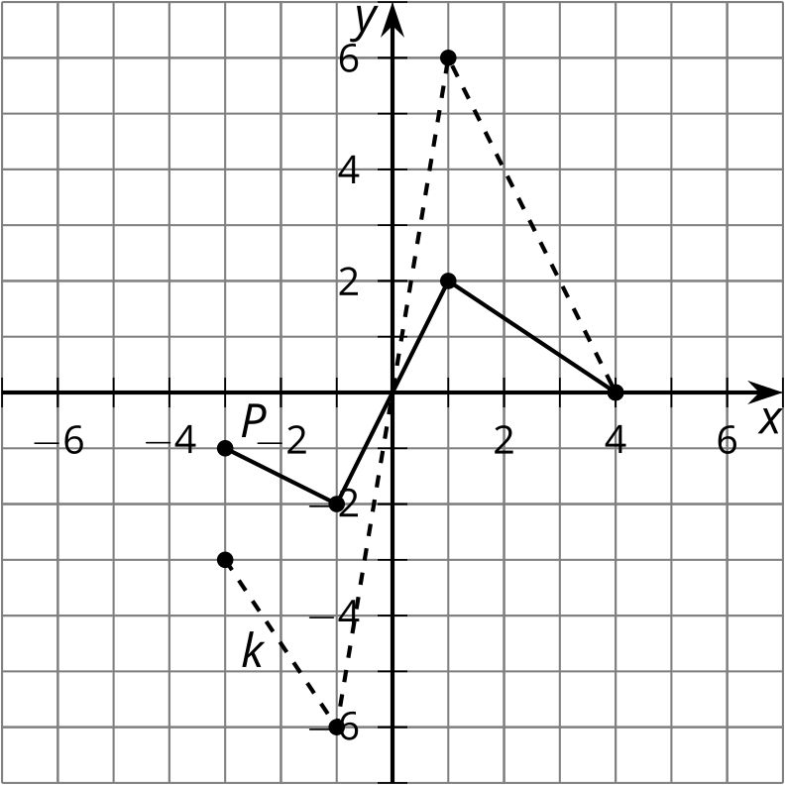
- Write an equation for $k$ in terms of $P$.
- On the same axes, graph the function $m$ where $m\left(x\right)=P\left(0.75x\right)$.
- The highest point on the graph of $P$ is $\left(1,2\right)$. What is the highest point on the graph of a function $n$ where $n\left(x\right)=P\left(5x\right)$? Explain or show your reasoning.
- The point furthest to the right on the graph of $P$ is $\left(4,0\right)$. If the point furthest to the right on the graph of a function $q$ is $\left(18,0\right)$, write a possible equation for $q$ in terms of $P$.

Are you ready for more?
What transformation takes $f\left(x\right)=2x\left(x−4\right)$ to $g\left(x\right)=8x\left(x−2\right)$?

Lesson 9 Summary
Here are two graphs showing the distance traveled by two trains $t$ hours into their journeys. What do you notice?
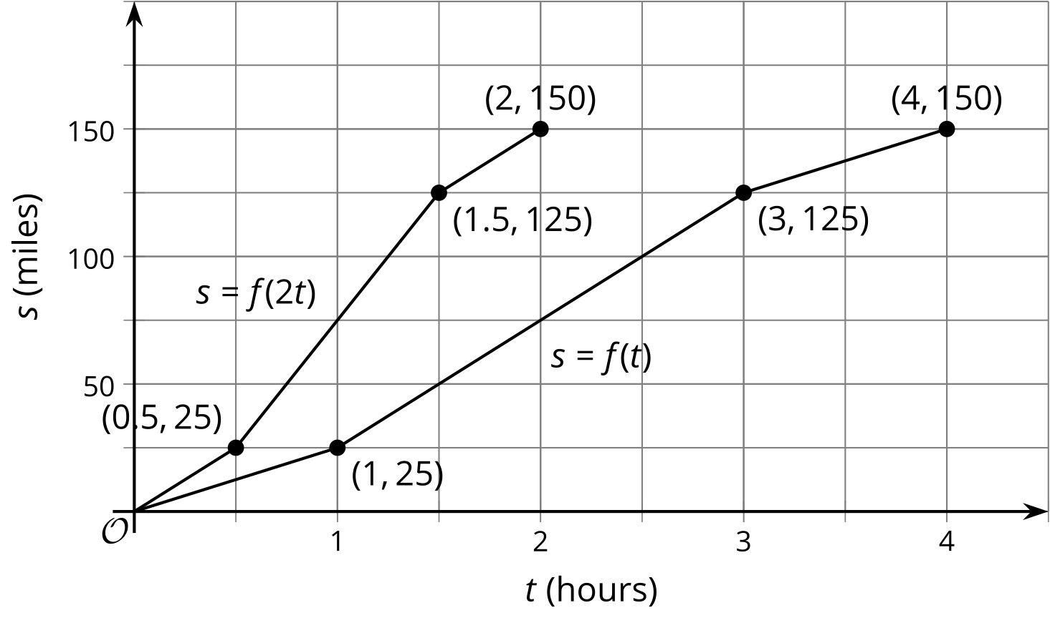
Where Train A traveled 25 miles in 1 hour, Train B traveled 25 miles in half the time. Similarly, Train A traveled 150 miles in 4 hours while Train B traveled 150 miles in only 2 hours. Train B is traveling twice the speed of Train A.
A train travelling twice the speed gets to any particular point along the track in half the time, so the graph for Train B is compressed horizontally by a factor of $\frac{1}{2}$ when compared to the graph of Train A. If the function $f\left(t\right)$ represents the distance Train A travels in $t$ hours, then $f\left(2t\right)$ represents the distance Train B travels in $t$ hours, because Train B goes as far in $t$ hours as Train A goes in $2t$ hours.
If a different Train C were going one fourth the speed of Train A, then its motion would be represented by $s=f\left(0.25t\right)$ and the graph would be stretched horizontally by a factor of 4 since it would take four times as long to travel the same distance.
© CC BY 2019 by Illustrative Mathematics®

