Lesson 14: Volume of Right Prisms
Let’s look at volumes of prisms.

14.1: Three Prisms with the Same Volume
Rectangles A, B, and C represent bases of three prisms.
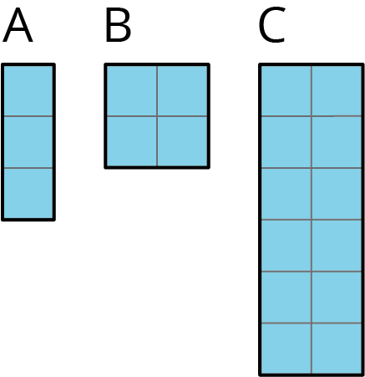
- If each prism has the same height, which one will have the greatest volume, and which will have the least? Explain your reasoning.
- If each prism has the same volume, which one will have the tallest height, and which will have the shortest? Explain your reasoning.

14.2: Finding Volume with Cubes
Your teacher will give you a paper with a shape on it and some snap cubes.
- Using the face of a snap cube as your area unit, what is the area of the shape? Explain or show your reasoning.
- Use snap cubes to build the shape from the paper. Add another layer of cubes on top of the shape you have built. Describe this three-dimensional object.
- What is the volume of your object? Explain your reasoning.
- Right now, your object has a height of 2. What would the volume be:
  - if it had a height of 5?
  - if it had a height of 8.5?

14.3: Can You Find the Volume?
Your teacher will give you a set of three-dimensional figures.
- For each figure, determine whether the shape is a prism.
- For each prism:
  - Find the area of the base of the prism.
  - Find the height of the prism.
  - Calculate the volume of the prism.
 | Is it a prism? | area of prism base (cm²) | height (cm) | volume (cm³)
figure A
figure B
figure C
figure D
figure E
figure F

Are you ready for more?
Imagine a large, solid cube made out of 64 white snap cubes. Someone spray paints all 6 faces of the large cube blue. After the paint dries, they disassemble the large cube into a pile of 64 snap cubes.
- How many of those 64 snap cubes have exactly 2 faces that are blue?
- What are the other possible numbers of blue faces the cubes can have? How many of each are there?
- Try this problem again with some larger-sized cubes that use more than 64 snap cubes to build. What patterns do you notice?

14.4: What’s the Prism’s Height?
There are 4 different prisms that all have the same volume. Here is what the base of each prism looks like.
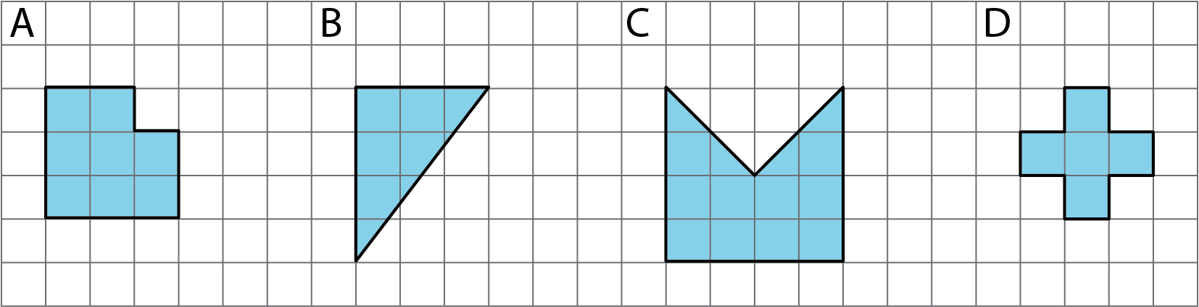
- Order the prisms from shortest to tallest. Explain your reasoning.
- If the volume of each prism is 60 units³, what would be the height of each prism?
- For a volume other than 60 units³, what could be the height of each prism?
- Discuss your thinking with your partner. If you disagree, work to reach an agreement.

Lesson 14 Summary
Any cross section of a prism that is parallel to the base will be identical to the base. This means we can slice prisms up to help find their volume. For example, if we have a rectangular prism that is 3 units tall and has a base that is 4 units by 5 units, we can think of this as 3 layers, where each layer has $4⋅5$ cubic units.
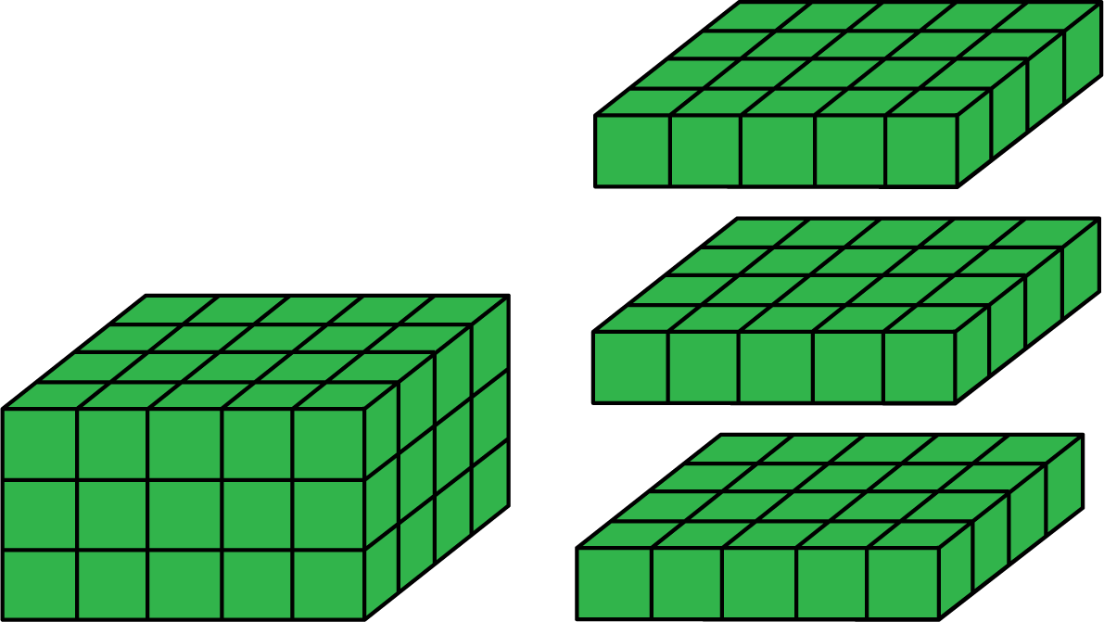
That means the volume of the original rectangular prism is $3\left(4⋅5\right)$ cubic units.
This works with any prism! If we have a prism with height 3 cm that has a base of area 20 cm², then the volume is $3⋅20$ cm³ regardless of the shape of the base. In general, the volume of a prism with height $h$ and area $B$ is
$V=B⋅h$
For example, these two prisms both have a volume of 100 cm³.
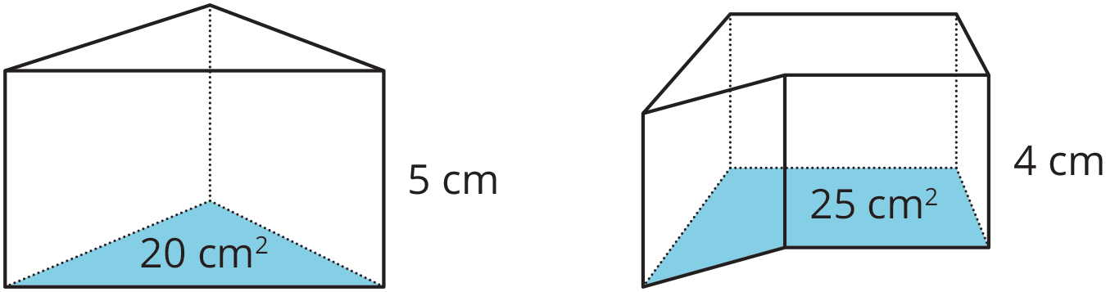
© CC BY Open Up Resources. Adaptations CC BY IM.

