Grade 2
Unit 3Lesson 5CC BY NC 2024 Illustrative Mathematics®
Unit 3, Lesson 5

Measure in Meters
- Let’s measure lengths in meters.
Grade 2
Unit 3Lesson 5CC BY NC 2024 Illustrative Mathematics®

Activity 1Reptiles to Measure
The tape pieces on the floor represent the lengths of each reptile.
- Measure each reptile. Write the unit.
  - What is the length of the Gila monster?
  - A: Gila monster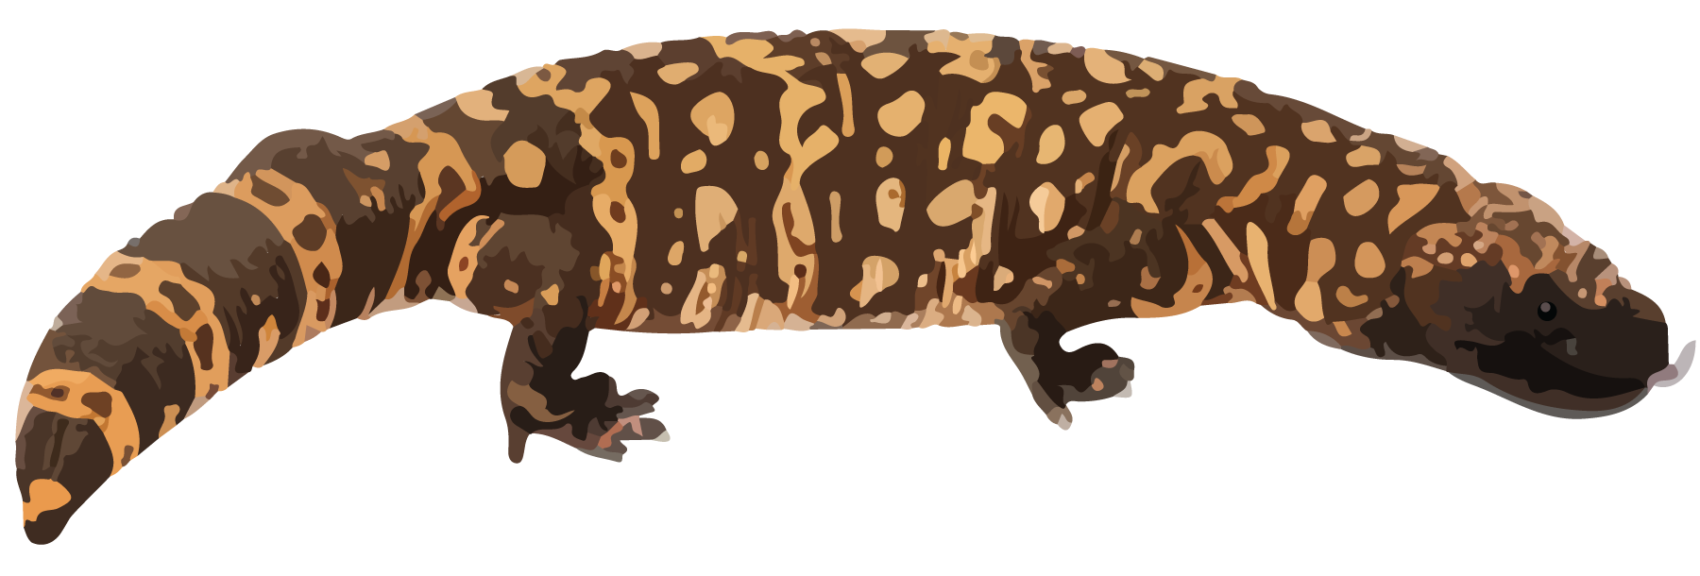
  - ​​​
  - What is the length of the baby alligator?
  - B: baby alligator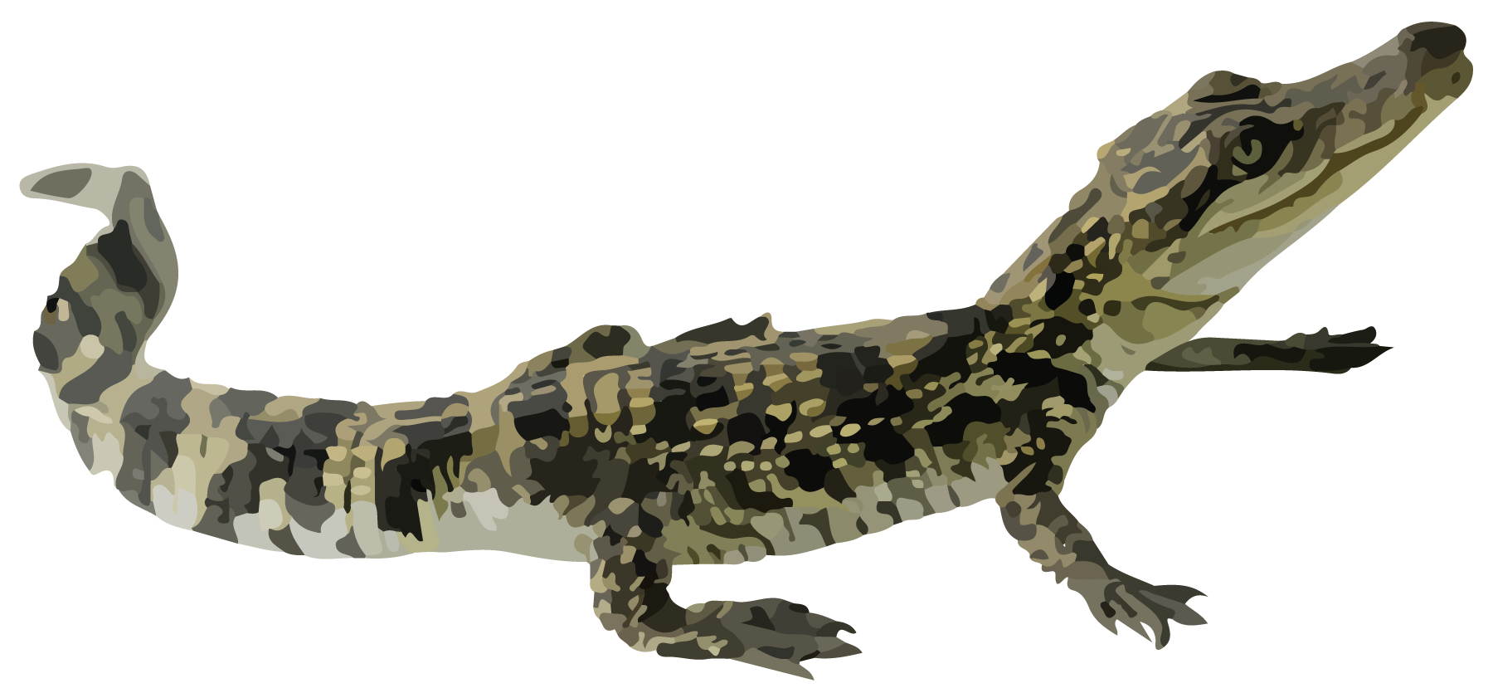
  - What is the length of the baby cobra?
  - C: baby cobra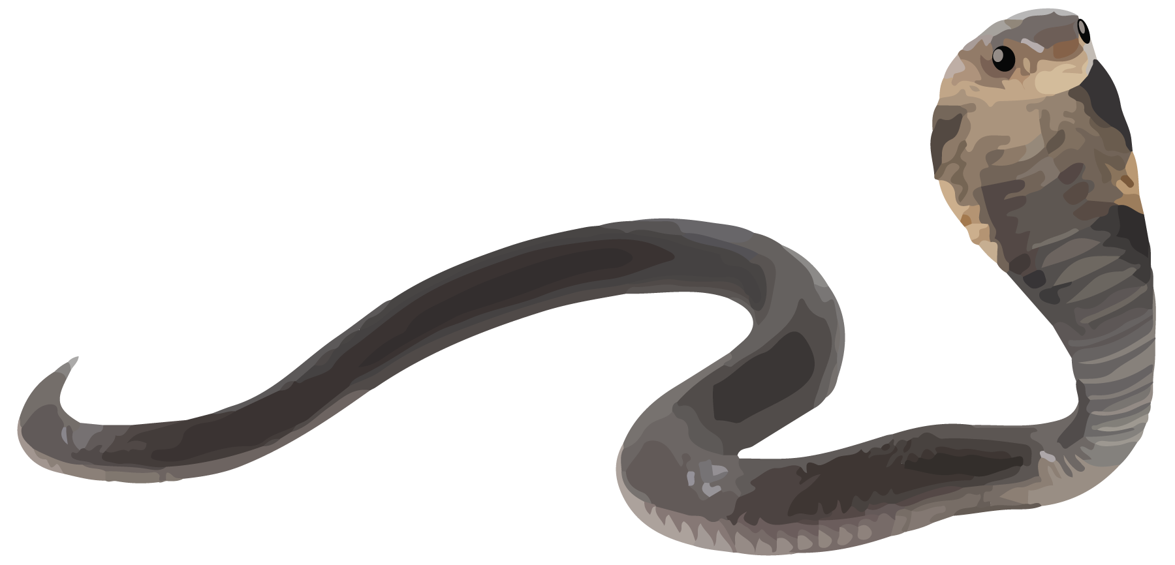
  - What is the length of the Komodo dragon?
  - D: Komodo dragon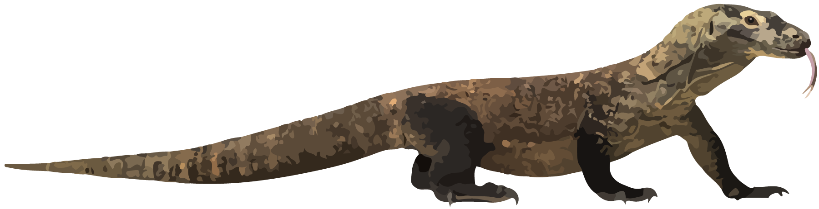
Grade 2
Unit 3Lesson 5CC BY NC 2024 Illustrative Mathematics®

Activity 2Measure with a Meter Stick
- Measure the length of the Komodo dragon in meters.
- D: Komodo dragon
- Compare your Komodo dragon measurements in the first activity to the measurements in the second activity. How are they alike? How are they different?
- Measure each reptile in centimeters or meters. Write the units.
  - How long is the adult alligator?
  - E: adult alligator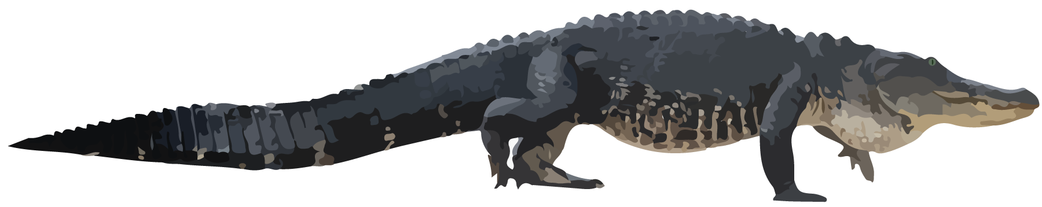
  - How long is the adult cobra?
  - F: adult cobra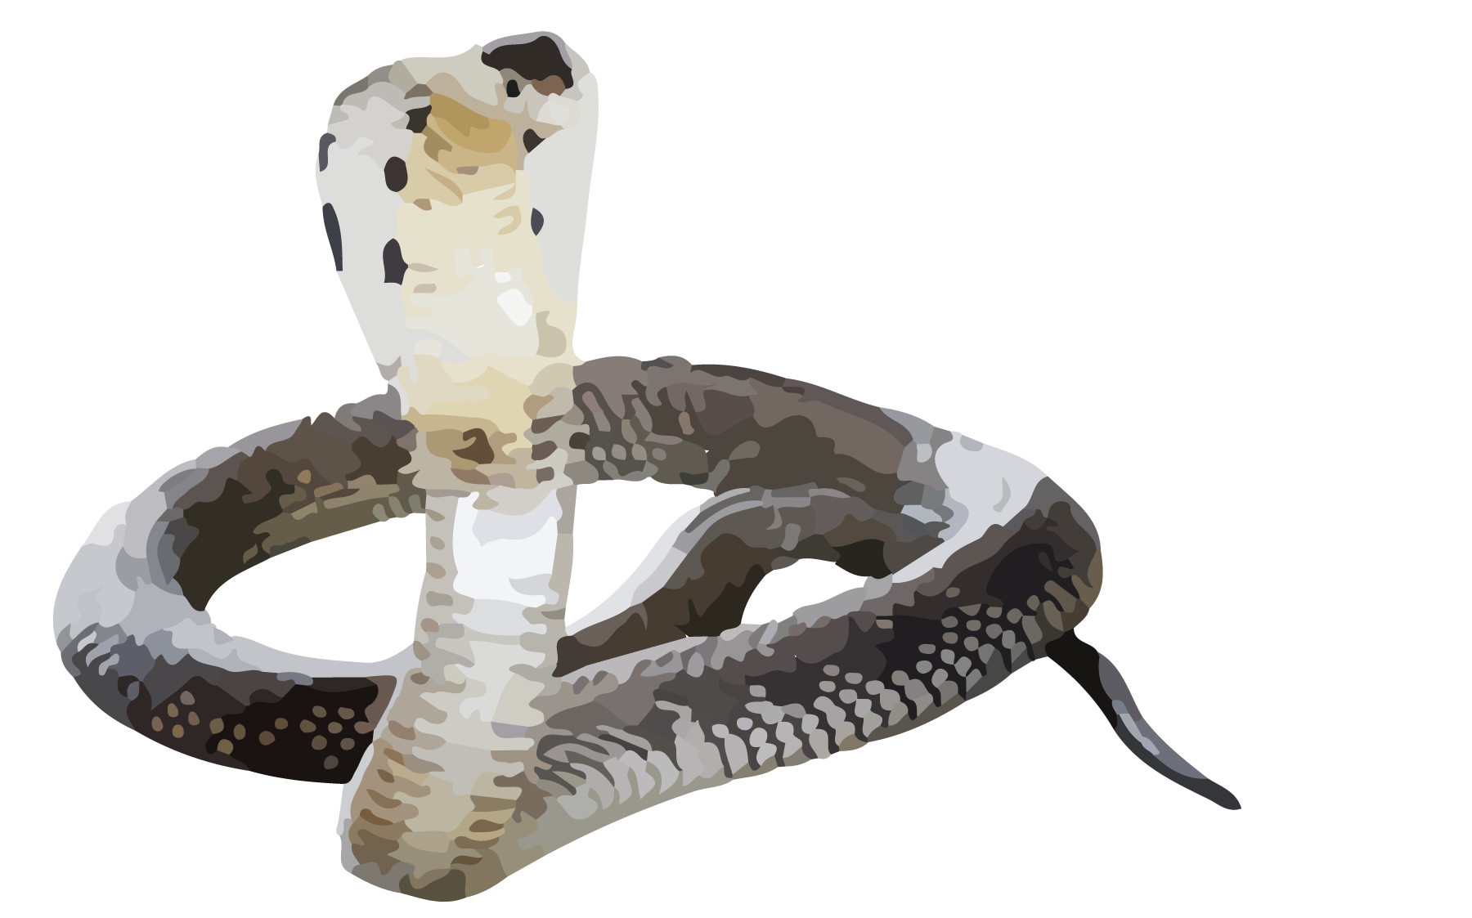
  - How long is the ribbon snake?
  - G: ribbon snake