Algebra 1
Unit 7Lesson 6CC BY NC 2024 Illustrative Mathematics®
Unit 7, Lesson 6

Building Quadratic Functions to Describe Situations (Part 2)
- Let’s look at the objects being launched in the air.
Algebra 1
Unit 7Lesson 6CC BY NC 2024 Illustrative Mathematics®

6.1Sky Bound (Part 1)
A person with a t-shirt launcher is standing in the center of the field at a soccer stadium. He is holding the launcher so that the mouth of the launcher, where the t-shirts exit the launcher, is 5 feet above the ground. The launcher sends a t-shirt straight up with a velocity of 90 feet per second.
Imagine that there is no gravity and that the t-shirt continues to travel upward with the same velocity.
- Complete the table with the heights of the t-shirt at different times.
- seconds | - 0 | - 1 | - 2 | - 3 | - 4 | - 5 | - $t$
- distance above ground (feet) | - 5
- Write an equation to model the distance in feet, $d$, of the t-shirt $t$ seconds after it was launched if there was no gravity.
Algebra 1
Unit 7Lesson 6CC BY NC 2024 Illustrative Mathematics®

6.2Sky Bound (Part 2)
Earlier, you completed a table that represents the height of a t-shirt, in feet, as a function of time, in seconds, if there were no gravity.
- This table shows the actual heights of the t-shirt at different times.
- seconds | - 0 | - 1 | - 2 | - 3 | - 4 | - 5
- distance above ground (feet) | - 5 | - 79 | - 121 | - 131 | - 109 | - 55
- Compare the values in this table with those in the table that you completed earlier. Make at least 2 observations.

  - Plot the two sets of data that you have on the same coordinate plane.
  - 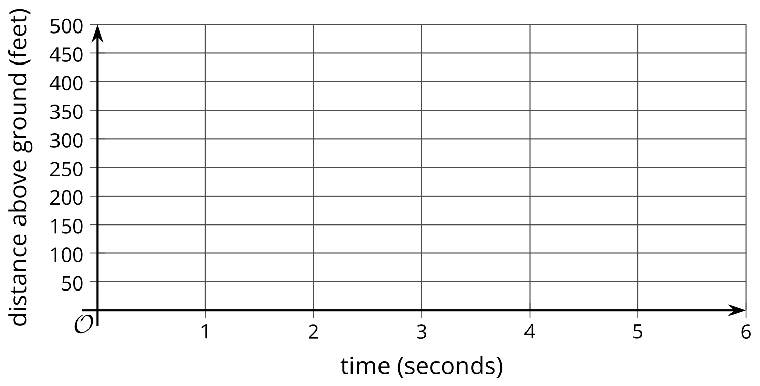
  - How are the two graphs alike? How are they different?
- Write an equation to model the actual distance, $d$, in feet, of the t-shirt $t$ seconds after it was launched. If you get stuck, consider the differences in distances and the effects of gravity from an earlier lesson.
Algebra 1
Unit 7Lesson 6CC BY NC 2024 Illustrative Mathematics®

6.3Graphing a Cannonball
The function defined by $d=50+312t−16t^{2}$ gives the height in feet of a cannonball $t$ seconds after the ball leaves the cannon.
- What do the terms 50, $312t$, and $\text{-}16t^{2}$ tell us about the cannonball?
- Use graphing technology to graph the function. Adjust the graphing window to show: $0<t<25$ and $0<y<2,​000$.
- Observe the graph and:
  - Describe the shape of the graph. What does it tell us about the movement of the cannonball?
  - Estimate the maximum height that the ball reaches. When does this happen?
  - Estimate when the ball hits the ground.
- What domain is appropriate for this function, based on the situation? Explain your reasoning.

Are you ready for more?
The same cannonball is fired upward at 800 feet per second. Does it reach a mile (5,280 feet) in height? Explain your reasoning.

Lesson 6 Summary
In this lesson, we looked at the height of objects that are launched upward and then come back down because of gravity.
An object is thrown upward from a height of 5 feet with a velocity of 60 feet per second. Its height, $h\left(t\right)$, in feet, after $t$ seconds is modeled by the function $h\left(t\right)=5+60t−16t^{2}$.
- The linear expression $5+60t$ represents the height that the object would have at time $t$ if there were no gravity. The object would keep going up at the same speed at which it was thrown. The graph would be a line with a slope of 60, which relates to the constant speed of 60 feet per second.
- The expression $\text{-}16t^{2}$ represents the effect of gravity, which eventually causes the object to slow down, stop, and start falling back again.
Notice the graph intersects the vertical axis at 5, which means that the object was thrown into the air from 5 feet off the ground. The graph indicates that the object reaches its peak height of about 60 feet after a little less than 2 seconds. That peak is the point on the graph where the function reaches a maximum value. At that point, the curve changes direction, and the output of the function changes from increasing to decreasing. We call that point the vertex of the graph.
Here is the graph of $h$.
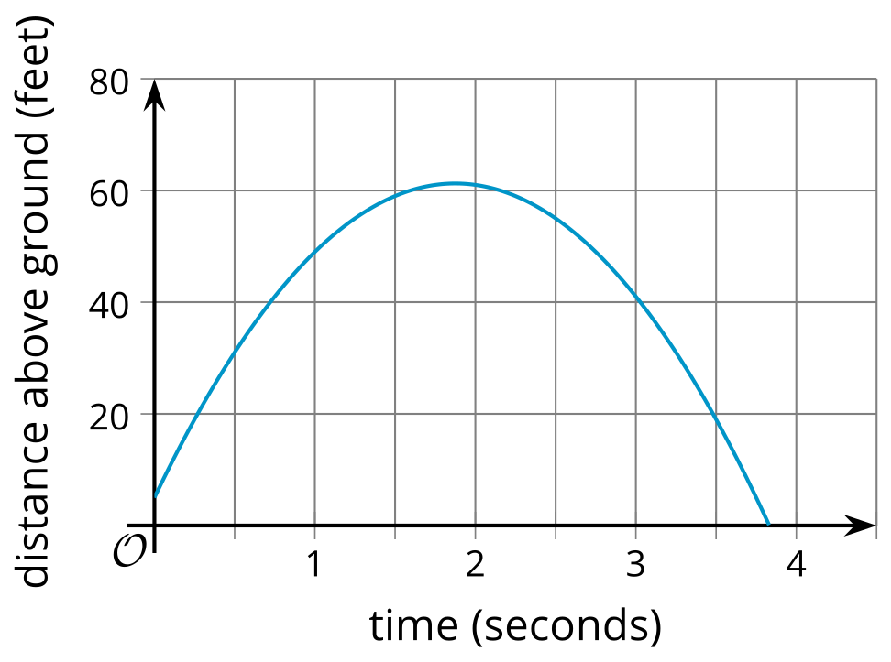
The graph representing any quadratic function is a special kind of “U” shape called a parabola. You will learn more about the geometry of parabolas in a future course. Every parabola has a vertex, because there is a point at which it changes direction—from increasing to decreasing, or the other way around.
The object hits the ground a little before 4 seconds. That time corresponds to the horizontal intercept of the graph. An input value that produces an output of 0 is called a zero of the function. A zero of function $h$ is approximately 3.8, because $h\left(3.8\right)≈0$.
In this situation, input values less than 0 seconds or more than about 3.8 seconds would not be meaningful, so an appropriate domain for this function would include all values of $t$ between 0 and about 3.8.

