Lesson 1: Representing Data Graphically
Let’s represent data with dot plots and bar graphs.

1.1: Curious about Caps
Clare collects bottle caps and keeps them in plastic containers.
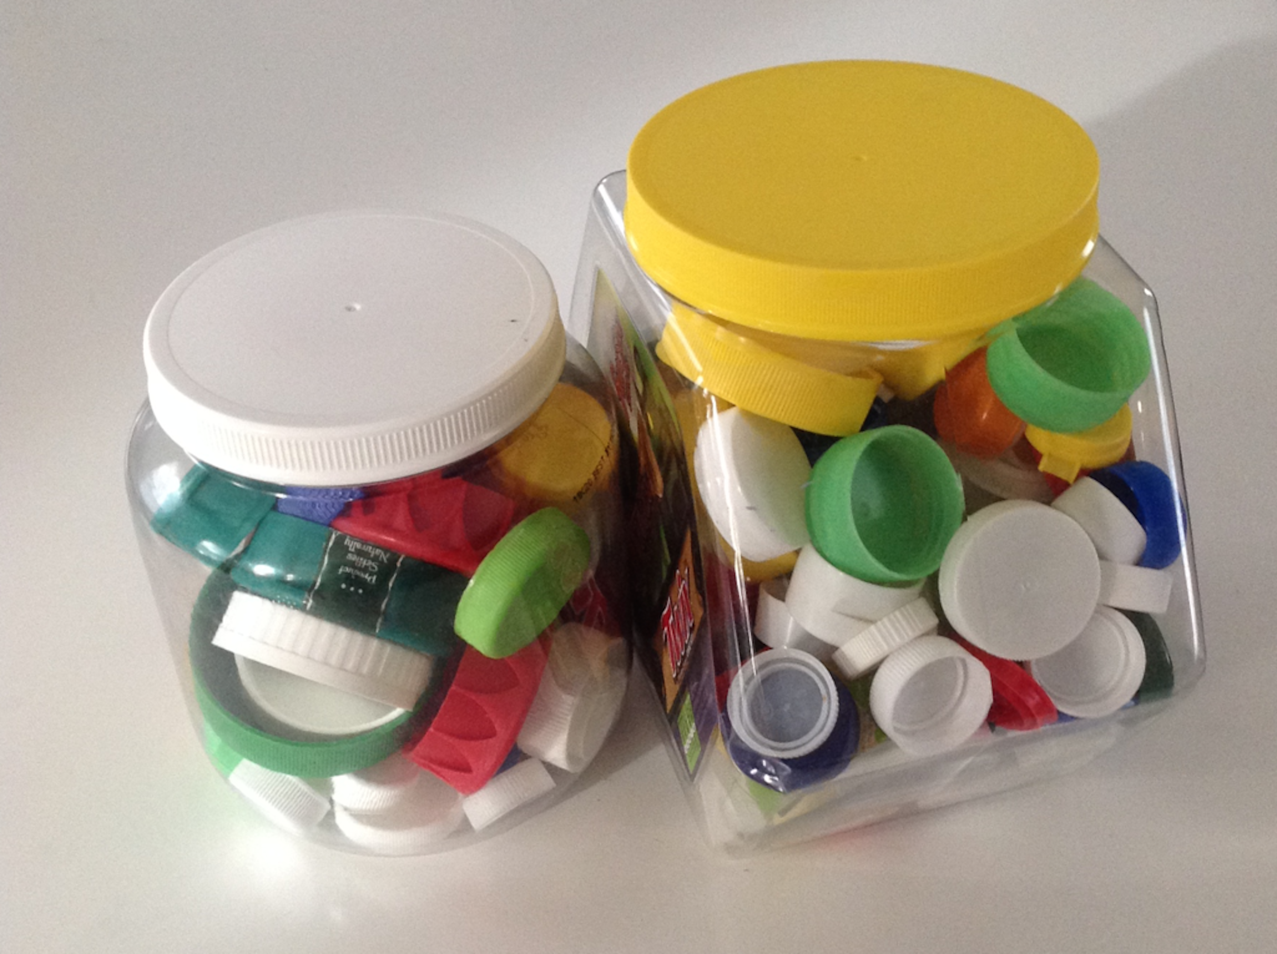
Write one statistical question that someone could ask Clare about her collection. Be prepared to explain your reasoning.

1.2: Estimating Caps
- Write down the statistical question your class is trying to answer.
- Look at the dot plot that shows the data from your class. Write down one thing you notice and one thing you wonder about the dot plot.
- Use the dot plot to answer the statistical question. Be prepared to explain your reasoning.

1.3: Been There, Done That!
Priya wants to know if basketball players on a men’s team and a women’s team have had prior experience in international competitions. She gathered data on the number of times the players were on a team before 2016.
men's team
3
0
0
0
0
1
0
0
0
0
0
0
women's team
2
3
3
1
0
2
0
1
1
0
3
1
- Did Priya collect categorical or numerical data?
- Organize the information on the two basketball teams into these tables.
- Men’s Basketball Team Players
- number of prior  competitions | - frequency  (number)
- 0
- 1
- 2
- 3
- 4
- Women’s Basketball Team Players
- number of prior  competitions | - frequency  (number)
- 0
- 1
- 2
- 3
- 4
- Make a dot plot for each table.
- Men’s Basketball Team Players
- 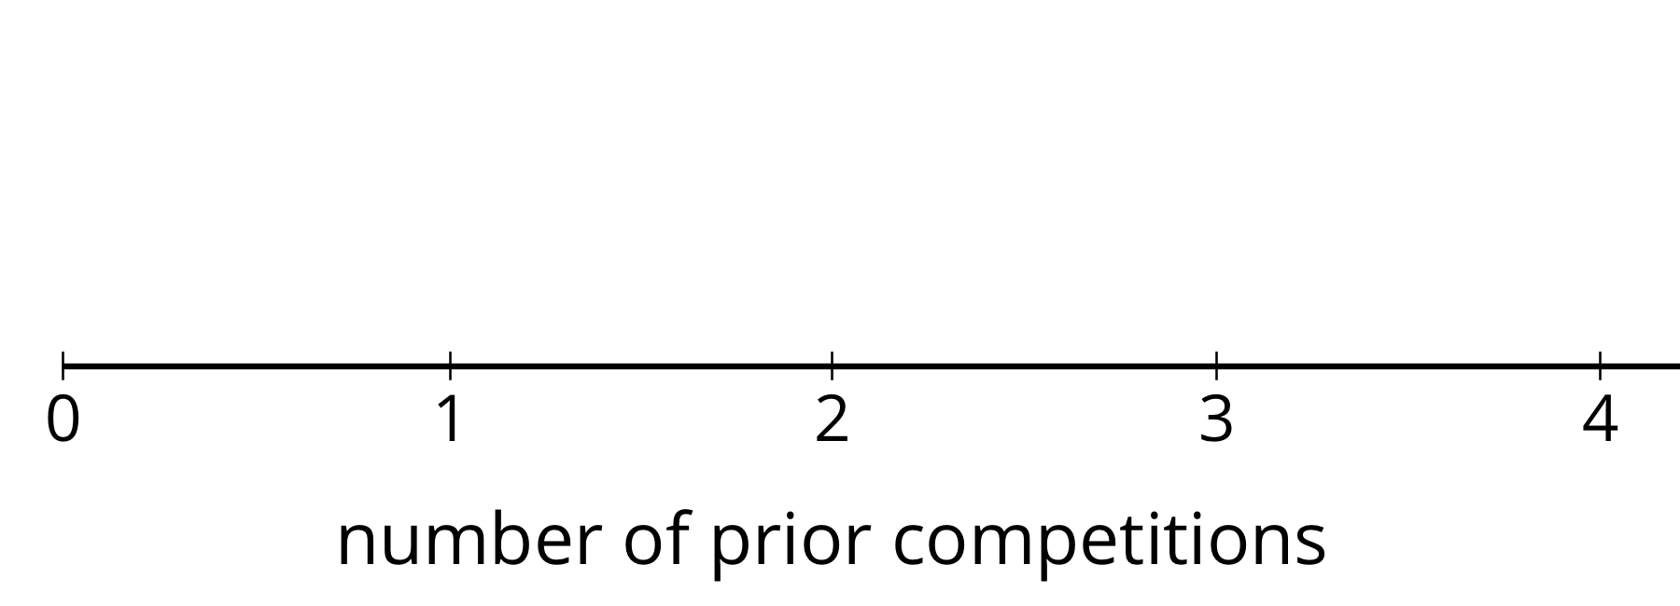
- Women’s Basketball Team Players
- Study your dot plots. What do they tell you about the competition participation of:
  - the players on the men’s basketball team?
  - the players on the women’s basketball team?
- Explain why a dot plot is an appropriate representation for Priya’s data.

Are you ready for more?
Combine the data for the players on the men’s and women’s teams and represent it as a single dot plot. What can you say about the repeat participation of the basketball players?

1.4: Favorite Summer Sports
Kiran wants to know which three summer sports are most popular in his class. He surveyed his classmates on their favorite summer sport. Here are their responses.
swimming
gymnastics
track and field
volleyball
swimming
swimming
diving
track and field
gymnastics
basketball
basketball
volleyball
track and field
track and field
volleyball
gymnastics
diving
gymnastics
volleyball
rowing
track and field
track and field
soccer
swimming
gymnastics
track and field
swimming
rowing
diving
soccer
- Did Kiran collect categorical or numerical data?
- Organize the responses in a table to help him find which summer sports are most popular in his class.
- sport | - frequency
- Represent the information in the table as a bar graph.

- 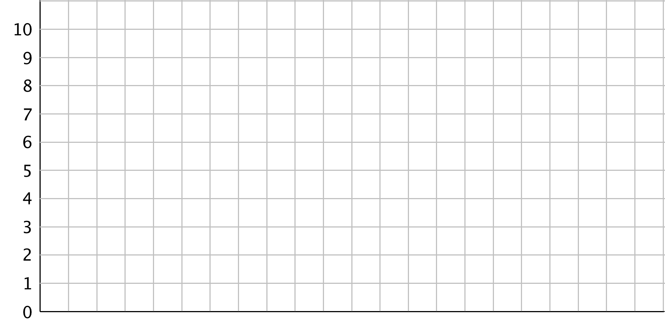

  - How can you use the bar graph to find how many classmates Kiran surveyed?
  - Which three summer sports are most popular in Kiran’s class?
  - Use your bar graph to describe at least one observation about Kiran’s classmates’ preferred summer sports.
- Could a dot plot be used to represent Kiran’s data? Explain your reasoning.

Lesson 1 Summary
When we analyze data, we are often interested in the distribution, which is information that shows all the data values and how often they occur.
In a previous lesson, we saw data about 10 dogs. We can see the distribution of the dog weights in a table such as this one.
weight in kilograms | frequency
6 | 1
7 | 3
10 | 2
32 | 1
35 | 2
36 | 1
The term frequency refers to the number of times a data value occurs. In this case, we see that there are three dogs that weigh 7 kilograms, so “3” is the frequency for the value “7 kilograms.”
Recall that dot plots are often used to to represent numerical data. Like a frequency table, a dot plot also shows the distribution of a data set. This dot plot, which you saw in an earlier lesson, shows the distribution of dog weights.
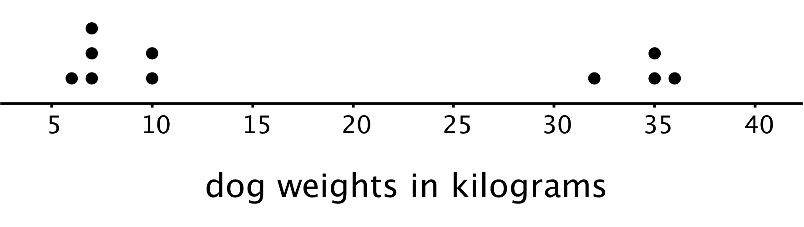
A dot plot uses a horizontal number line. We show the frequency of a value by the number of dots drawn above that value. Here, the two dots above the number 35 tell us that there are two dogs weighing 35 kilograms.
The distribution of categorical data can also be shown in a table. This table shows the distribution of dog breeds.
breed | frequency
pug | 9
beagle | 9
German shepherd | 12
We often represent the distribution of categorical data using a bar graph.
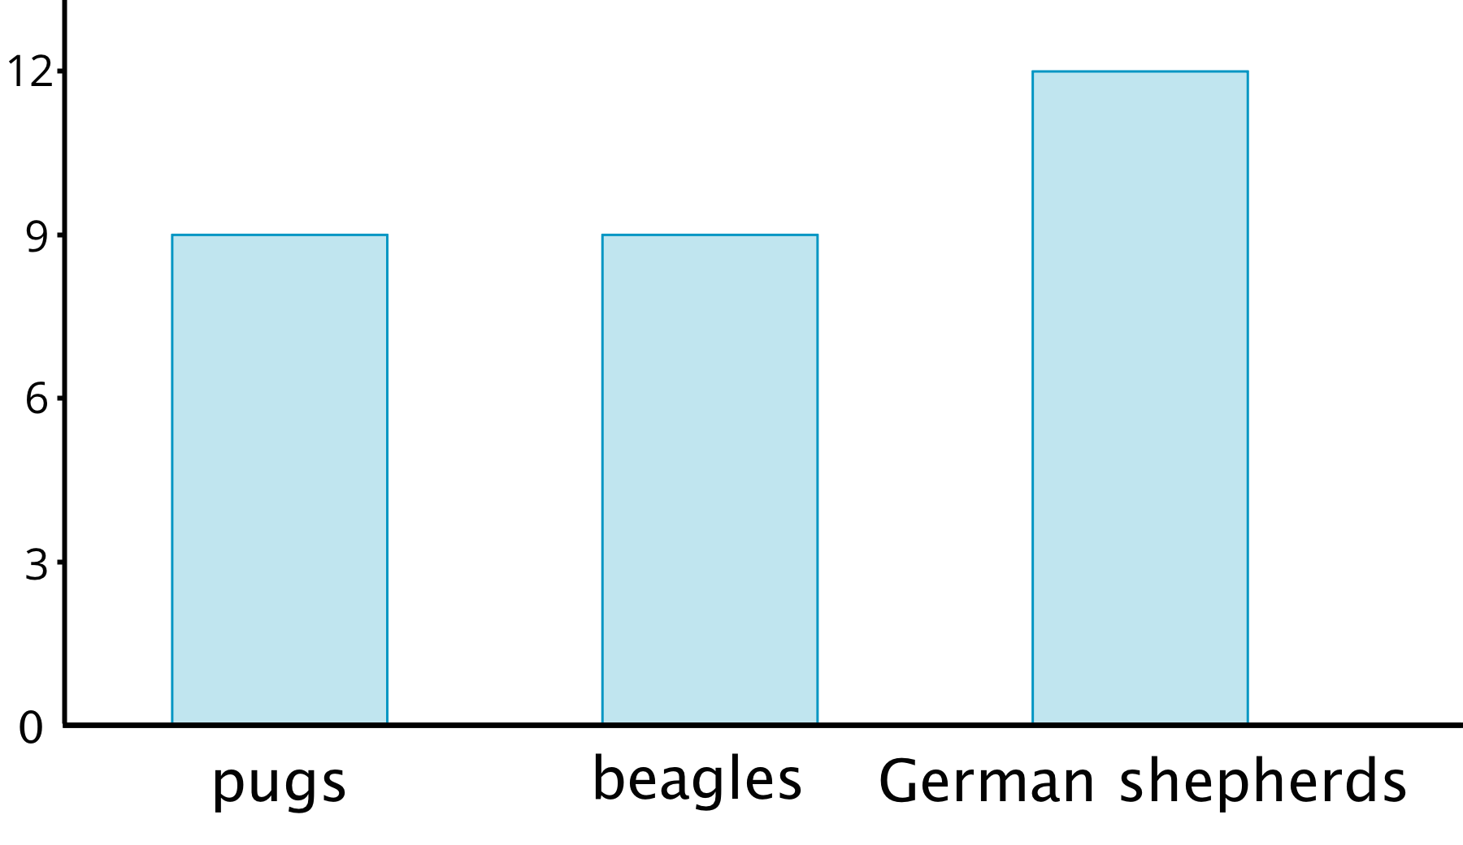
A bar graph also uses a horizontal line. Above it we draw a rectangle (or “bar”) to represent each category in the data set. The height of a bar tells us the frequency of the category. There are 12 German shepherds in the data set, so the bar for this category is 12 units tall. Below the line we write the labels for the categories.
In a dot plot, a data value is placed according to its position on the number line. A weight of 10 kilograms must be shown as a dot above 10 on the number line.
In a bar graph, however, the categories can be listed in any order. The bar that shows the frequency of pugs can be placed anywhere along the horizontal line.
© CC BY Open Up Resources. Adaptations CC BY IM.

