Lesson 10: Comparaciones usando valores posicionales (parte 1)

Standards Alignments
Addressing | 2.NBT.A.4, 2.NBT.B.8

Teacher-facing Learning Goals
- Compare three-digit numbers by reasoning about the value of the digits.

Student-facing Learning Goals
- Usemos el valor posicional para comparar números de tres dígitos.

Lesson Purpose
The purpose of this lesson is for students to compare three-digit numbers using their understanding of place value.
In grade 1, students compared two-digit numbers using the $<$, $>$, and $=$ symbols. In previous lessons, students represented three-digit numbers in different ways and identified the place value of digits in three-digit numbers.
In this lesson, students transition from representing and comparing three-digit numbers based on the counting sequence and their location on the number line to focus on reasoning based on place value. They compare hundreds to hundreds, tens to tens, and ones to ones and learn that any number with a greater number of hundreds is larger than a number with fewer hundreds, regardless of the value of the tens and ones (MP7). For example, $202>199$ because there are 2 hundreds compared to 1 hundred. In this lesson, they compare quantities represented with base-ten diagrams to support students’ reasoning based on place value.

Access for:

Students with Disabilities
- Engagement (Activity 1)

English Learners
- MLR8 (Activity 2)

Instructional Routines
Number Talk (Warm-up)

Lesson Timeline
Warm-up | 10 min
Activity 1 | 15 min
Activity 2 | 20 min
Lesson Synthesis | 10 min
Cool-down | 5 min

Teacher Reflection Question
Identify who has been sharing their ideas in class lately. Make a note of students whose ideas have not been shared and look for an opportunity for them to share their thinking in tomorrow’s lesson.

Cool-down
(to be completed at the end of the lesson) 5min
Cuenta y compara

Standards Alignments
Addressing | 2.NBT.A.4

Student-facing Task Statement
- Escribe el valor de cada diagrama en base diez como un número de tres dígitos. Usa los símbolos $>$, $=$ o $<$ para comparar los números.
- 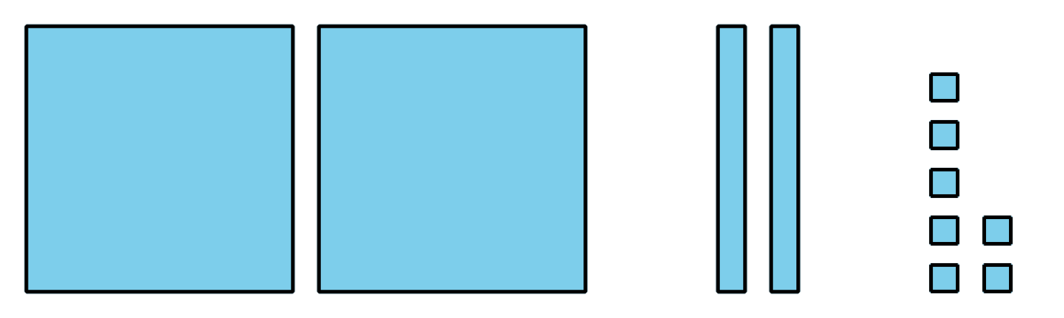
- 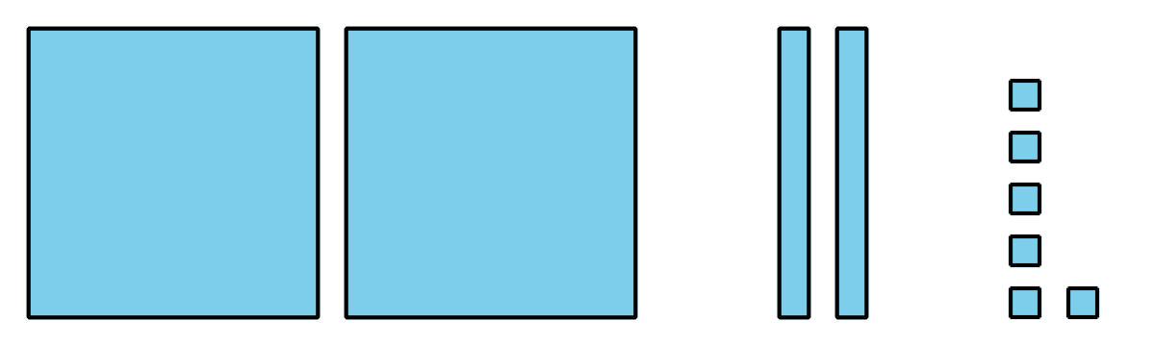
- _3333 _
- Explica cómo lo sabes.

Student Responses
- $227>226$
- 227 is greater than 226 because they have the same number of hundreds and tens, but 227 has 1 more one than 226.

