Grade 2
Unit 6Lesson 14CC BY NC 2024 Illustrative Mathematics®
Unit 6, Lesson 14

Center Day 3
- Let’s notice shapes in books, and practice adding and subtracting.
Grade 2
Unit 6Lesson 14CC BY NC 2024 Illustrative Mathematics®

Warm-up Number Talk: Adding Up to 4 Two-digit Numbers
Find the value of each expression mentally.
- $10+15+20+10$
- $5+30+20$
- $15+20+30$
- $25+15+5+15$
Grade 2
Unit 6Lesson 14CC BY NC 2024 Illustrative Mathematics®

Activity 2 Centers: Choice Time
Choose a center.
Capture Squares
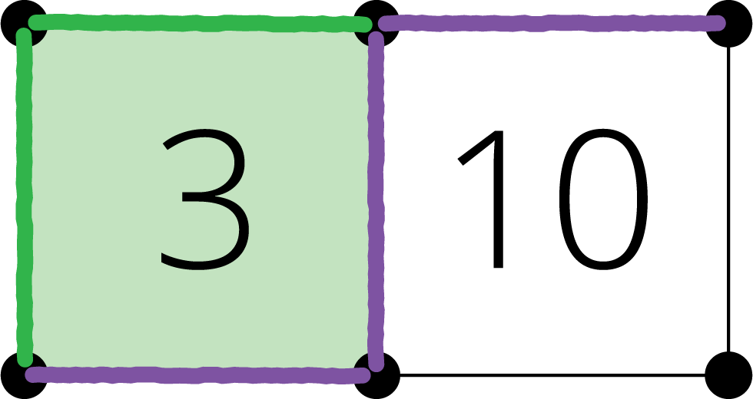
Number Puzzles
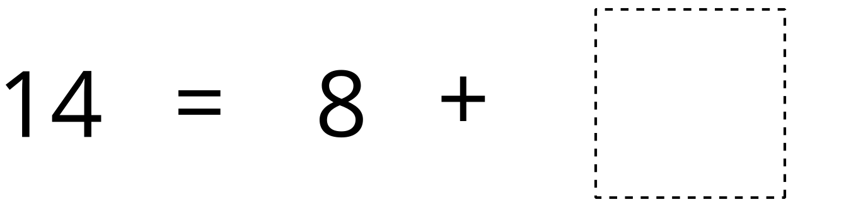
Picture Books


