Unit 5 Lesson 8: More Than One Way

WU Number Talk: Expressions (Warm up)

Student Task Statement
Find the value of each expression.
- $3+1$
- $1+3$
- $4−1$
- $4+1$

Activity Synthesis


1 Citrus Juice

Student Task Statement
Han squeezed 9 pieces of fruit to make juice.
Some of the fruits were satsumas.
The rest of the fruits were grapefruits.
How many of the fruits were satsumas?
Then how many of the fruits were grapefruits?
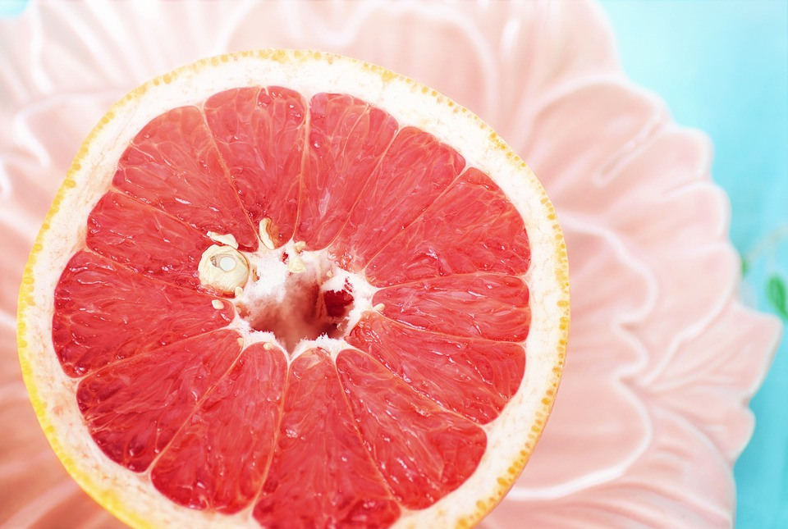
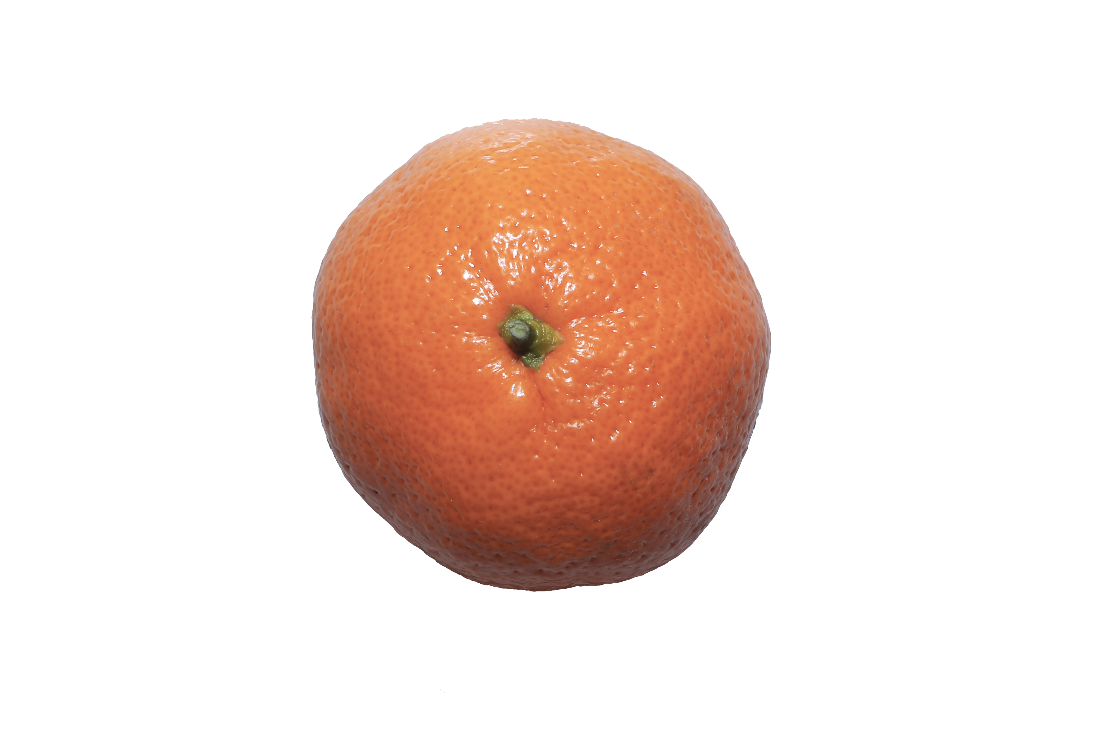
Clare:
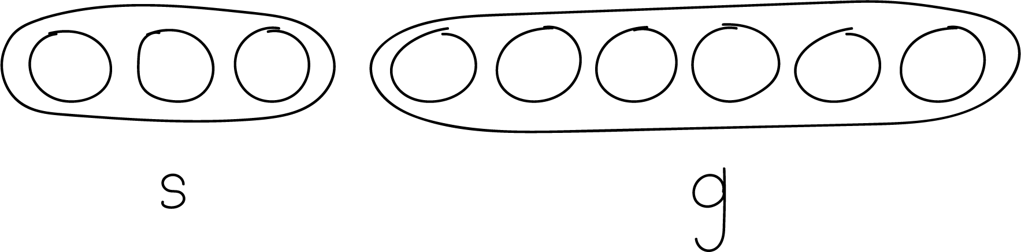
Diego:
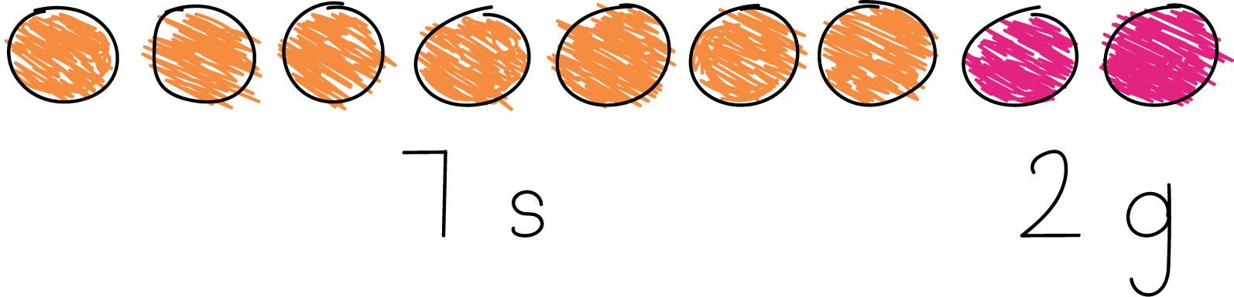
Han squeezed 9 pieces of fruit to make juice.
Some of the fruits were satsumas.
The rest of the fruits were grapefruits.
How many of the fruits were satsumas?
Then how many of the fruits were grapefruits?
Show your thinking using objects, drawings, numbers, or words.
Expression: ____________________________________

2 Dates to Stuff

Student Task Statement
Andre and his older brother have 8 dates.
They stuff some of the dates with cheese.
They stuff the rest of the dates with almonds.
How many of the dates did they stuff with cheese?
Then how many of the dates did they stuff with almonds?
Expression: _______________________________
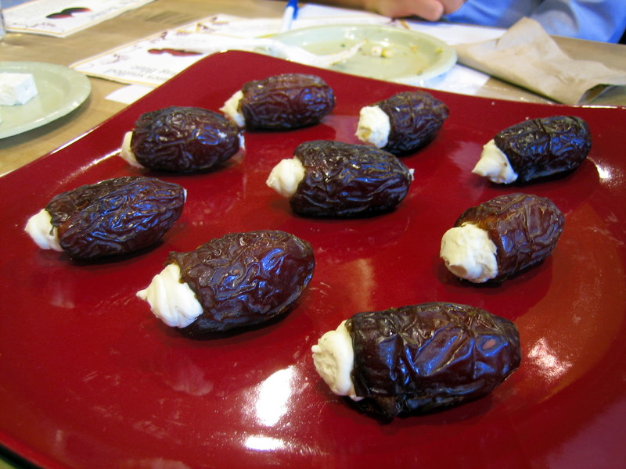
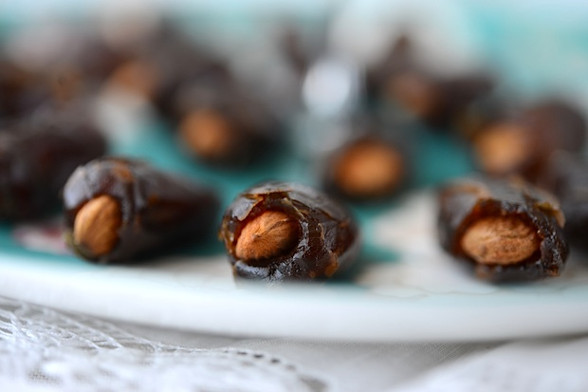

3 Centers: Choice Time

Student Task Statement
Choose a center.
What’s Behind My Back?
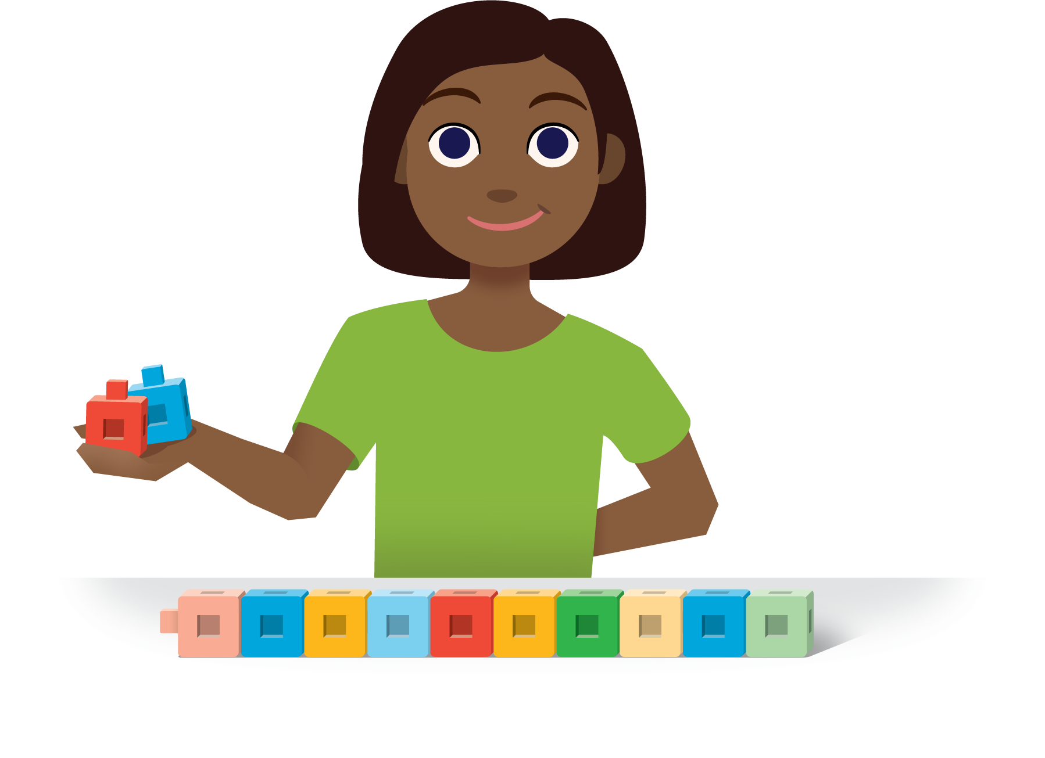
5-frames
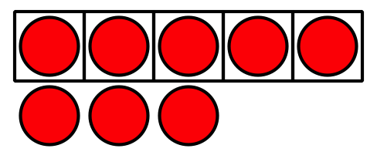
Make or Break Apart Numbers
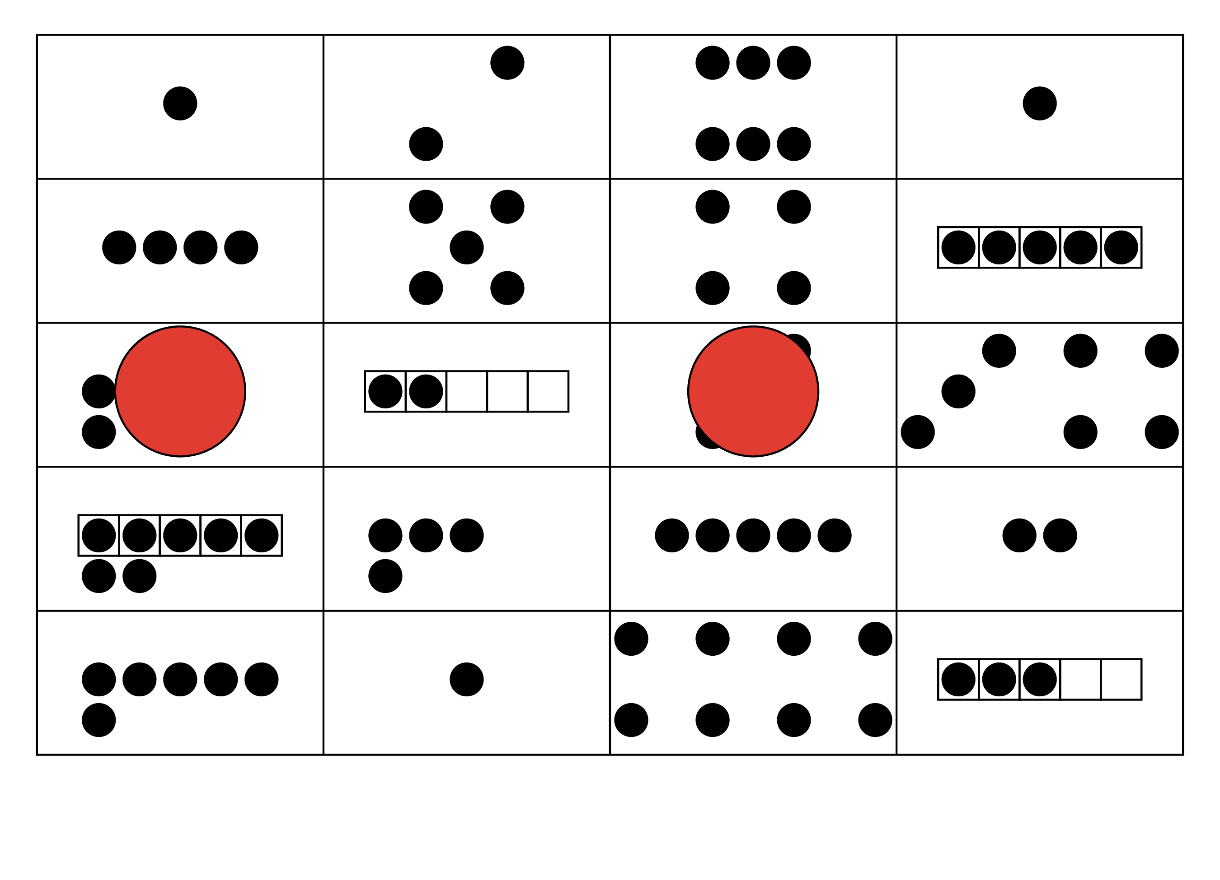
Math Stories


Images for Activity Synthesis
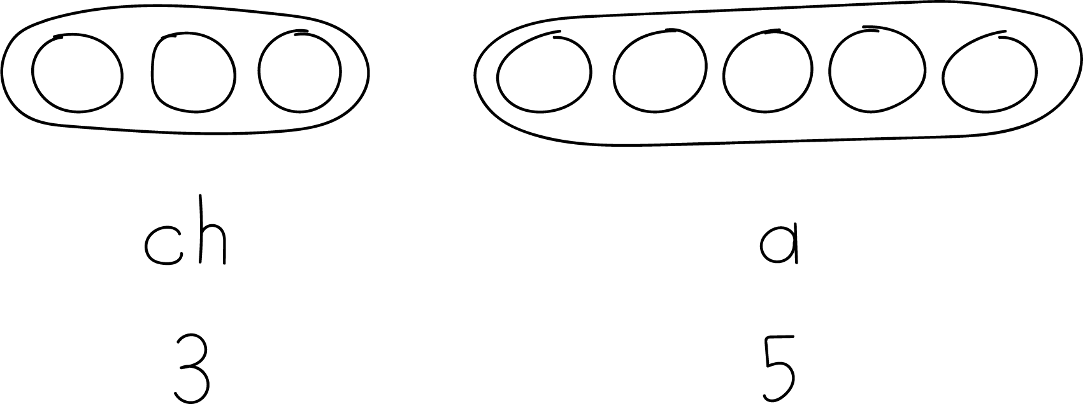
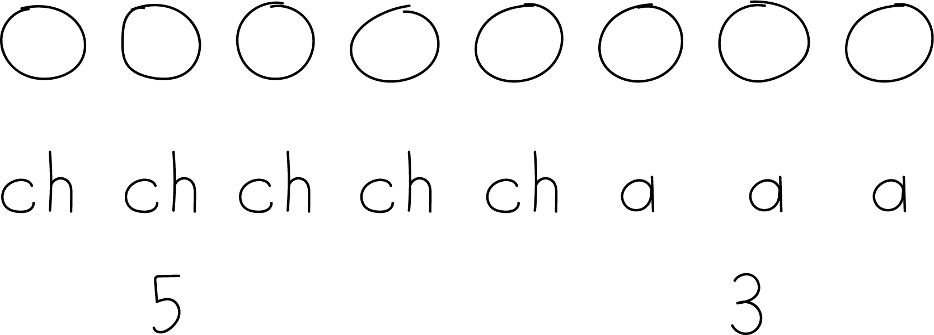
© CC BY 2021 Illustrative Mathematics®

