Unit 2 Lesson 9: Dilations

1 Notice and Wonder: Concentric Circles (Warm up)

Student Task Statement
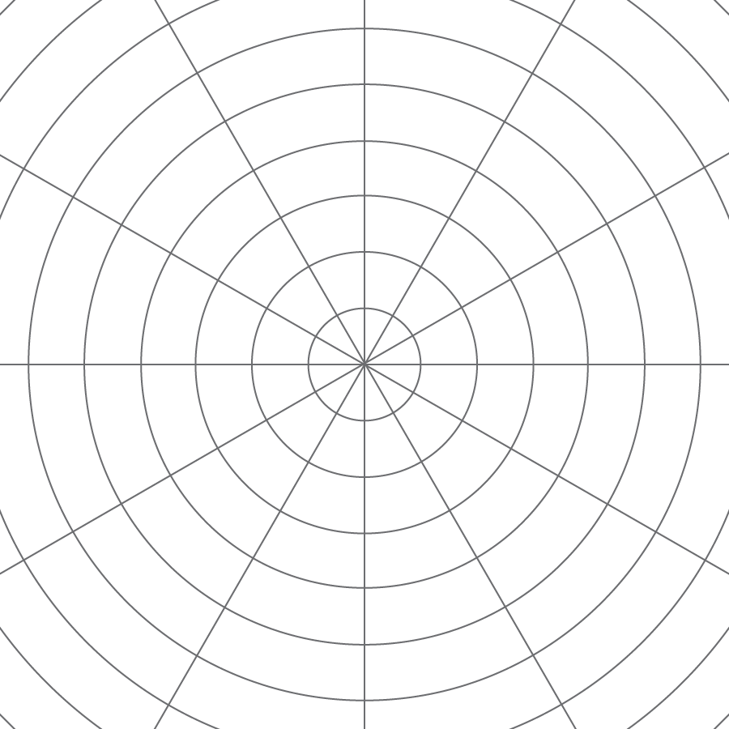
What do you notice? What do you wonder?

2 Quadrilateral on a Circular Grid

Images for Launch
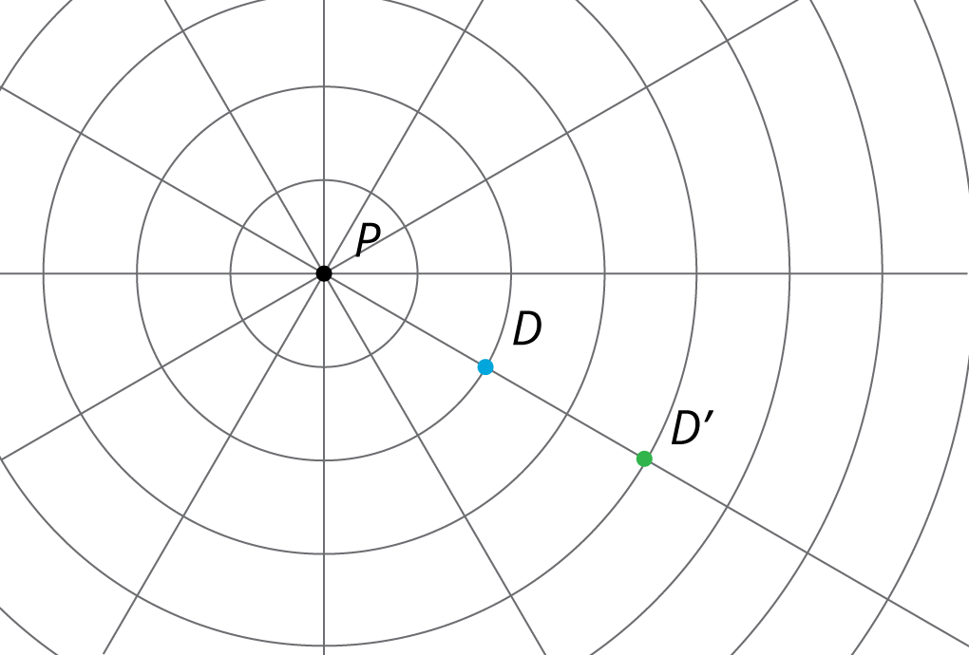

Student Task Statement
Here is a polygon $ABCD$.
- Dilate each vertex of polygon $ABCD$ using $P$ as the center of dilation and a scale factor of 2. Label the image of $A$ as $A^{′}$, and label the images of the remaining three vertices as $B^{′}$, $C^{′}$, and $D^{′}$.
- Draw segments between the dilated points to create polygon $A^{′}B^{′}C^{′}D^{′}$.
- What are some things you notice about the new polygon?
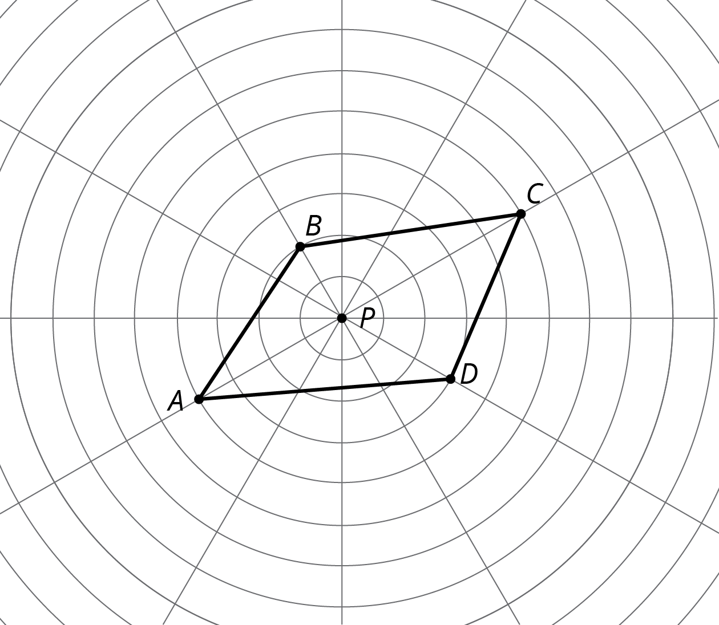
4. Choose a few more points on the sides of the original polygon and transform them using the same dilation. What do you notice?
5. Dilate each vertex of polygon $ABCD$ using $P$ as the center of dilation and a scale factor of $\frac{1}{2}$. Label the image of $A$ as $E$, the image of $B$ as $F$, the image of $C$ as $G$ and the image of $D$ as $H$.
6. What do you notice about polygon $EFGH$?

Activity Synthesis
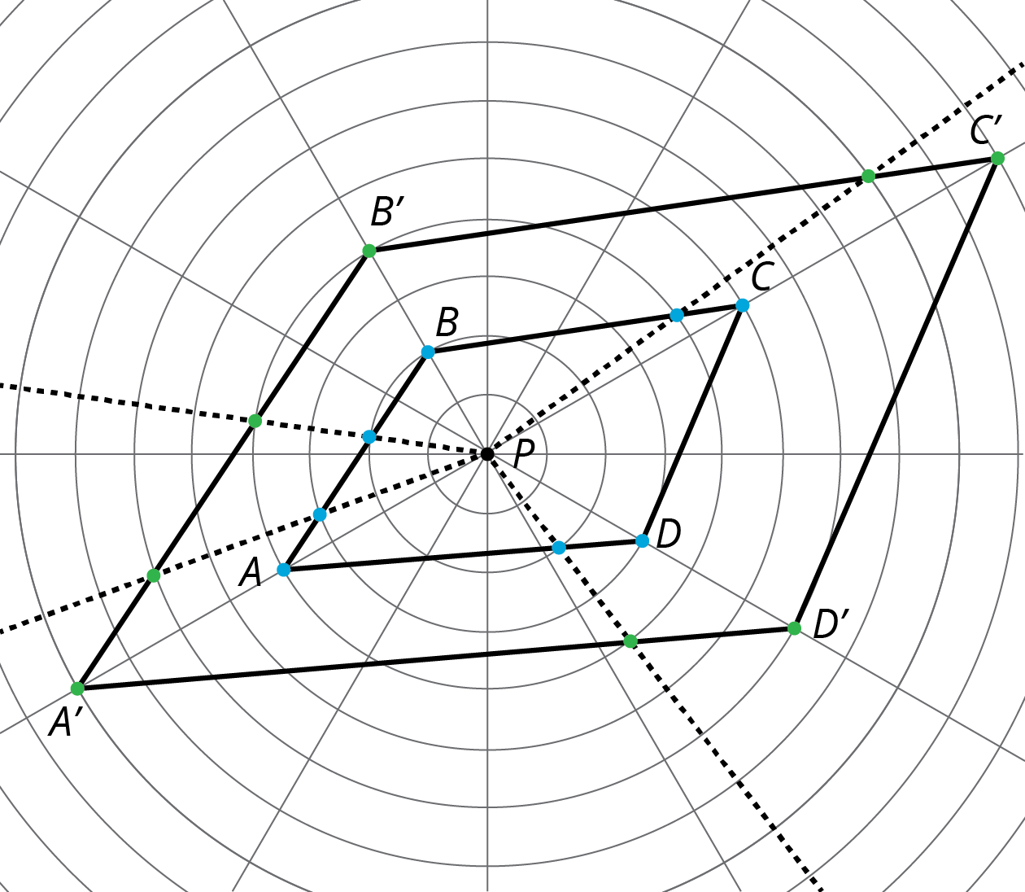

3 Getting Perspective

Images for Launch
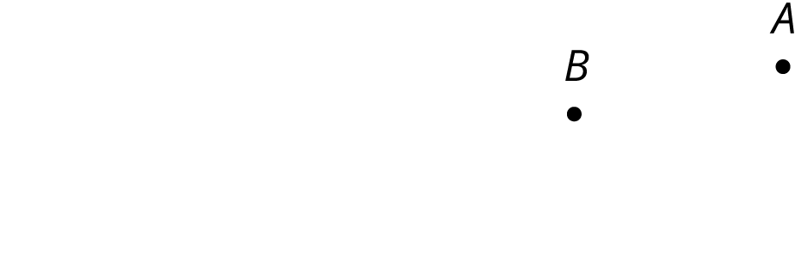
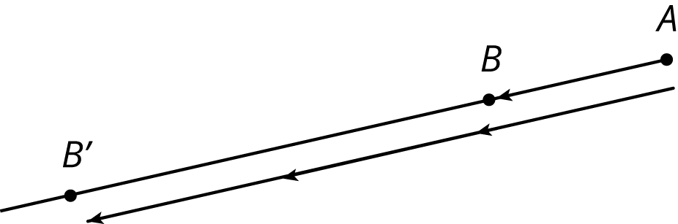
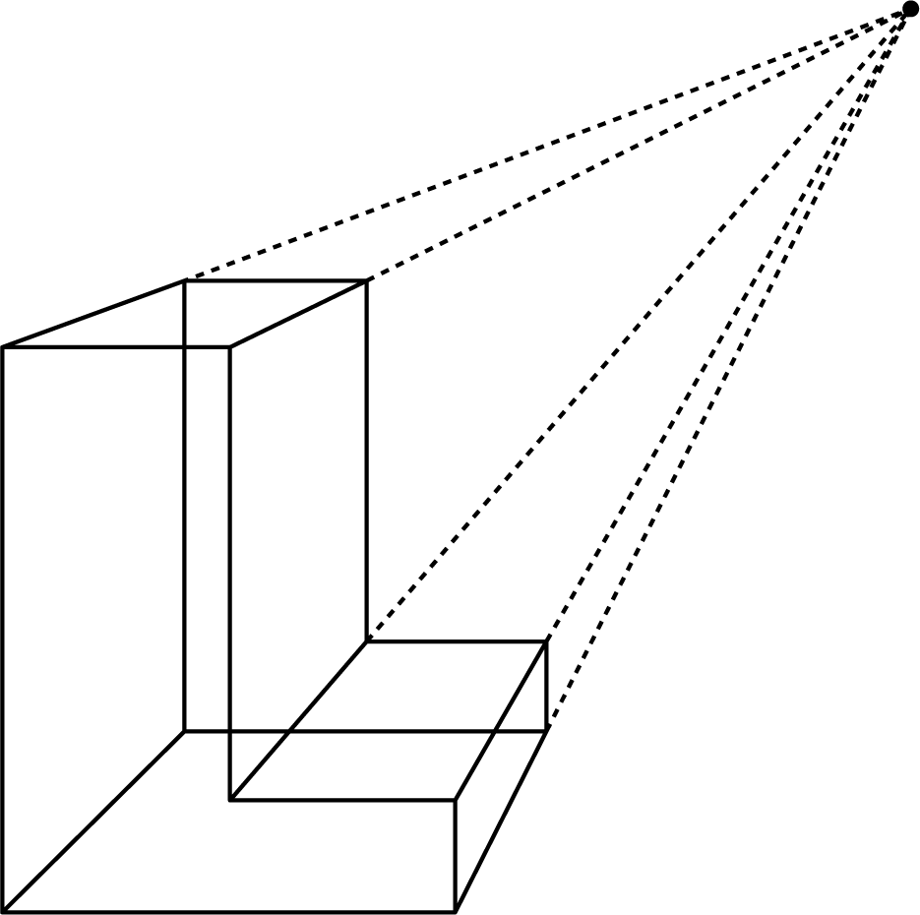

Student Task Statement
- Using one colored pencil, draw the images of points $P$ and $Q$ using $C$ as the center of dilation and a scale factor of 4. Label the new points $P^{′}$ and $Q^{′}$.
- Using a different color, draw the images of points $P$ and $Q$ using $C$ as the center of dilation and a scale factor of $\frac{1}{2}$. Label the new points $P^{″}$ and $Q^{″}$.
- 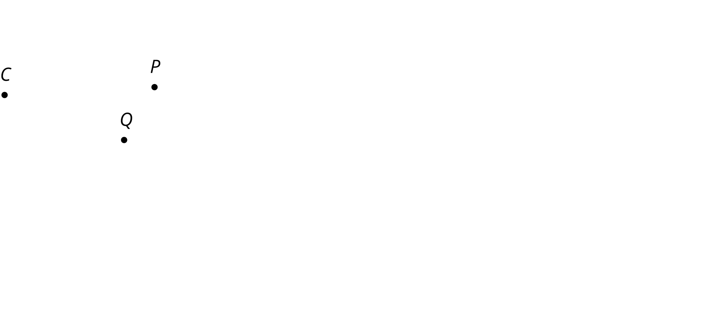
- Pause here so your teacher can review your diagram. Your teacher will then give you a scale factor to use in the next part.
- Now you’ll make a perspective drawing. Here is a rectangle.
- 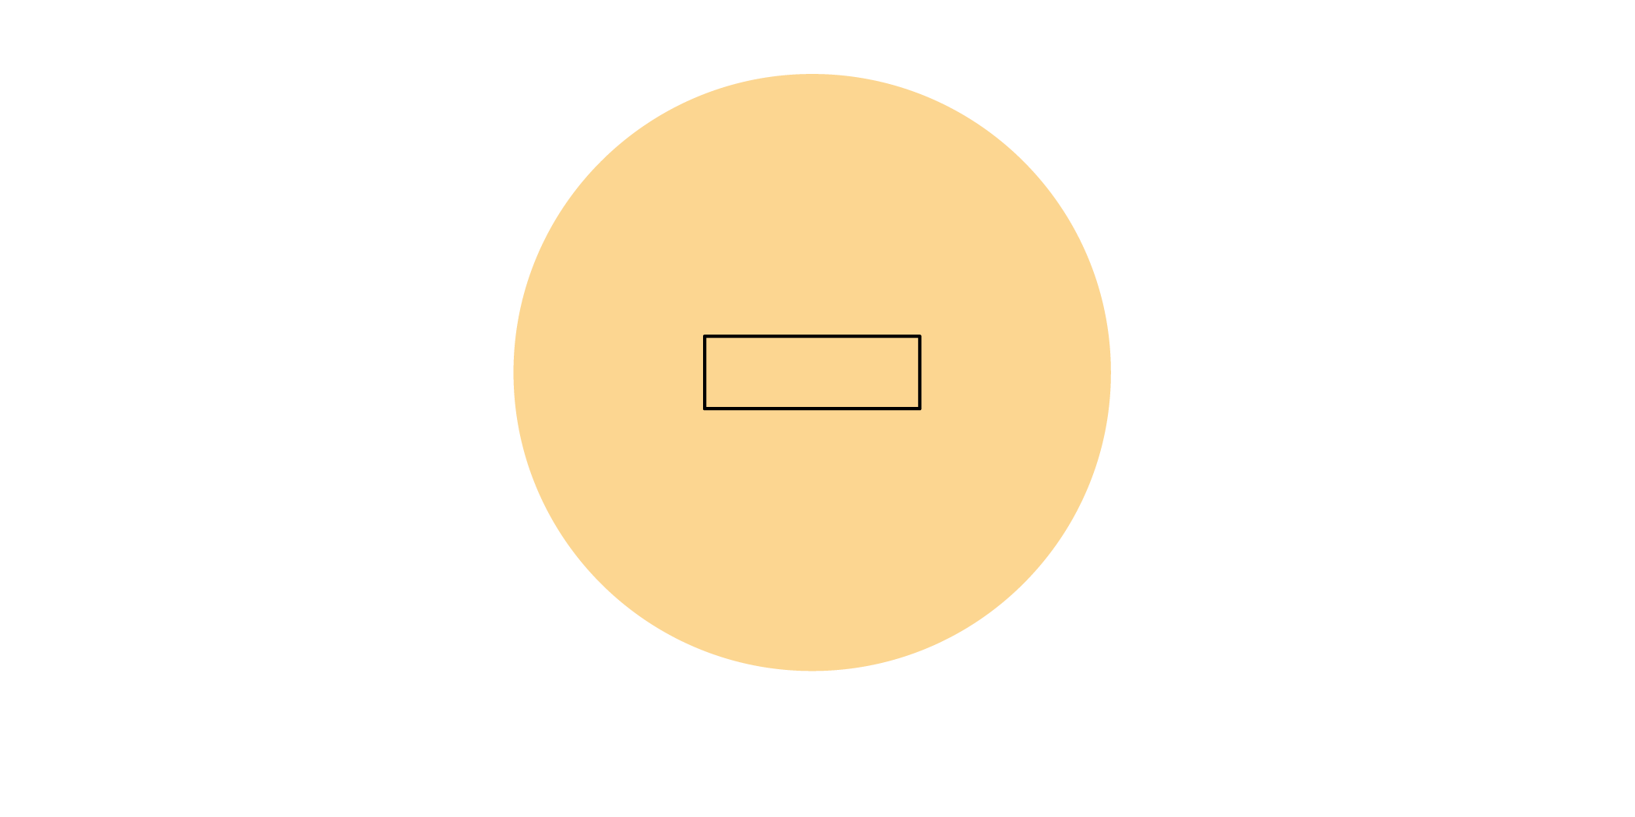
  - Choose a point inside the shaded circular region but outside the rectangle to use as the center of dilation. Label it $C$.
  - Using your center $C$ and the scale factor you were given, draw the image under the dilation of each vertex of the rectangle, one at a time. Connect the dilated vertices to create the dilated rectangle.
  - Draw a segment that connects each of the original vertices with its image. This will make your diagram look like a cool three-dimensional drawing of a box! If there’s time, you can shade the sides of the box to make it look more realistic.
  - Compare your drawing to other people’s drawings. What is the same and what is different? How do the choices you made affect the final drawing? Was your dilated rectangle closer to $C$ than to the original rectangle, or farther away? How is that decided?
© CC BY Open Up Resources. Adaptations CC BY IM.

