Grade 2
Unit 9Lesson 11CC BY NC 2024 Illustrative Mathematics®
Unit 9, Lesson 11

All about Tape Diagrams
- Let’s match diagrams, story problems, and equations.
Grade 2
Unit 9Lesson 11CC BY NC 2024 Illustrative Mathematics®

Warm-up Number Talk: Addition and Subtraction
Find the value of each expression mentally.
- $7+13$
- $27+13$
- $40−13$
- $40−27$
Grade 2
Unit 9Lesson 11CC BY NC 2024 Illustrative Mathematics®

Activity 1Card Sort: Represent Story Problems
Your teacher will give you a set of cards. Match each story problem with a diagram and an equation.
Grade 2
Unit 9Lesson 11CC BY NC 2024 Illustrative Mathematics®

Activity 2 Write Stories
Choose 1 of the diagrams. Write a story problem that the diagram could represent. Solve the problem.

- 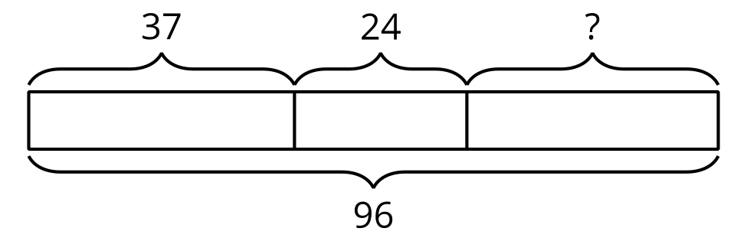

- 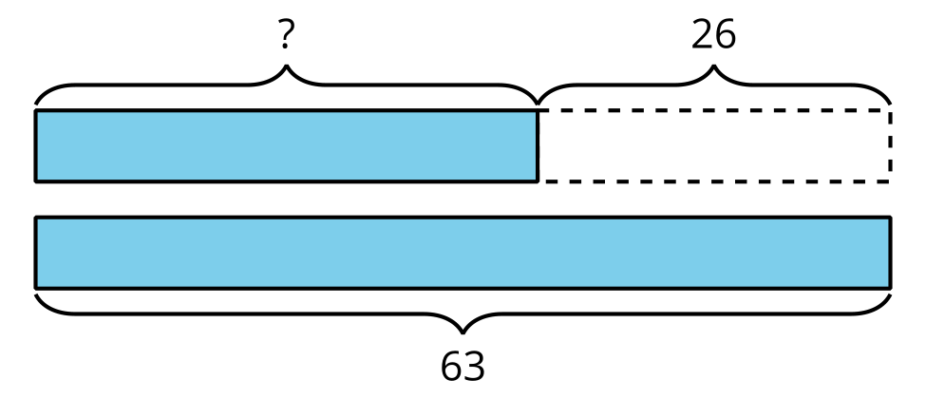

- 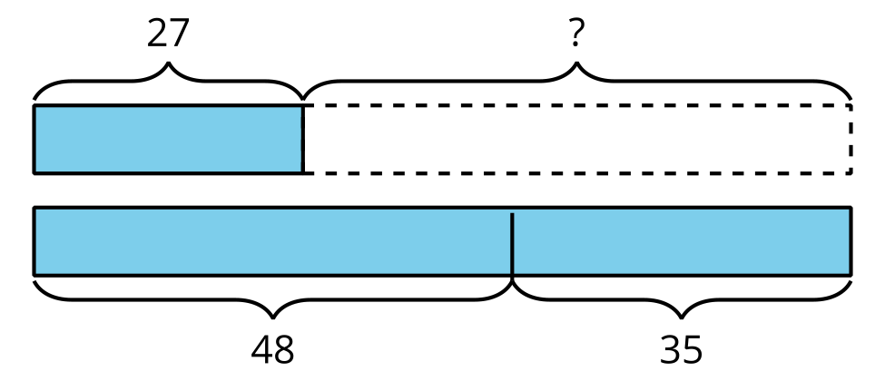
Problem ______

