Lesson 4: The Shape of Data Distributions
- Let’s explore various shapes of data.

4.1: Math Talk: Number Line Distance
Mentally, find the distance between the two values on a number line.
- 70 and 62
- 70 and 70
- 70 and 79
- 70 and 97

4.2: Suspicious Descriptions
For each picture and description:
- Do you agree or disagree with the description?
- If you agree, explain how you know it is correct.
- If you disagree, explain the error and write the correct description. Explain how you know it is correct.

Bell-shaped since there is a central peak for symmetric data that is less frequent on the ends.
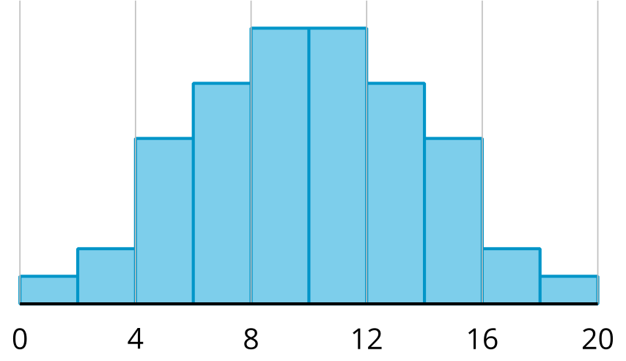
​​​​​​

Symmetric because if the distribution was cut in half, both sides would be the same shape.
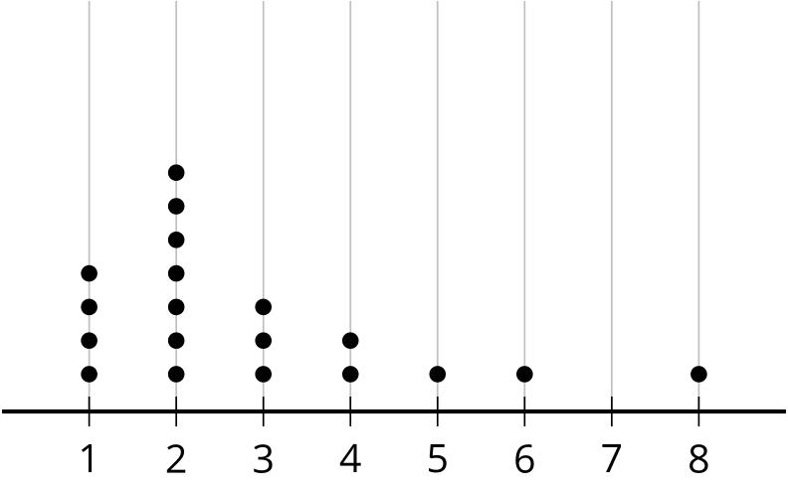
​​​​​​

Uniform because there seems to be the same amount of data points across the entire distribution.
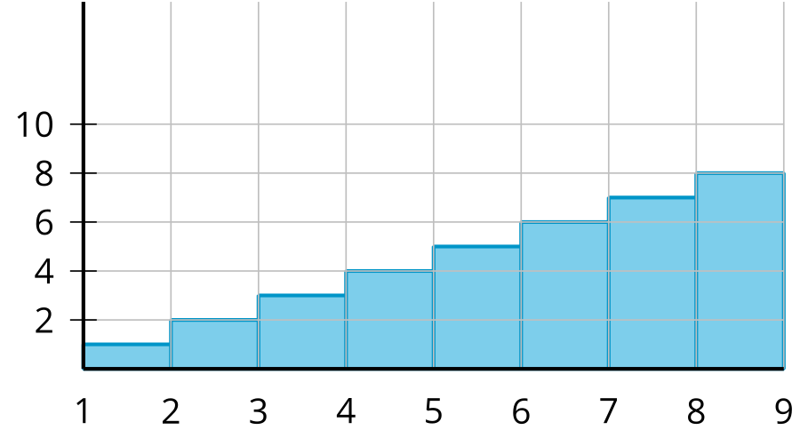
​​​​​​

Symmetric because if the distribution was cut in half, both sides would be the same shape.
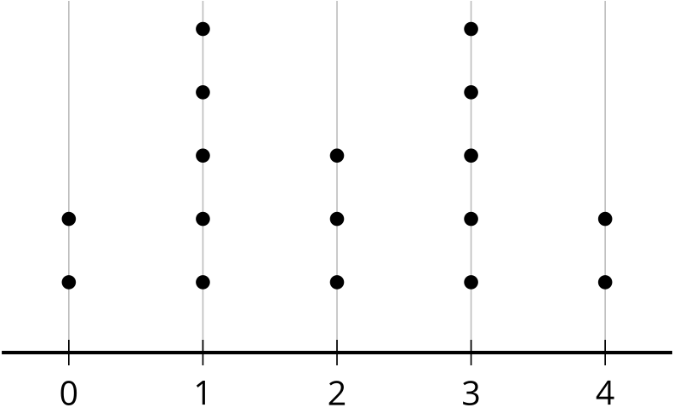
​​​​​​

Skewed left since most of the data is on the left side of the distribution.
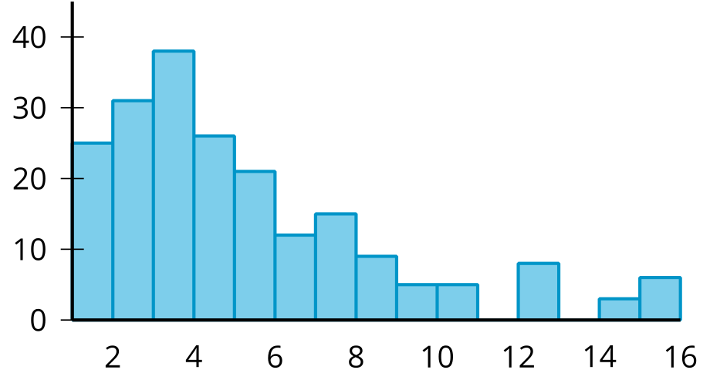
​​​​​​

4.3: Whipping Data into Shape
Describe the shape of each distribution using the terms approximately, symmetric, bell-shaped, skewed left, skewed right, uniform, or bimodal. Estimate the center of each distribution.

A
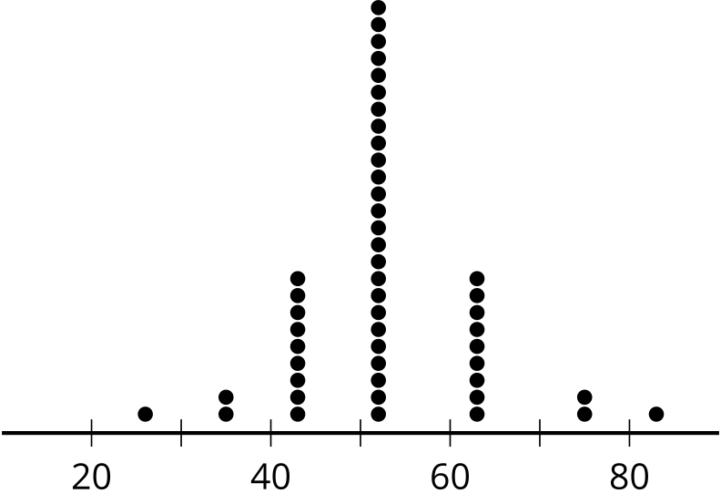
​​

B
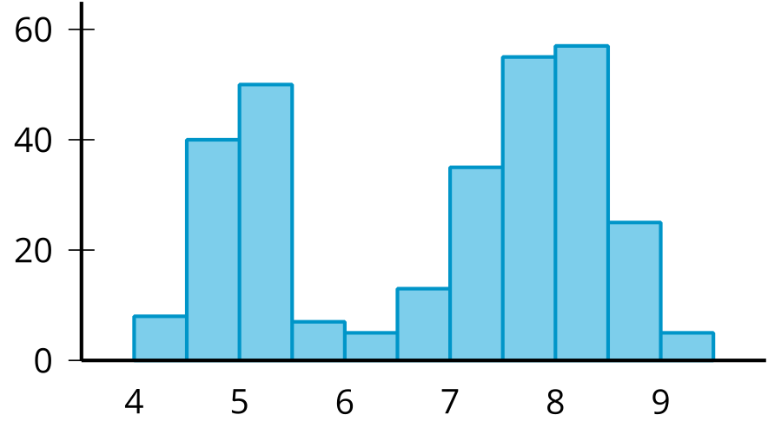

C
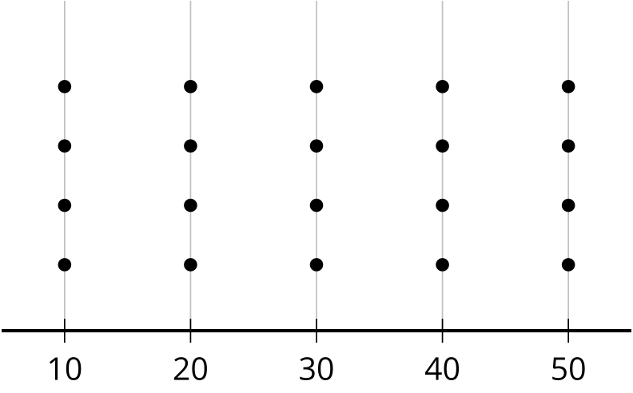

D
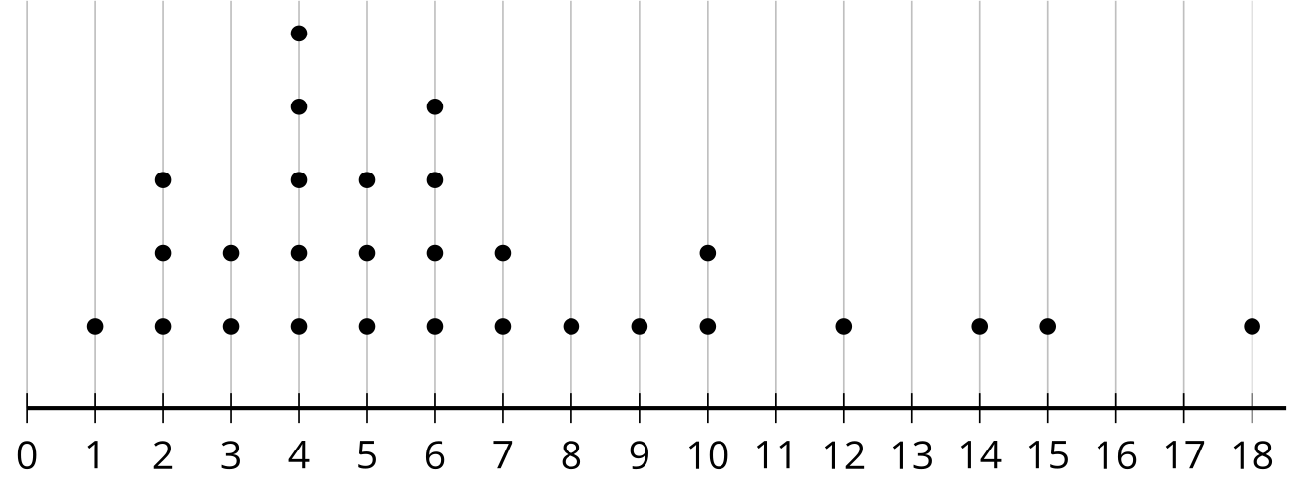

E
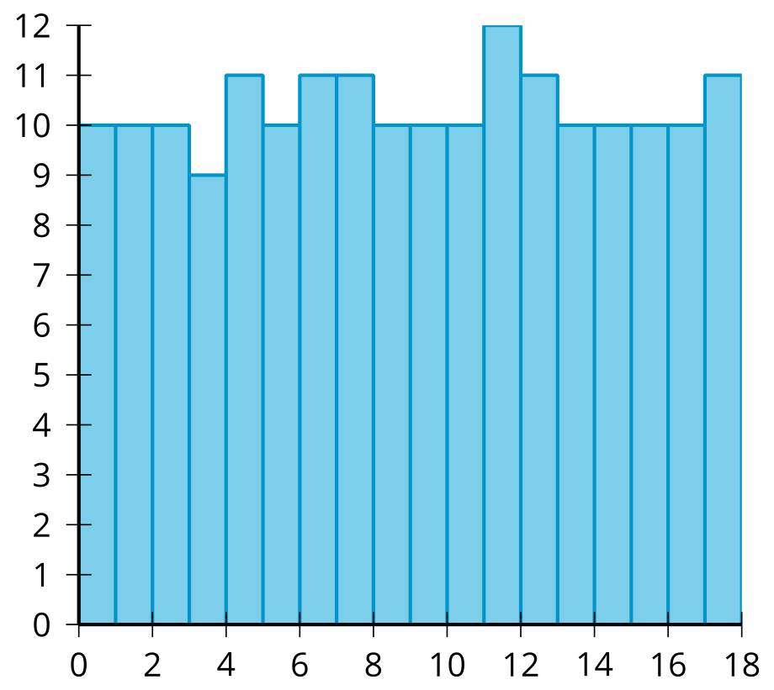
​​​​​

F
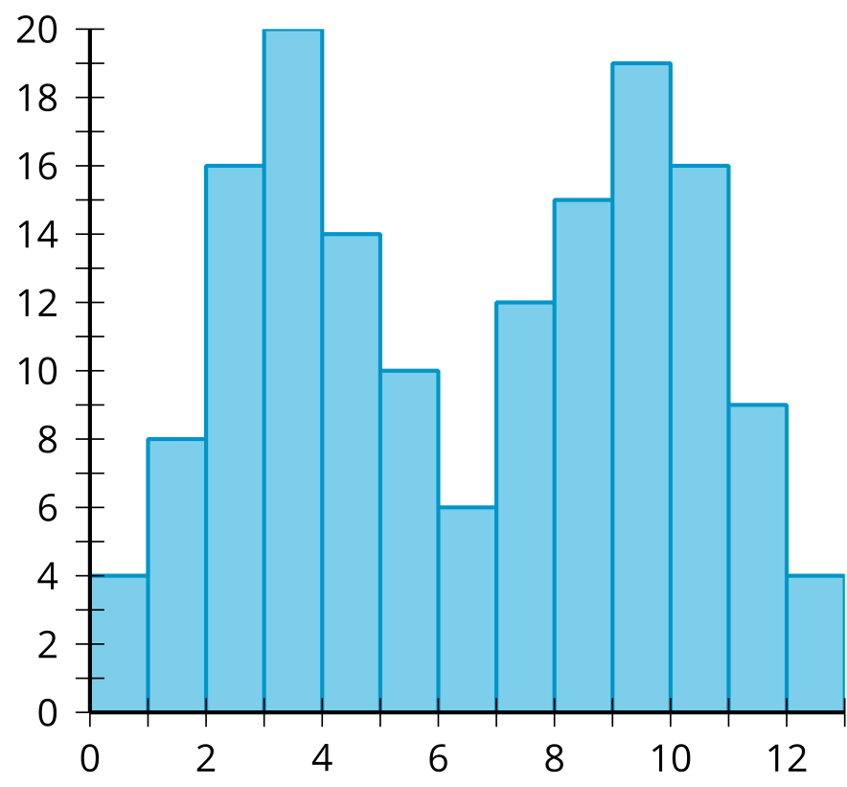
​​​​​​

G
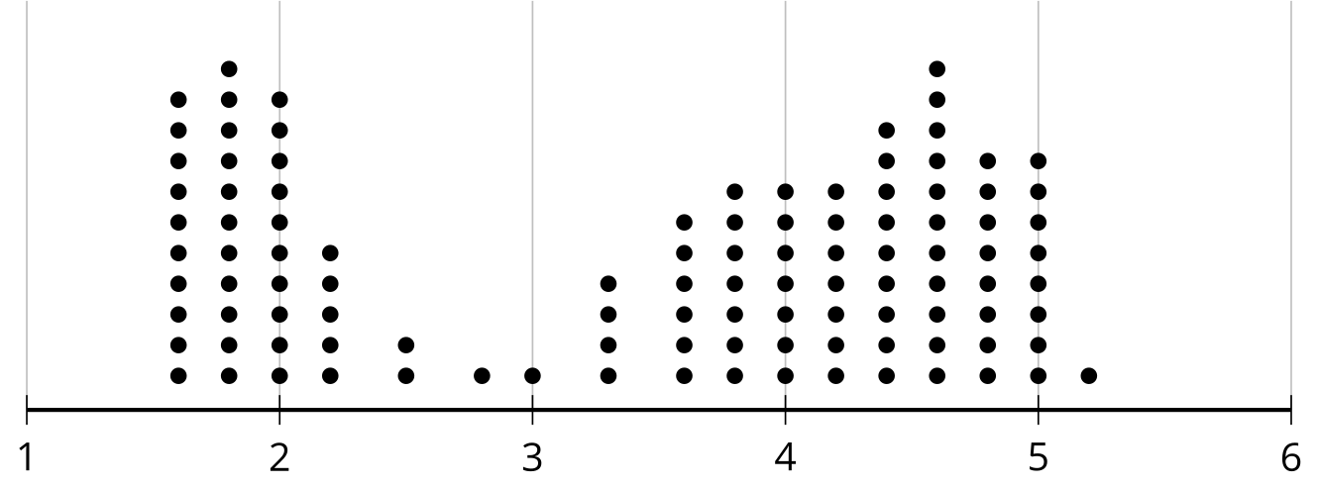

H
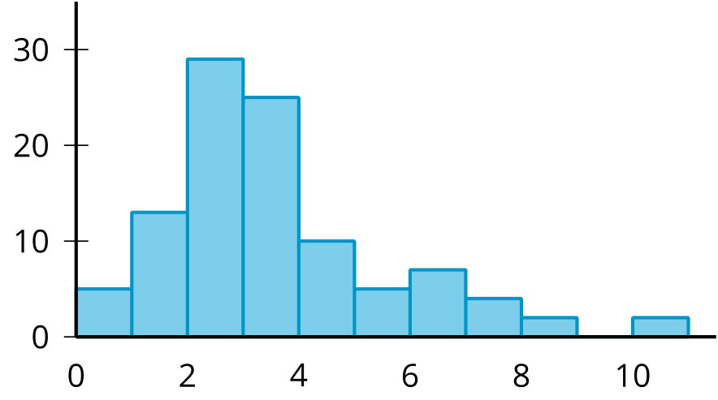
© CC BY 2019 by Illustrative Mathematics®

